DAY 5 — CAPSTONE DESIGN DOCUMENT
Employee / Task Manager
A Console-Based Java Application — Architecture, Domain Model & Release Readiness
Integration, Debugging, Review and Assessment
Prepared for: Core Java — Week 1, Module 1
Document Version 1.0 | 26 August 2026

Industrial lens: a professional developer must do more than make the happy path work — they explain assumptions, identify invalid states, demonstrate reproducible setup, make a meaningful commit, and handle a failure scenario without guessing.

Table of Contents
Table of Contents 2
1. Overview & Objectives 3
1.1 Goals 3
1.2 Non-Goals (this module) 3
2. Requirements 3
2.1 Functional Requirements 3
2.2 Non-Functional Requirements 4
3. Architecture 4
3.1 Package Layout 5
4. Domain Model 5
4.1 Class Responsibilities 6
5. Task Lifecycle 6
5.1 Transition Rules 6
6. Assign-Task Sequence 7
7. Invalid States & Edge Cases 7
8. Assumptions 8
9. Release Readiness Checklist 8
10. Glossary 9

1. Overview & Objectives
This document specifies the design for the Day 5 capstone lab: a small, explainable, console-based Employee / Task Manager built in Java. It is written at the level expected of a real design document handed to a reviewer before implementation begins — it defines scope, domain model, architecture, state rules, and the failure scenarios a developer must be able to walk through live.
The exercise is deliberately scoped small so that every design decision can be justified. Persistence, concurrency, and networking are explicitly out of scope for this module and are called out where relevant.

1.1 Goals
- Model a small but realistic domain (Employee, Task) with clear ownership of behaviour.
- Support the full task lifecycle: create, assign, start, complete, cancel.
- Support search by title and filtering by status or priority.
- Print a summary report of current state.
- Demonstrate release-readiness: assumptions, invalid-state handling, reproducible setup, a meaningful commit, and a live failure-scenario walkthrough.

1.2 Non-Goals (this module)
- Persistence to disk or a database — data is held in memory only.
- Multi-user access or concurrency control.
- A GUI or web interface — the console is the only client.

2. Requirements

2.1 Functional Requirements
ID | Requirement | Notes
FR-1 | Create an employee | Requires name and role; system assigns a unique id
FR-2 | Create a task | Requires title and priority; defaults to NOT_STARTED
FR-3 | Assign a task to an employee | Fails clearly if either id is unknown
FR-4 | Start a task | Valid only from NOT_STARTED
FR-5 | Complete a task | Valid only from IN_PROGRESS
FR-6 | Cancel a task | Valid from NOT_STARTED or IN_PROGRESS only
FR-7 | Search tasks by title | Case-insensitive substring match
FR-8 | Filter tasks by status or priority | Combinable filters
FR-9 | Print a summary | Counts by status, and a per-employee task list

2.2 Non-Functional Requirements
ID | Requirement | Rationale
NFR-1 | No invalid state is ever silently accepted | Correctness must be provable by reading Task alone
NFR-2 | Domain classes have zero I/O dependencies | Keeps business rules unit-testable without a console
NFR-3 | Build and run reproducible from a clean checkout | Reviewer must run it without guessing steps
NFR-4 | Clear, single-purpose git history | One meaningful commit per logical change

3. Architecture
The application follows a simple three-layer architecture. Dependencies point strictly downward: the presentation layer depends on the service layer, which depends on the domain layer — never the reverse. This keeps the domain model free of console I/O concerns and independently testable.
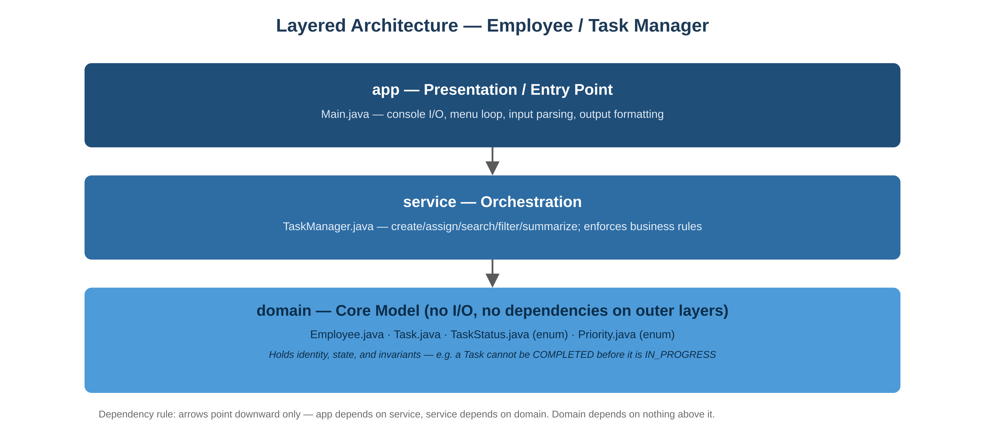
Figure 1. Layered architecture — dependency direction runs top to bottom.

3.1 Package Layout
src/
com/acme/taskmanager/
app/
Main.java
domain/
Employee.java
Task.java
TaskStatus.java
Priority.java
service/
TaskManager.java

4. Domain Model
Employee owns identity and role. Task owns its title, assignee, and status transitions — the transition rules live on Task itself rather than being scattered through TaskManager, so an invariant can never be bypassed by calling code. TaskManager owns orchestration: creating records, wiring an assignment, and running search/filter queries across its collections.
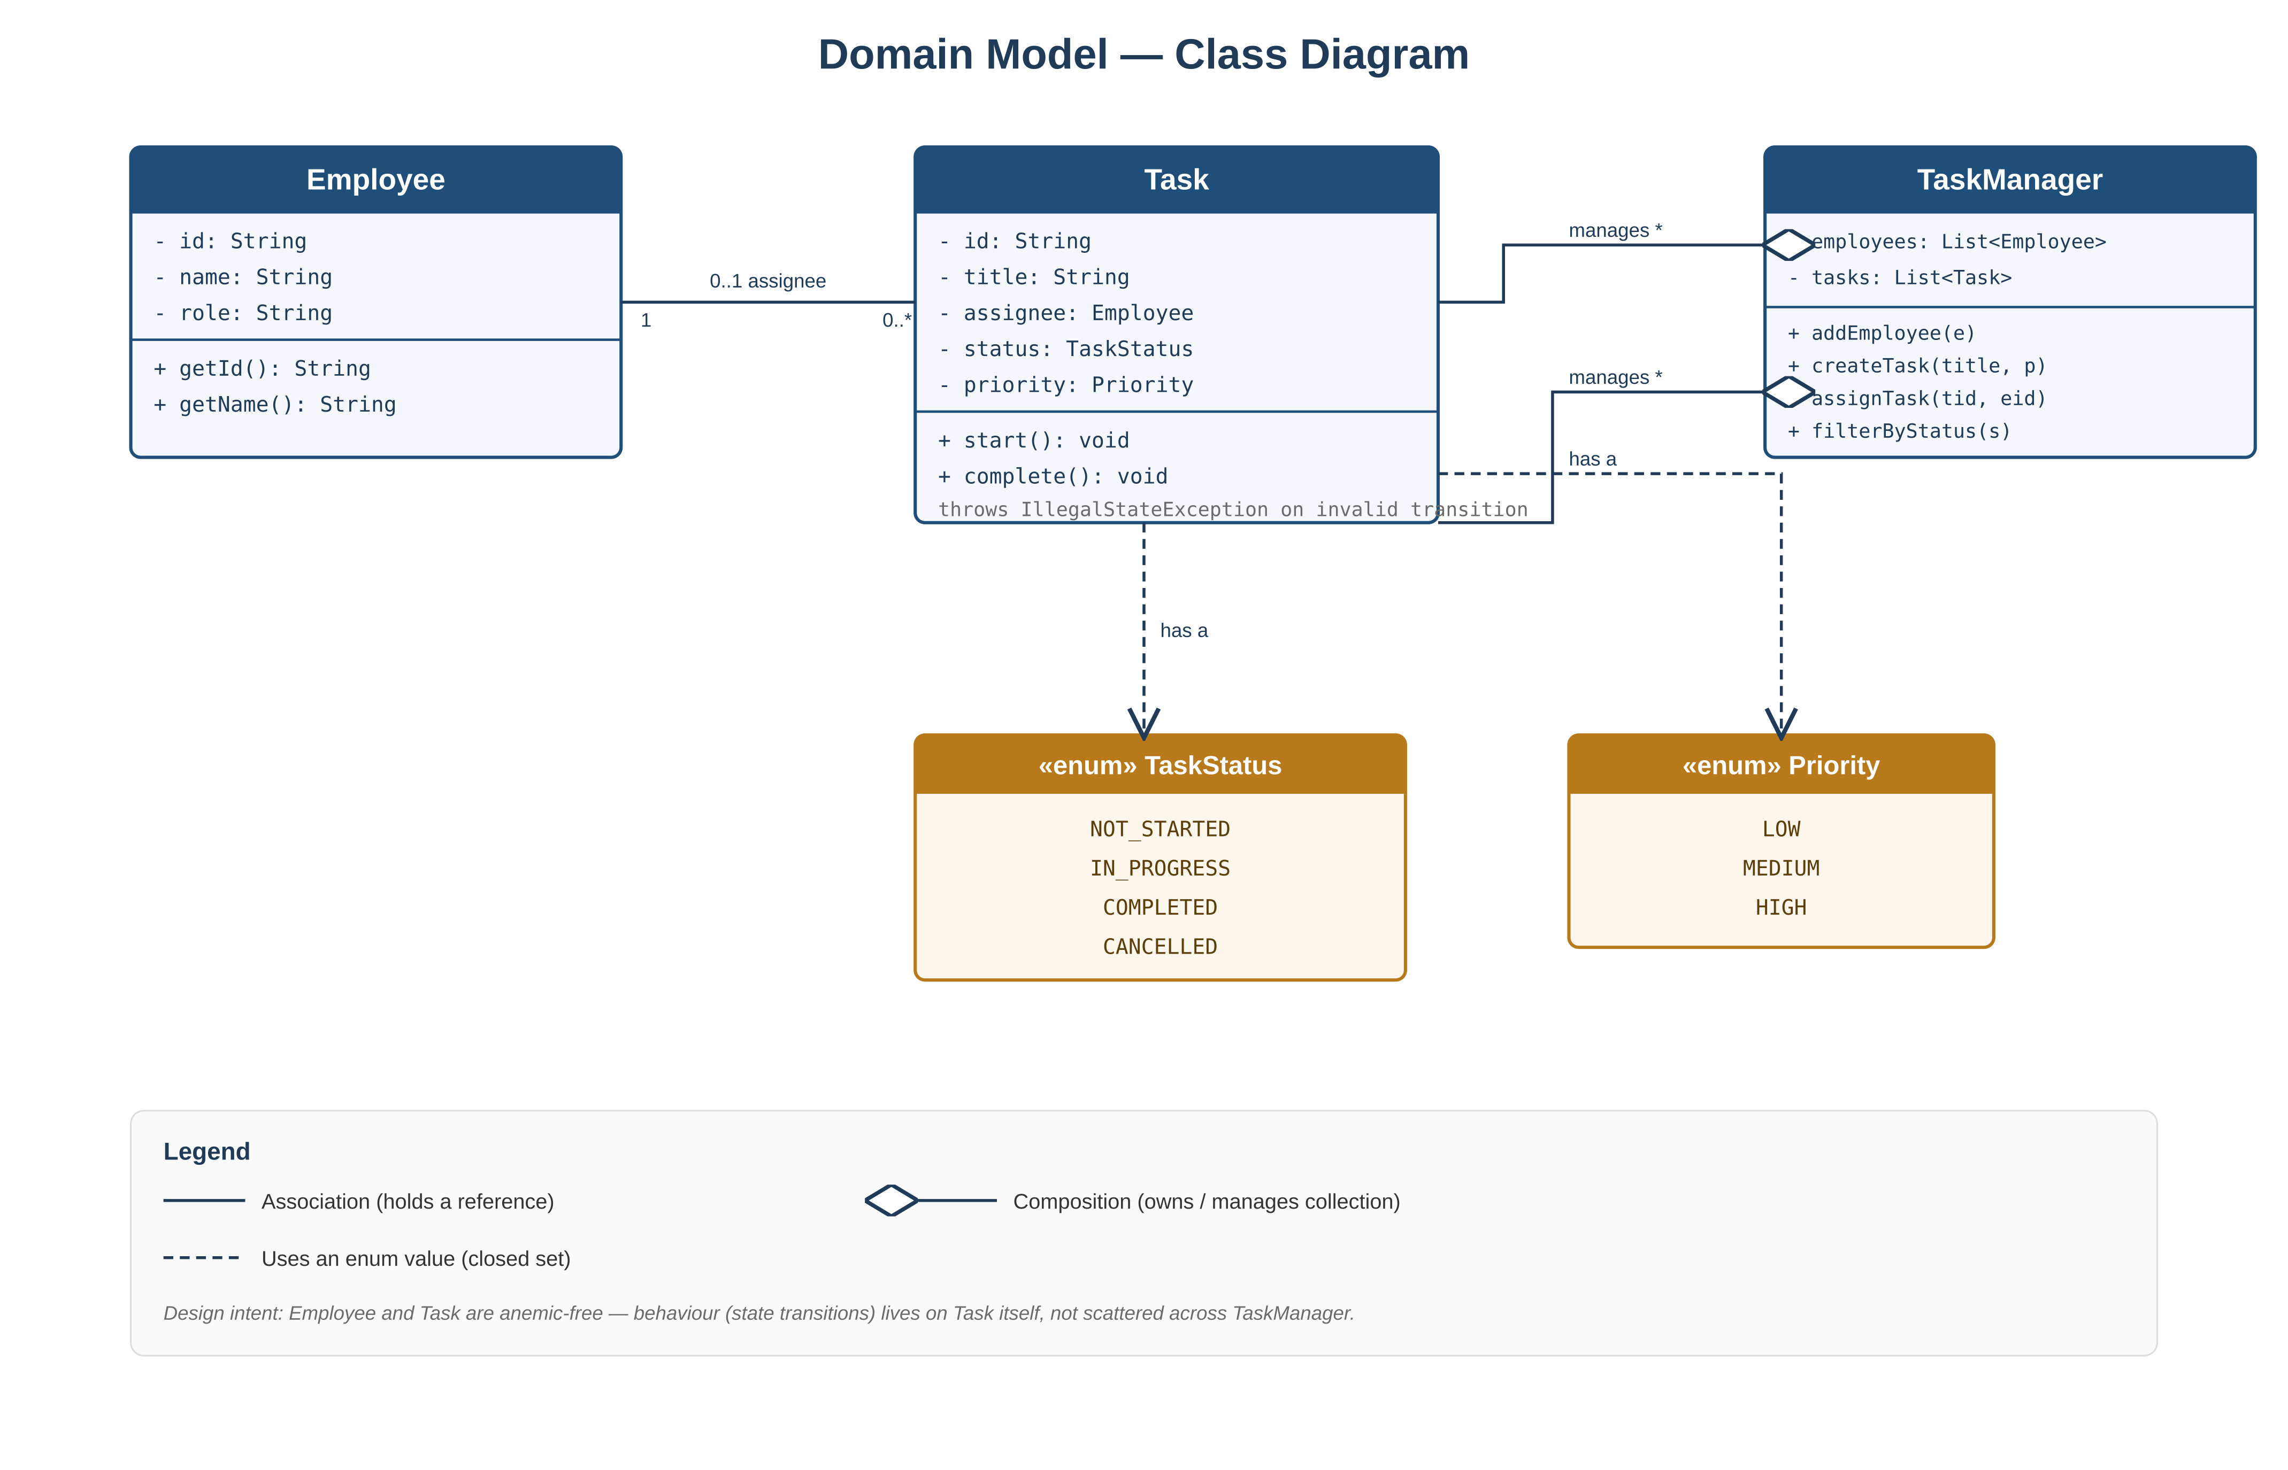
Figure 2. Domain model class diagram, including relationships and closed-set enums.

4.1 Class Responsibilities
Class | Responsibility | Key Invariant
Employee | Identity and role | id is immutable once created
Task | Title, assignee, status, priority | Status only moves along legal transitions (Section 5)
TaskManager | Orchestration across employees and tasks | Never mutates Task state directly — delegates to Task
TaskStatus (enum) | Closed set of lifecycle states | NOT_STARTED, IN_PROGRESS, COMPLETED, CANCELLED
Priority (enum) | Closed set of priority levels | LOW, MEDIUM, HIGH

5. Task Lifecycle
A Task moves through a small, well-defined state machine. Every transition is a method on Task; any call that would produce an illegal transition throws immediately rather than leaving the object in an ambiguous state.
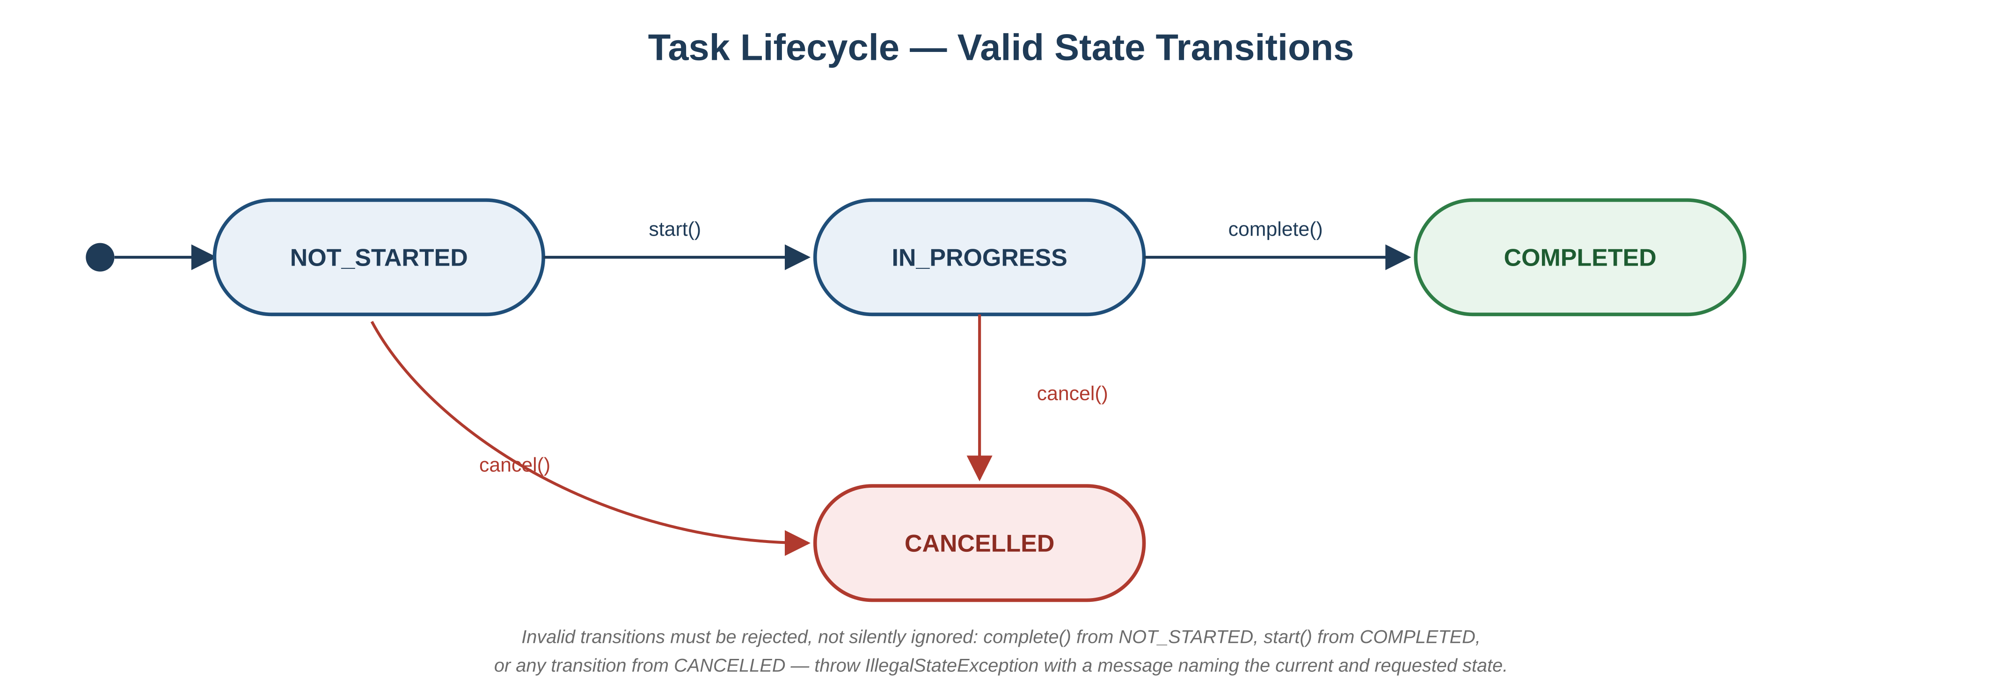
Figure 3. Valid and invalid Task status transitions.

5.1 Transition Rules
From | Method | To | Guard
NOT_STARTED | start() | IN_PROGRESS | Always allowed
IN_PROGRESS | complete() | COMPLETED | Always allowed
NOT_STARTED / IN_PROGRESS | cancel() | CANCELLED | Not allowed once COMPLETED
Any | start() / complete() out of order | — rejected | Throws IllegalStateException
CANCELLED / COMPLETED | any transition | — rejected | Terminal states are immutable

6. Assign-Task Sequence
The assignment flow is the clearest illustration of how validation is layered: TaskManager resolves ids and delegates the actual state check to Task. This is also the scenario used for the Day 5 live failure-handling walkthrough — reassigning a completed task, or assigning to an unknown employee id, must fail predictably and explainably.
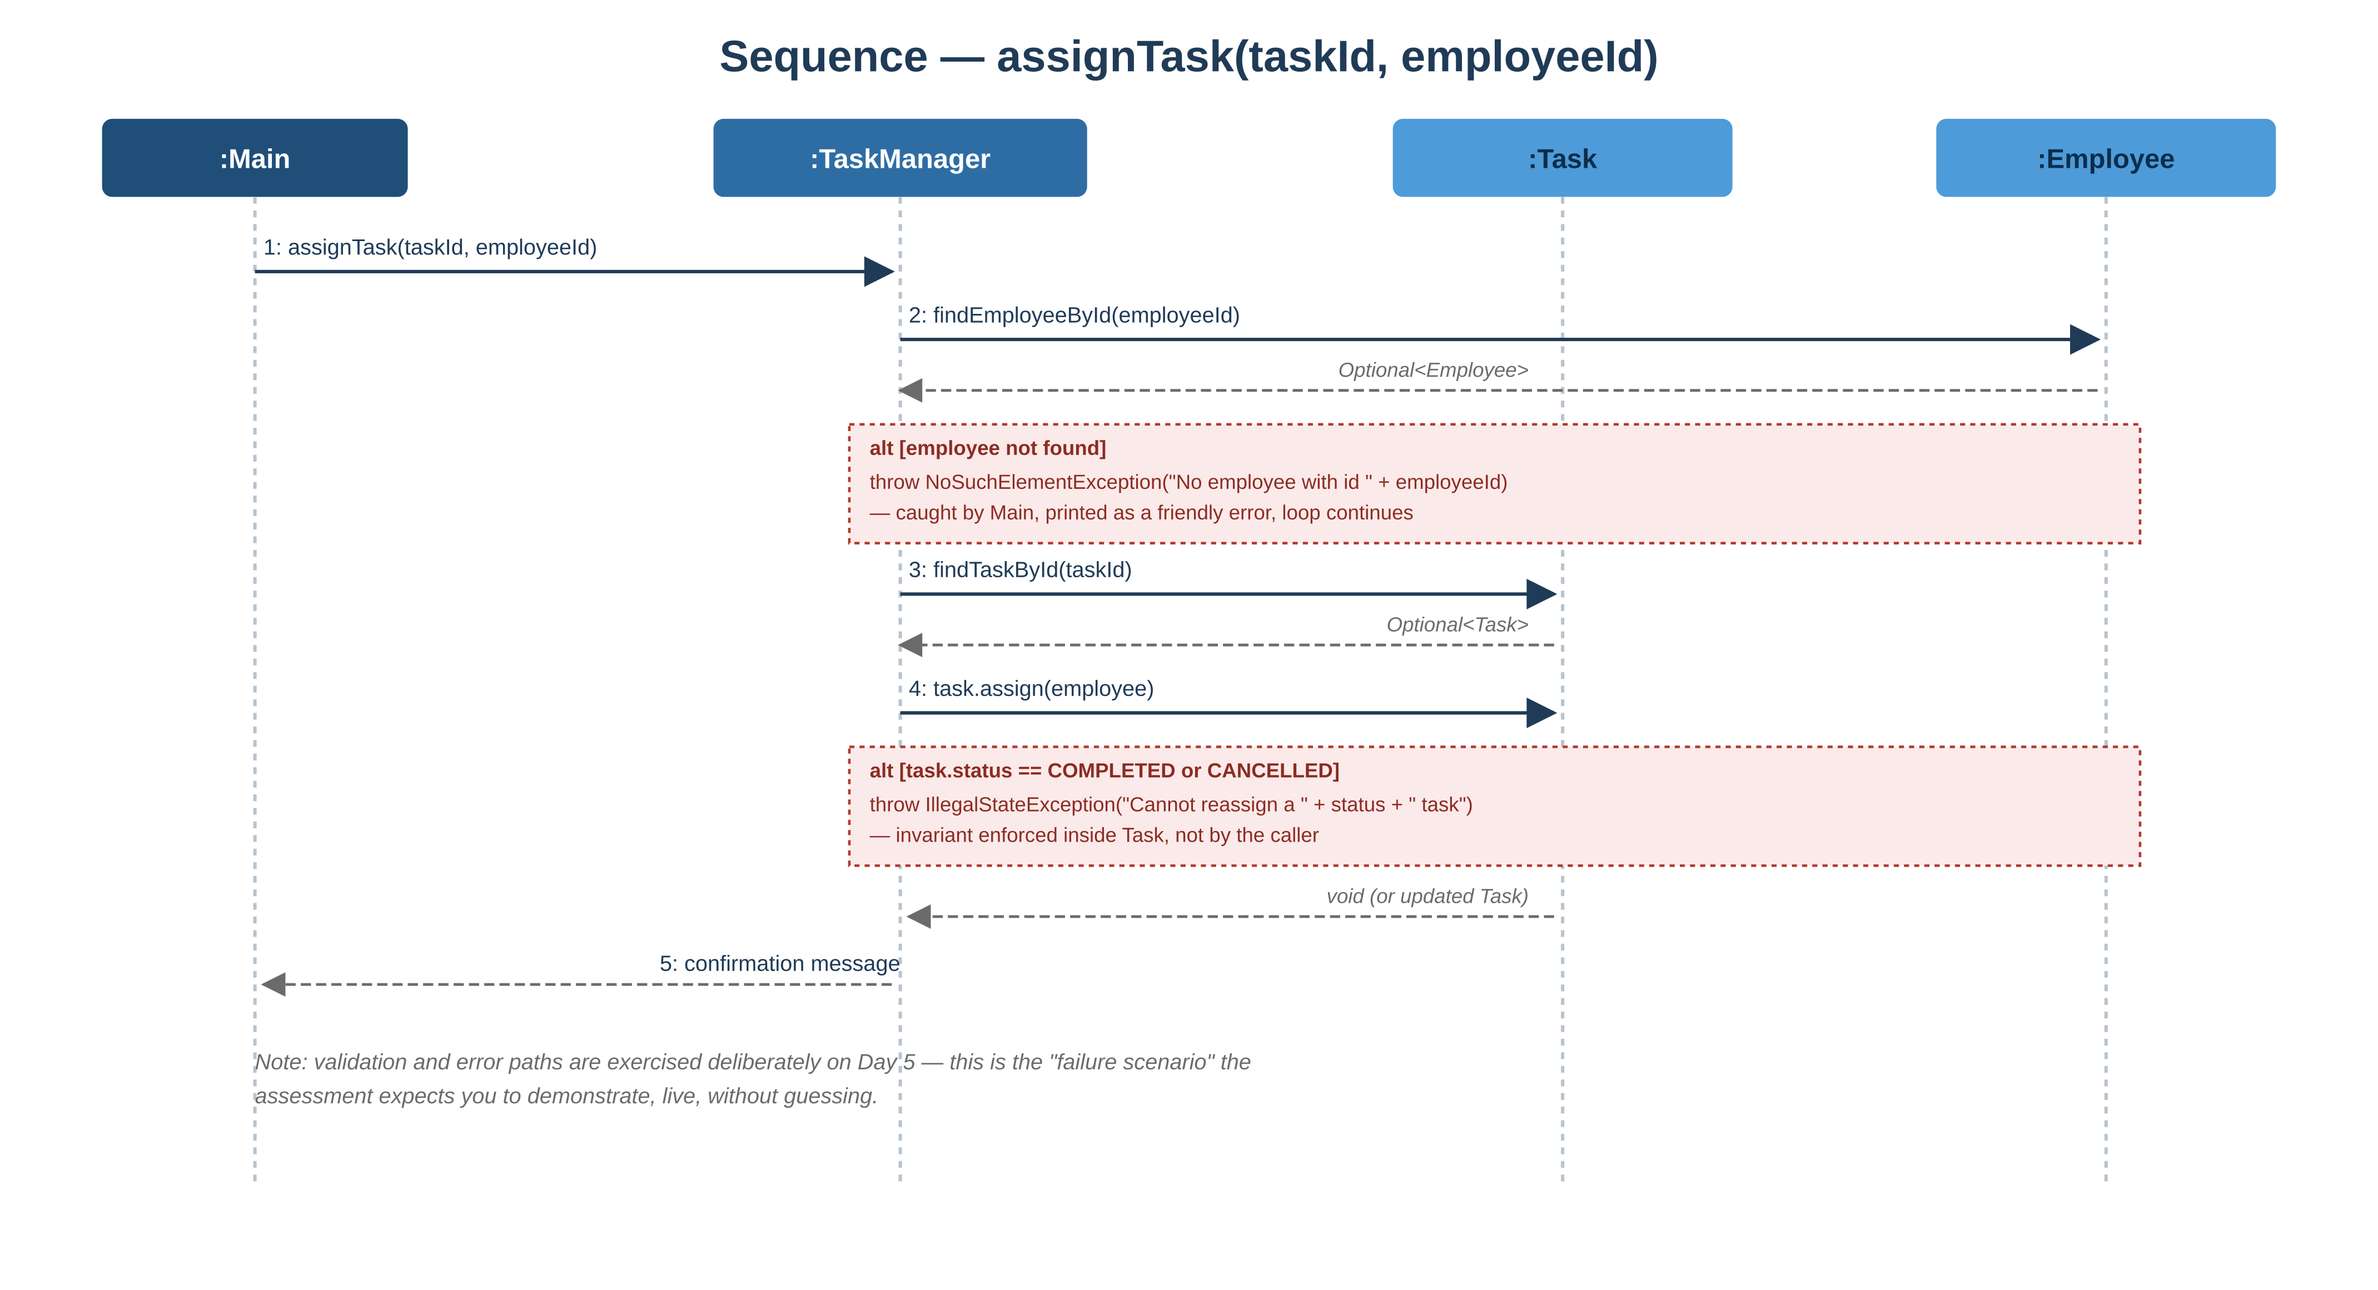
Figure 4. assignTask(taskId, employeeId) — happy path and both rejection paths.

7. Invalid States & Edge Cases
Identifying invalid states in advance is part of the release-readiness bar for this module. The table below is the minimum set a reviewer will probe.
Scenario | Expected Behaviour
Assign a task to a non-existent employee id | Throw NoSuchElementException with the offending id in the message
Assign a non-existent task id | Throw NoSuchElementException with the offending id in the message
complete() called before start() | Throw IllegalStateException naming current and requested state
start() called on a COMPLETED or CANCELLED task | Throw IllegalStateException; terminal states are immutable
Create a task with a blank title | Reject at creation with IllegalArgumentException
Search with an empty query string | Return an empty result set, not all tasks
Filter combining status and priority with no matches | Return an empty list, not null
Duplicate employee id generation | Not possible by construction — id generation is centralized in TaskManager

8. Assumptions
Where the brief was ambiguous, the following assumptions were made explicit rather than left implicit in code:
- An employee may hold zero or many tasks at once; no cap is enforced in this module.
- A task has at most one assignee at a time; reassigning overwrites the previous assignee rather than queuing a history.
- Ids are generated internally (e.g. incrementing or UUID) — the console never asks the user to supply one.
- "Summary" means counts per status plus a per-employee task listing; no additional metrics are implied by the brief.
- In-memory storage is expected to reset on every run; no seed data is required unless requested for a demo.

9. Release Readiness Checklist
This is the checklist actually walked through during the Day 5 assessment.
- Happy path runs end to end: create employees and tasks, assign, start, complete, search, filter, summarize.
- Every invalid state in Section 7 is demonstrated live, not just described.
- Domain classes (Employee, Task, TaskStatus, Priority) have no import of console or I/O classes.
- Project builds and runs from a clean checkout with no undocumented steps.
- Git history contains at least one commit with a clear, scoped message describing what changed and why.
- Can explain, unprompted, why a given design choice was made (e.g. why cancel() is disallowed after COMPLETED).

10. Glossary
Term | Meaning
Invariant | A condition that must always hold true for an object, e.g. a terminal Task never changes state again
Domain layer | Code representing core business concepts, independent of how the app is delivered (console, web, etc.)
Orchestration | Coordinating calls across multiple domain objects to fulfil a use case
Terminal state | A state with no further outgoing transitions — COMPLETED and CANCELLED here
End of document.

