HTML STRUCTURE

<Html>

<head>

<title>Structure of HTML</title>

</head>

<body>

Hello it is my first HTML.

</body>

</html>

Output:>

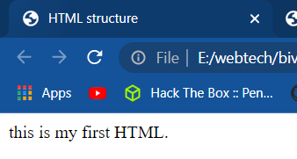

HTML Headings

Heading TAG!

<Html>

<head>

<title>Heading Tags</title>

</head>

<body>

<h1>Hello</h1>

<h2>Whats up! </h2>

<h3>Hello,goodmorning</h3>

<h4>Hello GOodnignt</h4>

<h5>Hello what's your name</h5>

<h6>Hello This is heading 6 </h6>

</body>

</html>

Output:>

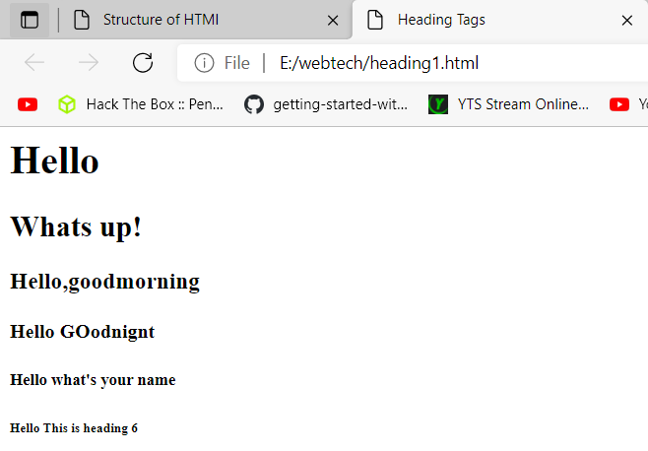

HTML Paragraphs

HTML paragraphs are defined with the <p> tag.

<html>

<body>

<p>Dherai din bata yaha sunyta kaalo badal chayeko jasto

Eh sathi timi kaha chau bhana na laamo din haru katna nai garho bho

Sano chada hami khelne garthyou tyo galli ma chimeki karauthe saro

Aja ko kata cha ko kata cha tara mannle mero balyakal pukaryo

Khojiraheko chu din haru testai jawani le kaha purayo

Bato cha beglai tara bhetne chaun hami nirash huna pardaina bho

Ooo ooo ooooo

Ohhh ohhh ohhhhh.</p>

<p>Sajha eta bata tara herchu timi pani uta bata hera hai

Chamkila tara sara mera pyara sathi bhai heri najikiyoun hai

Jivan ko bato bhanthe gham ra chaya chata odera kataunai parne

Bacha dekhi padhi lekhi aghi badhyou hami sangai aba janu nai parne

Kohi lai bannu cha thulo manche kohi bhane ghadi sangai

Bitaunchan jindagi jasari tara sathi bhaye huncha sajilai

Oooo ooo ooooo

Ohhh ohhh ohhhhh.</p>

</body>

</html>

OUTPUT:>

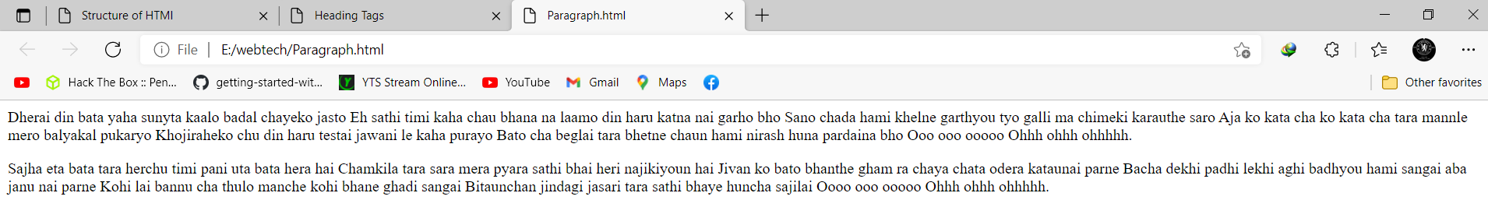

Formatting in Html:

<html>

<head>

<title>Formating tags</title>

</head>

<body>

<b>this is a bold text </b><br>

<i>this is an italic text</i><br>

<strong>this is a important text</strong><br>

<em> this is emphasized text</em>

<big>This is a big text</big><br>

<small>This is a small text</small><br>

today is 28<sup>th</sup>June 2021. <br>

Water formula is H<sub>2</sub>O.<br>

carbon oxide formula is CO<sub>2</sub>.<br>

<strike>Rs. 500</strike> Rs. 250<br>

<strike > Portugal,Netherland,Austria,croatia</strike>:... Belgium,czech republic,Italy,spain<br>

<del>Rs. 500</del> Rs. 250<br>

<mark>This is marked text</mark><br>

<del>This text is delete</del> and <ins>this text is inserted</ins><br>

<u>This text i underlined</u><br>

<tt>this is tele typed </tt><br>

<p>Close to 1.8 billion doses of Covid-19 vaccines have been administered in the single largest vaccination campaign in the history of the world.</p>

<p>As with any effort of this scale, it was bound to have some glitches. One of them has been the wastage of vaccine doses in transport, storage, or in clinic.</p>

<address>BNp-10, Gondrang, Chitwan Nepal</address>

<abbr title="Central Processing Unit">CPU</abbr><br>

<dfn>CPU</dfn> stands for Central Processing Unit.

<blockquote>Close to 1.8 billion doses of Covid-19 vaccines have been administered in the single largest vaccination campaign in the history of the world.</blockquote>

<p><cite>The hackaton</cite> is a kind of creative events that has compitition among students<p>

<p> Ram said <q>I was a student at that time</q></p>

Press <kbd>ctrl + C</kbd> to copy any content from screen.<br>

<code>printf("HEllo world")</code><br>

<var> int a,b,c</var><br>

<samp>HEllo world</samp>

<hr>

End of text formatting

<hr>

</body>

</html>

Output:> 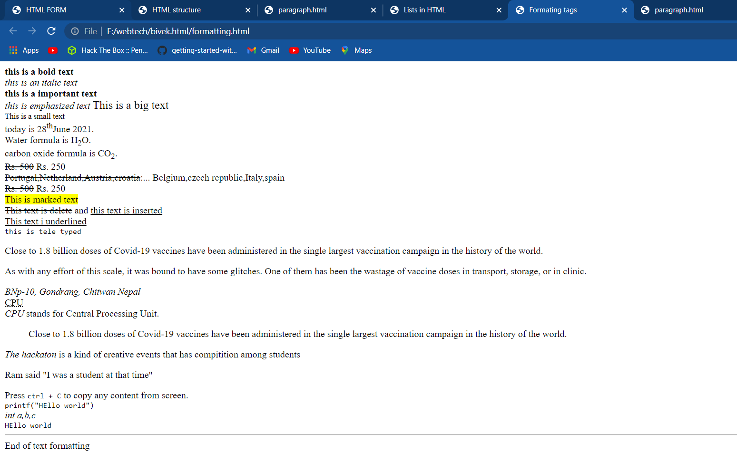

HTML Links – Hyperlinks:

HTML links are hyperlinks. You can click on a link and jump to another document. When you move the mouse over a link, the mouse arrow will turn into a little hand.

Hyperlink tag:

The HTML <a> tag defines a hyperlink. It has the following syntax.

syntax:

<a href="*url*">*link text*</a>

Where <a >is an Element and <href> is an attribute which indicate link destination.

Hyperlink tag:

<html>

<head>

<title>Hyperlink</title>

</head>

<body>

<h1> External link</h1>

<a href="http://www.facebook.com" target="blank">Open facbook in new tab</a><br>

<a href="http://www.facebook.com">open facebook in same tab</a>

<h1> Internal link</h1>

<a href="list.html" target="blank">open list page</a><br>

<a href="list.html">open list page</a>

<h1> Email link</h1>

<a href="anonymous@gmail.com" >Send Mail</a><br>

<a name="top"></a>

<h1> Intra link </h1>

<h2> songs by..</h2>

<p>

But you don't look like Foeseal

थाहा छैन के हो यो</br>

भावना अनौठो?</br>

के यही माया हो?</br>

के यही माया हो?</br>

माया होइन भने किन हेर्थेँ म तिमी तिर?</br>

भए पनि मनका कुरा भन्न सक्थेँ र?</br>

Hmm, एक्लै बसेर मुस्कुराउनु हो माया</br>

तिमीलाई हेरेर रमाउनु हो माया</br>

बरालिने मन त हो</br>

यादले जीवन सजाउनु हो माया</br>

ओ-हो-हो-हो</br>

ओ-हो-हो-हो</br>

ओ-हो-हो-हो</br>

ओ-हो-हो-हो</br>

आएँ म त हेर तिम्रै रहरमा</br>

भन कहाँ जाऊँ म?</br>

बसूँ कि तिम्रै मनको घरमा</br>

सबै भावना राखेर?</br>

भावनाहरू त उडी जान्छ तिमीलाई हेरेर (तिमीलाई हेरेर)</br>

राखेछु तिम्रै मायाको डोरीले बेरेर (डोरीले बेरेर)</br>

Hmm, एक्लै बसेर मुस्कुराउनु हो माया</br>

तिमीलाई हेरेर रमाउनु हो माया</br>

बरालिने मन त हो</br>

यादले जीवन सजाउनु हो माया</br>

ओ-हो-हो-हो</br>

ओ-हो-हो-हो</br>

ओ-हो-हो-हो</br>

ओ-हो-हो-हो</br>

फूलबुट्टे रातो सारीमा तिमी राम्री देखिन्छ्यौ (राम्री देखिन्छ्यौ)</br>

रिसाउँदा पनि किन हो तिमी राम्री देखिन्छ्यौ? (राम्री देखिन्छ्यौ)</br>

Hmm, एक्लै बसेर मुस्कुराउनु हो माया</br>

तिमीलाई हेरेर रमाउनु हो माया</br>

बरालिने मन त हो</br>

यादले जीवन सजाउनु हो माया</br>

</p></br>

???

///<p>Chelsea and PSG make €60m bids for Hakimi

4 hours ago 03:52

Inter appear ready to sell their star full-back

Chelsea and PSG have both made €60 million (£52m/$73m) offers for Achraf Hakimi, according to Gianluca Di Marzio.

Inter will likely be forced into selling the 22-year-old due to the club's unstable financial situation, and there are no shortage of suitors.

Chelsea could offer Emerson Palmieri or Andreas Christensen as a makeweight in the deal.

Cesar Azpilicueta on Kante: "He's a very special person. I Have not seen a player like him in my entire career. He covers a lot of ground, reaches the area, when we all run out of battery, he always has an extra battery"

Sometimes i also ask myself what kind of player is Kante 😂😂😂

Logan Paul fires back at fans pointing to suspicious moment during Mayweather bout: 'Shut the f--- up'</P> </br>

युरोकप सुरु हुन केही साता मात्र बाँकी रहँदा बेल्जियमका स्ट्राइकर रोमेलु लुकाकुले फुटबलमा रंगभेदी दुर्व्यवहार अहिलेसम्मकै उच्चविन्दुुमा रहेको बताएका छन्।

बेल्जियमले शनिबार रुसविरुद्ध खेल्दै युरोकप २०२०को सुरुआत गर्दैछ। लुकाकुले आफ्नो खेल जीवनमा धेरै पटक रंगभेदी दुर्व्यवहार बेहोरेका छन्। यस क्रममा सन् २०१९ मा समर्थकले बाँदर भन्दै गिज्याएका थिए। लुकाकुले पछिल्लो समय रंगभेदी दुर्व्यवहार अझ बढेको बताएका छन्।

इङ्लिस प्रिमियर लिग क्लब आर्सनलका पूर्वस्ट्राइकर थिएरी हेनरीले यसै महिनाको सुरुआतमा सामाजिक सञ्जाल बन्द गरेका थिए। हेनरी सामाजिक सञ्जालबाट अलग भएसँगै उनीमाथि भएको दुर्व्यवहारको विरोधस्वरूप इङ्लिस फुटबल क्लब र विभिन्न फुटबल संघले तीन दिन सामाजिक सञ्जाल नचलाउने घोषणा गरेका थिए।

‘इमानदारिताका साथभन्नु पर्दा रंगभेदी दुर्व्यहारमा कुनै कमी आएको छैन। रंगभेदी दुर्व्यवहारका विरोधमा धेरै अभियानहरू सञ्चालनमा आए पनि त्यसले मूर्तरूप भने लिन सकेको छैन’, लुकाकुले भने, ‘इटालीमा ममाथि प्रत्यक्ष रूपमा दुर्व्यहार भयो। सिरिएले ममाथि भएको घटनाको छानबिनसमेत गरेको थियो। हामीले इटालीमा रंगभेदी दुर्व्यवहारविरुद्ध जनचेतना बढाउने काम गरेपनि सोचेअनुरूपको नतिजा भने आउन सकेन। जब जनचेतना बढ्छ, तब मानिसको मानसिकतामा परिवर्तन आउँछ। सबै लिगले यस्तै खाले जनचेतना कार्यक्रम सञ्चालनमा ल्याउनु पर्छ। क्लबले प्रत्यक्ष रूपमा खेलाडी यस्तो समस्यामा छन् वा छैनन् बुझ्न जरुरी छ।’

रोमानिया र अस्ट्रियाविरुद्धको खेल अघि इङ्ल्यान्डका खेलाडीले घुँडा टेक्दा इङ्लिस समर्थकले उनीहरूलाई गिज्याएका थिए। कोभिड–१९ महामारीका कारण एक वर्षपछि धकेलिएको युरोकप यस पटक विभिन्न ११ राष्ट्रका ११ सहरमा सञ्चालन हुनेछ। प्रतियोगिता दौरान सीमित दर्शकलाई मात्र मैदान प्रवेशको अनुमति दिइने भएको छ।

‘जब युरोपियन सुपर लिग घोषणा भयो। समर्थकले सामाजिक सञ्जालमा तुरुन्तै त्यसको विरोध गरे। उनीहरू सडक प्रदर्शनमा समेत उत्रन तयार भए’, लुकाकुले भने, ‘हो म पनि सुपर लिगको विपक्षमा थिएँ। तर रंगभेदी दुर्व्यवहारको घटनाप्रति यस्तै प्रदर्शनहरू तत्काल किन गरिँदैन।’

</br>

</br>

annapurna post

थप समाचार

भेरीमा डुबेर बहिनीको मृत्यु, दिदी बेपत्ता

भेरीमा डुबेर बहिनीको मृत्यु, दिदी बेपत्ता

समाज / कर्णाली / २५ जेठ २०७८

मुख्यमन्त्री भट्टलाई बधाई दिँदै भीम रावलले भने- विधि र पद्धति मिच्नेले शिक्षा लिने कि ?

मुख्यमन्त्री भट्टलाई बधाई दिँदै भीम रावलले भने- विधि र पद्धति मिच्नेले शिक्षा लिने कि ?

राजनीति / २५ जेठ २०७८

भीरकोटमा कोभिडका बिरामीलाई अक्सिजनसहितको सेवा सुरु

भीरकोटमा कोभिडका बिरामीलाई अक्सिजनसहितको सेवा सुरु

स्वास्थ्य / गण्डकी / २५ जेठ २०७८

</br>

<p>

Good morning! We are discussing “News Guff (Day 7) - Talking News, Events and Analysis” with

@Roopess

, Dp Upadhyay, and The Speakers. Today, 9 Jun at 7:57 AM GMT 5:45 on

@clubhouse

. Join us!

Kamala Harris standing in a dark room: U.S. Vice President Harris visits Mexico© Reuters/CARLOS BARRIA U.S. Vice President Harris visits Mexico

Harris, who was a U.S. Senator from California starting in 2017 and traveled the country running for president in 2020, did not

specify when she last visited the border.

President Joe Biden has asked her to work on reducing the number of migrants arriving at the U.S.-Mexico border. She has said her main focus is on root causes, as well as acute causes, of migration. She also visited Guatemala on her first trip abroad since taking office.

Some Republican lawmakers have called on Harris to instead get a first-hand look at the border, where migration has reached its highest levels in 20 years and where they say help is urgently needed.

Harris, who has not made a trip to the border since becoming vice president, did not say when she might visit.

She defended her choice to make the visits south of the border in response to repeated questions from reporters, underscoring the Biden administration's push to tackle deeper reasons for migration from Central America.

"You can't say you care about the border without caring about the root causes," Harris said.

However, she also described the situation at the U.S. southern border as a "legitimate, correct" concern.

Harris noted U.S.-Mexico cooperation over border security includes "the work of processing migration within the country of Mexico and its southern border."

White House press secretary Jen Psaki also said she did not have a timeline for a potential trip, but emphasized Harris' job was to focus on the Northern Triangle countries of Guatemala, El Salvador and Honduras.

"Her assignment was to work with countries and leaders in the Northern Triangle to address root causes, address corruption, and sure, we're working together to address humanitarian concerns," Psaki told reporters at the White House.

"We're not taking advice from former President Trump or most of the Republicans who are criticizing us on this," Psaki added.

(Reporting by Nandita Bose and Daina Beth Solomon; Editing by Jonathan Oatis and David Gregorio)

</p></br>

<a href="#top">go to top</a>

</body>

</html>

Output:>

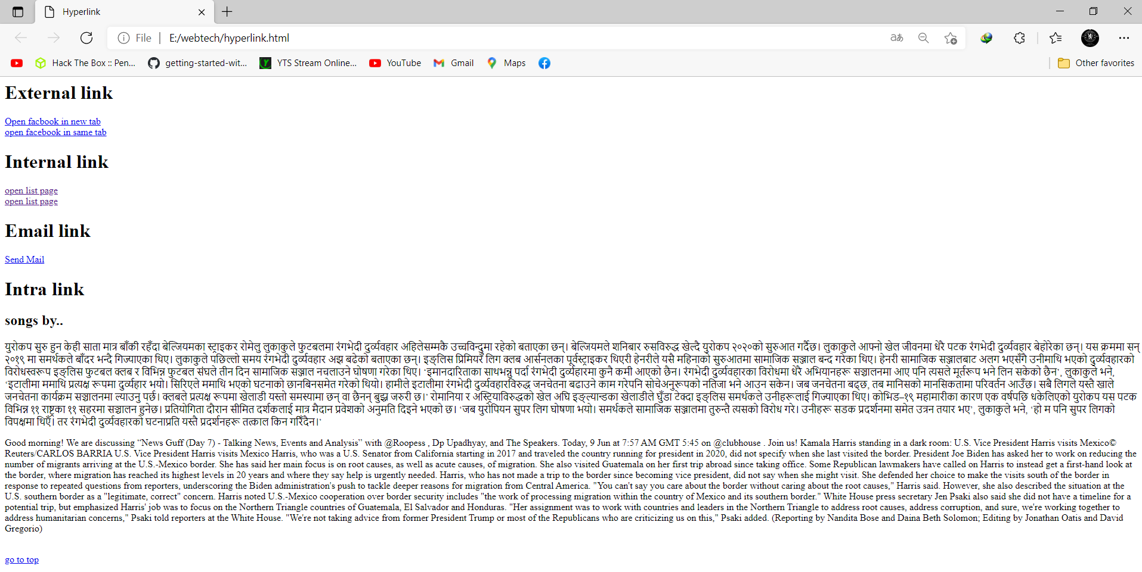

HTML Table:

The <table> tag defines an HTML table.

Each table row is defined with a <tr> tag. Each table header is defined with a <th> tag. Each table data/cell is defined with a <td> tag.

By default, the text in <th> elements are bold and centered.

By default, the text in <td> elements are regular and left-aligned.

<html>

<head>

<title>Tables</title>

</head>

<body>

<h1> Simple table</h1>

<table border="1" width="100%" bgcolor="white" align="left" cellspacing="10" cellpadding="20">

<caption><b>Student Information</b></caption>

<tr align="center">

<td>Name</td>

<td>roll Number</td>

</tr>

<tr>

<td align="right">Aayush</td>

<td>01</td>

</tr>

<tr>

<td>Sandip</td>

<td>26</td>

</tr>

<tr>

<td>Bikal</td>

<td>12</td>

</tr>

</table>

<h1> Spanning (Mix)Row and Columns</h1>

<table border="1">

<tr>

<td colspan="3"> Student Info</td>

</tr>

<table style="width:100%">

<tr>

<th>Firstname</th>

<th>Lastname</th>

<th>Age</th>

</tr>

<tr>

<td>Hari</td>

<td>paudel</td>

<td>32</td>

</tr>

<tr>

<td>Andy</td>

<td>krack</td>

<td>28</td>

</tr>

<tr>

<td>Gopal</td>

<td>Aier</td>

<td>25</td>

</tr>

</table>

</body>

</html>

Output:>

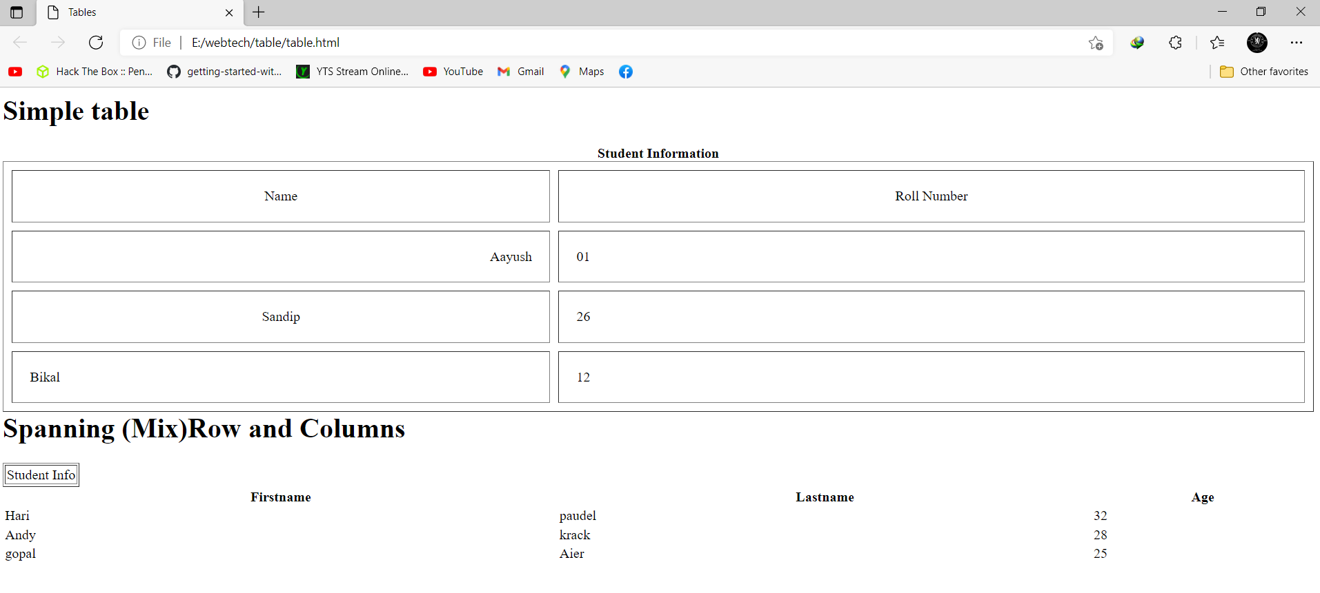

Html list:

Type of list

<html>

    <head><title>Lists in HTML</title>

    </head>

    <body>

    <h1>Example of list</h1>

    <ol type="1">

    <li>Ramesh</li>

    <li>Sakshyam</li>

    <li>Gitanjali</li>

    </ol>

    <ul type=”Disc”>

    <li>Samsung</li>

    <li>Acer</li>

    <li>Dell</li>

    </ul>

    <h1> Nested List</h1>

    <ul type=”Disc”>

    <li>Home</li>

    <li>About US

    <ul type=”circle”>

    <li>Principal MEssage</li>

    <li>BOD MEssage</li>

     </ul>

    </li>

    <li>Notice</li>

    <li>Examination</br>

    <ul type=”circle”>

    <li><img src ="htmml.png"  width="300" height="150"></li/>

    <li>Exam Routine</li>

    <ul type ="Disc">

    <li> <a href="https://www.neb.gov.np/" target="blank">Open offical site</a><br></li>

    </ul>

    </li>

    <li>Exam Result</li>

    <ul type ="cricle">

    <li> <a href="https://www.neb.gov.np/results" target="blank">Open Result site</a><br></li>

     </ul>

    </li>

    </ul>

    </body>

    </html>

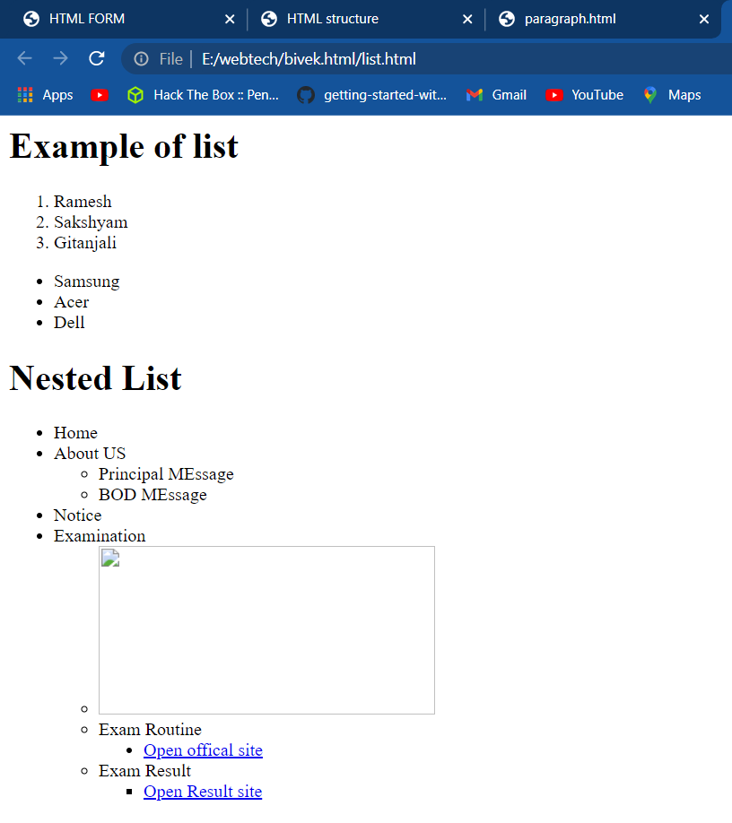

Colour tag:

<html>

<body>

<h1 style="background-color:DodgerBlue;">Hello World</h1>

<p style="background-color:Tomato;">

How many months since we became Champions of Europe?

</p>

</body>

</html>

Output:>

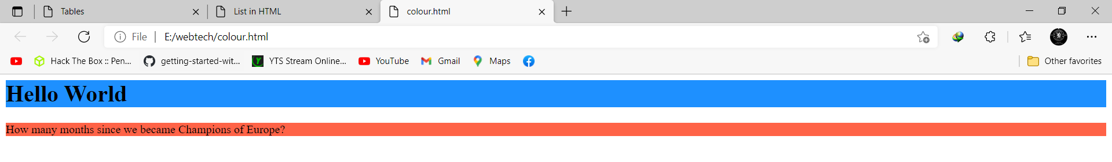

Frame and Iframe:

The HTML <iframe> tag specifies an inline frame. An inline frame is used to embed another document within the current HTML document.

<html>

<body>

<h2>HTML Iframes</h2>

<h3> ENGLAND VS GERMAN ,Euro 2020 round 16</h3>

<p>This is the third meeting between England and Germany at the European Championship – Germany won 6-5 on penalties following a 1-1 draw in the 1996 semi-final, before England won 1-0 in the group stages at EURO 2000.:</p>

<iframe src="Paragraph.html" height="200" width="500" title="Iframe Example"></iframe>

<iframe src="list.html" height="200" width="500" title="Iframe Example"></iframe>

<iframe src="hyperlink.html" frameborder="1"></iframe><br>

<iframe src="new 2.html" frameborder="1" height="200"></iframe>

</body>

</html>

**Output:**

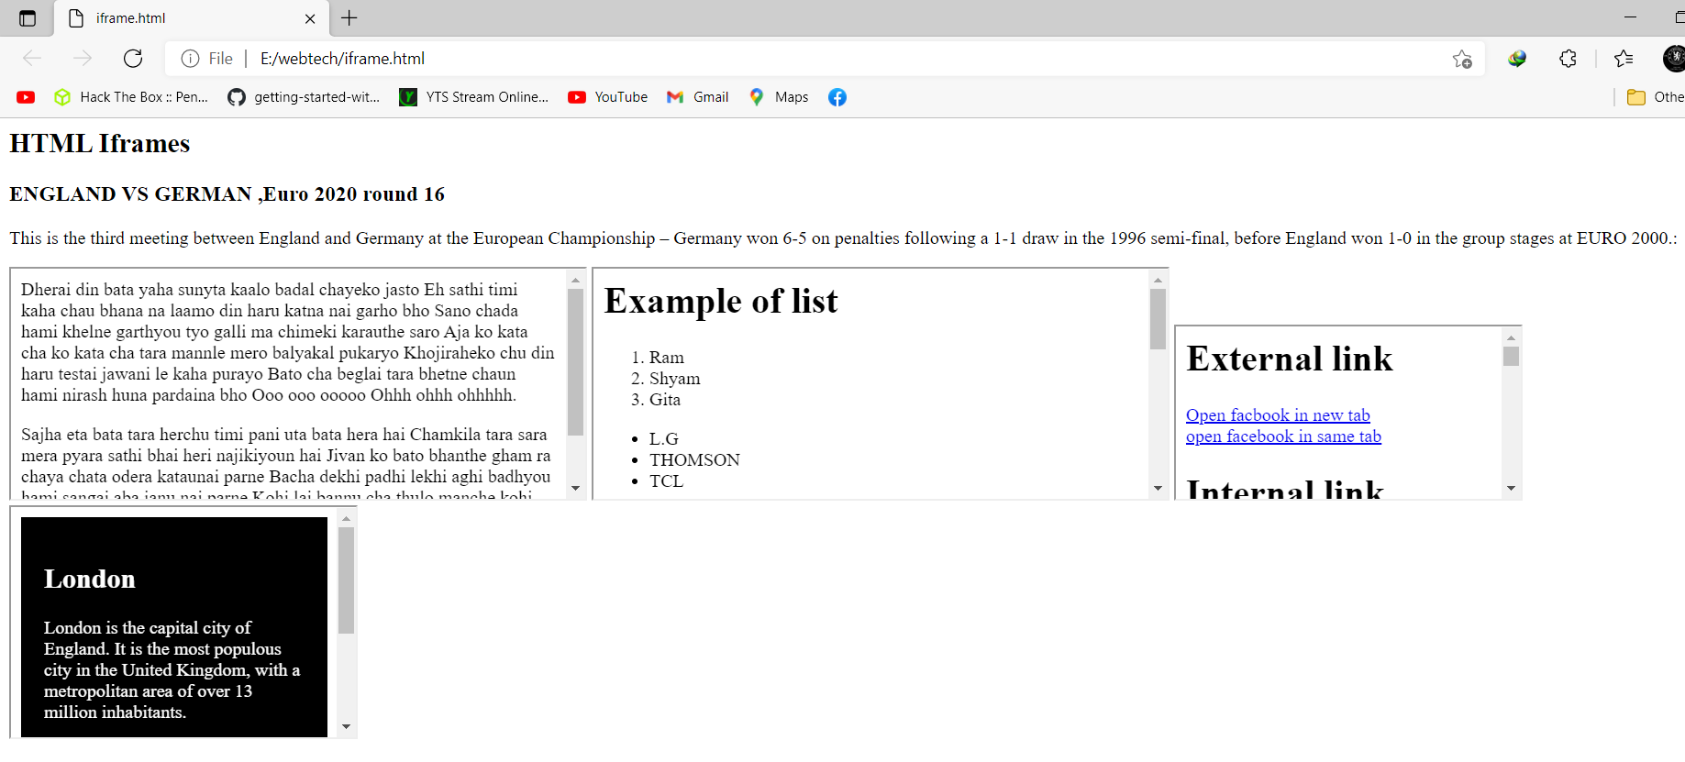

**Form Tag in Html:**

The <form> element is a container for different types of input elements, such as: text fields, checkboxes, radio buttons, submit buttons, etc.

<html>

<head>

<title> HTML FORM</title>

</head>

<body>

<h1>Student Registration</h1>

<form>

<table>

<tr>

<td>Name</td>

<td><input type="text" required></td>

</tr>

<tr>

<td>Email ID</td>

<td><input type="email"></td>

</tr>

<tr>

<td>USer Name</td>

<td><input type="text"></td>

</tr>

<tr>

<td>Password</td>

<td><input type="password"></td>

</tr>

<tr>

<td>Confirm Password</td>

<td><input type="password"></td>

</tr>

<tr>

<td>Gender</td>

<td>

<input type="radio" name="gender">Male<br>

<input type="radio" name="gender">Female<br>

<input type="radio" name="gender">Others<br>

</td>

</tr>

<tr>

<td>Fav. Color</td>

<td><input type="color"></td>

</tr>

<tr>

<td>Upload Profile Picture</td>

<td><input type="file"></td>

</tr>

<tr>

<td>Expected Salary</td>

<td><input type="range" min="0" max="5000"></td>

</tr>

<tr>

<td>Pincode</td>

<td><input type="number"></td>

</tr>

<tr>

<td>Address</td>

<td><textarea></textarea></td>

</tr>

<tr>

<td>Date of Birth</td>

<td><input type="date"></td>

</tr>

<tr>

<td>How you hear us</td>

<td>

<select multiple>

<option>TV</option>

<option selected>Social Media</option>

<option selected>Radio</option>

<option>Friend</option>

</select>

</td>

</tr>

<tr>

<td>Select Course to Apply</td>

<td>

<select>

<option>Select</option>

<option>BBA</option>

<option selected>BIM</option>

<option>BCA</option>

</select>

</td>

</tr>

<tr>

<td>Aree and Submit</td>

<td>

<input type="checkbox">Agree<br>

<input type="submit" value="Save">

</td>

</tr>

</table>

</form>

</body>

</html>

**Output:**

