《 JavaEE技术 》课程实验报告

实验名称 | 基于DBUtils技术的学生信息管理系统
学 号 |  |  | 姓 名 |  | 班 级
实验日期 |  | 2018年11月25日 |  | 实验报告日期 | 2018年11月25日
指导老师 |  | 罗建明 |  | 实 验 地 点
评 语

≡≡≡≡≡≡≡≡≡≡≡≡≡≡≡≡≡≡≡≡≡≡≡≡≡≡≡≡≡≡≡≡≡≡≡≡≡≡

实验内容和目的 | 内容：在Eclipse和MySQL下，按要求完成下列操作：  - 利用EL和JSTL显示数据，Servlet做控制器。  - 利用DBUtils完成增删改查的操作。、  - DBUtils的query、update  - BeanHandler和BeanListHandler的使用。  - 使用JUnit对StudentDao进行单元测试。  目的：掌握MVC的原理。  掌握实体类和Dao的使用。
实验环境 | Windows系统、Eclipse、MySQL
实验重点及难点 | 分页查询。  DBUtils方法Query和Update的使用。  BeanHandler和BeanListHandler的使用。

实验过程（实验过程、实验结果及实验分析）
实验过程（分步骤、有文字描述、有代码分析、有截图）
一．导包，放到WebContent\WEB-INF\lib目录下，需要导入的包如下：
1. c3p0-0.9.5.2.jar
2. commons-dbutils-1.7.jar
3. mchange-commons-java-0.2.12.jar
4. mysql-connector-java-5.1.44-bin.jar
二．代码实现
1.新建C3P0Utils工具类（package cn.util）,代码如下：
// 得到一个数据源
private static DataSource dataSource = new ComboPooledDataSource();

public static DataSource getDataSource() {
return dataSource;
}

// 从数据源中得到一个连接对象
public static Connection getConnection() {
try {
return dataSource.getConnection();
} catch (SQLException e) {
throw new RuntimeException("服务器错误");
}
}

public static void release(Connection conn, Statement stmt, ResultSet rs) {
// 关闭资源
if (rs != null) {
try {
rs.close();
} catch (Exception e) {
e.printStackTrace();
}
rs = null;
}
if (stmt != null) {
try {
stmt.close();
} catch (Exception e) {
e.printStackTrace();
}
stmt = null;
}
if (conn != null) {
try {
conn.close();// 关闭
} catch (Exception e) {
e.printStackTrace();
}
conn = null;
}
}

2．配置文件：
<?xml version="1.0" encoding="utf-8"?>
<c3p0-config>
<default-config>
<property name="driverClass">com.mysql.jdbc.Driver</property>
<property name="jdbcUrl">jdbc:mysql://47.112.31.40:3306/student</property>
<property name="user">user1</property>
<property name="password">user1</property>
<property name="initialPoolSize">5</property>
<property name="maxPoolSize">10</property>
<property name="checkoutTimeout">3000</property>
</default-config>
<named-config name="otherc3p0">
</named-config>
</c3p0-config>

3.新建Student类，定义如下字段：
private Integer id;
private Integer stu_id;
private String name;
private Byte sex;
private String professional;
private String[] hobby;
private String hobbys;
private String self;
private String photo;

4.新建数据库表，字段与Student一致
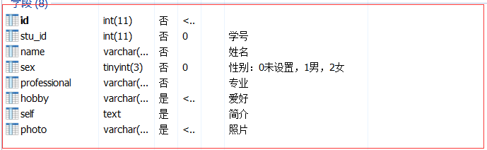
5.定义StudentDao类：
public interface StudentDao {
public int save(Student student) throws SQLException;
public int update(Student student) throws SQLException;
public int delete(int id) throws SQLException;
public Student getById(int id) throws SQLException;
public List<Student> getAll() throws SQLException;
public Long getSize() throws SQLException;
public List<Student> getByPage(int startIndex,int pageSize) throws SQLException;
}

6．定义StudentDaoImpl实现类，代码如下：
public class StudentDaoImpl implements StudentDao {
QueryRunner qr = new QueryRunner(C3P0Util.getDataSource());
//插入数据
@Override
public int save(Student student) throws SQLException {
String sql = "insert into s_user(stu_id,name,sex,professional,hobby,self,photo) values(?,?,?,?,?,?,?)";
int result = 0;
try {
result = qr.update(sql, student.getStu_id(), student.getName(), student.getSex(), student.getProfessional(),
Arrays.toString(student.getHobby()), student.getSelf(), student.getPhoto());
} catch (SQLException e) {
e.printStackTrace();
}
return result;
}

//更新数据
@Override
public int update(Student student) throws SQLException {
String sql = "update s_user set name=?,sex=?,professional=?,hobby=?,self=?,photo=? where id=?";
int result = 0;
try {
result = qr.update(sql, student.getName(), student.getSex(), student.getProfessional(),
Arrays.toString(student.getHobby()), student.getSelf(), student.getPhoto(), student.getId());
} catch (SQLException e) {
e.printStackTrace();
}
return result;
}

//根据id删除数据
@Override
public int delete(int id) throws SQLException {
int result = 0;
String sql = "delete from s_user where id=?";
try {
result = qr.update(sql, id);
} catch (SQLException e) {
e.printStackTrace();
}
return result;
}

//根据id获取数据
@Override
public Student getById(int id) throws SQLException {
String sql = "select id,stu_id,name,sex,professional,hobby as hobbys,self,photo from s_user where id=?";
Student student = null;
try {
student = qr.query(sql, new BeanHandler<>(Student.class), id);
String hobbys=student.getHobbys();
hobbys=hobbys.substring(1,hobbys.length()-1);
student.setHobby(hobbys.split(","));
} catch (SQLException e) {
e.printStackTrace();
}
return student;
}

//获取全部数据
@Override
public List<Student> getAll() throws SQLException {
List<Student> lists = new ArrayList<Student>();
try {
String sql = "select id,stu_id,name,sex,professional,hobby as hobbys,self,photo from s_user";
lists = qr.query(sql, new BeanListHandler<Student>(Student.class));
} catch (SQLException e) {
e.printStackTrace();
}
return lists;
}

//获取数据总条数
@Override
public Long getSize() throws SQLException {
Long count = null;
try {
String sql = "select count(*) from s_user";
count = qr.query(sql, new ScalarHandler<Long>());
} catch (SQLException e) {
e.printStackTrace();
}
return count;
}

//分页查询
@Override
public List<Student> getByPage(int startIndex, int pageSize) throws SQLException {
List<Student> lists = new ArrayList<Student>();
try {
String sql = "select id,stu_id,name,sex,professional,hobby as hobbys,self,photo from s_user limit ?,?";
lists = qr.query(sql, new BeanListHandler<Student>(Student.class),startIndex,pageSize);
} catch (SQLException e) {
e.printStackTrace();
}
return lists;
}

7．测试：
7.1.在StudentDaoImpl.java右键new->Other->Java->Junit,选择Junit Test Case:

Next选择save、update、delete、getAll四个方法生成StudentDaoImplTest.java文件，更改代码如下：
public class TestStudentDaoImpl {

private static IStudentDao dao;

@BeforeClass
public static void setUpBeforeClass() throws Exception {
Connection conn=ConnCreate.getConnection("jdbc:mysql://47.112.31.40:3306/student", "user1","user1");
dao=new StudentDaoImpl(conn);
}

@Test
public void testSave() {
Student student=new Student(null,2005010,"linan",(byte) 1,"计算机科学与技术",new String[]{"编程","运动"},"hello","2005001.jpg");
int res=dao.save(student);
System.out.println("信息插入"+(res>0?"成功!":"失败!"));
}

@Test
public void testUpdate() {
Student student=new Student(null,2005001,"张三丰",(byte) 1,"计算机科学与技术",new String[]{"编程","运动"},"你好","2005001.jpg");
int result=dao.update(student);
System.out.println("信息更新"+(result>0?"成功!":"失败!"));
}

@Test
public void testDelete() {
int result=dao.delete(4);
System.out.println("信息删除"+(result>0?"成功!":"失败!"));
}

@Test
public void testGetById() {
Student student=dao.getById(2005001);
System.out.println(student);
}

@Test
public void testGetAll() {
List<Student> lists=dao.getAll();
System.out.println(lists);
}

7.2. StudentDaoImplTest.java右键->run As->Junit Test进行测试，结果如下：
7.2.1．testSave：
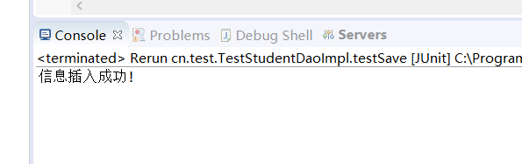
7.2.2．testUpdate：
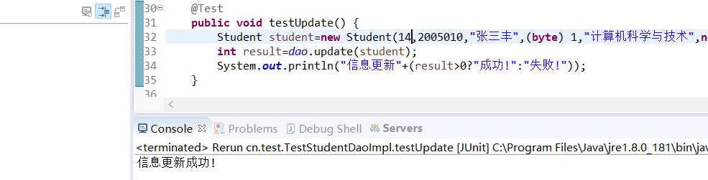
7.2.3．testDelete:
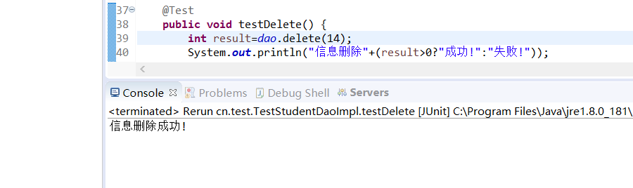
7.2.4．testGetAll
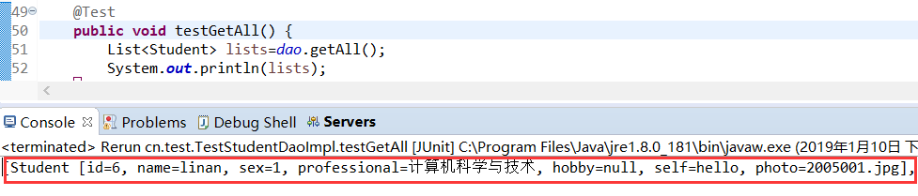

三．显示在网页上：
1．新建StudentServlet类（这是在原本动态数组基础上修改）：
protected void doPost(HttpServletRequest request, HttpServletResponse response)
throws ServletException, IOException {

request.setCharacterEncoding("utf-8");
String action = request.getParameter("action");
if (action != null) {
if (action.equals("save")) {
Student stu = doForm(request);
try {
dao.save(stu);
} catch (SQLException e) {
// TODO Auto-generated catch block
e.printStackTrace();
}
response.sendRedirect("student");
} else if (action.equals("update")) {
Student stu = doForm(request);
try {
dao.update(stu);
response.sendRedirect("student");
} catch (SQLException e) {
// TODO Auto-generated catch block
e.printStackTrace();
}
} else if (action.equals("delete")) {
Integer id = Integer.parseInt(request.getParameter("id"));
try {
dao.delete(id);
response.sendRedirect("student");
} catch (SQLException e) {
// TODO Auto-generated catch block
e.printStackTrace();
}
} else if (action.equals("more")) {
Integer id = Integer.parseInt(request.getParameter("id"));
Student stu;
try {
stu = dao.getById(id);
System.out.println(stu);
request.setAttribute("stu", stu);
} catch (SQLException e) {
// TODO Auto-generated catch block
e.printStackTrace();
}
request.getRequestDispatcher("more.jsp").forward(request, response);
} else if (action.equals("edit")) {
Integer id = Integer.parseInt(request.getParameter("id"));
Student stu;
try {
stu = dao.getById(id);
request.setAttribute("stu", stu);
request.getRequestDispatcher("edit.jsp").forward(request, response);
} catch (SQLException e) {
// TODO Auto-generated catch block
e.printStackTrace();
}
}
} else {
int num = 1;
String pageNum = request.getParameter("pageNum");
if (pageNum != null)
num = Integer.parseInt(pageNum);
try {
long totalRecord;
totalRecord = dao.getSize();
int pageSize = 5;
PageBean<Student> pageBean = new PageBean<>(num, pageSize, (int) totalRecord);
System.out.println("start:" + pageBean.getStartIndex());
List<Student> list = dao.getByPage(pageBean.getStartIndex(), pageSize);
pageBean.setList(list);
request.setAttribute("pageBean", pageBean);
request.getRequestDispatcher("listJSTL.jsp").forward(request, response);
} catch (SQLException e) {
// TODO Auto-generated catch block
e.printStackTrace();
}
}
}

private Student doForm(HttpServletRequest request) {
Integer id = 0;
Integer stu_id = Integer.parseInt(request.getParameter("stu_id"));
String name = request.getParameter("name");
Byte sex = Byte.parseByte(request.getParameter("sex"));
String professional = request.getParameter("professional");
String[] hobby = request.getParameterValues("hobby");
String self = request.getParameter("self");
String photo = request.getParameter("photo");
Student stu = new Student(id, stu_id, name, sex, professional, hobby, self, photo);
return stu;
}
2．从数据库取出数据如下：
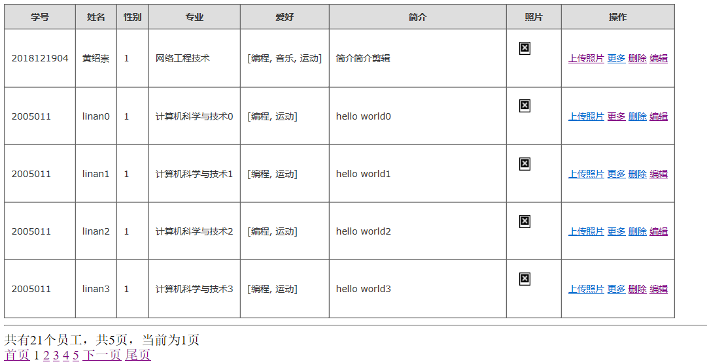

实验总结与心得（300字）
通过实验，我了解到DbUtils是Apache组织提供的一个对JDBC进行简单封装的开源工具类库，本实验用到一下ResultSetHandler实现类：
- BeanHandler：将查询结果的第一行数据，返回给student对象
- BeanListHandler：将查询结果的每一行封装到student对象，然后再存入List集合
- ScalarHandler：获取数据条数

