Q1.

Code- function number(){

for(let num=1;num<=100;num++){

if(num%3==0 && num%5===0){

console.log("fizzbuzz");

}

else if(num%3===0){

console.log("fizz");

}

else if(num%5===0){

console.log("buzz")

}

else{console.log(num)}

}

}

console.log(number())

Output-

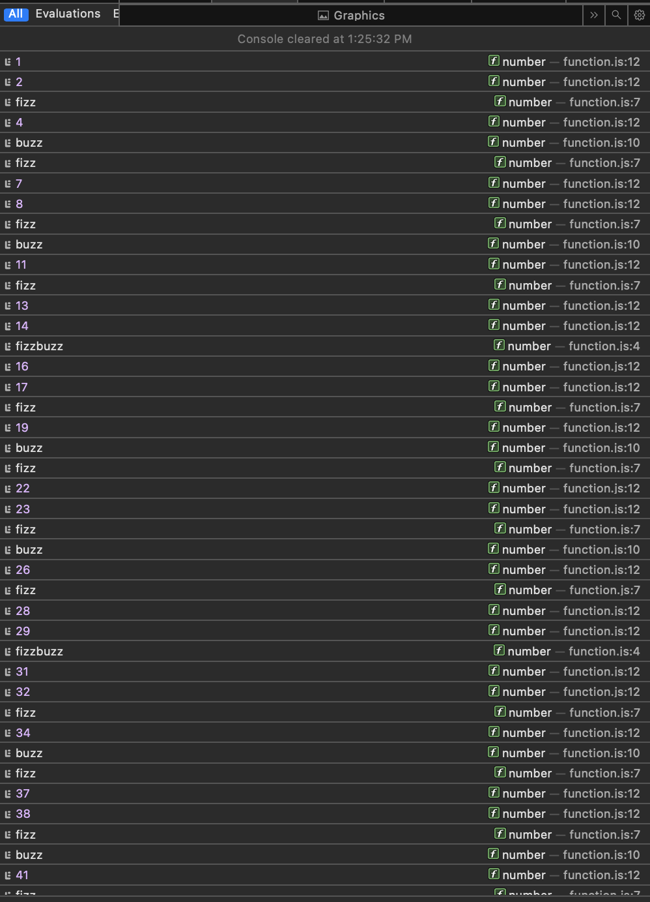 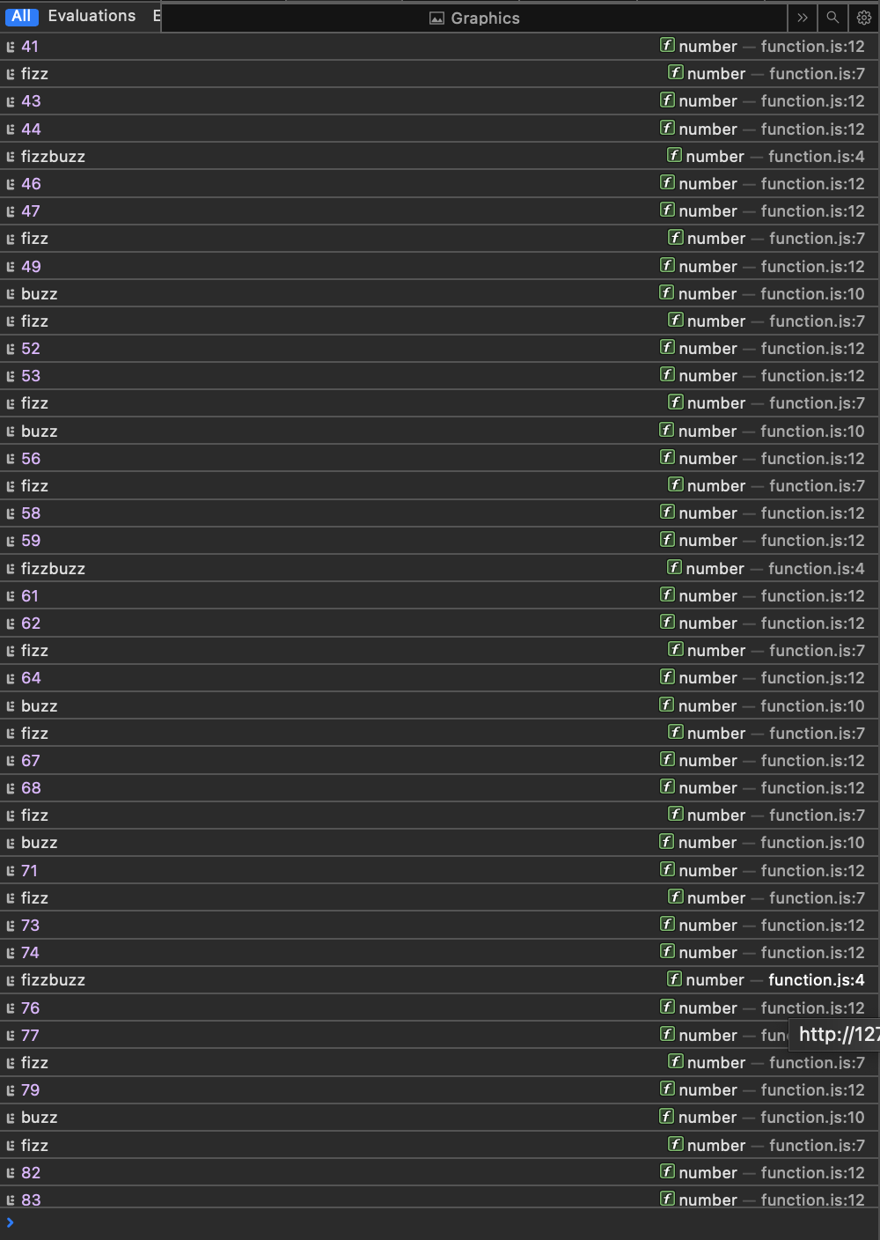 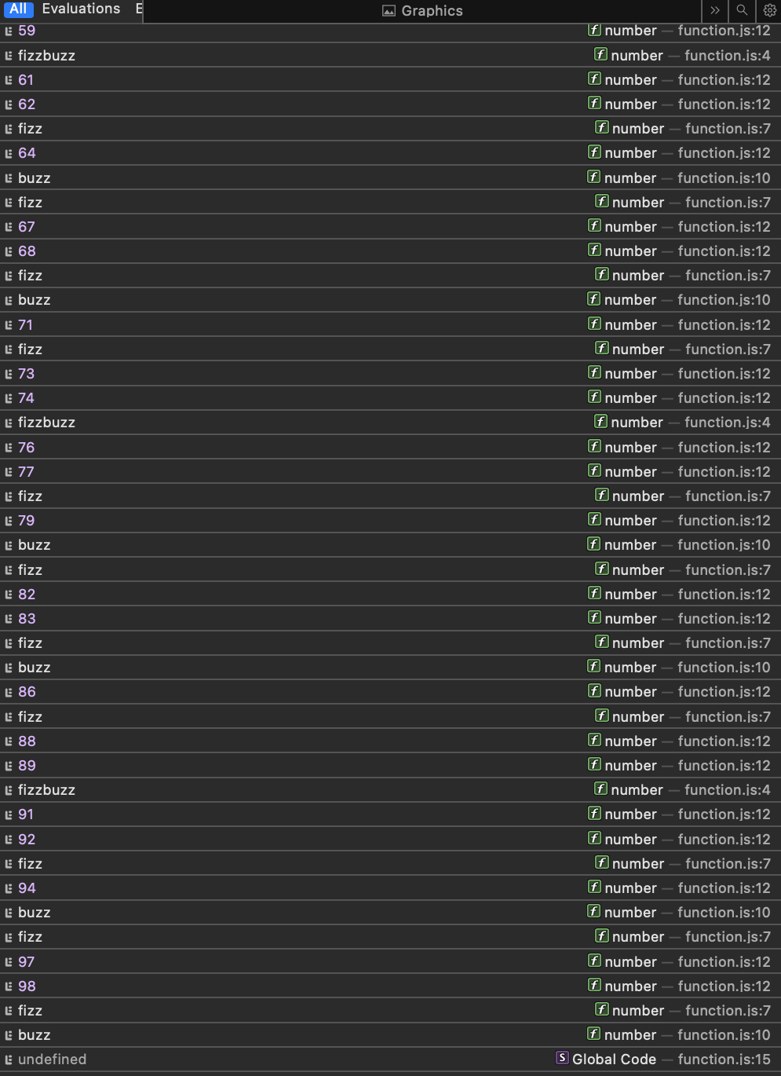目

目

Q2.

Code- function isOperand(c)

{

return (c.charCodeAt(0) >= '0'.charCodeAt(0) && c.charCodeAt(0) <= '9'.charCodeAt(0));

}

function value(c)

{

return (c.charCodeAt(0) - '0'.charCodeAt(0));

}

function evaluate(exp)

{

if (exp.length == 0) return -1;

let res = value(exp[0]);

for (let i = 1; i<exp.length; i += 2)

{

let opr = exp[i], opd = exp[i+1];

if (isOperand(opd) == false) return -1;

if (opr == '+') res += value(opd);

else if (opr == '-') res -= value(opd);

else if (opr == '*') res *= value(opd);

else if (opr == '/') res /= value(opd);

else return -1;

}

return res;

}

let exp1= "7+1+5*4-6"

console.log(evaluate(exp1))

Output-

46

Q3

Code- var flatten = function(a, r) {

if (!r) {

r = [];

}

for (var i = 0; i < a.length; i++) {

if (a[i].constructor == Array) {

flatten(a[i],r);

} else {

r.push(a[i]);

}

}

return r;

}

console.log(flatten([1,[2,3,[4,5,6],[7,[8,9,[10]]]]]));

Output -



Q4.

Code- const isAnagram=(str1,str2) =>{

if(str1.length !== str2.length){

return false;

}

const charCount =Array(26).fill(0);

for(let i=0;i<str1.length;i++){

charCount[str1.charCodeAt(i)-"a".charCodeAt(0)]++;

charCount[str2.charCodeAt(i)-"a".charCodeAt(0)]--;

}

return charCount.every((count) => count ===0);

};

const str1="listen";

const str2="silentsf";

if( isAnagram(str1,str2)){

console.log("is valid alagram")

}

else{

console.log("not valid alagram")

}

Output -



Q5.

Code- let arr = ["delhi", "mumbai", "goa", "mumbai", "himachal", "goa"];

function removeDuplicates(arr) {

return arr.filter((item, index) => arr.indexOf(item) === index);

}

let newArr = removeDuplicates(arr);

console.log(newArr);

Output-



Q6.

Code- function capital_letter(str)

{

str = str.split(" ");

for (var i = 0, x = str.length; i < x; i++) {

str[i] = str[i][0].toUpperCase() + str[i].substr(1);

}

return str.join(" ");

}

console.log(capital_letter("this is a javascript program to captalize the first character of every word in a string"))

Output-



Q7.

Code- function fibonacci_numbers(n) {

if (n == 0) {

return 0;

}

else if (n == 1) {

return 1;

}

else {

return fibonacci_numbers(n - 2) + fibonacci_numbers(n - 1);

}

}

let n = 8;

for (let i = 0; i < n; i++) {

console.log(fibonacci_numbers(i));

}

Output -

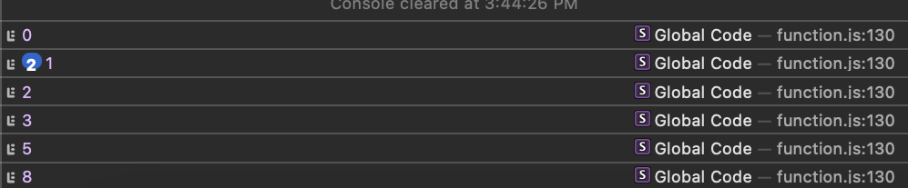

Q9.

Code- let array=[23,82,43,56,78,98,76,345,9,454];

let evenArray=array.filter((val)=>{

return val%2==0;

});

console.log(evenArray)

Output-



Q10.

Code- function capital_letter(str)

{

str = str.split(" ");

for (var i = 0, x = str.length; i < x; i++) {

str[i] = str[i][0].toUpperCase() + str[i].substr(1);

}

return str.join(" ");

}

console.log(capital_letter("this is a javascript program to captalize the first character of every word in a string"))

Output-

