Java

Program – set of instructions

Machine level language – binary language – 0s and 1s

Compiler – Compiler converts program to machine understandable

format all at once and then execute.

int sum(int a ,int b){

return a+b;

}

Eg: c, c++, scala,smalltalk …

Interpreter- Interpreter converts each line of program to machine level

while it is executing.

Eg: Ruby,python etc..

Java is a platform and language.

Java follows WORA – write once run any where.

Features:

Simple

Platform Independent

Distributed

MultiThreaded

Robust

Secure

GarbageCollection- deallocation of memory when object its no longer being used- its taken care by jvm

Java is compiled and interpreted.

FileName.java – source code

compiled by javacompiler to bytecode- FileName.class

Interpreter converts to binary code and executes.

Java:

JDK – JavaDevelopmentKit

JRE- JavaRuntime environment

JVM-JavaVirtualMachine – jvm is system dependent but it makes JavaLanguage system independent.

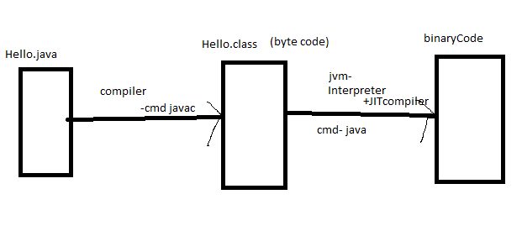

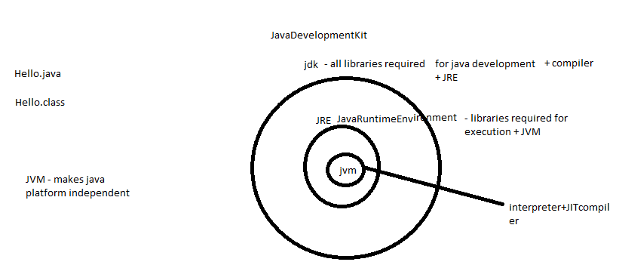

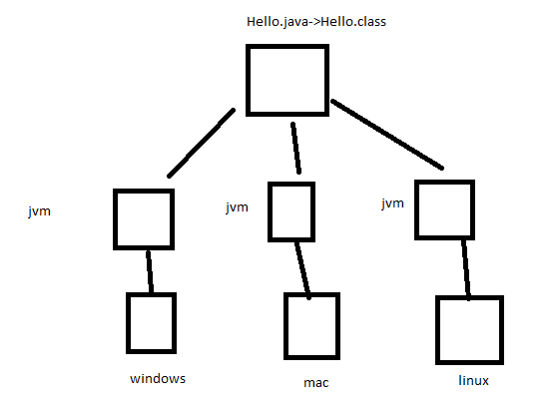

jvm- interpreter + JIT(just in time) compiler

int sum(int a ,int b){

return a+b;

}

display all even numbers from 1-100

display(){

for(int i=1;i<=100;i++){

if(i%2==0){

print(I + “is even”);

}

}}

interpreter- 100\*1=100seconds + 3 seconds = 103seconds

JIT compiler – logic inside for loop is compiled to machine code in 1second , saved in memory and reused for all iterations.

1sec + 3 seconds – 4seconds