2015--2016年度第一学期 初三英语期中试卷
请将答案写在答题卡上
听力部分（20分）
第一部分 听对话回答问题（10分）
本部分共有10道小题，每小题你将听到一段对话，每段对话听两遍。
- How does David usually spend his free time?
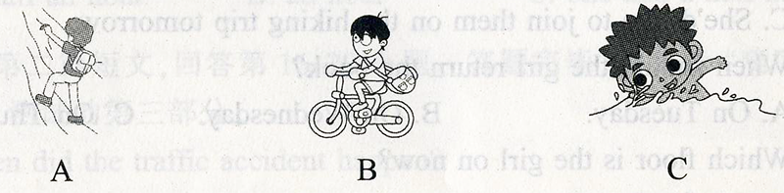
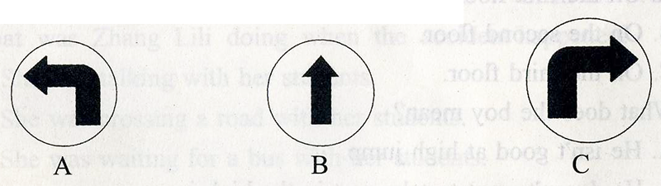
- How can the woman get to the supermarket?
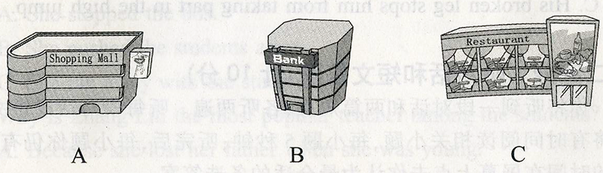
- Where are the two speakers?
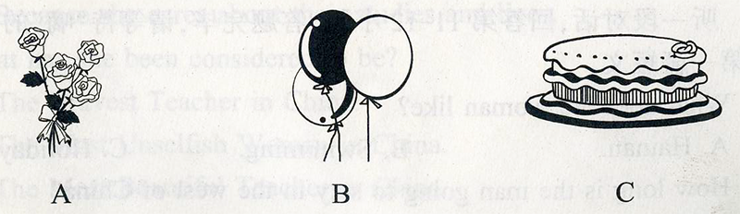
- What has Mike brought to Laura for her birthday?
- Where is the nearest bank?
- About two blocks away.
- About three blocks away.
- About five blocks away.
- What is the woman doing?
- She is singing a song.
- She is writing a paper.
- She is reading a book.
- What does Miss Black mean?
- She hates hiking.
- She’d like to go hiking today.
- She’d like to join them on the hiking trip tomorrow.
- When should the girl return the book?
- On Tuesday. B. On Wednesday. C. On Thursday.
- Which floor is the girl on now?
- On the first floor.
- On the second floor.
- On the third floor.
- What does the boy mean?
- He isn’t good at high jump.
- He doesn’t want to take part in the high jump.
- His broken leg stops him from taking part in the high jump.
第二部分 听对话和短文答题（10分）
你将听到一段对话和两篇短文，各听两遍。
听第一段对话，回答第11-12小题。
- What does the woman like?
- Hainan. B. Swimming. C. Holiday.
- How long is the man going to stay in the west of China?
- For a week. B. For a month. C. For a year.
听第一篇短文，回答第13-15小题。
How to have a healthy supper
Before it | drink some 13
During it | eat some 14 , meat and rice
After it | take a walk for about 15  have some fruit
- A. water B. soup C. milk
- A. fruit B. vegetables C. bread
- A. half an hour B. an hour C. one and a half hours
听第二篇短文，回答第16-20小题。
- When did the traffic accident happen?
- In the morning B. In the afternoon. C. In the evening.
- What was Zhang Lili doing when the accident happened?
- She was talking with her students.
- She was crossing a road with her students.
- She was waiting for a bus with her students.
- How did Zhang Lili save the students?
- She stopped the bus.
- She pushed the students away.
- She ran away with the students.
- Why is Zhang Lili the most popular teacher among the students?
- Because she lost her father when she was young.
- Because she teaches very well in the school.
- Because she cares about their studies and lives.
- What has she been considered to be?
- The Bravest Teacher in China.
- The Most Unselfish Woman in China.
- The Most Beautiful Teacher in China.
笔试部分（100分）
一、单项选择(共20小题:每小题I分，满分20分)
从A、 B、 C.、D四个选顶中选出可以填入空白处的最佳选项.
21. There is ______ university in the east of the city and ______ university is big and modern.
A. a; the B. the; a C. the; an D. an; the
22. ______he was exercising at the park yesterday morning, he found a purse under the tree.
A. While B. Before C. Though D. If
23. We should pay more attention ______teenage problems.
A. at B. to C. in D. on
24. The company was set up _______. My father has been working in it for nearly thirty years.
A.1980s B. in the 1980s C. at 1980 D. at 1980s
25. We are ______the people in need are helped in time.
A. proud to B. pride of C. proud of D. proud that
26. You ______ come to the office today______ someone else will do the work for you.
A. needn’t； so B. needn’t； since
C. don t need to； so D. don’t need； since
27. The song reminded me of the old golden days as soon as it _______.
A. played B. plays C. is played D. was played
28. _______ of them knows French, so I have to ask a fourth person for help.
A. Neither B. Either C. Both D. None
29. —It’s dangerous to walk across the street carelessly.
—You’re right. We can’t be ________ careful while crossing the street.
A. so B. very C. too D. more
30. — What do you think of the white dress?
— I _______ its style, but I _______ not choose it because of its price.
A. would rather; prefer B. prefer; prefer
C. would rather; would rather D. prefer; would rather
31. I helped my grandparents with the housework.________ fun I had though I felt tired.
A. How great B. How a great C. What great D. What a great
32. — Have you got John's letter?
—Yes, but I don't think his letter is worth _______.
A. answering it B.to answer it C. answering D. being answered
33. Our English teacher is very strict _______ us and he is strict _______ his teaching.
A. with; at B. with; with C. at; at D. with; in
34. _______ His (his) children _______ his wife were invited to the party.
A. Either…or B. Neither…nor
C. /…as well as D. Not only…but also…
35. As Jack left his membership card at home, he wasn't allowed into the sports club.
A. going B. to go C. go D. gone
36. — Would you mind _______the door? — ________. It’s really cold here.
A. close; Yes B. closing; Of course
C. closing; Of course not D. close; Sure
37. We all think _______ necessary ________to the teacher carefully in class.
A it; listening B. that; to listen C. it’s; listen D. it; to listen
38. —He’s never been to Mount Huang, ________? — ________. He wishes to go there again.
A. is he; No, he isn’t B. has he; No, he hasn’t
C. is he; Yes , he is D. has he; Yes, he has
39. The old man feels very _________because all his children have gone abroad and his wife _________ for almost two years.
A. alone, has died B. lonely, died
C. lonely, has been dead D. alone, has been dead
40. You’ll never succeed in ________ my mind unless you are right.
A. change B. changed C. to change D. changing
二、完形填空(共15小题:每小题1分，满分15分)
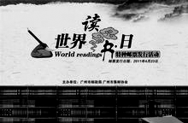
阅读下面短文，根据短文内容，从短文后各题所给的A、 B、 C、 D四个选项中，选择最佳项。
World Book Day falls on April 23 every year. It was set up by UNESCO (联合国教科文组织) in 1955 to encourage people, especially teenagers, to discover the pleasure of 41 .
Many countries celebrate World Book Day. On that day in the UK, millions of students can buy 42 of special price, much lower than usual in any bookstore. It has been done every year 43 1998. World Book Day is also celebrated in China. Many great people do lots of reading 44 they’re very busy. So young people should spend more time 45 . “Books can’t change the world, but people can change the world by changing 46 through reading,” he said.
Reading can benefit (有益于) people 47 . Reading helps us become more knowledgeable and more intelligent. Reading helps us to follow the 48 developments of science and technology. Reading 49 us with information about other culture and places of the world. When we read, we may find many things 50 are unfamiliar to us. We would have to use our brain 51 about them or do more reading to find out the answers. The more we read, the more we know. The more we know, the 52 we become. Reading is also one of the most important ways to learn a foreign language 53 English. We all know that we 54 learn everything at school, for example, the ways English people are speaking and writing today.
“Reading makes a full man.” Books, magazines, newspapers and other kinds of reading materials can help to know more about the outside world and perfect us. 55 , it is necessary for us to form the habit of reading every day.
41. A. listening B. speaking C reading D. writing
42. A. clothes B. dictionaries C. computers D. books
43. A. since B. in C. from D. by
44. A. because B. though C. through D. when
45. A. read B. to read C. reading D. to reading
46. A. ourselves B. yourselves C. themselves D. itself
47. A. in many ways B. by the way C. in any way D. in the way
48. A. earlier B. later C. latest D. last
49. A. shares B. gets C. opens D. provides
50. A. those B. that C. where D. how
51. A. think B. to think C. talk D. to talk
52. A. outstanding B. prettier C. smarter D. outgoing
53. A. like B. at C. about D. towards
54. A. can B. can’t C. might D. have to
55. A. So B. However C. Now that D. Therefore
三、阅读理解(共10小题;每小题2分，满分20分)
阅读下面的三篇短文，根据短文内容，从短文后各题所给的A、B、C、 D四个选顶中，选择最佳选项。

(A)
Apple’s logo is one of the most familiar icons(图标)around the world.
But what’s the story about the Apple logo? The image of the apple is obvious，because that’s the name of the company. What about the bite? The famous story is that the logo shows respect and honour for Alan Turing. He was the father of computer science. He researched artificial intelligence(人工智能)and unlocked German wartime codes(密码). However，after the war，he was put into prison(监狱)，because of his beliefs（信念，信条）. He could not stand the looking down and chose to bite a poisoned apple to end his life in the prison.
However，Rob Janoff，who designed the famous Apple logo，said，“It’s not the truth, but only a legend. The real reason why I designed it with a bite is very simple. I wanted people to get that it was an apple not a cherry. When I go to markets to buy apples，I always mistake apples for cherries. It really has nothing to do with the scientist. ”
Are you kidding? An apple is much bigger than a cherry. It’s very easy to tell. But if you use an apple to design a logo, some people may mistake it for a cherry.
56. Both the apple and the cherry are almost the same actually in________.
A. shape B. size C. colour D. weight
57. According to the passage，Alan Turing________.
A. died in the prison B. used an apple to design a logo
C. was put into prison during the war D. was the father of a computer company
58. What’s the purpose of writing the passage about the apple logo?
A. To introduce its designer. B. To tell us a legend （传说）about it.
C. To try to find the truth of it. D. To explain its market research.
(B)
①Have you ever wondered what goes through your mind when you choose where to sit in a new classroom? Or in a waiting room full of strangers? Or on a bus? Researchers have found out some interesting facts.
②Girls sit by girls and boys sit by boys. Adults sit together and young people choose another young person to sit near. But it goes further than this. We even choose to sit near someone who looks like us. People with glasses are more likely to sit near other people with glasses. People with long hair sit closer to other people with long hair.
③We seem to believe that people with similar habits or hobbies will share similar experiences and we are more likely to be accepted by people like ourselves or even, we think we may be safer with people who look like us. Sometimes that’s true but it’s a pity if we always stay with the same people, the same group. The danger in always staying in our comfort zone (舒适区)is that we just recycle the same opinions, the same tastes and the same ideas. We lose the chance to learn something new, find out about interesting things, hear funny stories and discover difference.
④When we always stay with the same people, how can we break down the barriers（屏障，障碍）which prevent us from getting to know people with different ideas? And how can we avoid the ignorance (无知)? If you want to live in a society that opens to changes, new things and different opinions, be the cat among the pigeons（鸽子）.
⑤Move out of your comfort zone. Go and sit next to someone different. And don’t just sit there in silence. Say hello. Ask a question. Start a conversation. That’s how we make friends. That’s how we learn about people. That’s how we open our minds to new ideas. That’s how we live an exciting life.
59. From the passage, we know that people prefer sitting by someone who .
A. is like themselves B. has a sense of humor
C. is open-minded D. lives an exciting life
60. The sentence “Unsurprisingly, we prefer to sit closer to people like ourselves.” should be
placed at the beginning of __________.
A. Paragraph 1 B. Paragraph 2 C. Paragraph 3 D.Paragraph 4
61. What is the purpose of the passage?
A. To tell us just to be ourselves in social life.
B. To introduce ways to learn about the world.
C. To explain how people communicate with others.
D. To encourage us to meet people of different kinds.
(C)
News 1 : Have you ever thought of being able to fly around the world in a few hours though it is about 40,000 kilometers? One day，maybe you can. Last Saturday，the American X－43A airplane made its first flight. It reached a speed of 8,000 kilometres an hour. This makes it the fastest plane in the world. The X－43A is only three to four metres long，but it's very heavy：it weighs（重）1,270 kilogrames.
News 2 : Have you ever got angry at books that are full of mistakes? Don't worry，things will get better soon. Last week，China started checking textbooks，dictionaries and children's books all over the country. The government（政府）said the results of the checking would come out at the end of June.
News 3 : There will be a new “star” in the sky soon. China plans to send a satellite(人造卫星) into space by December 2006. It will stay in space for one year. It will go around the moon and take pictures. It must be very expensive，right? That's for sure－1. 4 billion yuan！
News 4 : Floods（洪水）across the northern Mexican(墨西哥的) state of Coahuila killed at least 32 people and left100 more missing. It was reported on Monday. The heavy rain hit the state all night last Friday，so some banks of the river were broken. Along the river about 3，000 families were seriously affected（受影响）.
62. If the X-43A goes around the earth，it will take about _____ hours to finish the trip.
A. 3 B. 5 C. 8 D. 12
63. Which of the following about News 2 is TRUE?
A. There are many mistakes in most of the textbooks，dictionaries and children's books.
B. All the students have to use the books full of mistakes till the end of June.
C. After the checking books will become better and better.
D. A few mistakes are not serious for children.
64. Which of the following about the new “star" is NOT TRUE?
A. It will help us know more about the moon.
B. It will go around the earth for one year.
C. It will cost 1. 4 billion yuan.
D. It will be sent up by the year 2006.
65. Many families were affected because of ______.
A. the heavy rain on Monday B. the broken banks of the river
C. the floods across Mexico D. the death of 132 people
四、词汇运用(共10小题:每小题1分，满分10分)
A)根据句意，用括号中所给单词的正确形式填空，每空一词.
66. What a great ______________ (suggest) you offered me! Thank you.
67. I really don’t know whether _____________（take）on new challenges this time.
68. Different people have different ____________ (think) after seeing this film.
69. My grandpa also has a QQ though he is in her____________ (40).
70. Most nurses are very good and patient, but some are very ____________.（patient）
B)根据句意及汉语提示，写出各单词的正确形式，每空一词.
71. My father ____________ (承诺) to buy me a new bike as my birthday gift yesterday evening.
72. To our ____________ (吃惊), he succeeded in passing the exam.
73. It won’t do them any good, but it won’t do them any harm, __________ (也).
74. The boy has made an even ____________ (愚蠢的) mistake. What a pity!
75. The clever boy has no ____________ (困难) making a decision.
五、短文填空(共10小题；每小题1分，满分10分)
根据短文内容及所给首字母提示写出所缺单词.使短文意思完整，每空一词.
How to deal with homesickness
When you sleep somewhere else, like at a summer camp or a friend’s house, you know you’re there for a fun time. But for some kids, when they are away f 76 home they feel sad. They start to m 77 their own beds, their own parents, and all the things at home. It’s called being homesick (想家的). Do you want to feel less homesick? Here’s how:
S 78 more time in doing fun things. The more fun things you do, the less time you’ll have to feel homesick. So try to take part in a 79 and soon you might start to have a good time.
You can plan to call your mum or dad. For a night visit, maybe you can call once that night, and a 80 in the morning. In the camp, you might set a regular day and time for a phone call home. You can also send e-mails or short m 81 __ to keep in touch (保持联系) with family and friends. If you’re away for a while, you might e 82 write a letter! When you contact someone, make s 83 to tell them the fun things you’re doing!
Sometimes, just tell someone that you’re feeling homesick. This will h 84 you feel better, maybe you can tell a friend that you feel homesick. And the two of you can do something fun,
s 85 as telling jokes. If you’re at camp, a camp counselor (顾问) would be a good person to talk to. He or she might have some ideas to help you feel better.
六、任务型阅读(共10小题；每小题1分，满分10分)
阅读下面短文，根据短文内容完成表格中所缺信息,每空一词。
A report in a newspaper says that school accidents, such as food poisoning (食物中毒), fires, electricity and traffic, kill more primary and middle school students than anything else. So we must learn how to protect ourselves better. Here are some tips for keeping safety in mind every day.
On our way home or to school: Wait for the green traffic light, and look left and right before we cross the road. We’d better wear bright-color clothes, so the drivers can see us easily. Don’t believe strange people in the street.
At school: When students around us begin to push each other, we need to stand still and try to hold onto something, or stay in a corner until the crowd(人群) leaves. If we fall down in a moving crowd, use both hands to cover the head. Lean(斜靠) to one side, curl up (蜷缩) our body and bend (弯曲) the legs.
In a fire: Stay calm. Leave the classroom quickly under the directions of the teachers. Smoke can be more dangerous than fire, so use a piece of cloth to cover our mouth and nose. What will we do if the clothes burn? Remember not to run! Drop and fall to the ground. Then roll! It will make the fire go out.
For eating: Wash fruits carefully before eating them. Check the expiration dates (保质期) on the packages of the snacks, and if it looks or smells bad, don’t eat it.
Tips: Keep 86 in mind every day
Fact | It’s reported that school 87 kill more students than anything else
Safety Tips | On the way | ◆Wait for the green light, look both sides before 88 road.  ◆Wear bright colours.  ◆Don’t 89 strangers in the street.
Safety Tips | At school | ◆We 90 to stand still and try to hold onto something, or stay in a corner until the crowd leave  ◆We’d better use both hands to cover the head, leaning to one side, curling up our body and bending our 91 .
Safety Tips | In a fire | ◆Stay calm. Follow the teachers’ 92 and leave quickly.  ◆Cover our mouth and nose 93 a piece of cloth.  ◆Drop to the ground and roll over and over to put out the fire.
Safety Tips | For eating | ◆Wash fruits carefully before we eat them.  ◆Check the expiration dates. Don’t eat the food that goes 94 .
Purpose | To make the students know the tips that 95 them from danger.

七、书面表达(共1题:满分15分)
假如你叫Mei Mei，在英语学习网站上看见一个帖子，一个叫Susan的美国学生，平时学习非常刻苦勤奋，但是上次考试却没有得到高分，心情很糟糕。请根据下面的提示，给她写一封回帖。
1.心情不好是可以理解的。
2.想得到高分没错，但学习的目的主要是学到更多的知识，而不仅仅是好成绩。
3.提出建议：（1）要与老师、朋友和家人一起分忧，找到适合自己的学习方法。
（2）不要过于担心，要放松心态。如：可在周末走进大自然，欣赏美景。或者…….
（3）对自己要有自信。
要求：1）表达清楚，语法正确，上下文连贯；
2）必须包括所有相关信息，并作适当发挥；
3）词数：80词左右（回帖的开头与结尾已给出，不计入总词数）；
Dear Susan,
As we all know, many students like you care a lot about their grades in exams.
▲
▲
▲
▲
▲
▲
2015—2016学年第一学期 初三英语期中考卷 参考答案
听力部分（20分）
  - B C C A B 6-10 B C B B C
11-15 B B B B A 16-20 C B B C C
笔试部分 （100分）
一．单项选择（20分）
21-25 A A B B C 26-30 B D D C D
31-35 C C D C B 36-40 C D D C D
二．完形填空（15分）
41-45 CDABC 46-50 CACDB 51-55 BCABD
三．阅读理解（20分）
56-58 AAC 59-61 ABD 62-65： BDCB
四．词汇运用（10分）
66. suggestion 67. to take 68. thoughts 69. forties 70. impatient
71. promised 72. surprise 73. either 74. sillier 75. difficulty
- 短文填空（10分）
76. from 77. miss 78. Spend 79. activities 80. again
81. messages 82. even 83. sure 84. help 85. such
六．任务型阅读（10分）
86. safety 87. accidents 88. crossing 89. believe 90. need
91. legs 92. directions 93. with 94. bad 95. protect
- 书面表达（15分）
Dear Susan,
As we all know, many students like you care a lot about their grades in exams. They all want to get high marks, But you should know the goal of studying is to improve our knowledge.
The aim of exams is letting us know how much we know, why we lost the points, then, we should improve ourselves . We can share our worries with our parents and teachers. We can ask other students the problems that we don’t understand. Be hard-working and try our best to get higher marks in the next exam.
My advice is that you should be relaxed before exams. Don’t be worried too much. Try your best. You can also enjoy the beauty outside at the weekends. Believe in yourself!
Wish you good luck!
Loves from
HamMei

