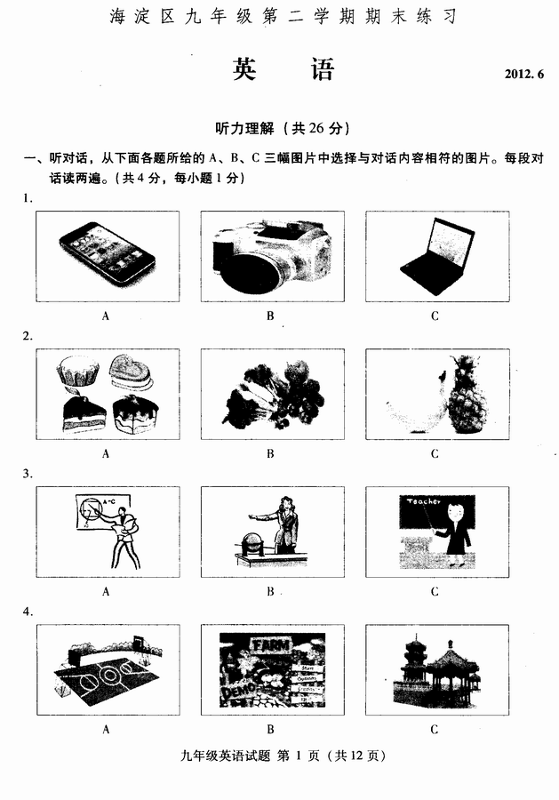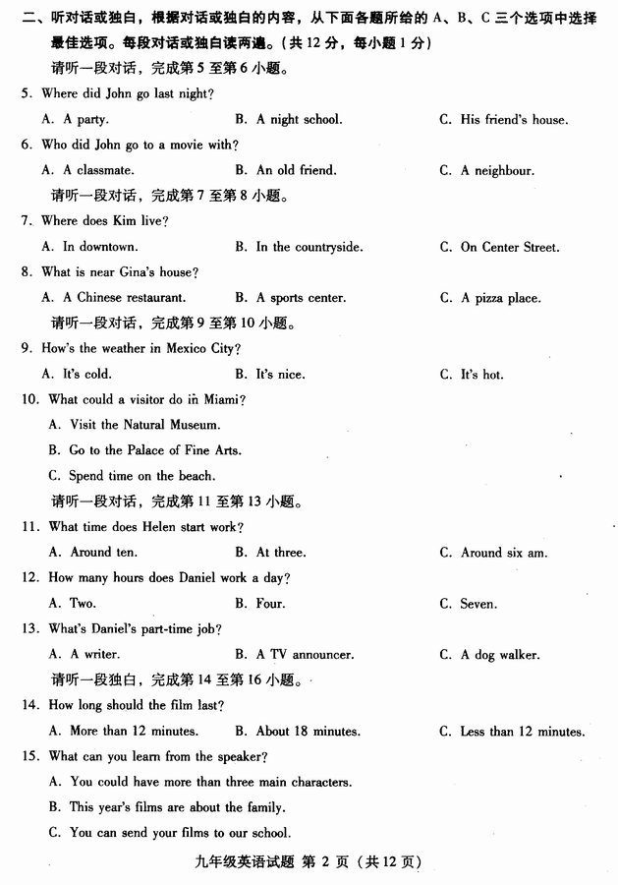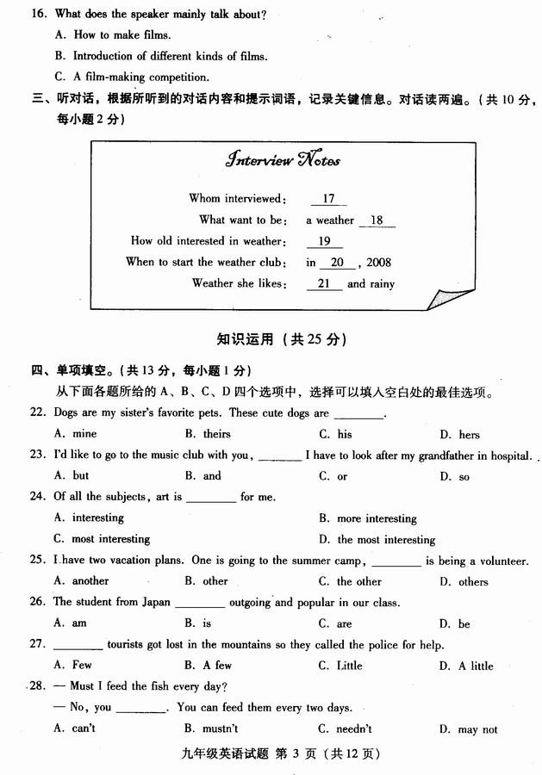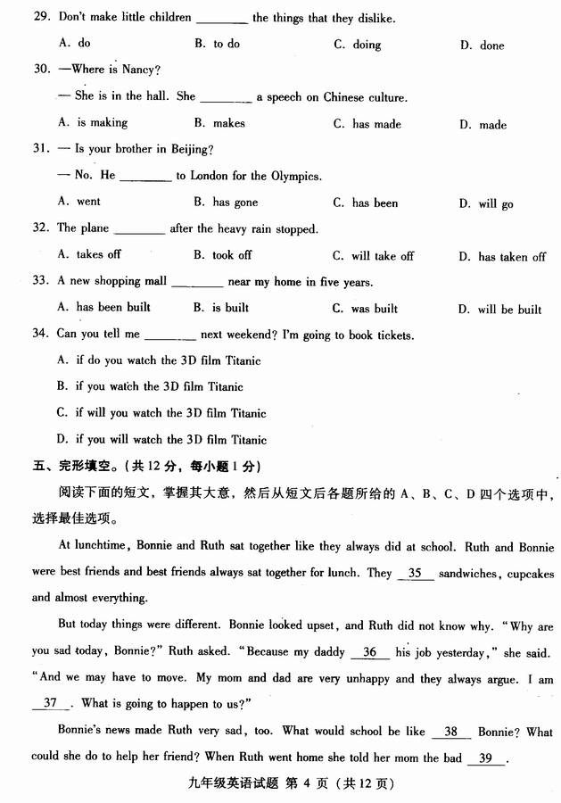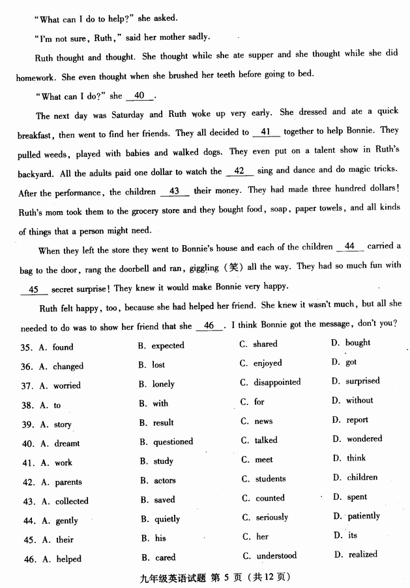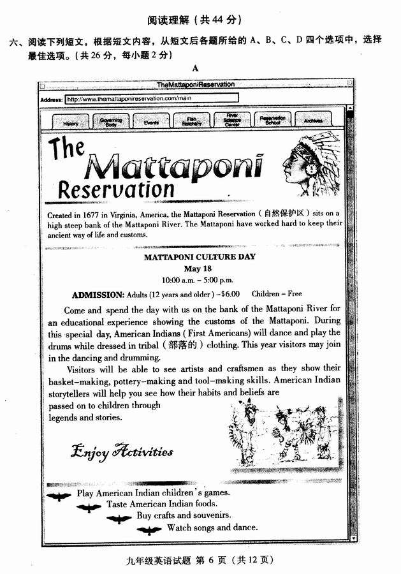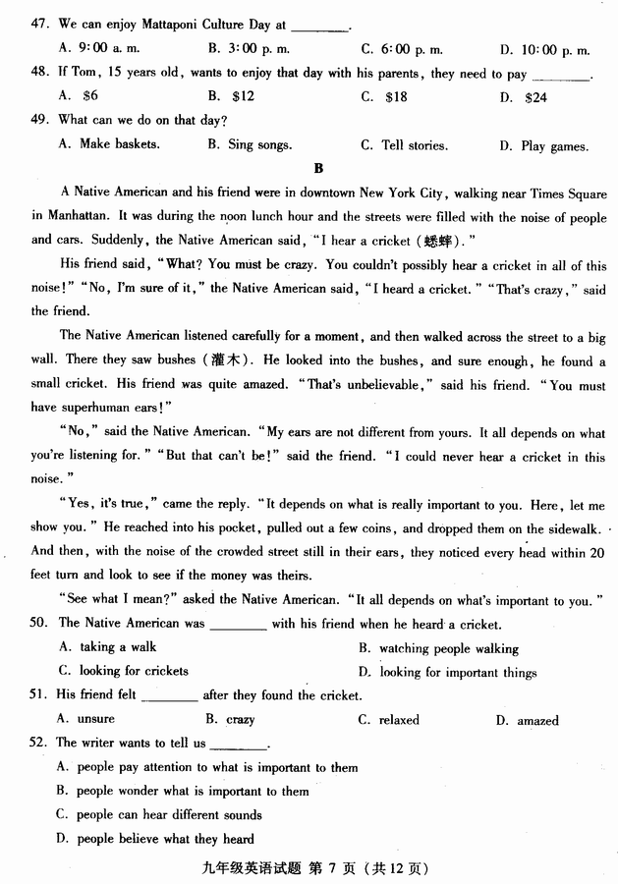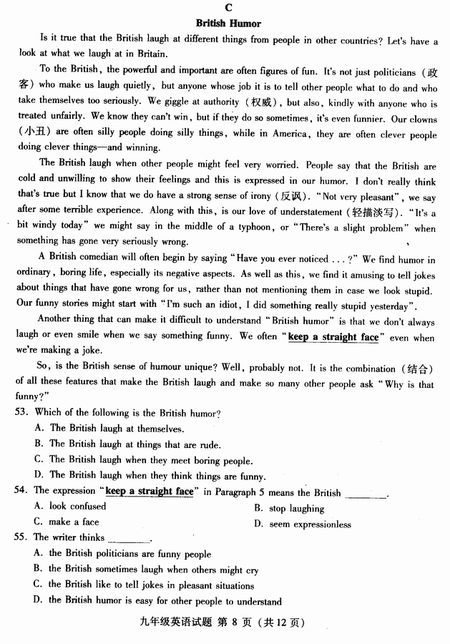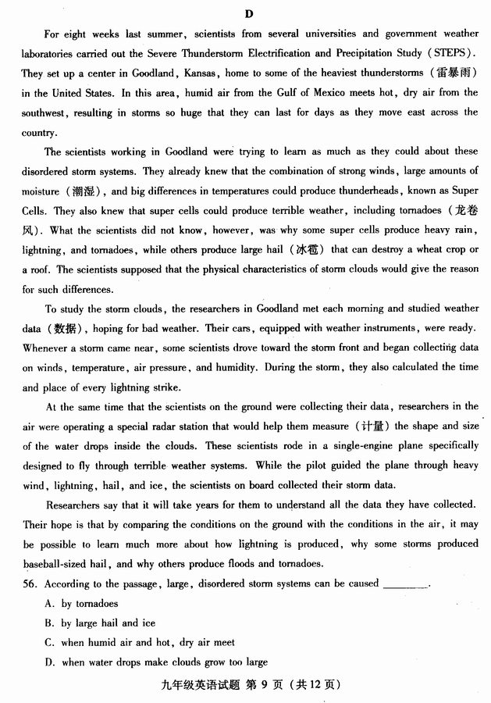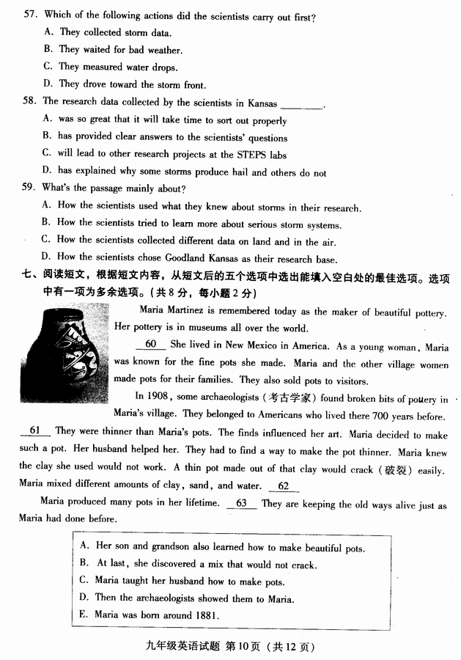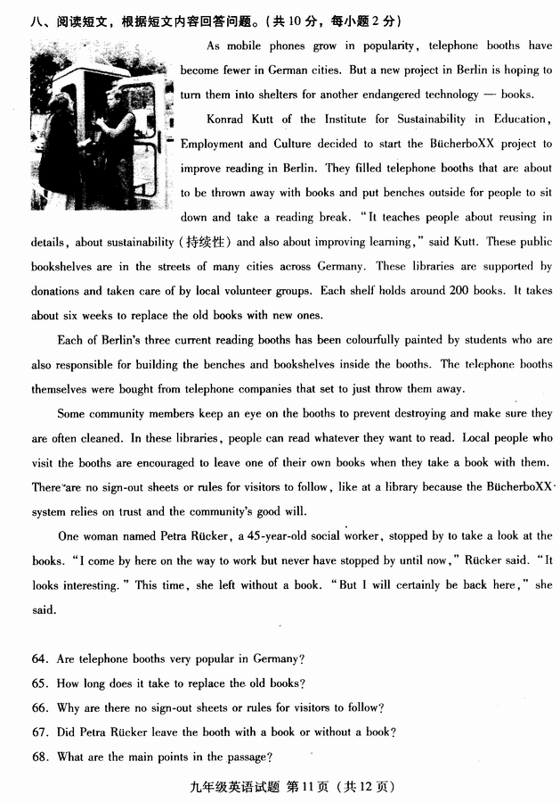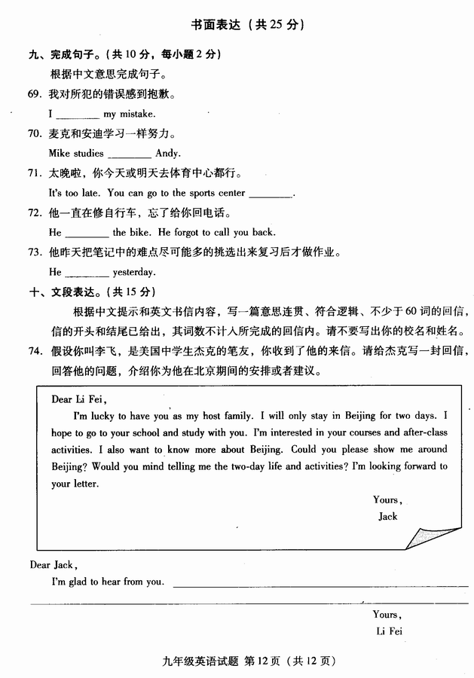

海淀区九年级第二学期期末练习
英语试卷答案及评分参考
2012.06
听力理解 (共26分)
一、听对话， 选择与对话内容相符的图片。（共4分，每小题1分）
1. B 2. B 3. A 4. C
二、听对话或独白，选择最佳选项。（共12分，每小题1分）
5. A 6. B 7. A 8. C 9. B 10. C 11. B 12. A 13. C
14. C 15. A 16. C
三、听对话记录关键信息。（共10分，每小题2分）
17. Lucy 18. reporter 19. ten / 10 20. May 21. sunny
知识运用 （共25分）
四、单项填空（共13分，每小题1分）
22. D 23. A 24. D 25. C 26. B 27. B 28. C 29. A 30. A 31. B
32. B 33. D 34. D
五、完形填空（共12分，每小题1分）
35. C 36. B 37. A 38. D 39. C 40. D 41. A 42. D 43. C 44. B
45. A 46. B
阅读理解（共44分）
六、阅读短文，选择最佳选项。（共26分，每小题2分）
47. B 48. C 49. D 50. A 51. D 52. A
53. A 54. D 55. B 56. C 57. B 58. A 59. B
七、阅读短文，还原句子。（共8分，每小题2分）
60. E 61. D 62. B 63. A
八、阅读短文，回答问题。（共10分，每小题2分）
64. No. / No, they aren’t.
65. (For) about six weeks.
66. Because the BücherboXX system relies on trust and the community’s good will.
67. Without a book.
68. What the project is and how it works.
书面表达 （25分）
九、完成句子（共10分，每小题2分）
69. am sorry for
70. as hard as
71. either today or tomorrow
72. kept repairing
73. didn’t do his homework until he picked out as many difficult points as possible in the notes and went over them
十、文段表达（共15分）
74. One possible version:
Dear Jack,
I’m glad to hear from you. It’s my honor to be with you and show you around Beijing. Now I will tell you about my plan for your two-day stay here.
On the first day, I am going to take you to my school and study with me. In the morning, you can choose 3 classes to listen to. In the afternoon, there will be different kinds of clubs after class. I am sure you will fall in love with my school.
On the second day, I plan to have a bus tour to enjoy the sights of Beijing. We will get off at Tian’an Men Square, where we can feel the perfect mixture of the past and the present. After walking on the magnificent square, we can visit the Palace Museum. Here you can see some wonderful buildings and learn about Chinese history better.
So, what’s your decision? I just can’t wait to meet you and you’re always welcome！

Yours,
Li Fei

附：听力材料
- 听对话，从下面各题所给的A、B、C三幅图片中选择与对话内容相符的图片。每段对话读两遍。
Number 1
M: Excuse me. Could you please show me the camera?
W: Sure. Here you are.

Number 2
M: What should I do to keep healthy?
W: You should eat more vegetables.

Number 3
M: Sarah, what’s your favorite subject?
W: I like math best. It’s really fun.

Number 4
M: We are going to the park. Would you like to join us?
W: That sounds great. I’d love to.

- 听对话或独白，根据对话或独白的内容，从下面各题所给的A、B、C三个选项中选择最佳选项。每段对话或独白读两遍。
请听一段对话，完成第5至第6小题。
W: Hi, John, what did you do last night?
M: Oh, I had a great time last night! I went to a party and met an old
friend of mine. We hadn’t seen each other for years, so we had a lot to talk
about. After that we went to a movie.
W: Hmm, it seems like you had a great time.
W: Yeah. I guess you’re right!

请听一段对话，完成第7至第8小题。
W: Where do you live, Kim?
M: I live in an apartment downtown.
W: Oh, that's convenient.
M: Yeah. But there is a lot of traffic. I can't stand the noise sometimes! Where do you live, Gina?
W: I have a house in the countryside.
M: Oh, I bet it's really quiet. But is there much to do there?
W: No, not much. In fact, nothing ever really happens. That's the trouble.
But there’s a great pizza place. The pizzas are delicious and very cheap.
M: Wow! You’re really lucky!

请听一段对话，完成第9至第10小题。
M: Can you tell me a little about Mexico City?
W: Sure. What would you like to know?
M: Well, what's a good time to visit?
W: I think you can go anytime. The weather is always nice.
M: Oh, good! And what should I see there?
W: Well, you should visit the National Museum and go to the Palace of Fine Arts.
M: It sounds really exciting!
W: Where are you from again, David?
M: I’m from Miami, Florida.
W: Oh! I’ve always wanted to visit Miami. What’s it like? What can I do there?
M: Well, there’s a lot to do. But a visitor should spend some time on the beach. The
beaches there are beautiful.

请听一段对话，完成第11至第13小题。
M: How do you spend your days, Helen?
W: Well, on weekdays I get up around ten. Then I read the paper for an hour and have lunch at about noon.
M: Really? What time do you go to work?
W: I start work at three.
M: And when do you get home at night?
W: I get home pretty late, around midnight.
M: So what do you do, exactly?
W: I'm a TV announcer. Don't you know me? I do the news report on KNTV!
M: Oh, I'm sorry. I don't watch TV.
W: And you, Daniel? What’s your day like?
M: Well, right now, I’m in school, so I just have a part-time job. But I’m pretty busy. I get up early, around six am. Then I work from seven until nine. I go to school and study until four pm. Then I work again from five until seven.
W: So what do you do?
M: (laughs) I’m a dog walker.
W: A what? What’s that?
M: A dog walker. I take people’s dogs for walks. It’s great, and it keeps me in shape, too.

请听一段独白，完成第14至16小题。

If you want to make films then you’ll be interested in our new competition. If you’re between 11 and 18, you can enter this year’s Film-making competition. The film should last no more than 12 minutes and you should have at least three main characters.
We have seen some great films over the years from very exciting young film-makers. Last year’s films were about The Family, and we saw some wonderful films. This year, however, we want films about the weather – it can either be about how it makes you feel or how it can change a day. A challenging topic!
There are some fantastic prizes. Our first prize winner will visit London. We have other prizes to give away – there are 100 books and also some of the latest cameras to win.
You can send your films to us by post or bring them to our offices in the Market Square.
If you have any questions about the competition, we’ll be glad to hear from you. You can telephone us at 163-55934.

三、听对话，根据所听到的对话内容和提示词语，记录关键信息。对话读两遍。
M: I’m talking to student Lucy, who wants to become a weather reporter.
Lucy, when did you become interested in weather?
W: Well, I could actually read a weather map when I was ten! I remember we had
really cold winters in my home town that made travelling difficult, so I’d turn on
the TV to see when we’d have good weather. My science teacher was surprised
how much I knew during our lessons on weather at school!
M: And you started a weather club at your school. What happened there?
W: Well, my teacher asked me to help other pupils learn about the weather, so I
started the club in May, 2008. The school already had a mini weather station, so
we used that to make a daily weather diary. And I found the information very useful for school projects I worked on!
M: So finally, Lucy, what’s your favorite weather?
W: Well, everyone likes it when it’s sunny, and I do, too, but when it’s raining hard
outside you get great grey clouds that are really beautiful, so I usually rush out in
the wet! Fog is interesting, too, the way it suddenly appears, but it’s a bit
dangerous, so I can’t say I really like it.

Dear Jack,
I’m glad to hear that you will come to Beijing and stay here for 2 days. It’s my honor to be with you and show you around Beijing, but to tell you the truth, two days is really short if you want to have a good look at the wonderful city. Next, I will tell you about my plan for your two-day stay here.
On the first day, I am going to take you to my school and study with me. I am sure you will fall in love with my school, because the courses and activities are enjoyable and interesting, especially the after-school activities. Students can not only open up their eyes to the world by reading books about science, history and so on, but also take exercise and relax themselves. Moreover, they can have doing what they love to do, such as playing chess, singing, making models and so on.
On the second day, I plan to have a bus tour. It is a good idea to enjoy the sight on the top deck of a double-deck bus. Then we will get off at Tian’an Men Square, where we can feel the perfect mixture and the past and the present. After walking on the magnificent square, we can visit the Place Museum, where the ancient emperors lived. Here you can see some wonderful buildings and learn about Chinese history better.
So, what’s your decision? I just can’t wait to meet you and you’re always welcome！

