八年级下期中测试卷（二）附答案
英语试题
本试题分为第I卷（选择题）和第II卷（非选择题）两部分，共120分。考试用时120分钟。
第I卷（选择题 共85分）
I. 听力测试（20分）
A) 听录音，在每组句子中选出一个你所听到的句子，每个句子听一遍。( 5分)
1. A. She went hiking in the hills . B. You should lie down and rest for a few days.
C. We should exercise more to keep healthy.
2. A. Most of our teachers come to school by bus B. My parents took me to the hospital
C. I’ll help to clean up the city parks.
3. A. Is the hotel between the park and the station?
B. Could you please take the dog for a walk?
C. Can you put my article in next month’s magazine?
4. A. Why don’t you go to sleep earlier this evening? B. Let’s stop talking about our problems.
C. Bob hopes to fly to the moon some day.
5. A. What were you doing when the rainstorm came? B. When were you supposed to arrive?
C. What if everyone else brings a gift?
B) 听录音，从每题A、B、C三幅图画中选出与所听到的对话内容相符的一项。每段对话听两遍。（5分）

6. A． B. C.
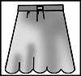
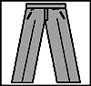

7. A. B. C.
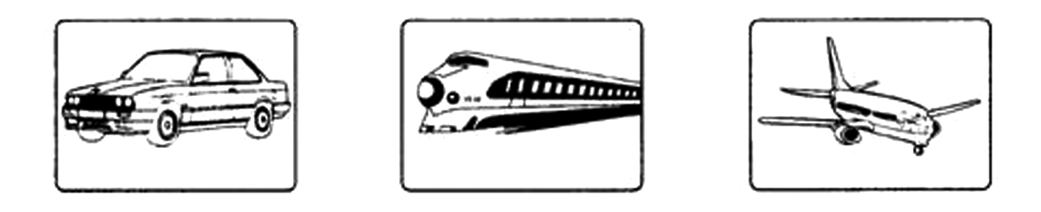

8. A. B. C.
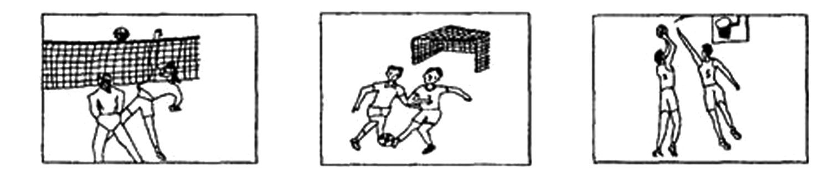

9. A. B. C.
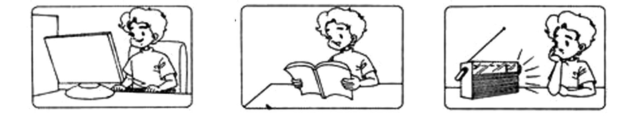

10. A. B. C.
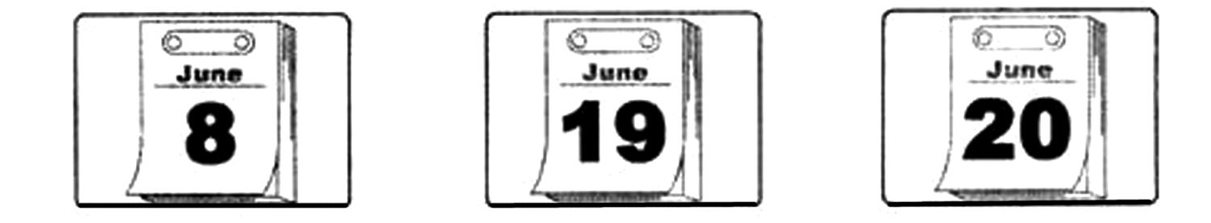
C) 在录音中你将听到一段对话及五个问题.根据对话内容及问题选择正确答案。对话及问题听两遍。(5分）
11. A. To the bookstore. B. To the police station. C. To the post office.
12. A. Lucy B. His sister. C. His friend.
13. A. 7:00 B. 7:30 C. 8:00
14. A. Fruits and vegetables B. Fast food C. Food and drinks
15. A. Yes, they will B. No, they won’t. C. It isn’t mentioned.
D) 在录音中你将听到一段短文及五个问题。根据短文内容及问题选择正确答案。短文及问题听两遍（5分）
16. A. He was small and thin. B. He was large and fat. C. He was tall and strong.
17. A. Every month. B. Every day. C. Every Friday.
18. A. Listening to the radio and eating apples.
B. Watching TV and waiting for her husband.
C. Listening to music and cleaning the room.
19. A. He saved the money little by little.
B. He bought the lottery tickets.
C. He found the money in his office.
20. A. He got ten thousand dollars.
B. He bought the lottery tickets.
C. She thought he hadn’t given her all the money.
Ⅱ.根据音标及句意选择正确单词（5分）
21. The teacher told Tom he _________ / k ʊ d / call her up if he had problems.
A. cook B. kid C. could D. count
22.The train came to a /stɔp/ slowly at the station.
A. shop B. store C. stop D. soup
23. Don’t / fait / with others. It’s bad manners.
A. fight B. fat C. fix D. fine
24. The old woman looked /'wʌrid / because she couldn’t find her purse.
A. windy B. wonder C. wooden D. worried
25．When you meet the ____/'prɒbəm/. Please call at 12345
A．popular B．public C．probably D．problem
III. 选择填空 从每题Ａ、B、Ｃ、Ｄ四个选项中，选出一个最佳答案。（30分）
26. She is ______ eight-year-old girl.
A. a B. an C. the D./
27. Students shouldn’t go to school _____eating breakfast. It’s bad for their health.
A. with B. without C. for D. by
28.—Do you know the song Gangnam Style?
—Of course. It interesting.
A. tastes B. smells C. sounds D. feels
29.____ a teacher, Mr. Wang thinks it's very important to teach the students how to learn.
A. From B. With C. As D. Of
30. Which sign means you can’t drop litter?
A.  B.  C. 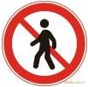 D. 
31. She forgot to bring her wallet so she_________ the bus at the bus stop and went back home.
A. got to B. got up C. got down D. got off
32. When he walks along the seaside, he sees many people________ on the beach.
A. lied B. lying C. lay D. to lay
33. Don’t shout at him. He is unable to hear you because he is_________ .
A.blind B. deaf C. hurt D.burnt
34. Jim spends every Sunday morning _________ in an animal hospital.
A. working B .looking C. reading D. walking
35. —Could you give me a hand? I want to _____the map on the wall. —With pleasure.
A. put up B. clean up C. fix up D. turn up
36. —The old man lives_________ ,but he doesn’t feel_________ .
A. alone lonely B. lonely lonely C. lonely alone D. alone alone
37. The girl is_________. She can’t use her legs and arms well.
A. interesting B. disabled C. brave D. great
38. —Thanks a lot for the dog you sent me.
—_________.
A. No, thanks. B. I'm glad you like it.
C. Please don't say so. D. Don’t mention it.
39.－Lucy，could I use your computer? －Sorry, I’m going to ______it now.
A. work in B. work at C. work on D. work over
40. He ______some books ______ me, and never gave them back.
A. lent, to B. lent, from C. borrowed, to D. borrowed, from
41.—Could I use your car? —Sorry，you ______. I have to go out.
A. could B. can C. couldn’t D. can’t
42.—How about ______ the dog for______? — That sounds good.
A. taking, a walk B. taking, walk C. take, a walk D. take, walking
43. You can go out, but you clean your room first.
A. have B. are C. could D. have to
44. She looked ________ when she heard the _______ news.
A. surprised; surprising B. surprising; surprised
C. surprising; surprising D. surprised, surprised
45.You should ______ your problems ______ your father.
A. talk with, about B. talk about, with C. talk to, about D. talk with, with
46. —My best friend didn’t trust me anymore. What should I do?
—____________ you write a letter to him?
A. Maybe B. How about C. Why not D. Why don’t
47.It was Friday evening. Mr. and Mrs. Green _____ ready to fly to England.
A. are getting B. get C. were getting D. got
48. My father was too tired. He lied down _________________.
A. in silent B. in silence C. keep silent D. keep silence
49.The children decide their school yard this Friday afternoon.
A. clean B. to clean C. cleaning D. cleaned
50.—Who taught you Japanese?
—Nobody. I learned it by .
A. myself B. my C. me D. I
51.Many volunteers food and water to the local people in Japan after the tsunami.
A. gave out B. cut out C. put out D. found out
52.—How is your grandma?
—She’s fine. She used to TV at home after supper. But now she is used to out for a walk.
A. watch; go B. watching; go C. watching; going D. watch; going
53. I found ____ difficult to work together with her.
A. it B. its C. that D that’s
54. It’s too noisy in Jinan. I want to go to___________ quiet when I retire.
A something B anything C somewhere D anywhere
55. —________? —Oh… I have a headache. I can’t stand it.
A. What’s the time B. How are you C. What’s the matter D. What are you doing
Ⅳ．完形填空 阅读下面短文，从每题A、B、C、D四个选项中，选出一个能填入文章中相应空白处的最佳答案。（10分）
Do you think of your parents? “Yes, of course.” You may answer. “I buy a present for my mother on _56___. And I give my father a present on Father’s Day,_57___. ” Then what about the other days of the year? Always __58___ to think of your parents , not just on some important days.
I have a friends who _59___ alone, because her parents live in another city. One day I went to see her. We had a nice chat. Then she said she wanted to make a __60____. She dialed(拨) the number , but then she put the phone __61___ . After about ten seconds, she dialed the number again. “Hi, Mum…”
Later I asked, “Why did you dial the number __62___?” she smiled, “ My parents are old. They can’t get close to the telephone_63____. I always do so when I call them. I just want to give them _64__time to answer the call.
My friend is a good girl. She is always __65___her parents. You also want to be a good child, right? So why not learn from her?
56. A. Father’s Day B. Mother’s Day C. Teachers’ Day D. Children’s Day
57. A. too B. also C. either D. yet
58. A. refuse B. forget C. decide D. remember
59. A. live B. lives C. lived D. living
60. A. face B. card C. call D. cake
61. A. up B. off C. down D. on
62. A. once B. twice C. many times D. few times
63. A. lonely B. slowly C. quietly D. quickly
64. A. less B. few C. enough D. little
65. A. thinking about B. laughing at C. looking for D. talking about
Ⅴ.补全对话阅读对话，从每题A、B、C、D四个选项中，选出一个最佳答案完成对话。（5分）
A: Hi, Dick! What are you going to do tonight?
B: I have no idea. What do you suggest?
A: How about going to see a movie?
B: 66 . But I hear there is a talk at seven in the City Hall.
A: What’s the talk about?
B: The history of music. 67
A: Me, too. 68
B: Good idea! Let’s go to the City Hall instead of going to the movies.
A: By the way, my friend Jenny likes music, too. 69
B: Certainly. 70
A: Let’s meet at the school gate at 6:30 in the evening, OK?
B: OK. See you then.
A: See you.
66. A. That sounds good. B. I have no time
C. I’m sorry to hear that. D. It doesn’t matter.
67. A. I don’t like the history. B. Shall we go to movies?
C. I enjoy music very much. D. Let’s go to the park.
68. A. Do you like going shopping? B. Will you go hiking?
C. How about your mother D. Why not go to the talk together?
69. A. She’s good at singing. B. Can we ask her to go with us?
C. Please go to the concert. D. Sorry, I won’t.
70. A. When and where shall we meet? B. Thanks for asking me.
C. I hope you have a nice day D. How can you get there?
Ⅵ．阅读理解 阅读下列短文，从每题A、B、C、D四个选项中，选出一个能完成所给句子或回答所提问题的最佳答案。（15分）
A
A woman was at the cinema, and she was enjoying the film very much. But there was a man in the next seat, and he began looking on the floor under him. The woman was angry and whispered, “What are you doing there? What are you looking for?” “A piece of hard chocolate（巧克力）,”the man whispered to her, “I dropped it on the floor.” “A piece of chocolate?” the woman said angrily, “It’s dirty now! Take this and be quiet, please! I’m listening to the film!” She gave the man a big piece of chocolate. “But,” the man said, “my teeth are in the piece on the floor!”
71. The woman was _________.
A. watching a TV play B. listening to the music
C. watching a football match D. seeing a film
72. The man sat _________ the woman.
A. behind B. in front of C. next to D. far from
73. The woman was angry because _________.
A. the man spoke loudly B. the man didn’t talk to her
C. she dropped a piece of chocolate D. she couldn’t listen to the film clearly
74. The word “whisper” means “speak in a _________ voice”.
A. low B. loud C. pleasant D. big
75. In fact the man was busy looking for his _________.
A. glasses B. teeth C. ticket D. wallet
B

“Well, we're in our new house. Let's get a new pet to get along with it,” Mrs Brown said to her husband.” That sounds like a pretty good idea,” he answered. “Do you want to see the ads in the newspaper？” “No. Let's go to the animal shelter. Many pets there need homes. Since tomorrow is Saturday, we can both go,” she said.
The next morning the Browns met Mr Snow at the animal shelter. “We want to be sure that the pets here go to good homes,” Mr Snow said, “So I need to ask you some questions.”
After they talked for a while, the Browns decided to get a small dog. It wouldn't need a big house or a big yard. A small dog would bark（吠）and warn them if someone tried to break into their house. After Mr Snow gave the Browns a book on pet care, they chose one and wanted to take her home right away. But the animal doctor hadn't checked her yet. So Mr Snow told them to return on Sunday.
On Sunday afternoon the Browns went to the animal shelter. The animal doctor said, “Shadow has had all of her shots(预防针). She will be healthy.” The browns thanked the doctor and took Shadow home.
76. From the reading we learn that _______.
A. the Browns have never had a pet before.
B. the Browns knew about Shadow from the newspaper.
C. Shadow is a small and healthy dog.
D. Mr Brown didn't quite agree with his wife.
77. The underlined word shelter in the reading means _______.
A. a place to sell small dogs B. a place to keep homeless animals
C. a place to study animals D. a place to sell books on pet care
78. Mr Snow asked the Browns some questions to _______.
A. see if they had moved to a new house B. find out how rich the Browns were
C. know where they'd keep their new pet D. make sure they'd take care of pets
79. The Browns thinks that a small dog _______.
A. doesn't need any room to keep B. can help them watch their house
C. eats less food than a bigger one D. usually has a beautiful name
80. It's clear that _______.
A. Shadow will not be easy to get ill B. the Browns were not good with Shadow
C. Mr Snow didn't check Shadow at all D. Shadow likes barking a lot
C

Happiness is important for everyone. Most people want to be happy but few know how to find happiness. Money and success don't bring lasting happiness. Happiness depends on ourselves. In other words, we make our own happiness.
Some people believe that if they are wealthy, with the money they will be able to do anything they want, which means happiness. On the other hand, some people believe that holding a high position in the government is happiness. In this way, you have not only money, but also many other things which can't be bought by money. However, other people believe that having lots of money is not happiness, nor is holding a high position in the government. These people value(重视) their beliefs, or their intelligence, or their health. They think these can make them happy.
Here are a few ways to help you be happier.
The first secret of happiness is to enjoy the simple things in life. Too often, we spend so much time thinking about the future, for example, getting into college or getting a good job, that we don't enjoy the present. You should enjoy life's simple pleasures, such as reading a good book, listening to your favorite music, or spending time with close friends. People who have close friends usually enjoy happier and healthier lives.
The second secret of happiness is to be active. Many people go dancing or play sports. People can forget about their problems and only think about the activities.
Finally, many people find happiness in helping others. According to studies, people feel good when they volunteer their time to do many meaningful things for other people. If you want to feel happier, do something nice for someone. You can help a friend with his or her studies, go shopping to get food for an old neighbor, or simply help around the house.
学校 班级 姓名 编号
Now maybe you know how to find happiness!
81. The underlined word “wealthy” means “__________” in the article.
A. pleased B. healthy C. excited D. rich
82. Some people who hold a high position in the government think they can _________.
A. get money and something they can't buy with money
B. do what they want to do at any time
C. enjoy health which makes them work hard
D. take an active part in all kinds of activities every day
83. The writer thinks the secret of happiness is that people ___________.
A. think about getting money B. think of presents they don't like
C. often spend time with close friends D. often spend time on entering the college
84. Many people find it happy to ___________.
A. remember the old days and troubles B. do some meaningful things for others
C. go shopping to buy some food D. make much money and little success
85. The passage mainly tells us __________.
A. how to find happiness B. how to save happiness
C. to do something good for others D. to value our beliefs or health
第Ⅱ卷（非选择题 共35分）
Ⅶ．选词填空 （10分）
得 分 | 评卷人
- 阅读短文，从方框中选择适当的词填空（每次限用一次）
difficulty, get, old, hang, refuse

My problem is that I can’t 86________ on with my family. Relations between my parents have become 87___________.They fight a lot, and I really don’t like it. It’s the only communication they have. I don’t know if I should say anything to them about this. When they argue, it’s like a big, black cloud 88__________over our home. Also, my 89_______brother is not very nice to me. He always 90________to let me watch my favorite TV show.
B.阅读短文，从方框中选择适当的动词，并用其适当形式填空。有的需要加助动词或不定式符号。（每词限用一次）
play plan get work see
I think the children can share some housework, it’s a big help because parents 91___________ hard every day. Last Sunday morning, I 92___________ to play football, but when I saw my mum 93___________ ready for the washing. I decided to help her. So I told my friends 94___________ football by themselves. Mum was happy 95_________ that, she was proud of me.
Ⅷ.改写句子 按括号中的要求完成改写后的句子，每个空格填一个单词。（5分）
得 分 | 评卷人
96. She should drink some water.(改为否定句）
She _________drink_________ water.
97. He fell down when playing soccer.(改为一般疑问句）
_______he _____down when playing soccer?
98. My headache started about two days ago.(对划线部分提问)
__________ did your headache ___________?
99. The girl looks like her mother very much. (改写句子,句意不变)
The girl ___________ ___________her mother very much.
100. My teacher told me. Don’t be late again. (改写句子,句意不变)
My teacher told me___________ ___________be late again.

Ⅸ.完成句子 根据汉语意思完成英语句子，每个空格填一个单词。（5分）
得 分 | 评卷人
101. 作为一名登山者，他习惯于冒险。
As a mountain climber, he is ______ _____ taking risks.
102. 一周了，她没做任何家务，我也没做。
For one week, she did not do any housework and _______ _______ I .
103. 他们总是自愿贡献他们的时间来帮助他人.
They always _____________their time to _____________ other people.
104.你与同学相处的如何？
How do you _______ _______ with your classmates?
105. 由于地震的原因,市政府将推迟一些不太重要的工程。
The government of the city will _____________ _____________some less important projects because of the earthquake.
Ⅹ.任务型阅读 阅读短文，按要求完成各题。（5分）
得 分 | 评卷人
Some people have very good memories and can easily learn quite a long poem（诗）by heart. There are other people who can only remember things when they have said them again and again. The famous English writer，Charles Dickens said that he could walk down any streets in London and then tell you the name of every shop he had passed. Many of the great men of the world have had wonderful memories.
A good memory is of great help in learning a language. Everybody learns his own language by remembering what he learns when he is a small child. Some children don’t live in their own country, and they seem to learn two languages almost as easily as one. In school, it is not so easy to learn a foreign language because students have so little time for it and they are busy with other lessons.
A man’s mind is rather like a camera, but it takes photos not only of what we see but also of what we feel, hear , smell and taste. When we take a real photo with a camera, there is much to do before the photo is finished and ready to show to our friends. In the same way, here is much work to be done before we can keep a picture for ever in our minds.
Memory is the diary we all carry about with us.
106.根据短文内容完成句子(每空限填一个单词)。
Some people are good at ______ _______ _______.
107.根据短文内容完成句子(每空限填一个单词)。
Other people can only remember things by _______ _______ _______ ________.
108.把短文中画底线的句子译成汉语。
_______________________________________________________________.
109.根据短文内容回答问题。
What did Charles Dickens have?
_________________________________________________.
学校 班级 姓名 编号
100.根据短文内容回答问题(不超过10个单词)。
What does a good memory help you do?
________________ ________________
Ⅺ.书面表达（10分）
得 分 | 评卷人
根据所给图画，用英语写一篇80词左右的短文。要求完整叙述图画内容。

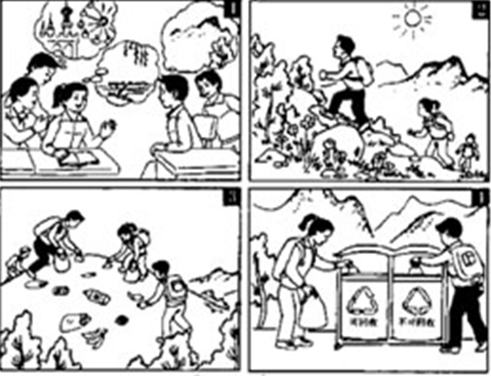

______________________________________________________________________________

______________________________________________________________________________

______________________________________________________________________________

______________________________________________________________________________

______________________________________________________________________________

______________________________________________________________________________

______________________________________________________________________________

______________________________________________________________________________

附: 听力材料
A. 听录音，在每组句子中选出一个你所听到的句子，每个句子听一遍。
1. You should lie down and rest for a few days.
2. I’ll help to clean up the city parks.
3. Could you please take the dog for a walk?
4. Why don’t you go to sleep earlier this evening?
5. What were you doing when the rainstorm came?
B. 听录音，从每题A、B、C三幅图画中选出与所听到的对话内容相符的一项。每段对话听两遍。
6．M: Can I help you, Madam?
W: Yes, please. I’m looking for a pair of shoes for my daughter.
7．W: Hi , Li Lei, are you going to Beijing during the vacation?
M: Yes, I’ll go there by plane with my friends.
8. W: What are you going to be when you grow up, Mike?
M: I’m going to be a football player.
9. M: What did Tom do last Sunday evening?
W: He played computer games at home..
10. M: Jenny, could you please come to my birthday party on June 8?
W: Sure, I’d love to. And I’ll give you a big surprise.
C. 在录音中你将听到一段对话及五个问题。根据对话内容及问题选择正确答案。对话及问题听两遍。
M: Hi, Lucy.
W: Oh, hi, Jim. Where are you going?
M: I’m going to the post office. I want to send a letter to my sister.
W: By the way, what are you going to do this weekend?
M: Nothing much. Why?
W: My friends and I are going to the forest for a picnic. Would you like to join us?
M: A picnic？Yes. That would be great! I think it will be very interesting. When shall we start and where shall we meet?
W: How about eight o’clock tomorrow morning outside the school gate?
M: I want to spend more time in the forest. Shall we make it a little earlier?
W: Well, what about half past seven?
M: All right, half past seven. I’ll be there on time.
W: And we need to take some food and drinks with us.What about going shopping together this afternoon?
M: Sure. I will call you then.
W: OK, see you later.
Questions: 11. Where is Jim going?
12. Who does Jim want to send a letter to?
13. When are they going to meet?
14. What do they need to buy for the picnic?
15. Will they go shopping together?
D. 在录音中你将听到一段短文及五个问题。根据短文内容及问题选择正确答案。短文及问题听两遍
There was once a large, fat woman. She had a small, thin husband. He worked in a big office and got his weekly pay every Friday evening. As soon as he got home on Fridays, he had to give his wife all his money, and then his wife gave him back only enough to buy his lunch in the office every day. One day the small man came home very happily. He hurried into the living room. His wife was listening to the radio and eating apples there.
“You’ll never guess what happened to me today, dear,” he said.
He waited for a few seconds and said again, “I won ten thousand dollars on buying the llottery tickets!”
“That’s wonderful!” shouted his wife happily. But then she thought for a few seconds and said angrily, “But wait a minute! How could you have enough money to buy the tickets?”
Questions:16. What was the husband like?
17. When did the man get his pay?
18. What was his wife doing when the man hurried into the living room?
19. How did the husband get the ten thousand dollars?
20. Why was his wife angry with him?
参考答案：I. 1-5 B C B A A 6---10 C C B A A 11---15 C B B C A 16～20 ACABC
21-25 CCADD 26-30 BBCCB 31-35 DBAAA 36-40ABBCD 41-45DADAB 46-50 DCBBA
51-55 ADACC 56-60 BADBC
61-65 CBDCA 66-70 ACDBA
71-75 DCDAB 76-80 CBDAA 81-85 DACBA
- get 87 diffficulty 88 hang 89 old 90. Refuse
- work 92. planned 93. getting 94. to play 95. to see
- shouldn’t or 97. Did fall 98. When start 99. takes after 100. not to
101. used to 102. neither did 103. volunteer help 104. get on 105. put off
106. learning long poem 107. saying again and again 108. 在学校里，学好一门外语并不容易，因为他们几乎没有时间学它，并且还要忙其他学科。109. He had wonderful memories. 110. A good memory help you learn a language.
书面表达略

