湘潭县2015-2016学年上学期期末考试试卷

英语试卷
第一部分 听力技能 （共两节，计25分）
第一节 听力选择 (15小题，计15分) 听对话，选择相应的图片或正确的答案。听每段对话前，你将有时间阅读各个小题，每小题5秒钟；听完后，各小题将给出5秒钟的作答时间。
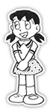
( )1. Who are they talking about?


A. B. C.

( )2. Where was the dress made?
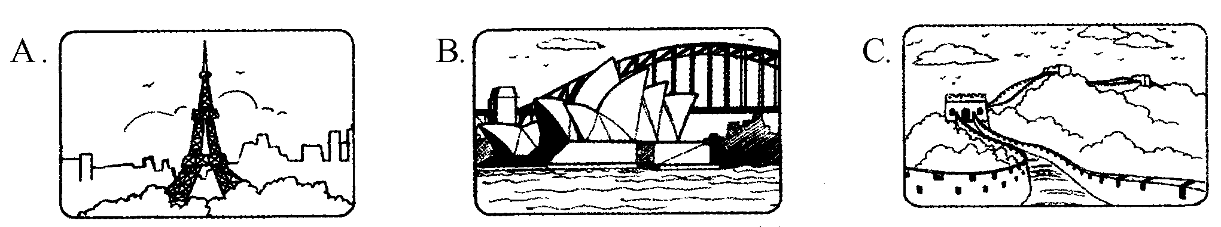

( )3. When did Jim clean his bedroom?
A. Before supper. B. After supper. C. Yesterday.
( )4. What kind of music does Tom prefer?
A. The music that she can dance to.
B. The music that has great lyrics.
C. The music that isn’t too loud.
( )5. How did Jim feel after seeing the movie?
A. Tired. B. Excited. C. Relaxed.
听下面的对话，回答6-7小题。
( )6. What time is it?
A. 11:30. B. 12:00. C. 12:30.
( )7. How is the restaurant?
A. It’s very small, and the food is bad.
B. It’s vey small, but the food is very good.
C. It’s very small, and the food is bad.
听下面的对话，回答8-9小题。
( )8. Which Festival are Dave and Mary talking about?
A. Easter. B. Christmas. C. Thanksgiving.
( )9. What will Dave probably do during the holiday?
A. Stay at home. B. Go to the movies. C. Hang out with friends.
听下面的对话，回答10-12小题。
( )10. How does the woman learn English?
A. By listening to the radio.
B. By reading English magazines.
C. By watching a CCTV English program.
( )11. Where does the woman work?
A. In a shop. B. In a bank. C. In a hospital.
( )12. Why does the woman learn English?
A. To go abroad one day.
B. To communicate with foreigners.
C. To help his son with his homework.
听下面的对话，回答13-15小题。
( )13. Whose T-shirt is it?
A. Paul’s. B. Bob’s. C. John’s.
( )14. What do Bob and John like doing?
A. Playing basketball. B. Playing baseball. C. Playing tennis.
( )15. Where may John and Bob be?
A. In the park. B. In the library. C. On the playground.
第二节 笔录要点（5小题，计10分）根据你所听到的内容，完成下面的表格填空，每空不超过3个单词。
Computers
History | Time: invented in 16）
History | Size: as large as（17）
History | Weight: about 30 tons
History | Material: plastic, steel and（18）
Usage  （用途） | - Help us（19）  - Let us know more about the world and open our eyes.  c. Let us have fun.
Opinions | One of the most（20） inventions in the world.

第二部分 知识运用（共两节，计25分）
第一节 语法填空（15 小题，计15分）从所给的A、B、C三个选项中选择最佳答案填空。
( )21. The right pronunciation of the word “discover” is .
A. [dis＇gʌə(r)] B. [dis＇kʌə(r)] C. [dis＇kauvə(r)]
( )22. Tea was invented by _______ accident.
A. an B. the C. ＼
( )23. The boy always makes _______ cry.
A. she B. her C. hers
( )24. Our classroom must______every day.
A. clean B. be cleaned C. is cleaned
( )25. I eat five meals a day. I have _____ 5 pounds.
A. put on B. put up C. put in
( )26. The hall is ______ to hold one hundred people.
A. enough big B. big enough C. as big
( )27. This dictionary______ Ellen’s. Look, her name is on it.
A. must be B. can’t be C. might be
( )28. —When ________ the telephone ________?
—In 1876.
A. is; invented B. did; invented C. was; invented
( )29. Students are supposed _______ school uniforms on school days.
A. wear B. to wear C. wearing
( )30. When we got to the hospital, Mary _______ there.
A. left B. has left C. had left
( )31. ________ interesting story it is! We all fall in love with it.
A. How B. What a C. What an
( )32. I love the singers _______ write their own songs.
A. whom B. whose C. who
( )33. Jill still went to school _______ she was ill yesterday.
A. even though B. no matter C. as soon as
( )34. Emily from America asked .
A. we would have a holiday on Christmas Day
B. whether people celebrated Thanksgiving Day in China
C. that his father will come back on Spring Festival
( )35. —Thank you for taking me around your school, Daming.
—______.
A. My pleasure B. OK C. Don’t thank me
第二节 词语填空 ( 10小题，计10分)
通读下面的短文，掌握其大意，然后从各题所给的A、B、C三个选项中选出一个最佳答案。
A poor young man stood at a gate of the railway station, playing his violin. Many people put money into the (36) lying in front of him.
The next day, the young man came to the (37) of the railway station again. He (38) a large piece of paper on the ground. It said, “Last night, a gentleman named George Sand put something (39) into my hat by mistake. Please come soon, Mr. Sand.”
About half an hour later, a middle-aged man ran to the young man and said, “It’s you! You do come here. I know that you are honest and will (40) come here.” The young man asked, “Are you Mr. George Sand? Did you lose anything?” “A lottery(奖券) ticket,” answered the middle-aged man. The young man took out a lottery ticket and gave it to the man.
The prize of the lottery ticket was worth $ 500,000. Yesterday when the middle-age man knew he (41) , he was very happy. He took out 50 dollars and put it in the hat. However, the lottery ticket was also (42) in.
Someone asked the young man, “Why didn’t you just (43) the prize of the lottery ticket for yourself?” The young man said, “ (44) I don’t have much money, I live happily. But if I lose (45) , I won’t be happy forever.”
( )36. A. hat B. bag C. basket
( )37. A. street B. window C. gate
( )38. A. looked at B. put off C. took out
( )39. A. strange B. important C. dirty
( )40. A. certainly B. never C. sometimes
( )41. A. lost B. won C. fell
( )42. A. filled B. pulled C. thrown
( )43. A. take B. borrow C. do
( )44. A. Because B. Although C. Since
( )45. A. job B. pleasure C. honesty
第三部分 阅读技能（共三节，计40分）
第一节 阅读选择 ( 10小题，计20分)
阅读下面的材料，从每题所给的A、B、C三个选项中，选出最佳选项回答问题或完成句子。
A
Emily and Alex were happy when their family moved to a house with a very big garden. They liked to watch the birds flying among the trees in the garden. They even started to put food out to attract more birds. Everything was fine for a few days until one afternoon there was a strange bumping noise (碰撞声) on a window. Emily went outside and found a small bird dead on the grass.
During the next month, five more birds died in the same way. “Why would they fly to the windows?” they wondered. Finally they found out the truth. When the birds were flying, they couldn’t see into the rooms. All they saw was the reflection(反射) of the garden.
The family tried keeping curtains(窗帘)across the windows, but this made the room dark. Then they bought some strong black paper and cut out the shape of a hawk. They made six hawks – one for each window. They stuck the hawks to the windows. When the birds saw the hawks, they would fly away. After that, there were no more dead birds.
( )46. They put food out to attract birds because they .
A. had a special garden for birds
B. wanted to see more birds in the garden
C. had much food to feed the birds
( )47. birds died in the garden.
A. 4 B. 5 C. 6

( )48. The birds flew to the windows because ________.
A. they found the windows clean
B. they fought for more food
C. all they saw was the reflection of the garden.
( ) 49. The underlined word “hawk” means in Chinese.
A. 鹰 B. 丛林 C.山脉
( )50. What is the story mainly about?
A. Why the birds died in the garden.
B. The family that were good at paper-cutting.
C. How the family saved the birds in the garden.
B
阅读下面的海报，完成51-53小题。
Hong Kong Harbor Cruise(海港游) By Night
Enjoy your wonderful dinner on the ferry(渡口) and see the fantastic city lights.
TIME: 7:00 pm PRICE: With dinner
Adult: HK$300 Child under 12:HK$210
START/STOP: Kowloon Public Pier / Near Star Ferry Pier
TICKET OFFICE: Star Company (123 Canton Road )
NOTICE: No swimming.
( )51. Jim is 10, if he wants to have dinner with his parents on the ferry, they will pay ______.
A. HK$810. B. HK$684. C. HK$510.
( )52. Where can they buy the tickets?
A. Kowloon Public Pier. B. Near Star Ferry Pier. C. Star Company
( )53. What can’t they do on the ferry?
A. Enjoy the wonderful dinner. B. See the fantastic city lights. C. Swimming.

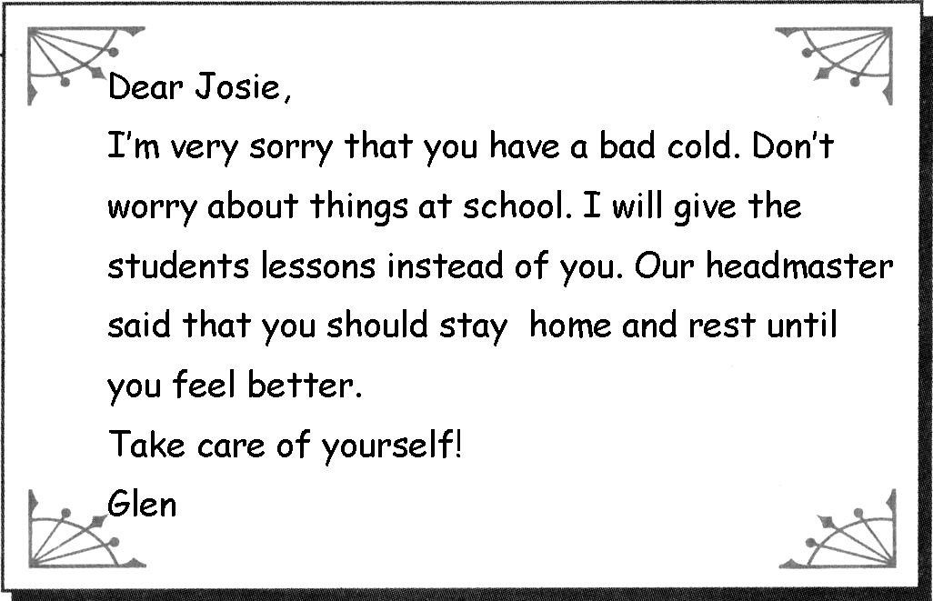
阅读右边的便条，完成54-55小题。
( )54. What do you know from the letter?
A. Glen worries about his lessons.
B. Josie is not feeling well today.
C. Josie is ill at hospital.
( )55. Which statement is true?
A. Josie and Glen are students.
B. Josie is a student and Glen is her teacher.
C. Josie and Glen are both teachers.

第二节 摘录要点( 5小题，计10分) 阅读短文，然后在下面的表格中完成内容摘要，每空不超过3个单词。
Teenagers and adults can learn a lot from volunteering. Here are some great places for them to volunteer.
Hospitals
Teens working in hospitals can get job experience in the medical field. They also have the chance to work with people and learn some social skills. Adults, especially retired adults, volunteering in hospitals can get the chance to stay healthy and spend their free time.
Nursing homes
For teens, volunteering in a nursing home can help them realize how they should respect the old. For working adults, it’s a chance to share work skills in a special way. There they can help teach computer classes, art or dance to keep the old happy and satisfied.
Museums
Museums are always looking for volunteers. They need office workers to serve the visitors or help clean the rooms. And they prefer museum docents (讲解员) who know a lot about how the museums work.
Remember wherever you volunteer, be willing to do anything without being asked. Then you can get the most out of volunteering.
Some great places to volunteer
Places | Chances
Hospitals | Teens: get job experience; work with people and learn some (56)  Retired adults: to (57) and spend their free time.
Nursing homes | Teens: learn how to (58) ________________ the old  Adults: share work skills and keep the old (59)
60. | Teens and adults: volunteer to be office workers and museum docents.
第三节 回答问题 ( 5小题, 计10分) 阅读下面的材料，然后根据材料内容回答问题。
Nowadays, computers and Internet are playing an important part in our life. We usually need to set passwords(密码) when we use computers and Internet. In order to keep our accounts (账户)and personal information safe, we must learn how to set safe passwords.
Experts have some useful advice for you. You’d better remember them. First, make your password out of capital(大写的)letters. It only takes a hacker(黑客)10 minutes to work out a 6-letter password made of small letters. But the same password in capital letters takes 10 hours to work out. Second, add numbers or symbols to your password. It may be much safer. Third, never use personal information for passwords and use different passwords for different accounts. At last, a user should change his or her passwords every 90 days. In this way, hackers won’t guess your passwords.
61. What do we usually need to do when we use computers and Internet?

62. Why must we learn how to set safe passwords?

63. How many pieces of advice are given to us by the experts?

64. Is it safe to use personal information for passwords?
65. How often should a user change his or her passwords?

第四部分 写作技能（共三节，计30分）
- 翻译语篇 （5小题，计10分）
阅读下面的材料，然后将划线部分的句子译成汉语或英语。
We live in a small town and almost everyone knows each other. (66)这里过去很安静。However, these days, (67)something unusual is happening in our town. Victor, a teacher at my school, is really nervous. (68)When he was interviewed by the town newspaper, he said, “Every night we hear strange noises outside our window. (69) My wife thinks that it could be an animal, but my friend and I think it must be teenagers having fun. (70)我的父母给警察打了电话，but they found nothing strange. They think it might be the wind. I don’t think so!”
66.
67.
68.
69.
70. 第二节 完成对话 （5小题，计10分）
根据上下文将下面的对话补充完整。
Lucy: Hello, Mary! You look so upset. (71) ?
Mary: I’m afraid of the coming English test.
Lucy: What is your difficulty?
Mary: I don’t know how to get the pronunciation right.
Lucy: Have you studied with a group?
Mary: (72) .But it is useless for me.
Lucy: What about listening to tapes? You’d better follow the tape and do lots of listening practice.
Mary: (73) . I’ll try that. But (74) ?
Lucy: You can improve your writing skills by keeping an English diary everyday.
Mary: I’ll do as you tell me. Thank you so much.
Lucy: (75) .

- 情景作文（10分）
根据表格内容，以“How I’ve changed”为题，谈谈你的成长变化。
My changes
 | In the past | Now
Appearances | short, heavy, long hair | tall, strong, short hair, wear glasses
Personality | shy and quiet | active and outgoing
Hobby | watch TV, surf the Internet | play sports, communicate with parents
要求：意思表达清楚、连贯。可适当发挥，字数60-80个词。
注意：文中不得出现真实的校名和人名。开头已给出不计入总字数。

How I’ve changed
Time goes by, I grow up every day. Of course I have changed a lot in the last few years. Now let me show you my changes.

湘潭市2015年下期初中九年级期末考试

英语参考答案

第一部分 听力技能 （共两节，计25分）
第一节 听力选择 (15小题，计15分)
1-5 CCCBA 6-10 CBCAC 11-15 ABBAC
第二节 笔录要点（5小题，计10分）
16. 1946 17. a big house 18. glass 19. study and work 20. helpful
第二部分 知识运用（共两节，计25分）
第一节 语法填空（15小题，计15分）
21-25 BCBBA 26-30 BACBC 31-35 CCABA
第二节 词语填空 ( 10小题，计10分)
36-40 ACCBA 41-45 BCABC
第三部分 阅读技能（共三节，计40分）
第一节 阅读选择 ( 10小题，计20分)
46-50 BCCAC 51-55 ACCBC
第二节 摘录要点( 5小题， 计10分)
56. social skills 57. stay healthy 58. respect 59. happy and satisfied
60. Museums
第三节 回答问题 ( 5小题, 计10分)
61. We need to set passwords.
62. To keep our accounts and personal information safe.
63. Four. 64. No, it isn’t. 65. Every 90 days.
第四部分 写作技能（共三节，计30分）
- 翻译语篇 （5小题，计10分）
66. It used to be very quiet
67. 不同寻常的事正发生在我们的小镇上
68. 当他被当地报纸采访的时候
69. 我妻子认为有可能是一只动物
70. My parents called the policemen
第二节 完成对话 （5小题，计10分）
71. What’s the matter? / What’s wrong?/ What happened? /What’s the trouble?
72. Yes, I have.
73. It’s a good idea.
74. how can I improve my writing skills?
75. You’re welcome. / Not at all. / My pleasure.
第三节 情景作文（10分）略

