Deep learning‑based effective fine‑grained weather forecasting model

In this paper author is using light weight temporal (time) features from weather data to forecast weather accurately as all existing forecast algorithms will not use any temporal features so its accurate forecast error rate will be high. This paper evaluate performance of propose LSTM (long short term memory) and TCN (Temporal convolution network) with various existing algorithms such as Support Vector Regression, Decision Tree regression, ARIMA and many more. All this existing algorithms will take only historical data as features to trained forecasting model and it has no support for time series historical data evaluation but propose LSTM and TCN can evaluate data by using time series so it can forecast weather accurately. In propose paper author evaluating each algorithm performance in terms of RMSE (root mean square error) which represents difference between actual and forecasted values. The lower the RMSE the better is the forecasting algorithm.

In all algorithm TCN is giving less RMSE and to train all algorithms author using WEATHER dataset and we are also using same dataset and this dataset you can find inside dataset folder. Below is th dataset screens

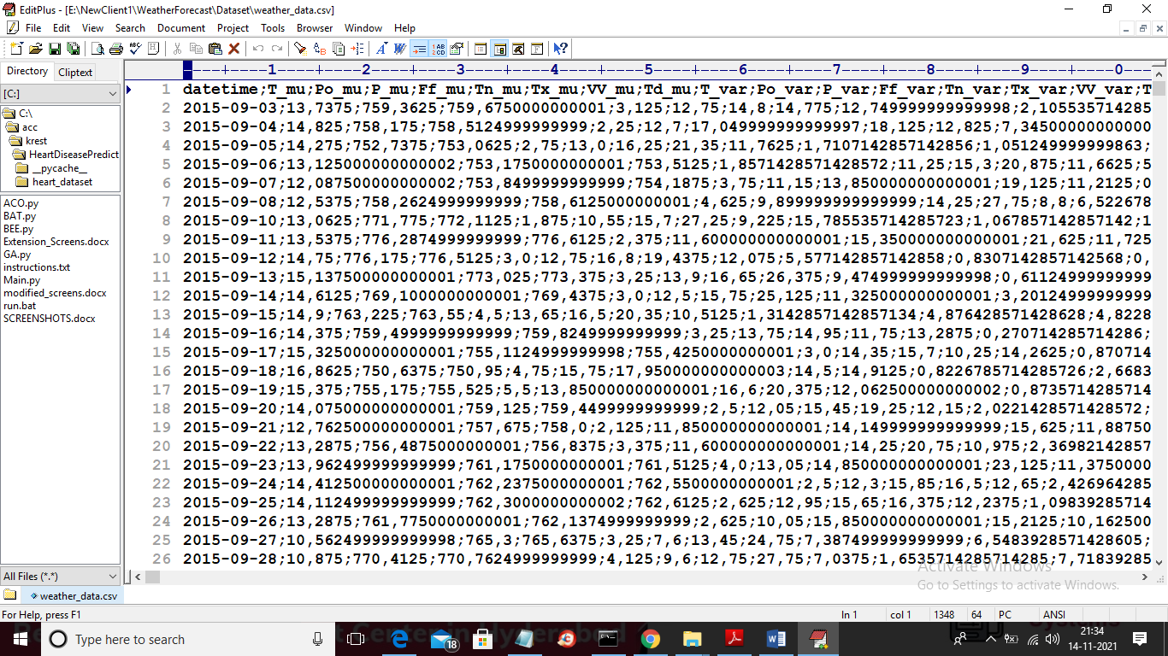

In above screen first row contains dataset column names and remaining rows contains dataset values and first column contains datetime as time series and T_mu represents weather temperature. We will take both feature to train all algorithms. We are dividing dataset into train and test and then we are building model on train data and then evaluating algorithm performance by predicting test data.

We have implemented this project using JUPYTER and below are the output screens

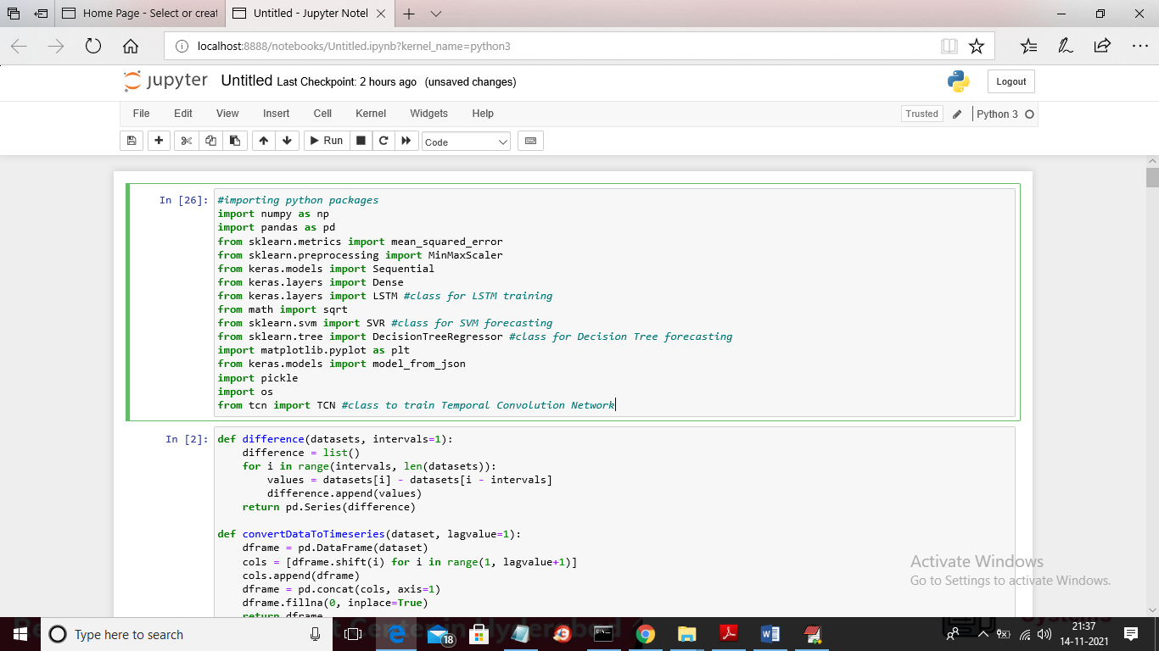

In above screen you can read light blue colour comments starting with hash symbol to know about SVR, Decision Tree, TCN and LSTM implementation

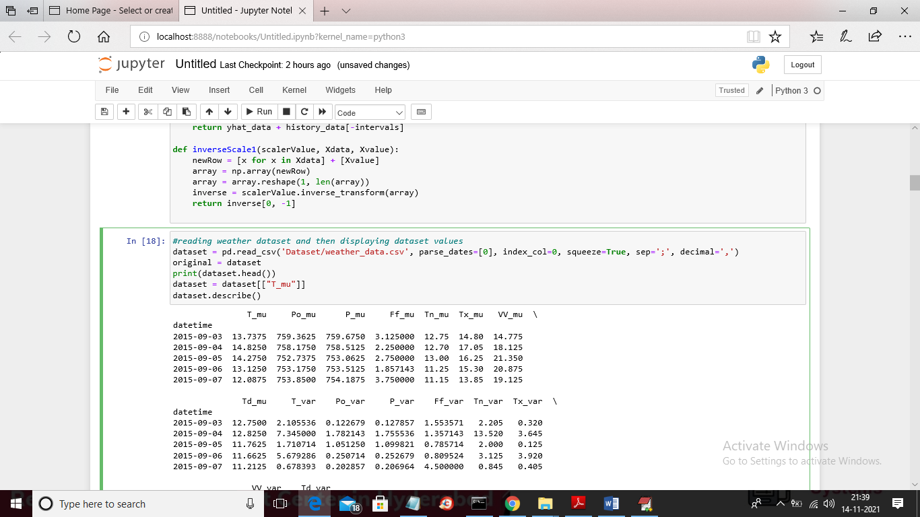

In above screen we are reading dataset and then displaying records from that dataset

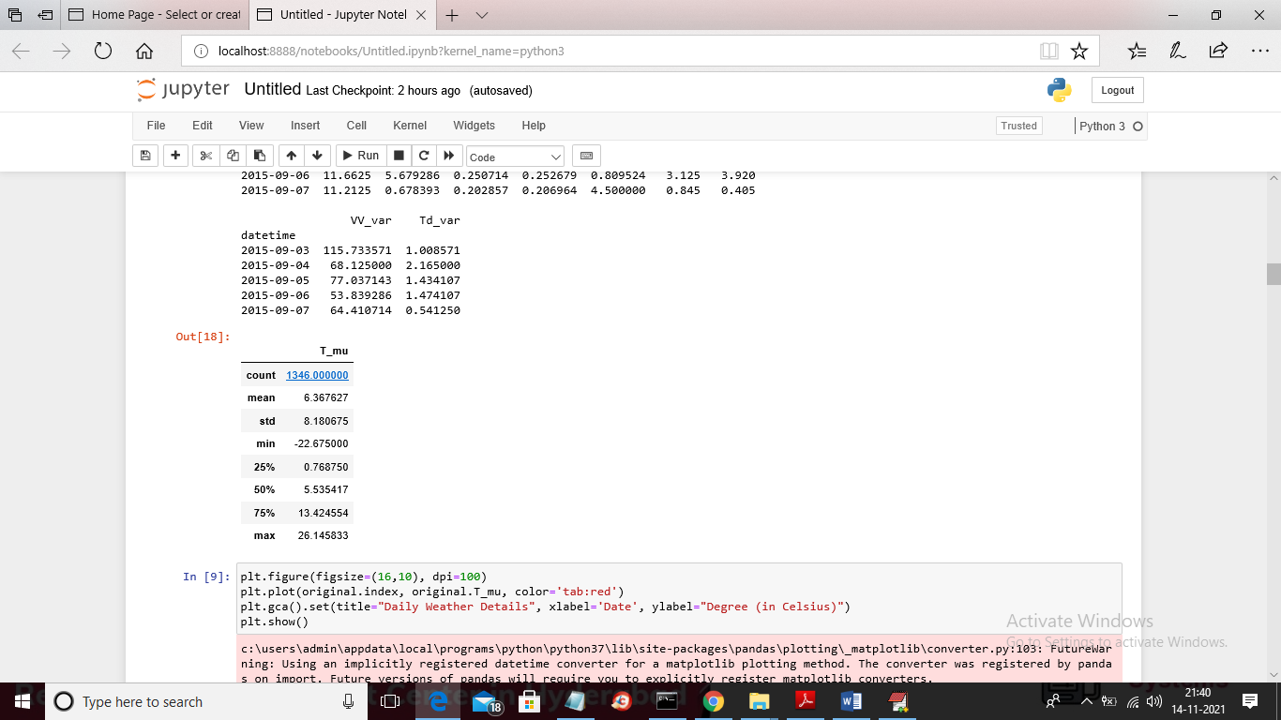

In above screen displaying MEANS and count of weather dataset and in below screen we are plotting weather/temperature values in each date

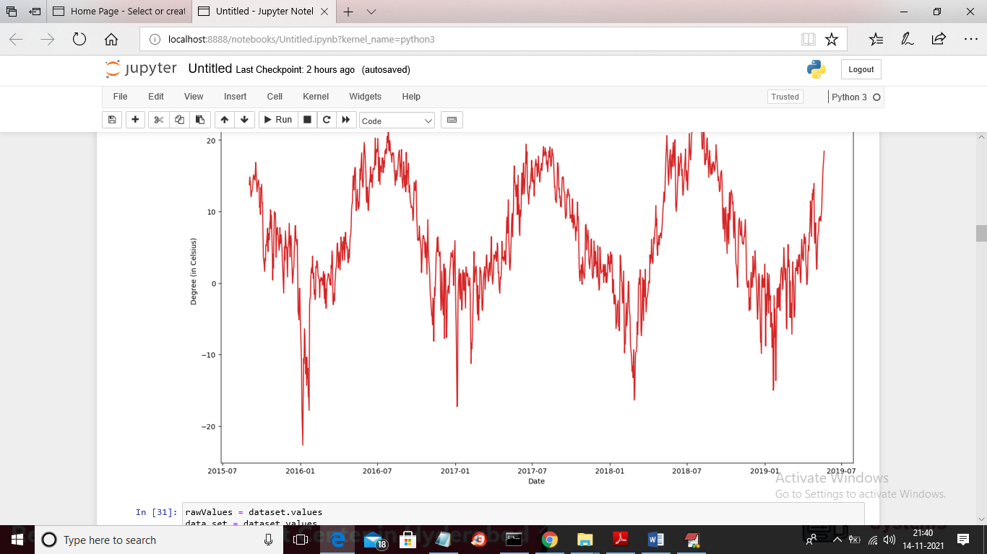

In above graph x-axis represents DATE and y-axis represents weather/temperature values and in below screen you can see we are training dataset with SVR

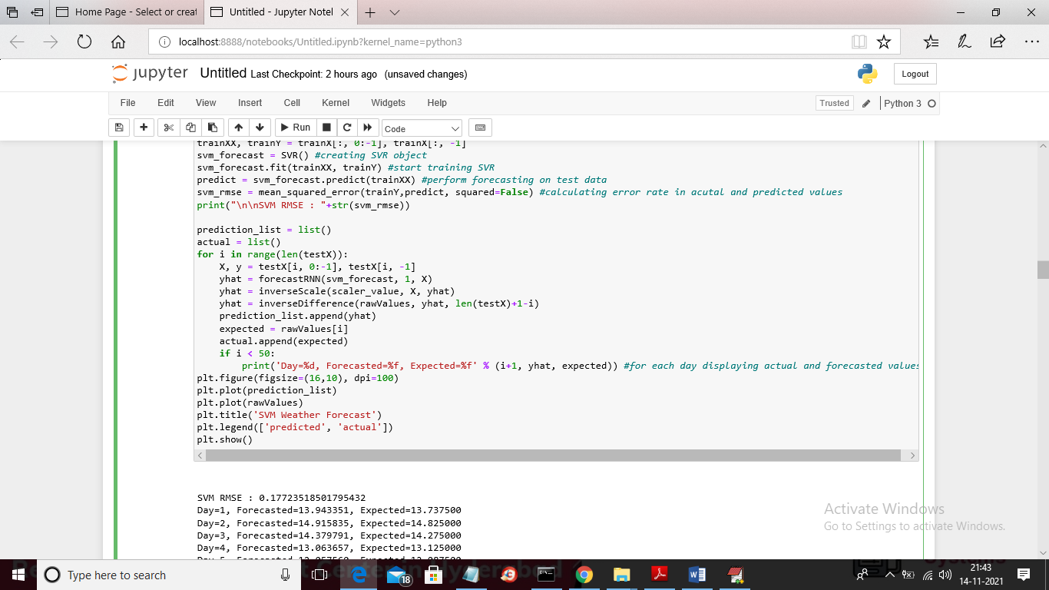

Below is the output of SVR forecasting

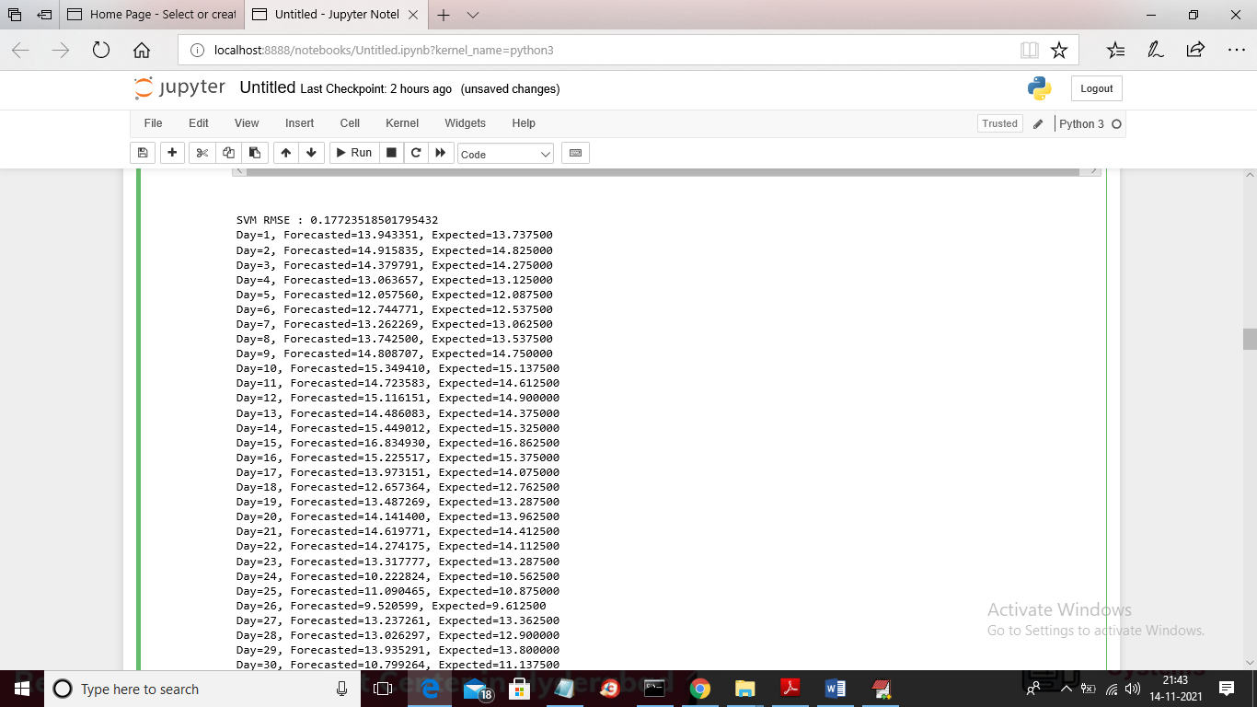

In above screen we can see SVR RMSE is 0.177 and then for each day we can see forecasted and actual test data values and in below screen we can see comparison graph between actual and forecast values

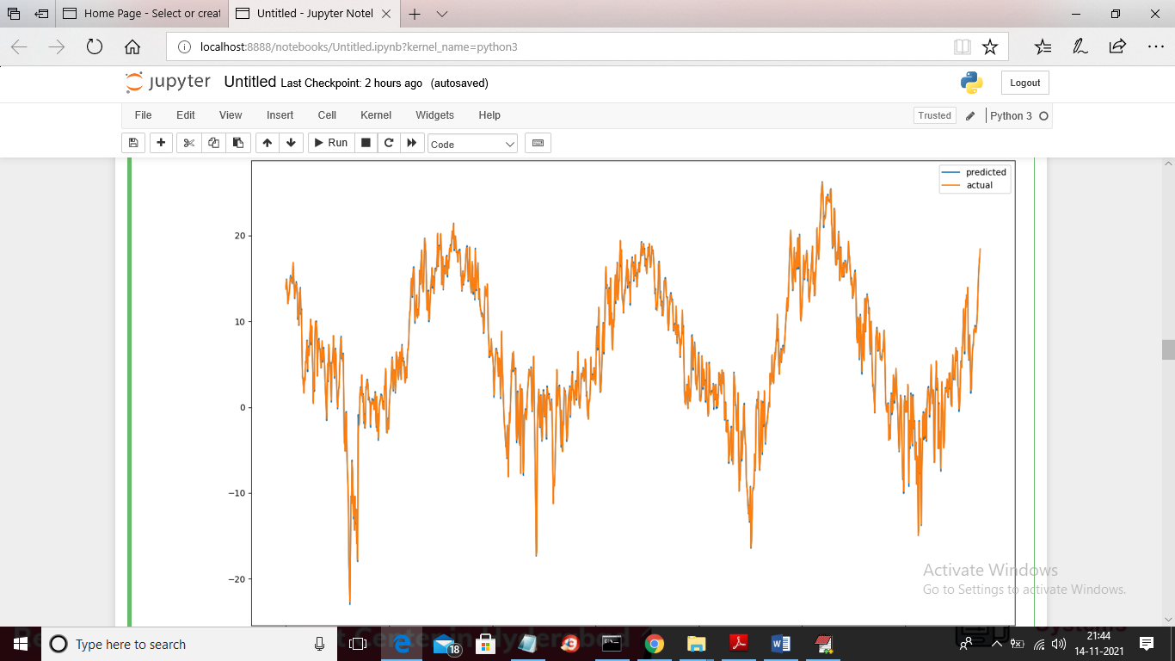

In above graph blue line is for ‘Forecasted values’ and orange is for actual values and we can see there is close difference between blue and orange line as both has closed values so lines are overlap but still we can see orange (original test values) and blue line (forecasted values). Now below is the decision tree implementation

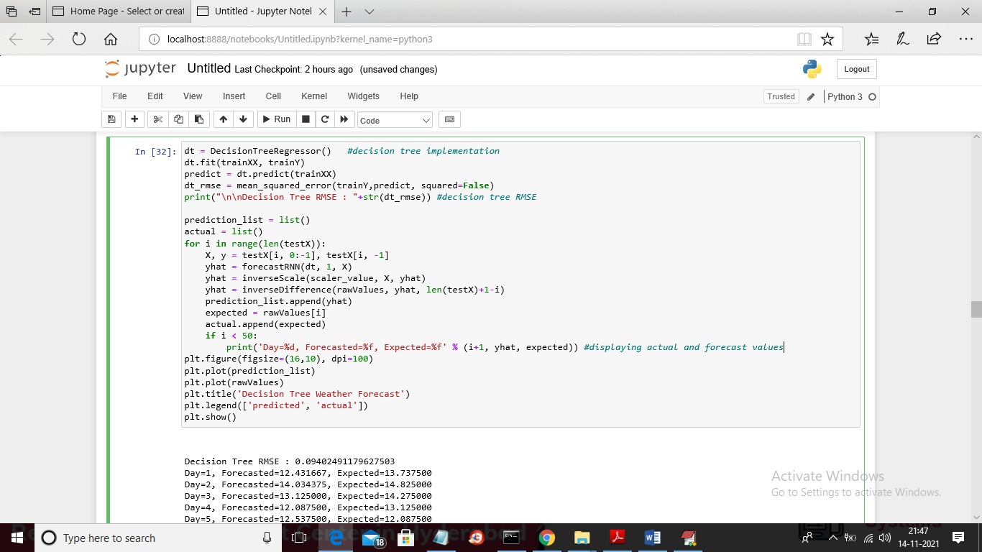

In above screen you can see result for Decision Tree RMSE as 0.094 and we can see actual and forecast values and below is the decision tree forecast comparison graph

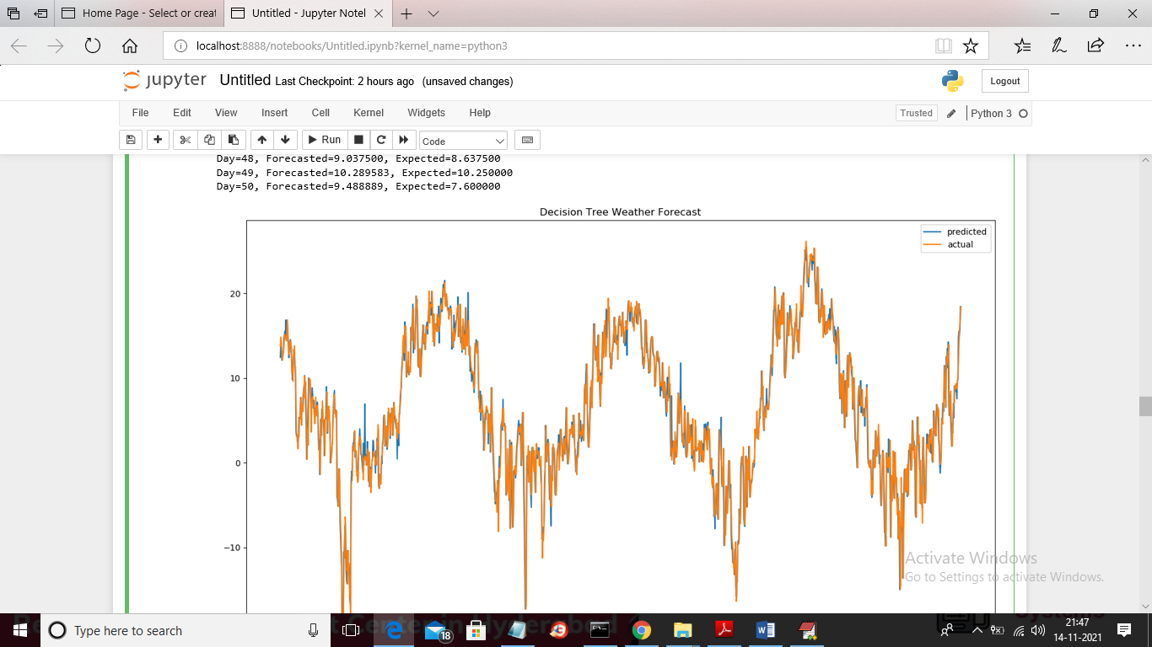

Below is the LSTM code

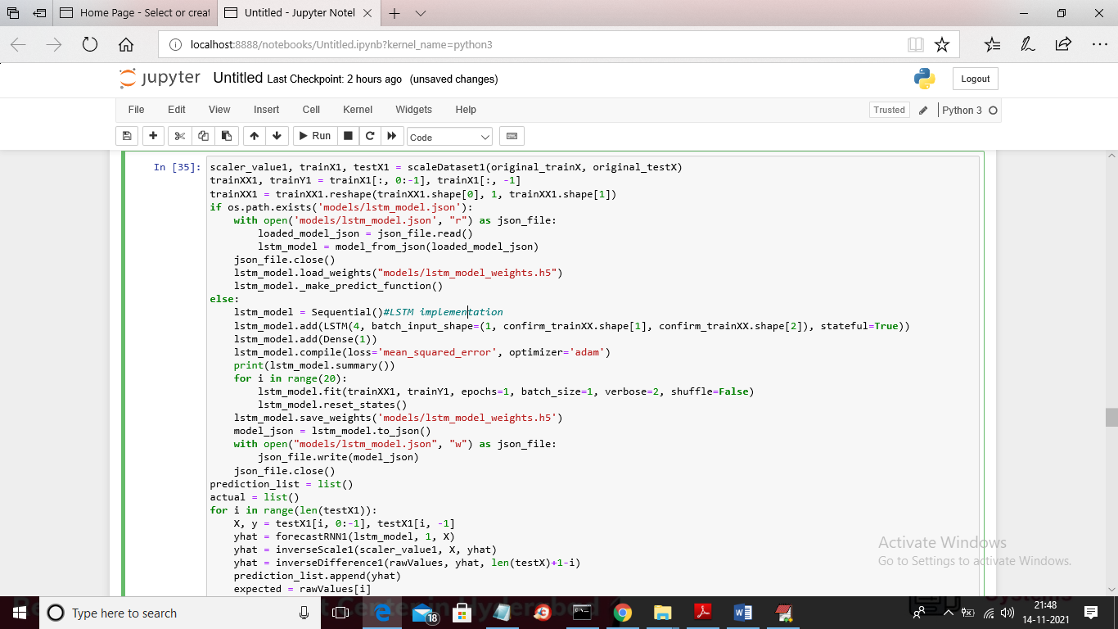

Below is the LSTM RMSE

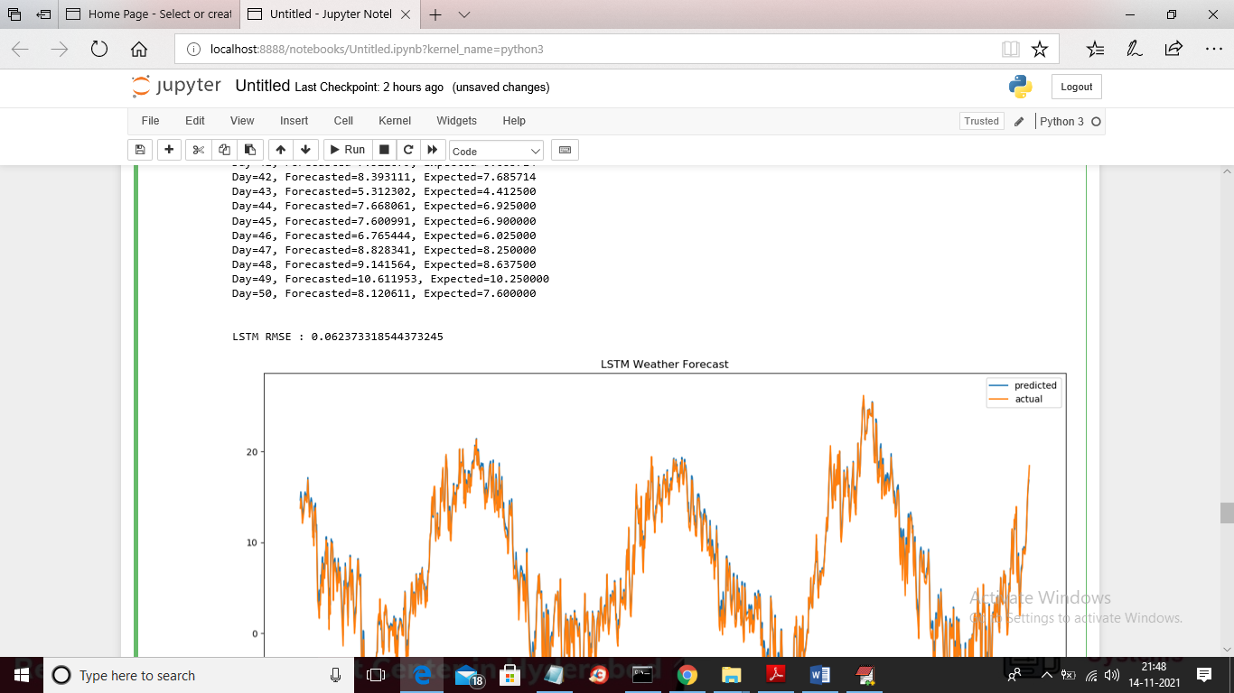

In above screen LSTM RMSE is 0.06237 and below is the LSTM forecast graph

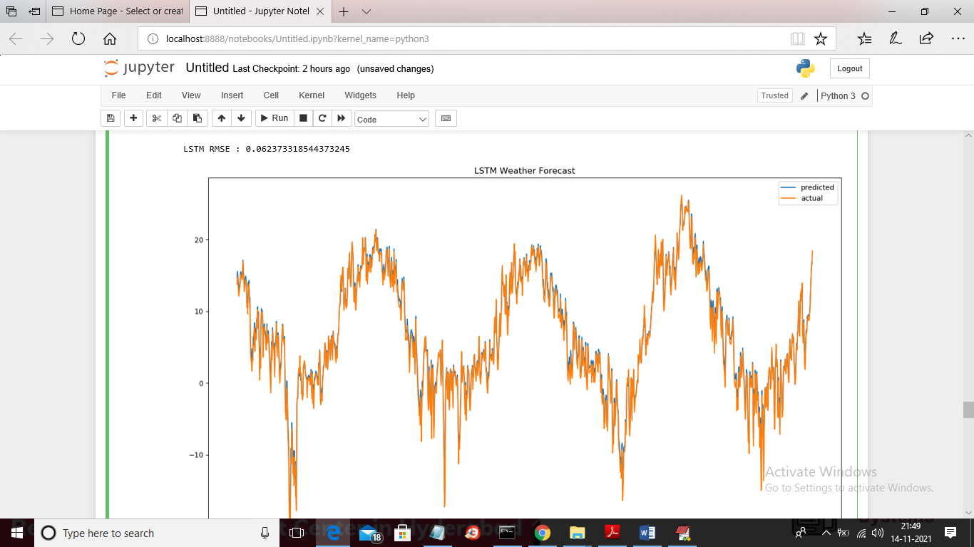

Below is the TCN implementation

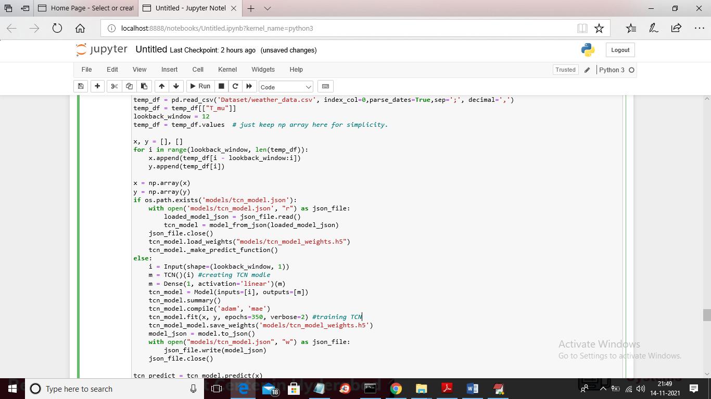

Below is the TCN RMSE output

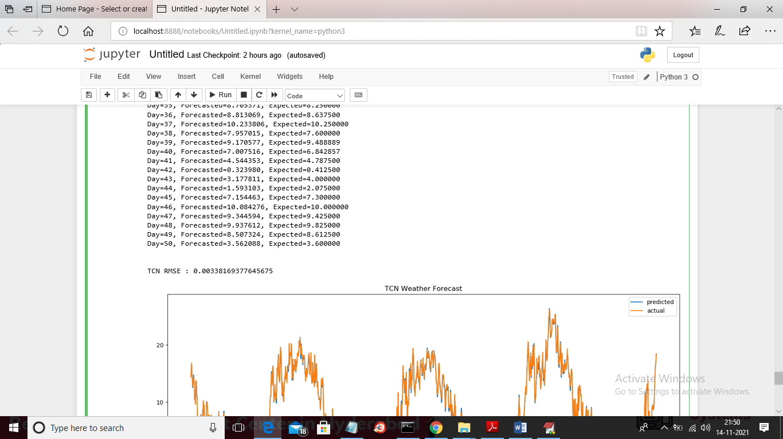

In above screen TCN RMSE is 0.0033 and below is the TCN forecast graph

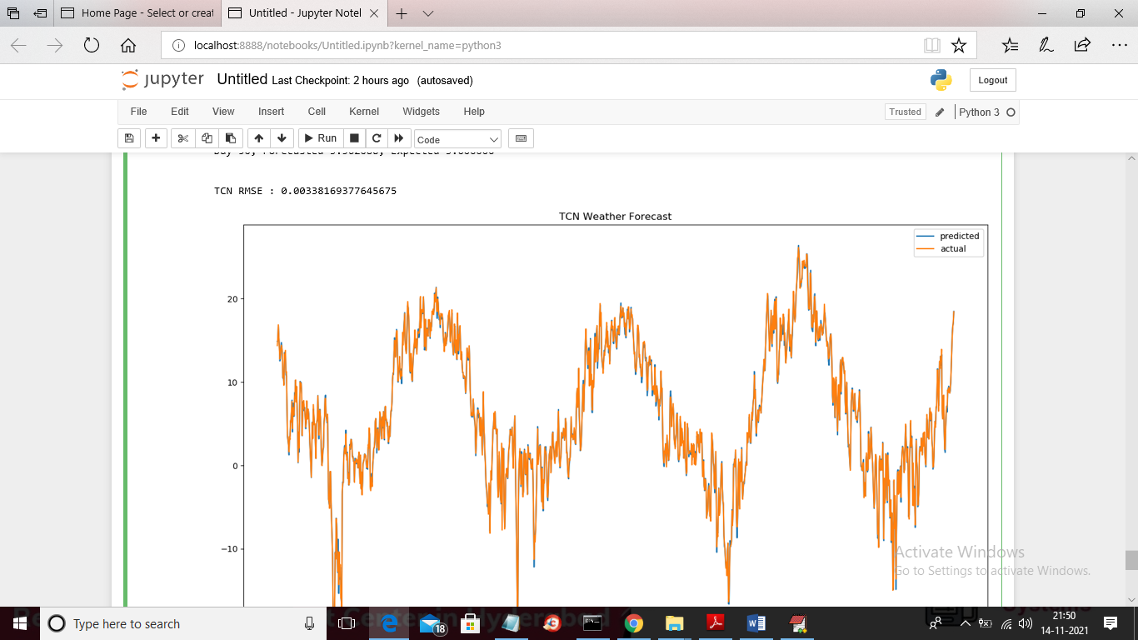

Below is the RMSE comparison graph between all four algorithms

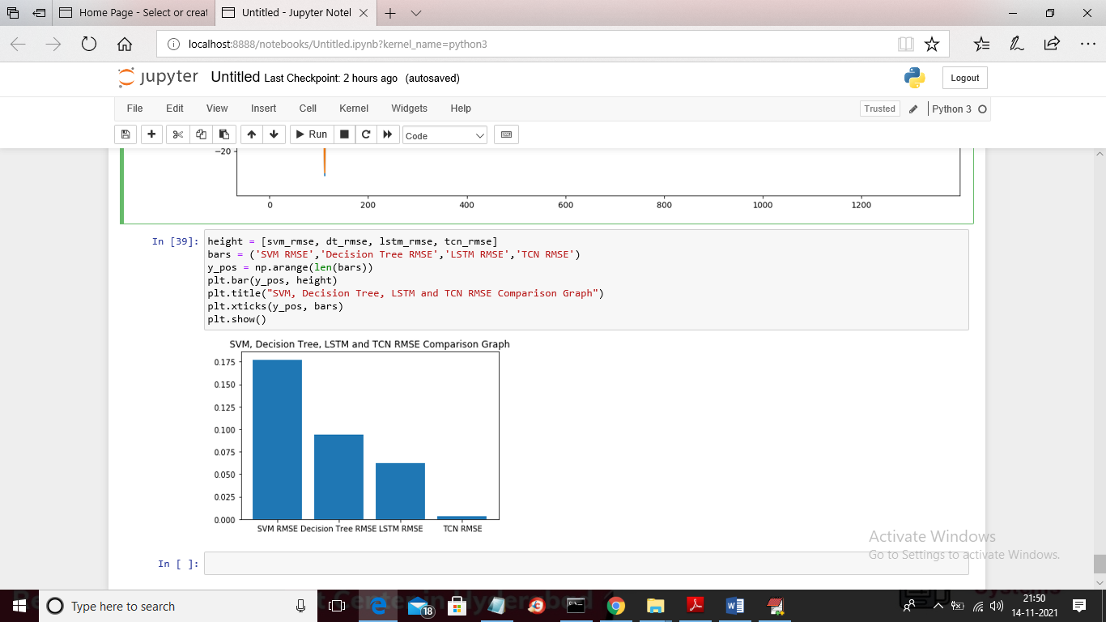

In above graph x-axis represents algorithm names and y-axis represents RMSE values and we can see in all algorithms LSTM and TCN has got less error rate