**FRONTEND ASSIGNMENT**

**WEB DESIGNING**

**MODULE:1(HTML)**

**1.Are the HTML tags and elements the same thing?**

**Ans.** Tags and Elements are not the same. They are the pieces themselves, example. or a header is an element, a paragraph is an element.

**2. What are tags and attributes in HTML?**

**Ans.** HTML tags are used to hold the HTML element. HTML element holds the content. HTML attributes are used to describe the characteristic of an HTML element in detail. Whatever written within a HTML tag are HTML elements. HTML tag starts with < and ends with >.

**3. What are void elements in HTML?**

**Ans.** A void element is **an element whose content model never allows it to have contents under any circumstances**. Void elements can have attributes. The following is a complete list of the void elements in HTML : area, base, br, col, command, embed, hr, img, input, keygen, link, meta, param, source , track, wbr.

**4. What are HTML Entities?**

**Ans**. An HTML entity is a piece of text ("string") that begins with an ampersand ( & ) and ends with a semicolon ( ; ). Entities are frequently used to display reserved characters (which would be interpreted as HTML code), and invisible characters (like non-breaking spaces).

**5. What are different types of lists in HTML? • What is the ‘class’ attribute in HTML?**

**Ans**. There are three list types in HTML: ordered list — used to group a set of related items in a specific order. unordered list — used to group a set of related items in no particular order. description list — used to display name/value pairs such as terms and definitions

**6. What is the difference between the ‘id’ attribute and the ‘class’ attribute of HTML elements?**

**Ans.** Difference between id and class attribute. The difference between them is that “id” is unique in a page & can only apply to at most one element, while “class” selector can apply to multiple elements.

**7. What are the various formatting tags in HTML?**

**Ans.**

* <strong> - Important text
* <em> - Emphasized text
* <b> - Bold text
* <sup> - Superscript text
* <mark> - Marked text
* <i> - Italic text
* <del> - Deleted text
* <sub> - Subscript text
* <small> - Smaller text
* <ins> - Inserted text

**8. How is Cell Padding different from Cell Spacing?**

**Ans.** Cellpadding basically defines the space present between a table cell's border and the content present in it. Cellspacing basically defines the space present between individual adjacent cells.

**9. How can we club two or more rows or columns into a single row or column in an HTML table?**

**Ans.** You can merge two or more table cells into a column by using the colspan attribute in the <td> HTML tag (table data). To merge two or more rows of cells, the rowspan attribute is used.

**10.** **What is the difference between a block-level element and an inline element?**

**Ans.** inline elements do not force a new line to begin in the document flow. Block elements, on the other hand, typically cause a line break to occur although, as usual, this can be changed using CSS.

11. **How to create a Hyperlink in HTML?**

**Ans.** To create a hyperlink in an HTML page, the <a> and </a> tags are used, which are the tags used to define links. The <a> tag indicates where the hyperlink starts and the </a> tag indicates where it ends. Any text added inside these tags will act as a hyperlink. The URL for the link is added in <a href=” EX.URL LINK ”>.

12. **What is the use of an iframe tag?**

**Ans.** The <iframe> tag specifies an inline frame. An inline frame is used to embed another document within the current HTML document.

**13. What is the use of a span tag? Explain with example?**

**Ans.** The <span> tag is an inline container used to mark up a part of a text, or a part of a document. The <span> tag is easily styled by CSS.(Example. <p>My brother has <span style="color:blue">blue</span> eyes.</p>)

14**. How to insert a picture into a background image of a web page?**

**Ans.** The easiest way to add a background image is to use the background image attribute inside the <body> tag. The background attribute we specify in the <body> tag is not supported in HTML5. Using CSS properties, we can also add a background image to a webpage.

15. **How are active links different from normal links?**

**Ans**. Some browsers recognize an active link when the mouse cursor is placed over that link; others recognize active links when the link has the focus. Those that don't have a mouse cursor over that link is considered a normal link. Some browser recognize active links when the mouse cursor is placed over that link.

**Example.**

<!DOCTYPE html>

<html lang="en">

<head>

    <meta charset="UTF-8">

    <meta http-equiv="X-UA-Compatible" content="IE=edge">

    <meta name="viewport" content="width=device-width, initial-scale=1.0">

    <title>Document</title>

</head>

<body>

    <h2>This is a Link</h2>

    <h1>

        Welcome to

<!-- Mercedes link add -->

        <a href="https://www.mercedes-benz.com/en/">

            Mercedes-benz

        </a>

    </h1>

</body>

</html>

**Output:**

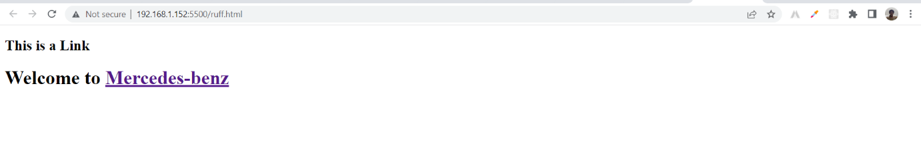

16.  **What are the different tags to separate sections of text?**

**Ans**. There are three tags that are used to separate text:

* <p> tag – This contains text in the form of a new paragraph.
* <br> Tag – Generally the <br> tag is used to separate lines of text. It breaks the current line and conveys the current to the forward line.
* The <blockquote> tag is used to define a large quoted section.

17**. What is SVG?**

**Ans.**

* SVG stands for Scalable Vector Graphics
* SVG defines graphics in XML format
* SVG is used to define vector-based graphics for the web
* SVG integrates with other W3C standards such as DOM and XSL
* Every element and every feature in SVG files can be animated
* SVG is a W3C recommendation

Example.

<!DOCTYPE html>

<html lang="en">

<head>

    <meta charset="UTF-8">

    <meta http-equiv="X-UA-Compatible" content="IE=edge">

    <meta name="viewport" content="width=device-width, initial-scale=1.0">

    <title>Document</title>

    <style>

        /* svg squre css start */

    svg

    {

        height: 800px;

        width: 800px;

        background-color: greenyellow;

    }

    /* svg squre css end */

</style>

</head>

<body>

<h1>My first SVG</h1>

<!-- svg circle start -->

<svg width="100" height="100">

  <circle cx="400" cy="400" r="200" stroke="red" stroke-width="4" fill="green" />

</svg>

<!-- svg cicle end -->

</body>

</html>

**Output:**

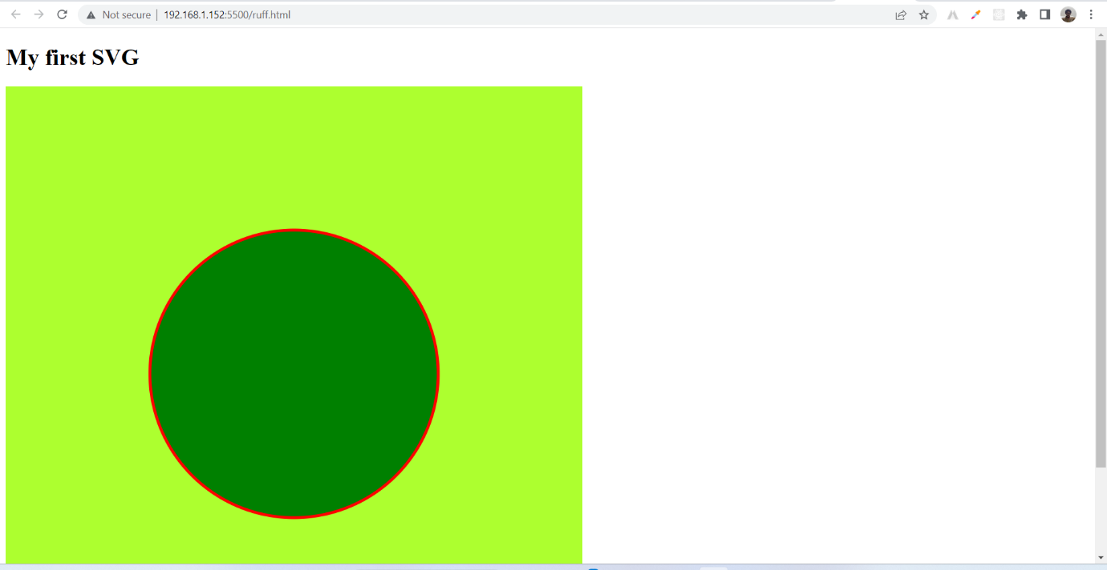

**18.** **What is difference between HTML and XHTML?**

**Ans.**

|  |  |  |
| --- | --- | --- |
| SR.No. | HTML | XHTML |
| 1. | HTML stands for Hypertext Markup Language. | XHTML stands for Extensible Hypertext Markup Language. |
| 2. | It was developed by Tim Berners-Lee. | It was developed by W3C i.e World Wide Web Consortium. |
| 3. | It was developed in 1991. | It was released in 2000. |
| 4. | It is extended from SGML. | It is extended from XML and HTML. |
| 5. | The format is a document file format. | The format is a markup language. |
| 6. | All tags and attributes are not necessarily to be in lower or upper case. | every In this, tag and attribute should be in lower case. |
| 7. | Doctype is not necessary to write at the top. | Doctype is very necessary to write at the top of the file. |
| 8. | It is not necessary to close the tags in the order they are opened. | It is necessary to close the tags in the order they are opened. |
| 9. | While using the attributes it is not necessary to mention quotes. | While using the attributes it is mandatory to mention quotes. |
| 10. | Filename extension used are .html, .htm. | Filename extension are .xhtml, .xht, .xml. |

**19. What are logical and physical tags in HTML?**

**Ans.**

|  |  |
| --- | --- |
| Logical tag | Physical tag |
| They are designed to mention the meaning of the enclosed text | they are designed to provide certain instructions regarding the display of enclosed text |
| Its syntax or format is- <Tag Name> character/s to be formatted. <Tag Name> | The format used here is- <Tag Name> characters to be formatted. </Tag Name> |
| They are used to mention visually impaired texts | They are used to indicate the specific characters which need formation |
| They carry certain obligations | They are extremely straightforward |
| Here the pages are more accessible | Page accessibility is comparatively low |
| Example of Logical Tags: <strong></strong> tag. This “strong” tag implies that the text is of great importance. Such tags are used by search engines to understand the page for better search results. | Example of Physical Tags: <b>, this tag will make the text bold.<i>, this will make the font style of the text italic. So physical tags are simple and straightforward tags that decide the appearance of the text. |
| It supports the latest technology | This concept is dependent upon the weak tools |
| Logical tags are used only to give information about the text, written in the HTML pages. | These were invented to provide style to the HTML pages. |