**Predicting IMDb scores**

Phase 3 :

IMDB dataset from various sources, like the official IMDB website or data repositories and kaagle. We might also use libraries like pandas or numpy to load the data from a CSV or other structured file.

**Data import :**

**Data = pd.read_csv(“/kaggle/input/netflix-original-films-imdb-scores/NetflixOriginals.csv”,encoding = “ISO-8859-1”)**

**dataDate = data.copy()**

**data.head()**

|  |  |  |  |  |  |  |
| --- | --- | --- | --- | --- | --- | --- |
| **S.No** | **Title** | **Genre** | **Premire** | **Runtime** | **IMDb score** | **Language** |
| **1** | Enter the anime | Documentry | August 5, 2019 | 58 | **2.5** | English/japanese |
| **2** | Dark forces | Thriller | August 21,2020 | 81 | **2.6** | Spanish |
| **3** | The app | Science/drama | December 26/2019 | 79 | **2.6** | Italian |
| **4** | The open house | Horror Thriller | January19 ,2018 | 94 | **3.8** | English |
| **5** | Kaali khuuhi | Mystery | October 30,2020 | 90 | **3.4** | Hindi |

**Data Preprocessing:**

**Data Cleaning**:

Remove any duplicate entries or irrelevant columns.

**Handle Missing Data:**

Check for and handle any missing values in the dataset.

**Text Processing:**

If our dataset contains textual data like reviews, you may need to preprocess and tokenize the text.

**Label Encoding**:

categorical labels (if any) into numerical format.

**Train-Test Split:**

Split the dataset into training and testing subsets. This helps assess the model's performance.

**Normalization/Scaling:**

If the datas are numerical data, it's often a good idea to normalize or scale the features for better model performance.

**Model-Specific Preprocessing:**

Some machine learning models require specific preprocessing steps. For example, recurrent neural networks (RNNs) for text data might require padding or truncating sequences

**Program :**

import pandas as pd

from sklearn.model_selection import train_test_split

from sklearn.preprocessing import LabelEncoder

from sklearn.feature_extraction.text import CountVectorizer

# Load the dataset

data = pd.read_csv("imdb_dataset.csv")

# Data preprocessing

# - Drop duplicates and handle missing values

data.drop_duplicates(inplace=True)

data.dropna(inplace=True)

# For text data (e.g., movie reviews), you can use CountVectorizer or other text preprocessing techniques.

# Encode labels to numerical values

label_encoder = LabelEncoder()

data['sentiment'] = label_encoder.fit_transform(data['sentiment'])

# Train-test split

X = data['review']

y = data['sentiment']

X_train, X_test, y_train, y_test = train_test_split(X, y, test_size=0.2, random_state=42)

**Different analysis:**

**Regression Analysis:**

Datas can treat the IMDB scores as continuous values and perform regression analysis to predict scores. Linear regression, decision trees, random forests, or gradient boosting algorithms are commonly used.

**Classification Analysis:**

Convert IMDB scores into categories (e.g., low, medium, high) and use classification algorithms like logistic regression, SVM, or deep learning models to predict the class.

**Deep Learning Models:**

Utilize deep neural networks, such as recurrent neural networks (RNNs) for text data or convolutional neural networks (CNNs) for image data, to predict IMDB scores.

**DAC**:

In this step we can perform the different analysis and Visualisation the datas using IMB cagnos.

**Data Preparation:**

Make sure the dataset with IMDb scores and other relevant data. This can be a CSV, Excel, or database file.

**IBM Cognos Installation:**

We have ensure that IBM Cognos installed and set up on our system.

**Create a New Report:**

Open IBM Cognos and create a new report or dashboard.

**Data Connection:**

Connect to the dataset within IBM Cognos. Import the data want to use for IMDb score predictions.

**Data Modeling:**

Create a data model if necessary, which may involve defining relationships between different data tables.

**Visualization Creation:**

In Cognas we can create various types of visualizations, like bar charts, line charts, or scatter plots. Choose the type of visualization that best represents IMDb score prediction.

Find the 3 most used languages in the movies in the data set.

**Bar graph**

df_lang = df['language'].value_counts()

df_lang.head(3).plot(kind='bar')

plt.show(block=True)

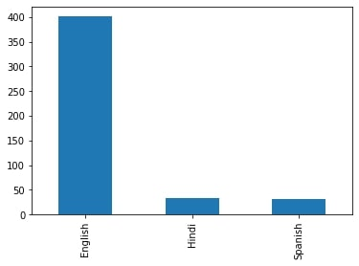

What is the correlation between IMDB score and ‘Runtime’? Examine and visualize.

sns.regplot(x=’imdb score’, y=’runtime’, data=df)

pot-shot(block=True)

x = round(df[‘imdb score’].corr(df[‘runtime’]), 3)

print(f’The correlation between runtime and imdb score is {x}.’)

**Scattered plot**

df[['title', 'runtime']].sort_values('runtime', ascending=False).head(10).plot(x='title', y='runtime', kind='bar')

plt.xlabel('Movie Title')

plt.ylabel('Runtime')

plt.show(block=True) df[['title', 'runtime']].sort_values('runtime', ascending=False).head(10).plot(x='title', y='runtime', kind='bar')

plt.xlabel('Movie Title')

plt.ylabel('Runtime')

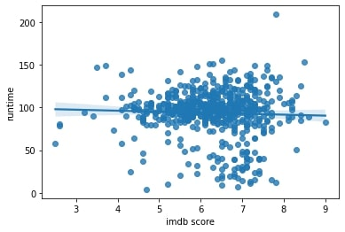plt.show(block=True)



What are the top 10 movies with the highest ‘runtime’? Visualize it.

Df[[‘title’, ‘runtime’]].sort_values(‘runtime’, ascending=False).head(10).plot(x=’title’, y=’runtime’, kind=’bar’)

Plt.xlabel(‘Movie Title’)

Plt.ylabel(‘Runtime’)

Plt.show(block=True)

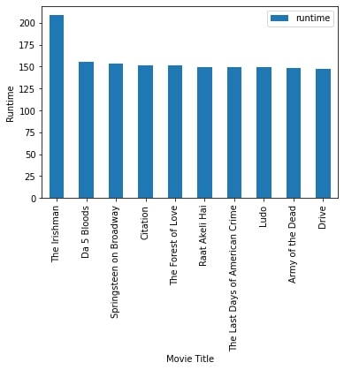

Above are the genres with languages and IMDB Score with rating higher than 7

Plt.figure(figsize = (12,12))

Sns.barplot(x = ‘IMDB Score’, y = ‘Title’,hue =’Language’, data = score_8)

**Data Analysis:**

Add your IMDb score prediction data to the visualization, along with any other relevant data we want to display.

**Customization & Interactivity :**

Customize the visualization by adding labels , titles, and adjusting the colors to make it interactive.

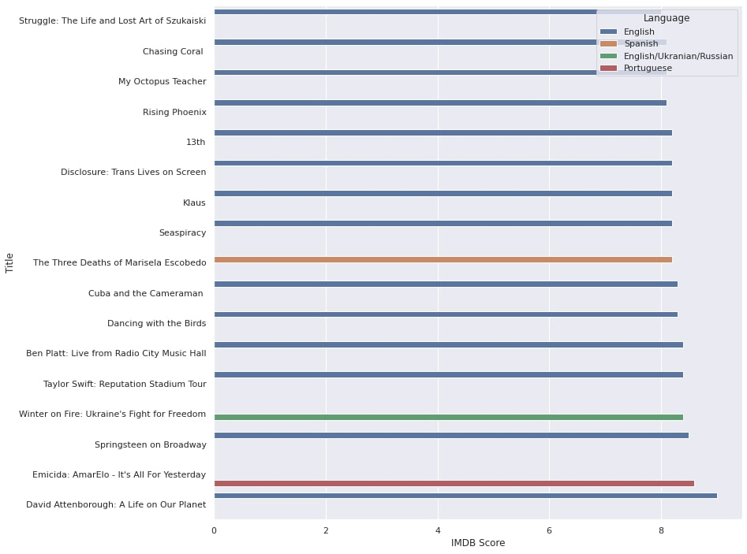Add interactive features like filters and drill through analysis for deeper analysis .

**Preview and Publish:**

Peview the visualization within IBM Cognos to ensure it looks as expected. Then, we can publish it for others to access.

**IOT :**

In this step we will use the IOT devices and deploying python script for IOT devices

Prepare the Python Script:

* Make sure the python script is optimized for performance, as IoT devices typically have limited resources.
* Use libraries and frameworks that are lightweight and compatible with IoT platforms.
* Test the IMDb score prediction model on the development machine before deployment.

**Install Python on IoT Device:**

* Some IoT devices come with Python pre-installed, while others may require manual installation.We have to Ensure that the Python version is compatible with the script.

**Transfer The Script:**

* Transfer the Python script to the IoT device using methods like SSH, FTP, or through a development environment provided by the IoT platform.

**Manage Dependencies:**

* Ensure that any required libraries and dependencies are installed on the IoT device. Use lightweight libraries when possible.

**Run the Script:**

* Execute the Python script on the IoT device. May use terminal commands or scripts for this purpose.

**Data Input and Output:**

* Define how data will be input to the script and how the predictions will be output. IoT devices might use sensors, external data sources, or APIs to gather data.

**Real-time Predictions:**

* Consider how often the IMDb score prediction script should run. Set up a schedule or event-triggering mechanism as per your application’s requirements.

**Monitoring and Maintenance:**

* Implement monitoring and error-handling mechanisms to ensure the script runs smoothly on the IoT device.
* Regularly update and maintain the script to accommodate changes or improvements.

**Testing and Validation:**

* Test the IMDb score prediction on the IoT device thoroughly to ensure accuracy and reliability.

**Security :**

* Finally we also ensure that the security of IOT devices which we are used for this process to ensure the safety of the process and python script.

**CAD:**

**Data Collection**:

Gather IMDb movie data, including movie details and historical IMDb scores. We can use web scraping tools, public datasets, or APIs to obtain this data.

**Data Storage:**

Store the collected data in a database. IBM Cloud offers various database services, such as IBM Db2, PostgreSQL, or cloud-native databases like IBM Cloudant.

**IBM Cloud Foundry**:

Create an application on IBM cloud foundry to use popular framework like flask django to developing application in python

**Data Ingestion**:

Build data ingestion mechanisms to import the movie data into the application's database.

**Machine Learning Model:**

Develop a machine learning model in Python to predict IMDb scores. Use libraries like scikit-learn or TensorFlow for this. Train the model using historical IMDb scores as your target variable.

**API Endpoint:**

Endpoin our machine learning model as an API endpoint using your IBM Cloud Foundry application. Then we can use web frameworks to create a REST API.

**Different type of Functions:**

**Prediction Function:**

Implement an API route that accepts movie information as input and returns a predicted IMDb score.

**Data Update Function:**

Create a function to update the model with new data periodically to improve prediction accuracy.

Authentication and Authorization: Implement security mechanisms to the API Functions or API endpoints.

**User Interface**:

Develop a user interface where users can input movie details and get IMDb score predictions. This interface can be a web application or a mobile app.

**Integration with Cloud Services:**

Utilise other IBM Cloud services like IBM Watson for natural language processing (NLP) to analyze user reviews, which can be used as additional features for prediction.

**Monitoring and Logging**:

**I**mplement monitoring tools and logging to track the performance and usage of the application.

**Testing and Validation**:

Thoroughly test the application and model to ensure accurate predictions. Use techniques like cross-validation and A/B testing to evaluate your model's performance.

**Deployment**: Deploy the application to IBM Cloud Foundry and make it accessible to users.