*Distributed* Coordination

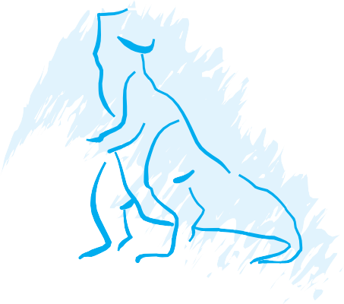

C*1*H A*8*PTER

No Exercises

**65**