*Multimedia* Systems

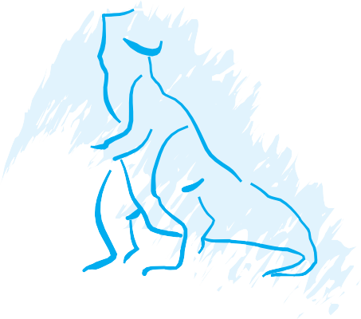

*2*CHA P*0*TER

No Exercises

**69**