*Influential* Operating Systems

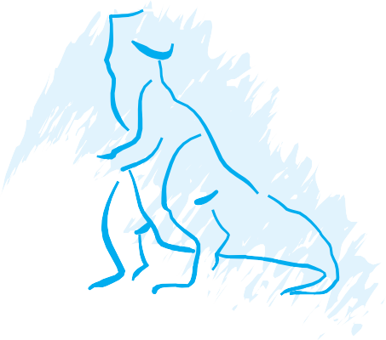

*2*CH A*3*PTER

No Exercises

**83**