AI Utilization Case Report
BMAD Method (Breakthrough Method for Agile AI-Driven Development)
Applied to: MyMusic Android App

Submitted: 2026-04-15 | Multimedia 1P | Duy LQ

Date of Submission | 2026.04.15
Name (Department) | Duy LQ (Multimedia 1P)
Case Title | Building MyMusic Android App Using BMAD Method
Utilization Scale | Full transformation of development workflow  From manual planning + ad-hoc AI prompting to structured, agent-orchestrated, documentation-first AI development lifecycle
Case Category | Productivity tool development (Agent-based workflow)  Design & Documentation: architecture, data model, API, doc generation  Coding: code generation, Clean Architecture implementation  Review: static analysis, code change summary  Testing: unit test generation (planned)
Tools Used | Cursor IDE, Cline (VS Code), Antigravity (Google DeepMind)
Models Used | Claude 4.5-Sonnet, Claude Opus 4.6, GPT-5

Case Details
1. What is BMAD Method?
BMAD (Breakthrough Method for Agile AI-Driven Development) is an open-source framework that brings structure, governance, and repeatability to AI-assisted software development. Instead of "vibe coding" (ad-hoc prompting), it treats AI as a disciplined team member following an agile process with clear roles, producing version-controlled artifacts at every phase.
1.1 Why BMAD? — Vibe Coding vs. BMAD Comparison
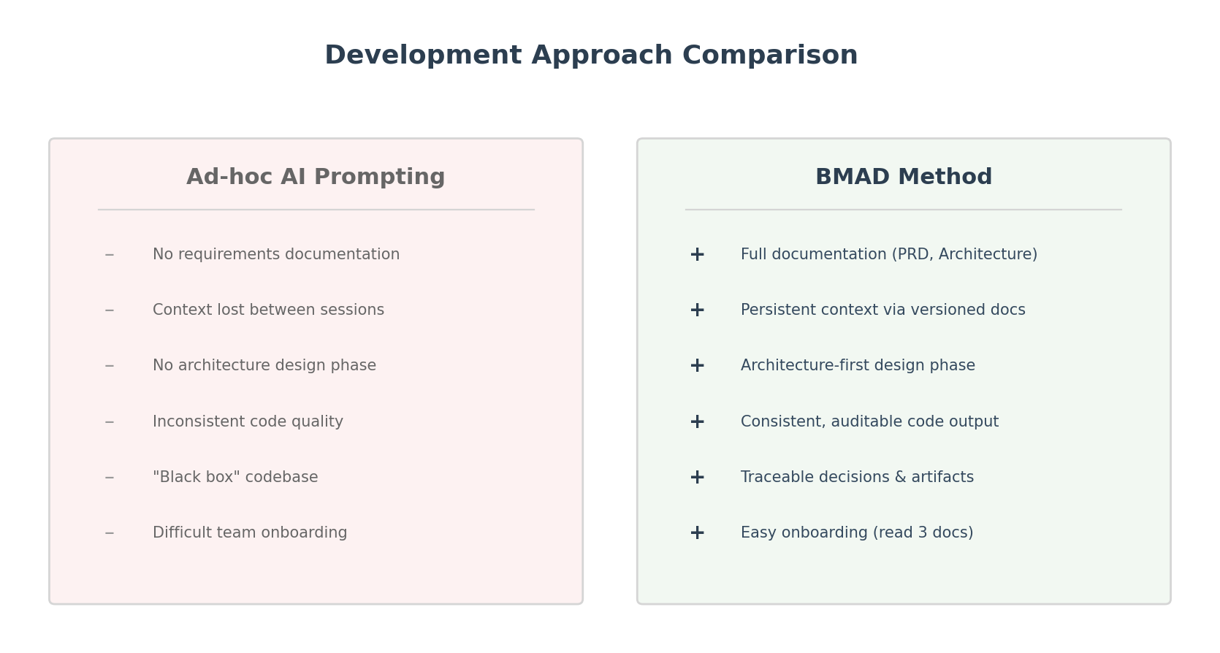
Figure 1: Vibe Coding vs BMAD Method — The core problem and solution
1.2 Specialized AI Agent Team
BMAD uses 6 specialized AI agent personas, each with distinct responsibilities mirroring a professional software team. Each agent produces explicit, version-controlled artifacts.
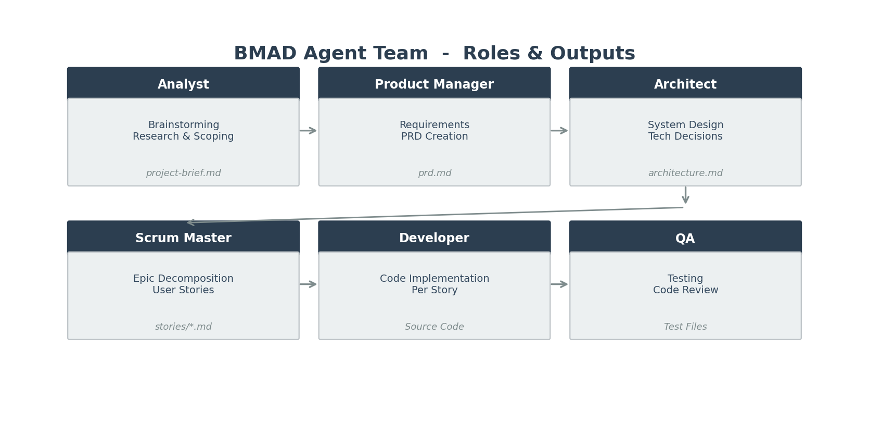
Figure 2: BMAD Agent Team — 6 specialized agents with outputs
Agent | Role | Output Artifact
Analyst | Brainstorming, research, scoping | project-brief.md
Product Manager | Requirements definition, PRD creation | prd.md
Architect | System design, technology decisions, API design | fullstack-architecture.md
Scrum Master | Epic decomposition, user story creation | stories/*.md
Developer | Code generation following stories + architecture | Source code files
QA | Test generation, code review, quality gates | Test files + review feedback

1.3 BMAD Workflow — 4-Phase Development Lifecycle
BMAD enforces a structured lifecycle with mandatory human review gates between each phase. This ensures quality control and prevents cascading errors.
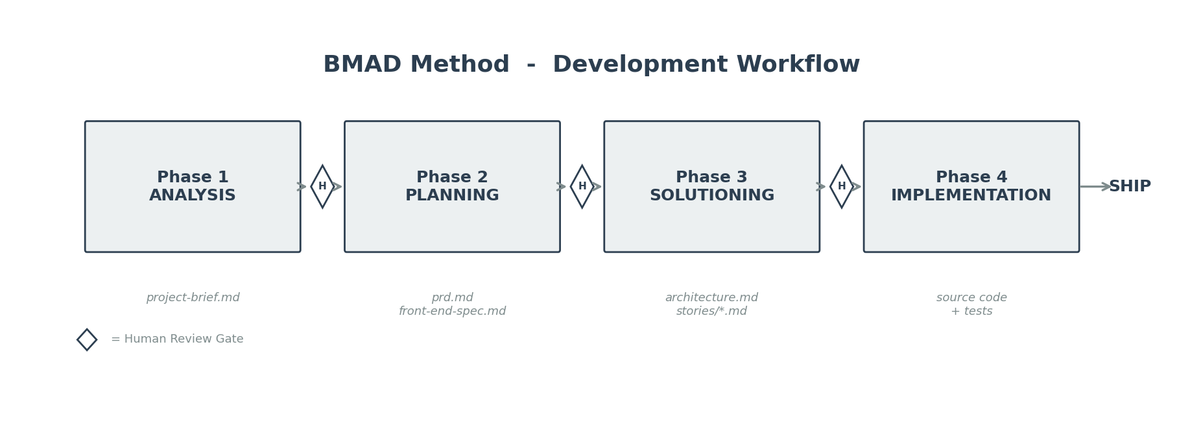
Figure 3: BMAD 4-Phase Workflow with Human Review Gates
Phase | Agent(s) | Key Activities | Output Artifacts
1. Analysis | Analyst | Brainstorm, research, risk ID | project-brief.md
Human Gate | Developer (Human) | Review scope, approve direction | Approval / feedback
2. Planning | Product Manager | Requirements (FR/NFR), UX goals | prd.md + front-end-spec.md
Human Gate | Developer (Human) | Review requirements completeness | Approval / feedback
3. Solutioning | Architect + Scrum Master | Architecture design, story decomposition | architecture.md + stories/
Human Gate | Developer (Human) | Review architecture decisions | Approval / feedback
4. Implementation | Developer + QA | Code and test story-by-story | Source code + tests

2. How We Applied BMAD to Build MyMusic
MyMusic is a modern Android music app built 100% in Kotlin with Jetpack Compose, Hilt DI, MVVM + Clean Architecture, powered by the Jamendo API for streaming music discovery and playback.
2.1 MyMusic Architecture (C4 Container Level)
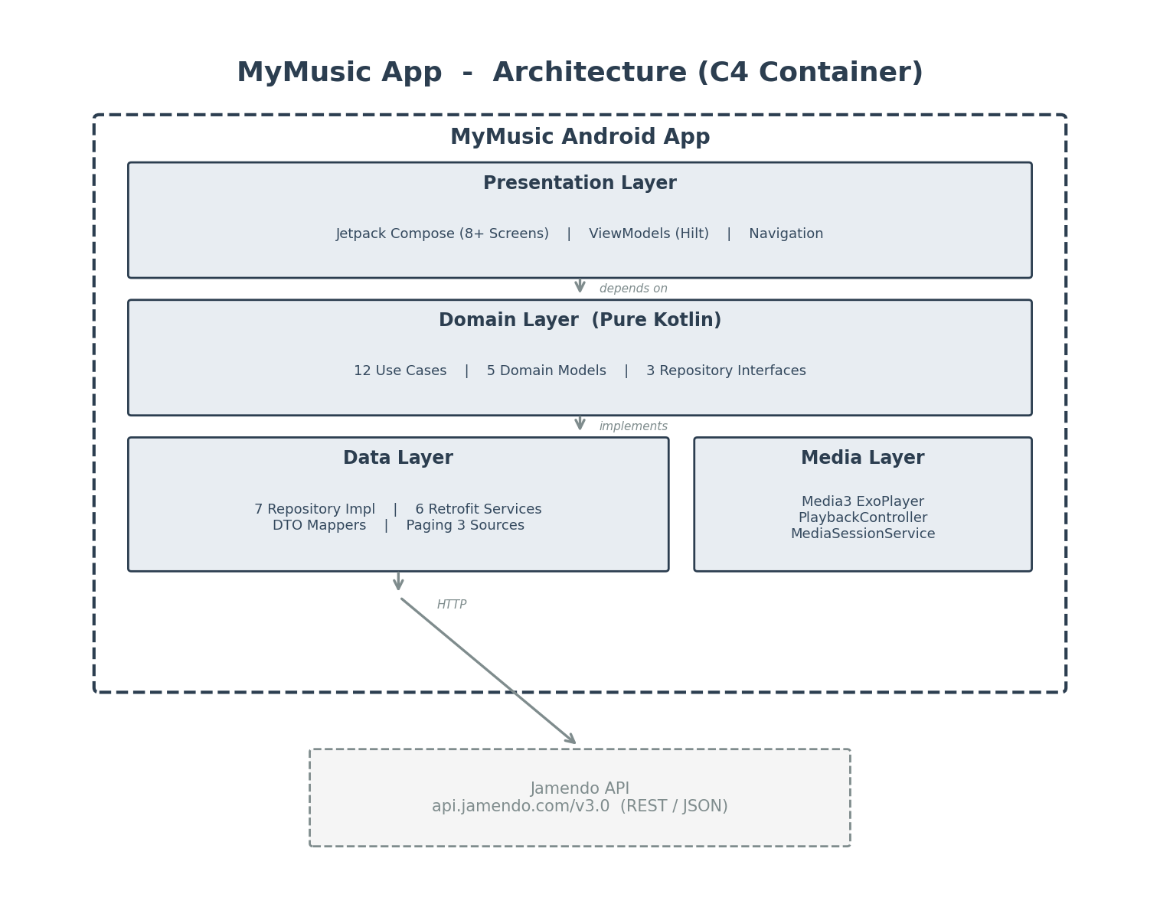
Figure 4: MyMusic App Architecture — 4-layer Clean Architecture with C4 model
2.2 Data Flow — From User Action to API and Back
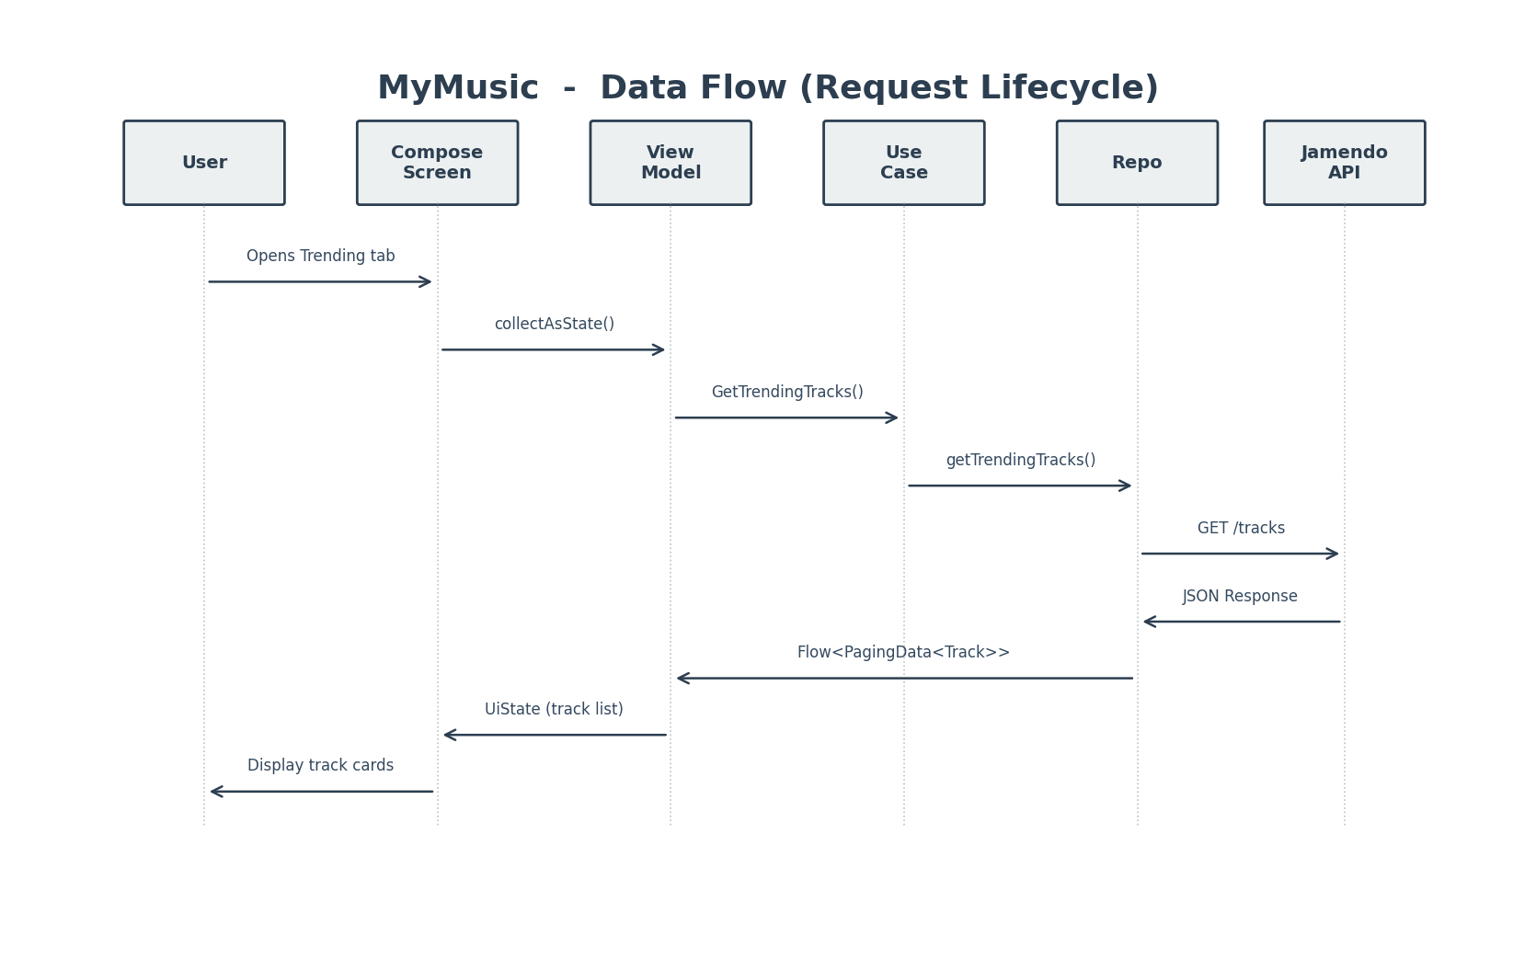
Figure 5: MyMusic Data Flow — User interaction to API call sequence
2.3 Codebase Statistics
Metric | Value | Notes
Total Kotlin source files | 102 | Generated following BMAD stories
Documentation files (docs/) | 80 | PRD, Architecture, UX Spec, Stories, Diagrams
User stories written | 22 | Across Epic 1 (8), Epic 2 (5), Epic 3 (6+)
Domain models | 5 | Track, Album, Artist, Playlist, SearchFilter
Repository interfaces | 3 | Domain layer contracts
Use cases | 12 | Business logic interactors
Retrofit services | 6 | Jamendo API endpoints
Repository implementations | 7 | Data layer
Presentation screens | 8+ | Compose screens + ViewModels
Architecture layers | 4 | Presentation / Domain / Data / Media
Test files | 0 | CRITICAL GAP - 0% test coverage

3. Why Should You Use BMAD? — Proven Benefits
3.1 Full Traceability — Requirement to Code
Every line of code in the project traces back through a clear chain: PRD Requirement -> Architecture Section -> Epic / Story -> Code File. This ensures no feature is "orphan code" without a documented reason.
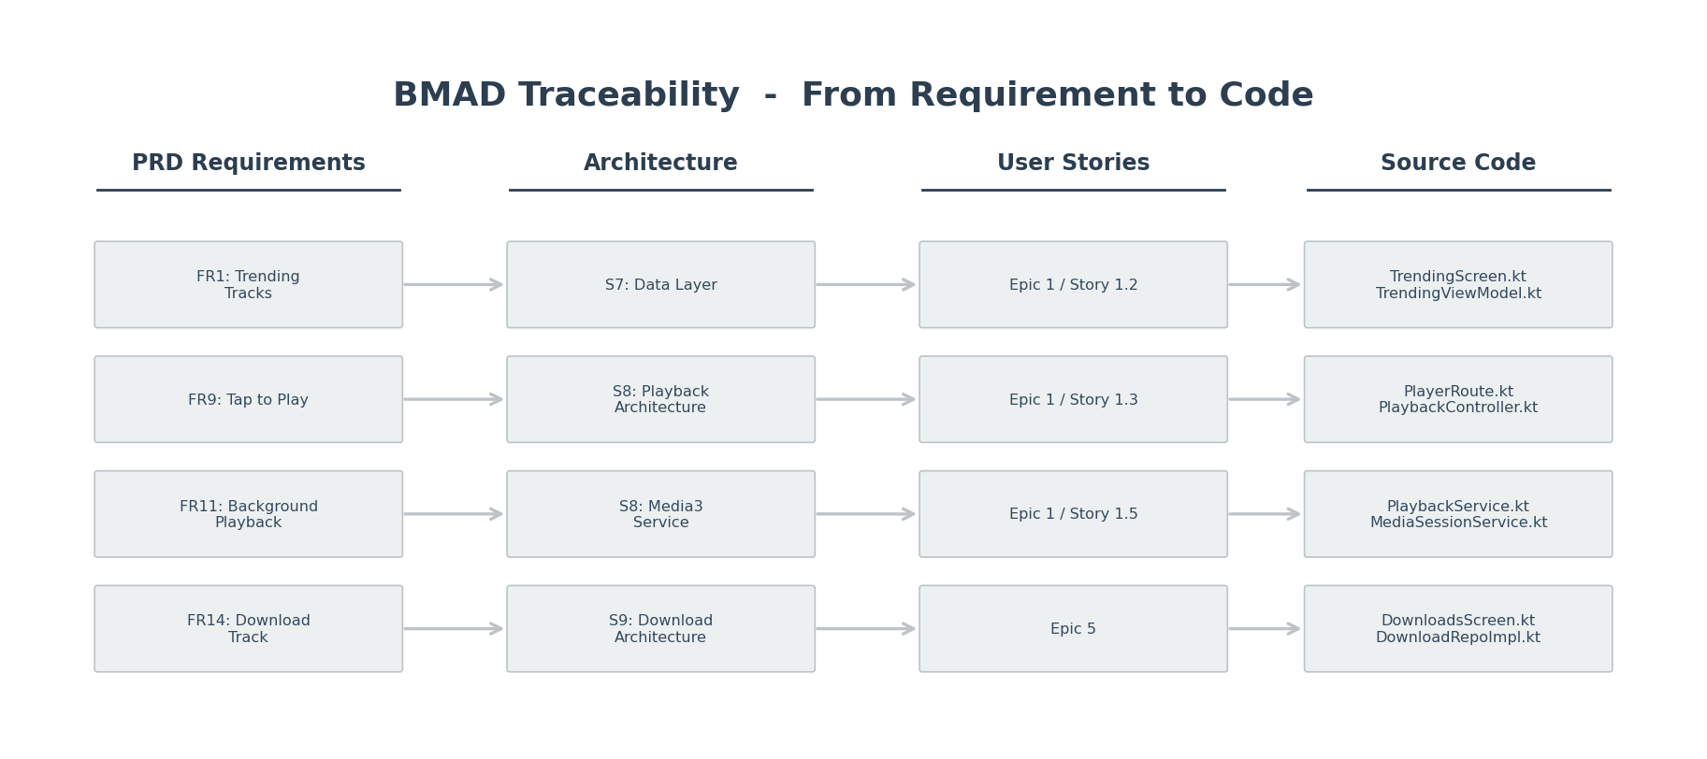
Figure 6: BMAD Traceability Map — from PRD FR to source code file
3.2 Concrete Benefits Proven by MyMusic
Benefit | Evidence from MyMusic Project
Clean Architecture from Day 1 | 4-layer separation (Presentation / Domain / Data / Media) enforced by architecture doc before any code was written
Zero Context Loss Between Sessions | 80 docs serve as persistent AI context. Agents always know the project state, even weeks later
Full Requirement Traceability | Every feature: PRD FR -> Architecture Section -> Epic -> Story -> Code file
Consistent Code Quality | All 102 files follow identical patterns: Hilt DI, StateFlow, Mapper, Paging
Fast Onboarding | New developer reads project-brief.md -> prd.md -> architecture.md -> starts coding within 30 minutes
Scalable Complexity | Started with Trending Tracks MVP, expanded to 3 epics + 22 stories without architectural churn

4. Weaknesses & Limitations of BMAD — Honest Assessment
BMAD is powerful but not perfect. Below is an honest assessment of its trade-offs, based on our real experience building MyMusic.
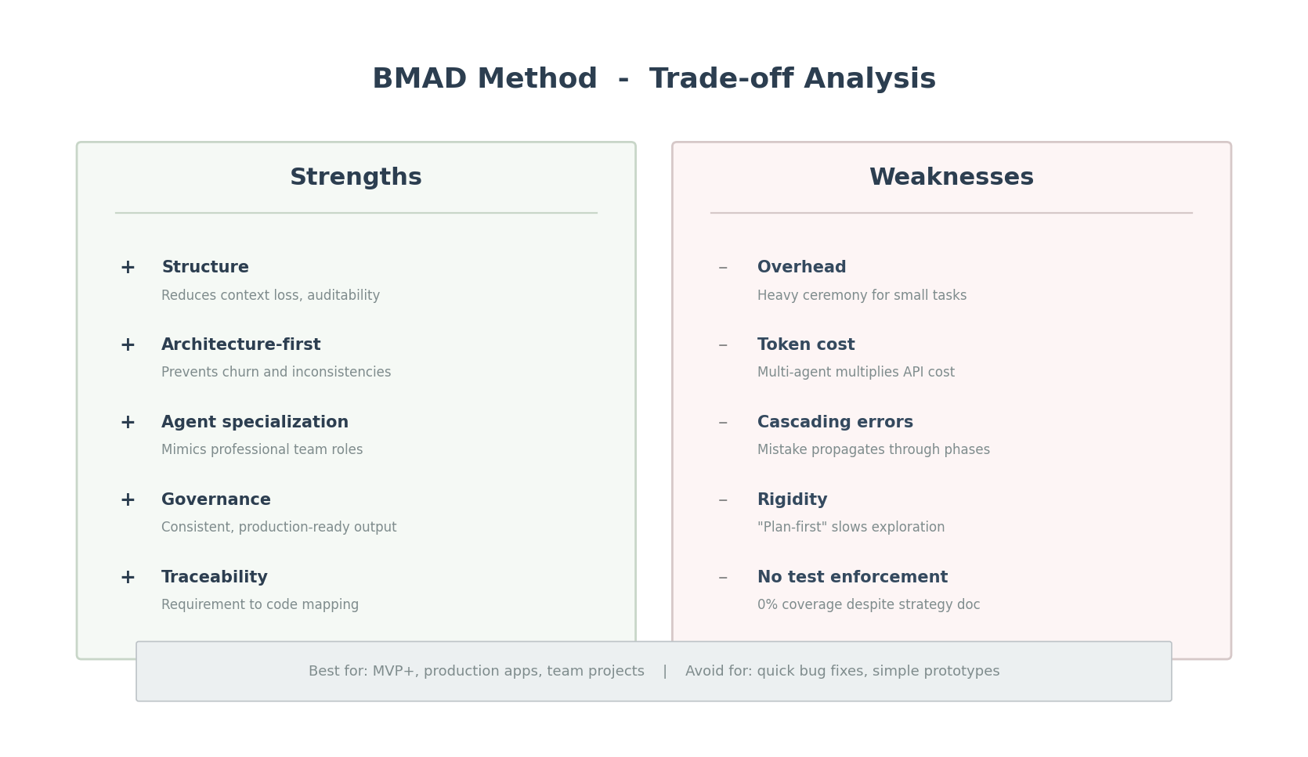
Figure 7: BMAD Strengths vs Weaknesses — Trade-off Analysis
4.1 Detailed Weakness Analysis
Weakness | Impact on MyMusic | Mitigation Strategy
Overhead for small tasks | Heavy ceremony even for a simple color change or minor bug fix | Use BMAD "Quick Flow" track for minor tasks (skip PRD/Architecture)
High token consumption | 80 docs + multi-agent = ~$8-15 USD API cost for full project | Use cheaper models for doc generation, premium models for critical decisions
Cascading errors | Wrong assumption in Phase 1 (e.g., API endpoint) propagates through all phases | Mandatory human review gate between every phase transition
Planning rigidity | "Plan everything first" slows down exploratory / experimental work | Use hybrid approach: BMAD for core, vibe coding for spikes
Forced quality metrics | Adversarial code review can create artificial nitpicking / developer fatigue | Remove minimum-issue requirements from code review agent prompts
Single-repo focus | Struggles with cross-service or multi-repo distributed architectures | Use BMAD Enterprise track for complex system-of-systems
No test enforcement | Test strategy documented (Architecture $17) but 0 actual tests created | Add explicit "generate tests" step as mandatory gate per story

4.2 When NOT to Use BMAD — Decision Guide
Scenario | Recommendation | Reason
Quick bug fix (< 1 hour) | Skip BMAD | Overhead not justified for minor fix
Small isolated feature | Quick Flow only | Tech-spec to implement, skip full docs
New MVP app (1-4 weeks) | Standard BMAD | Full workflow, best ROI
Enterprise / regulated | Enterprise BMAD | Need security + compliance + DevOps docs
Exploratory prototype | Use with caution | "Plan first" may slow discovery; consider hybrid
Refactoring existing code | Standard BMAD | Architecture doc prevents regressions

5. Current Testing Status
CRITICAL GAP: Despite a comprehensive test strategy documented in the architecture document (Section 17), NO actual test files were created.
Test Category | Status | Documented Strategy (Architecture S17)
app/src/test/ directory | Does NOT exist | Unit tests: mappers, use cases, repos with fakes
app/src/androidTest/ directory | Does NOT exist | Instrumented: ViewModels with coroutine testing
*Test.kt files | ZERO files found | UI tests: Compose key flows (Trending -> Play)
Unit Test Coverage | 0% | Target: mappers, use cases, ViewModels
Integration Test Coverage | 0% | Target: repos with fake servers
UI Test Coverage | 0% | Target: key user flows

Key Lesson: BMAD produces excellent test PLANS but does NOT enforce test CREATION. Human discipline and explicit story gates for testing are required.

Recommended priority for test generation:
- 1. TrackMapper (DTO to Domain) - pure function, easiest to test, highest ROI
- 2. GetTrendingTracksUseCase - validates business logic isolation
- 3. TrendingViewModel - UI state transition tests with coroutine TestDispatcher
- 4. PlaybackController - media state management edge cases

Time Saved by Using AI
# | Task | Before (Manual) | After (BMAD + AI) | Time Saved
1 | Requirements & PRD Creation | 24 hours (3 days) | 3 hours | 21 hours (87%)
2 | Architecture Design & Documentation | 16 hours (2 days) | 2 hours | 14 hours (87%)
3 | User Story Decomposition (22 stories) | 16 hours (2 days) | 1.5 hours | 14.5 hours (91%)
4 | Code Generation (102 Kotlin files) | 120 hours (15 days) | 24 hours | 96 hours (80%)
5 | Architecture Diagrams & Visual Docs | 8 hours (1 day) | 0.5 hours | 7.5 hours (94%)
 | TOTAL | 184 hours (~23 days) | 31 hours (~4 days) | 153 hours (83%)

Improvements or Benefits from AI Use
- Architecture quality: Clean 4-layer separation enforced from Day 1 - no spaghetti refactor needed later
- Documentation completeness: 80 docs generated (PRD, Architecture, UX Spec, 22 stories) vs. typical 0-3 docs in ad-hoc projects
- Consistency: All 102 Kotlin files follow identical patterns (Hilt, StateFlow, Mapper, Paging)
- Onboarding speed: New developer reads 3 docs and starts contributing within 30 minutes
- Traceability: Every code file traces back to Story -> Epic -> Architecture Section -> FR in PRD
- Decision documentation: Technology choices explained in architecture doc (why Kotlinx Serialization, why single-module, why Media3)
Limitations or Challenges
- No test files generated: Despite documented test strategy, BMAD did not enforce actual test creation. 0% test coverage is a critical gap.
- Token cost: Generating 80 documentation files + 102 source files consumed ~$8-15 USD in API tokens (Claude Sonnet).
- Overhead for small changes: Minor UI tweaks require checking PRD/Architecture alignment, which feels heavy.
- Cascading risk: Incorrect assumptions about Jamendo API in Phase 2 would propagate through all phases.
- Human discipline required: BMAD provides framework but developer must still review each artifact critically.

Output / Deliverable Link
Deliverable | Path / Location
Project Brief | docs/project-brief.md
Brainstorming Doc | docs/brain-stoming-documentation.md
PRD (16 FR + 13 NFR) | docs/prd.md
Front-End UX Spec | docs/front-end-spec.md
Architecture (21 sections) | docs/fullstack-architecture.md
User Stories (22) | docs/stories/*.md
Architecture Diagram | docs/diagrams/architecture-overview.mmd / .png
Source Code (102 files) | app/src/main/java/com/example/mymusic/
Built APK | app-debug.apk
This Report | docs/BMAD-Method-AI-Case-Report.docx

Appendix
A. Useful Prompts for BMAD Workflow
Phase 1 - Analyst Agent | "Brainstorm a [type] app with these features: [list]. Research API options, identify risks, and create a project-brief.md."
Phase 2 - Product Manager Agent | "Based on the project brief, create a PRD with functional requirements (FR1-FRn), non-functional requirements (NFR1-NFRn), epic list, and UI/UX goals. Run a checklist validation at the end."
Phase 3 - Architect Agent | "Create a full-stack architecture document based on this PRD. Include: module structure, DI graph, data flow, API design, error handling, testing strategy. Use Clean Architecture + MVVM."
Phase 3b - Scrum Master Agent | "Decompose Epic [n] into user stories with acceptance criteria. Each story must be independently implementable and include technical notes referencing the architecture document."
Phase 4 - Developer Agent (per story) | "Implement Story [n.m] following the architecture document. Use [tech stack]. Include unit tests for new business logic. Match patterns established in existing codebase."

B. Cursor Rules Template (.cursorrules)
# Project: MyMusic
# Method: BMAD

## Context Files (Always Read First)
- docs/project-brief.md - Project scope and goals
- docs/prd.md - Requirements (FR/NFR)
- docs/fullstack-architecture.md - Architecture decisions
- docs/stories/ - Current stories and acceptance criteria

## Architecture Rules
- MVVM + Clean Architecture (4 layers)
- All DI via Hilt (@Singleton, @ViewModelScoped)
- DTOs in data layer only; domain models in domain layer
- Mappers convert DTO <-> Domain at repository boundary
- UI state via StateFlow + collectAsStateWithLifecycle()
- Paging via Paging 3 PagingSource + cachedIn(viewModelScope)

## Testing (MANDATORY per story)
- Every new UseCase MUST have a unit test
- Every new Mapper MUST have a unit test
- Every new ViewModel MUST have state transition tests

C. BMAD Track Selection Guide
Project Type | BMAD Track | Key Artifacts
Bug fix / small feature | Quick Flow | Tech-spec -> Code
MVP / new product (1-4 weeks) | Standard BMAD | Brief + PRD + Architecture + Stories
Enterprise / regulated | Enterprise BMAD | Standard + Security + DevOps docs
Exploratory prototype | Hybrid approach | Lightweight brief -> spike -> full BMAD
Refactoring existing code | Standard BMAD | Architecture doc prevents regressions

Report generated: 2026-04-15 | Project: MyMusic | Method: BMAD | Multimedia 1P

