AI Practice — Best Practice Guide
Practice 1 of 3
Multi-Agent Structured Ideation
From a Short Idea to a Validated Concept
Using 4 Specialized AI Agents in Cursor

Submitted: 2026-04-16 | Video Editor | Duy LQ

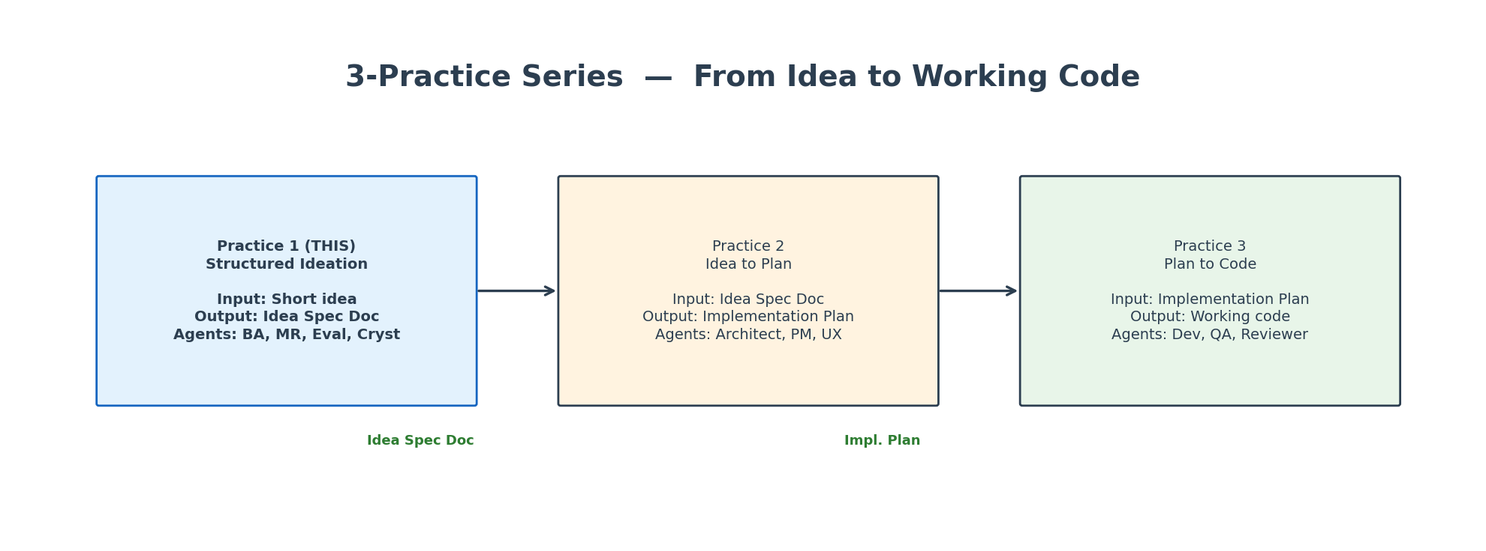
This is Practice 1 of a 3-part series: Ideation -> Planning -> Code

Practice | 1 of 3: Multi-Agent Structured Ideation
Method Based On | BMAD Method (Breakthrough Method for Agile AI-Driven Development)  Open-source multi-agent framework — github.com/bmad-code-org/BMAD-METHOD
Key Innovation | 4 specialized agents, each with ONE job and ONE output document  Separation of concerns: the agent who creates ideas is NOT the one who evaluates them
Tool | Cursor IDE (Agent Mode + .cursor/rules/ files)  Also works with: Claude, ChatGPT, Windsurf, any AI with system prompts
Input | A short initial idea (1-3 sentences)
Output | Idea Specification Document (12 sections, evidence-backed)
Time | 45-90 minutes total (4 separate AI sessions)
Files Included | 4 ready-to-use Cursor agent config files (.mdc)

1. Why Normal AI Brainstorming Doesn't Work
There are 3 levels of using AI for brainstorming. Most people stop at Level 1:
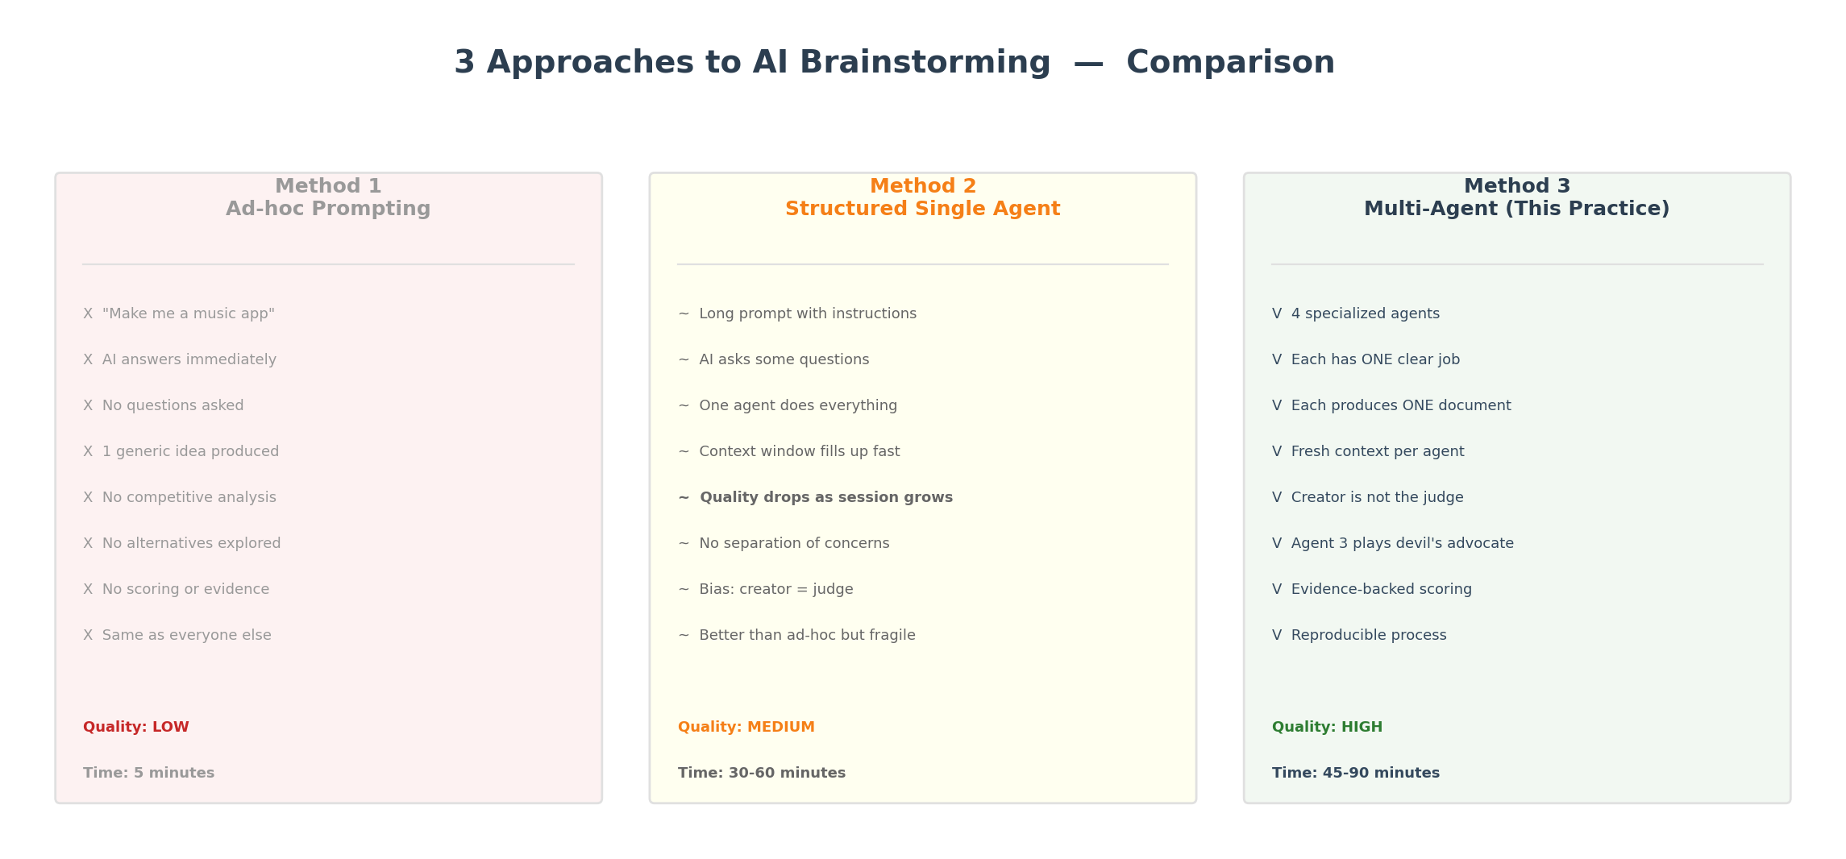
Figure 1: Three approaches — Ad-hoc, Structured Single Agent, Multi-Agent
 | Ad-hoc  (Level 1) | Single Agent  (Level 2) | Multi-Agent  (Level 3 — This)
Process | "Make me an app" | Long prompt with instructions | 4 agents, 4 sessions, 4 documents
Questions asked? | None | Some (if prompted) | 10-15 structured questions by Agent 1
Competitive analysis? | No | Maybe (if you ask) | Always (Agent 2's entire job)
Who evaluates? | Same agent | Same agent (bias) | Agent 3 = dedicated critical judge
Evidence? | None | Sometimes | Every score requires 1-sentence proof
Reproducible? | No | Depends on prompt | Yes — same 4 config files every time
Context overflow? | N/A | Yes (long sessions) | No — fresh context per agent
Quality | Low | Medium | High

Why Multi-Agent Specifically?
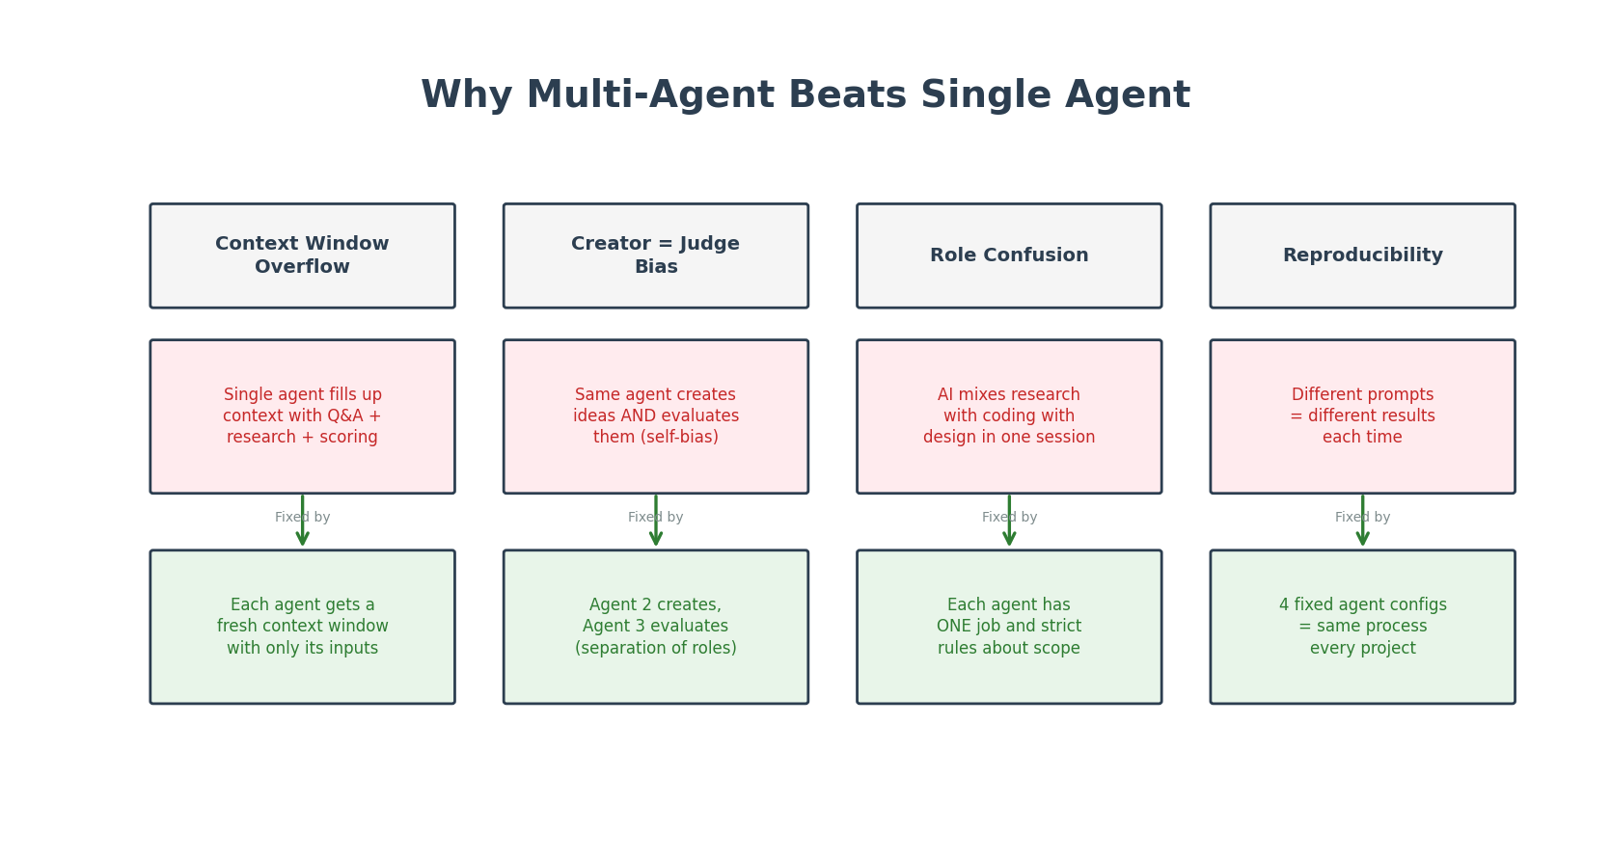
Figure 2: 4 problems with single-agent approach and how multi-agent fixes each
The core insight from BMAD Method: in real software teams, the analyst is NOT the architect, the architect is NOT the developer, and the developer is NOT the QA tester. Each role has a specific job. The same principle applies to AI agents.

2. The 4-Agent Ideation Pipeline
Each agent has ONE job, produces ONE document, and hands it to the next agent.
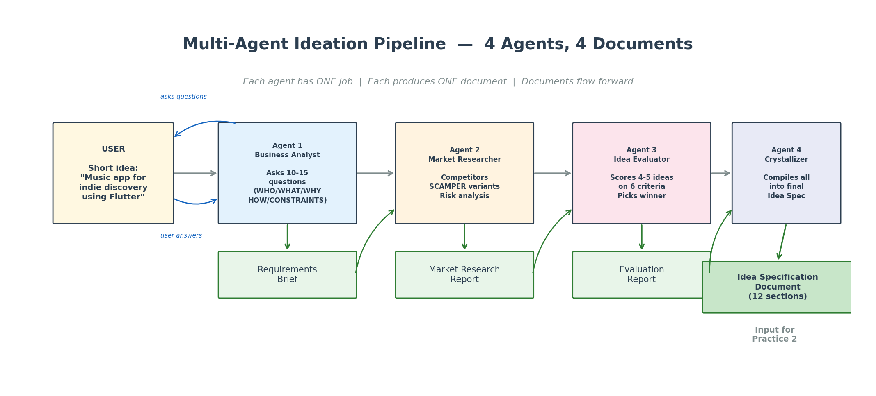
Figure 3: The 4-agent pipeline — each agent produces one document that flows forward
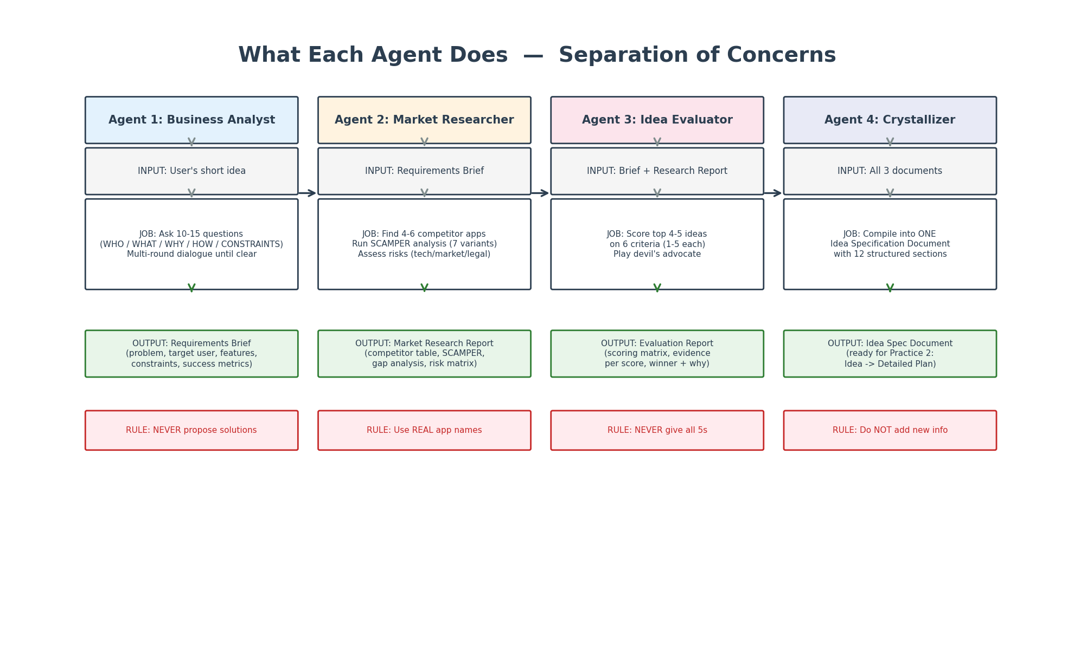
Figure 4: What each agent does — inputs, job description, outputs, and hard rules
Agent | Role | Input | Output | Key Rule
1. Business Analyst | Requirements discovery | User's short idea | Requirements Brief | NEVER propose solutions
2. Market Researcher | Competitive + SCAMPER | Requirements Brief | Market Research Report | Use REAL app names
3. Idea Evaluator | Critical scoring | Brief + Research | Evaluation Report | NEVER give all 5s
4. Idea Crystallizer | Compile final spec | All 3 documents | Idea Specification Doc | Do NOT add new info

3. Agent 1: Business Analyst — "Ask, Don't Assume"
This agent's only job is to ask questions and produce a Requirements Brief.
What Questions It Asks
Category | Example Questions | Why It Matters
WHO  (Target) | Who is the target user? Age/demographics?  Tech comfort level? Willing to pay? | Defines UX complexity,  pricing, feature set
WHAT  (Features) | Core features? Platform (web/mobile)?  Offline mode? Social features? | Scopes the MVP vs  full product
WHY  (Motivation) | What problem does this solve?  What apps do you NOT like? Why?  What makes your idea different? | Validates the idea  has a reason to exist
HOW  (Technical) | Budget? Timeline? Team size?  Scalability? Data storage needs? | Determines architecture  + feasibility
CONSTRAINTS | Regulatory requirements?  Tech restrictions? Existing infrastructure? | Catches blockers before  design begins

Multi-Round Dialogue
The agent doesn't stop after one round. It works like a real BA:
- Round 1: Asks 10-15 initial questions across all 5 categories
- User answers (can be brief)
- Round 2: Follows up on vague/broad answers with deeper questions
- Round 3: Confirms understanding, asks "anything I missed?"
Only then does it produce the Requirements Brief.
Output: Requirements Brief
A structured markdown document with these sections:
- Problem Statement — what pain point, for whom
- Target User Profile — demographics, tech level, usage frequency
- Must-Have Features (MVP) — what must be in v1
- Nice-to-Have Features (v2) — what can wait
- Out-of-Scope — explicitly NOT building (prevents scope creep)
- Constraints — platform, budget, timeline, team, regulatory
- Success Metrics — how do we know this product is successful

4. Agent 2: Market Researcher — "What Already Exists?"
This agent receives the Requirements Brief and researches the real market.
It produces 4 deliverables:
4.1 Competitive Analysis Table
Finds 4-6 existing apps/products that solve a similar problem:
App | Platform | Strengths | Weaknesses | Pricing | Users (est.)
Spotify | All | Huge library, great algo | Favors mainstream | Free/Premium $10/mo | 600M+
Bandcamp | Web | Artist-first, direct pay | Poor UX, no social | Free (artist pays %) | ~8M
SoundCloud | All | User uploads, community | Cluttered, ads | Free/$5/$16 | ~175M
Tidal | All | Hi-fi audio, artist focus | High price, small library | $11/$22 | ~5M

4.2 SCAMPER Variants
A creativity framework applied to generate 7 alternative approaches:
Letter | Technique | Example Variant
S | Substitute | Replace streaming with podcast-style episodes about indie artists
C | Combine | Music + Instagram-style story feature for artists
A | Adapt | Adapt TikTok's algorithm for music discovery
M | Modify | Real-time collaborative playlists (like Google Docs)
P | Put to other uses | Engine also discovers indie film/game soundtracks
E | Eliminate | Remove the feed — only curated weekly "drops"
R | Reverse | Artists pitch to listeners instead of listeners searching

4.3 Risk Assessment
Technical, Market, Legal, and Dependency risks — each with mitigation.
4.4 Market Gap Analysis
The key question: "What do ALL competitors miss that this idea could fill?"

5. Agent 3: Idea Evaluator — "Devil's Advocate"
This agent is the critical judge. Its job is to be harsh, not positive. It receives both the Requirements Brief AND the Market Research Report.
Why a Separate Evaluator?
If the same agent creates ideas AND judges them, it has creator bias — it will always favor its own ideas. By making Agent 3 a separate session with a separate context, it evaluates objectively based only on the documents.
Scoring Matrix
Criterion | Score | What It Measures
Feasibility | 1-5 | Can we build this with available tech/APIs?
Market Demand | 1-5 | Is there evidence of user need?
Uniqueness | 1-5 | How different from existing solutions?
Time to MVP | 1-5 | How quickly can a working v1 be built?
Scalability | 1-5 | Can this grow beyond initial users?
Cost Efficiency | 1-5 | How expensive to build and operate?

Example Output
Idea | Feas. | Market | Unique | Time | Scale | Cost | TOTAL
Original: Standard music app | 5 | 4 | 1 | 4 | 4 | 4 | 22
SCAMPER-C: Music + artist stories | 4 | 3 | 4 | 3 | 3 | 3 | 20
SCAMPER-E: Curated weekly drops only | 5 | 3 | 4 | 5 | 4 | 5 | 26 (Winner)
Gap: Artist-pitch-to-listener | 3 | 2 | 5 | 2 | 2 | 3 | 17

For every single score, the evaluator must write exactly 1 sentence of evidence.
Example: "Feasibility: 5 — No real-time streaming backend needed; weekly batch uploads reduce both server cost and technical complexity to near-zero for MVP."

6. Agent 4: Idea Crystallizer — "Compile & Finalize"
The final agent receives ALL 3 previous documents and synthesizes them into ONE Idea Specification Document with 12 sections.
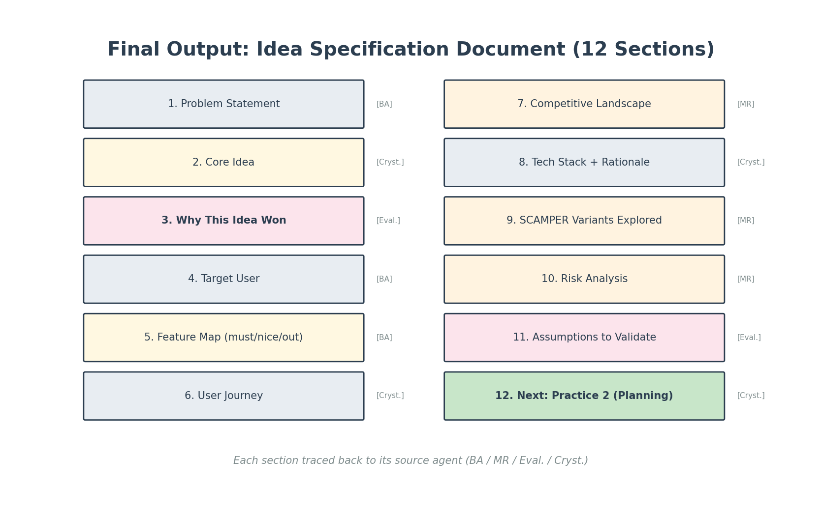
Figure 5: The 12-section Idea Specification Document — each section traced to its source agent
Traceability: each section comes from a specific agent:
Section | Source Agent | Content
1. Problem Statement | Business Analyst | What pain point, for whom, evidence
2. Core Idea | Crystallizer | One crisp paragraph describing the concept
3. Why This Idea Won | Idea Evaluator | Scoring summary, why this beat alternatives
4. Target User | Business Analyst | Demographics, tech level, willingness to pay
5. Feature Map | Business Analyst | Must-have (MVP) / nice-to-have / out-of-scope
6. User Journey | Crystallizer | Discovery -> onboard -> core -> retain -> monetize
7. Competitive Landscape | Market Researcher | Comparison table of 4-6 competitors
8. Tech Stack + Rationale | Crystallizer | Frontend/backend/DB/API choices with reasoning
9. SCAMPER Variants Explored | Market Researcher | Alternative approaches, why runner-up wasn't chosen
10. Risk Analysis | Market Researcher | Technical, market, legal, dependency risks
11. Assumptions to Validate | Idea Evaluator | Hypotheses that need to be tested
12. Next Step | Crystallizer | "This doc is the input for Practice 2: Planning"

7. How to Set Up in Cursor (Step-by-Step)
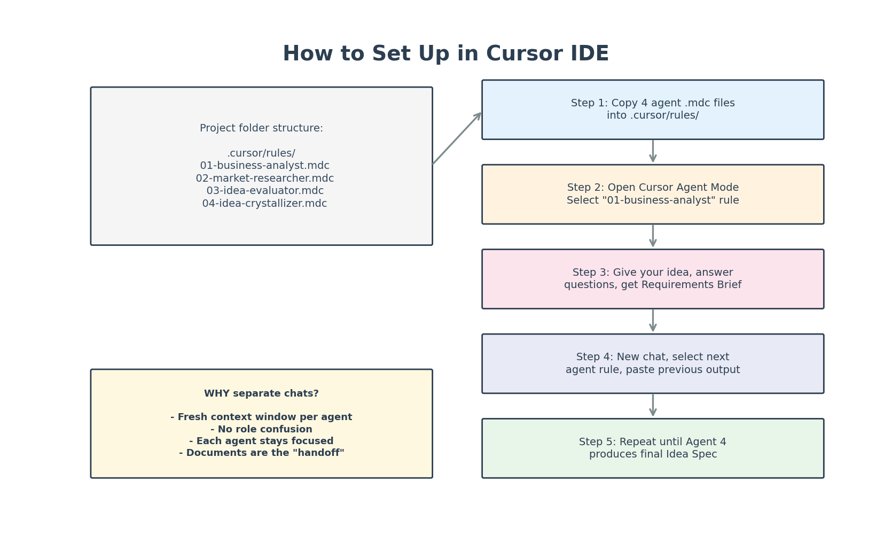
Figure 6: Cursor setup — copy 4 .mdc files, then run 4 separate chat sessions
Step 1: Copy Agent Files
Copy the 4 .mdc files from practice1/agents/ into your project's .cursor/rules/ folder:
your-project/
.cursor/
rules/
01-business-analyst.mdc
02-market-researcher.mdc
03-idea-evaluator.mdc
04-idea-crystallizer.mdc
Step 2: Agent 1 — Business Analyst
Open a NEW Cursor Agent Mode chat. Select the "01-business-analyst" rule.
Type your seed idea:
I have an idea for a project. Here it is:
"I want to make a music streaming app using Flutter + Firebase
that helps young people discover independent artists.
Something like Spotify but for indie music."
The agent will ask 10-15 questions. Answer them. After 2-3 rounds, it produces a Requirements Brief.
Save the Requirements Brief to a file (e.g., docs/requirements-brief.md).
Step 3: Agent 2 — Market Researcher
Open a NEW chat. Select "02-market-researcher" rule.
Paste the Requirements Brief and say:
"Here is the Requirements Brief from our Business Analyst.
Please run your full analysis: competitors, SCAMPER, risks, gaps."
Save the Market Research Report to a file.
Step 4: Agent 3 — Idea Evaluator
Open a NEW chat. Select "03-idea-evaluator" rule.
Paste BOTH the Requirements Brief AND the Market Research Report:
"Here are 2 documents from previous agents.
[Requirements Brief]
...
[Market Research Report]
...
Please score the top 4-5 ideas and recommend a winner."
Save the Evaluation Report.
Step 5: Agent 4 — Crystallizer
Open a NEW chat. Select "04-idea-crystallizer" rule.
Paste ALL 3 previous documents:
"Here are 3 documents from the previous agents.
[Requirements Brief]
...
[Market Research Report]
...
[Evaluation Report]
...
Please compile into the final Idea Specification Document."
The output is your final Idea Spec — the input for Practice 2 (Planning).
Why Separate Chats?
- Fresh context window: each agent gets only what it needs, not 50 pages of history
- No role confusion: Agent 3 can't see Agent 1's thought process, only its output
- Reproducible: same 4 file configs + same process = consistent quality every project
- Debuggable: if the evaluation is bad, you only re-run Agent 3, not everything

8. Also Works With Other AI Tools
The 4 agent configs are Cursor .mdc files, but the method works anywhere that supports system prompts or separate sessions:
Tool | How to Use This Method
Cursor IDE | Copy .mdc files to .cursor/rules/ (native integration, recommended)
ChatGPT | Paste the agent's system prompt as the first message in each NEW conversation
Claude | Use Projects feature: create 4 projects, each with one agent prompt
Windsurf | Use .windsurfrules files (similar to Cursor)
Gemini | Copy the agent prompt as first message in each new chat
Claude Code | Use /persona command or CLAUDE.md files

The key principle is the same everywhere: 4 separate sessions, 4 separate agent prompts, documents as handoff between sessions.
9. Tips & Best Practices
Do
- Keep the seed SHORT (1-3 sentences). The BA agent's job is to expand it.
- Answer Agent 1's questions honestly — short answers are fine.
- Save each agent's output as a separate file before starting the next agent.
- If Agent 3's scoring seems off, challenge it: "Why did you score X as 4?"
- The SCAMPER variants from Agent 2 often produce the winning idea — don't skip them.
- Use the Idea Spec Document from Agent 4 as the INPUT for Practice 2 (Planning).
Don't
- Don't put all 4 agents in ONE chat session (context overflow, role confusion).
- Don't skip Agent 1 (BA) — it is the most important. Bad requirements = bad everything.
- Don't accept Agent 3's first scoring without reading the evidence sentences.
- Don't modify Agent 4's output — if something is wrong, re-run the responsible agent.
- Don't use this for trivial tasks — if you already know exactly what to build, skip to Practice 2.
10. What's Next: Practice 2 & 3
Practice | Name | Input | Output | Agents
1 (this) | Structured Ideation | Short idea (1-3 sentences) | Idea Specification Document | BA, Market Researcher, Evaluator, Crystallizer
2 (next) | Idea to Plan | Idea Specification Document | Detailed Implementation Plan | Architect, PM, UX Designer
3 (last) | Plan to Code | Implementation Plan | Working code | Developer, QA, Code Reviewer

Each practice uses different specialized agents. The output of one practice is the input of the next. This is how BMAD method works: a chain of specialized agents producing documents that build on each other.
Appendix: Agent Configuration Files
The 4 .mdc files are included in practice1/agents/. Each file is a Cursor MDC rule file with these sections:
File | Lines | Key Sections
01-business-analyst.mdc | ~55 | Role, Job (5 question categories), Output format (Requirements Brief), Rules
02-market-researcher.mdc | ~55 | Role, Job (4 deliverables: competitors, SCAMPER, risks, gaps), Rules
03-idea-evaluator.mdc | ~60 | Role, Job (scoring matrix, evidence), Output format (Evaluation Report), Rules
04-idea-crystallizer.mdc | ~50 | Role, Job (compile), Output format (12-section Idea Spec), Rules

These files are ready to use — copy them to .cursor/rules/ and start immediately.

Report generated: 2026-04-16 | Practice 1 of 3: Multi-Agent Ideation | Video Editor

