AI Practice — Best Practice Guide
Practice 1 of 3
AI-Assisted Structured Ideation
From a Short Idea to a Validated Concept

Submitted: 2026-04-16 | Video Editor | Duy LQ

This is Practice 1 of a 3-part series:
1. Ideation: Idea -> Validated Concept (this document)
2. Planning: Concept -> Detailed Implementation Plan
3. Execution: Plan -> Working Code via AI Prompts

Practice | 1 of 3: AI-Assisted Structured Ideation
Scope | From a 1-2 sentence idea to a fully validated concept document  Covers brainstorming, clarification, expansion, evaluation, and crystallization
AI Tool Required | Any conversational AI: ChatGPT, Claude, Gemini, Cursor, etc.
Input | A short initial idea (1-2 sentences)  Example: "I want to make a music app using Flutter + Firebase"
Output | Idea Specification Document (12 sections)  Ready to be used as input for Practice 2 (Planning)
Time Required | 30-60 minutes of user-AI dialogue
Key Principle | AI should ASK questions first, not answer immediately

1. The Problem: Why Ad-hoc Brainstorming Fails
Most people use AI for brainstorming like this:
User: "Make me a music streaming app"
AI: "Sure! Here's a music app with playlists, search, and social features..."
This fails because:
- The AI generates the first plausible idea without understanding your actual needs
- No clarifying questions are asked — AI assumes everything
- Only ONE idea is generated — no alternatives explored
- No competitive analysis — the idea may already exist in 100 apps
- No evidence that the idea is viable — it just "sounds good"
- The result is generic: indistinguishable from what 1000 other people would get
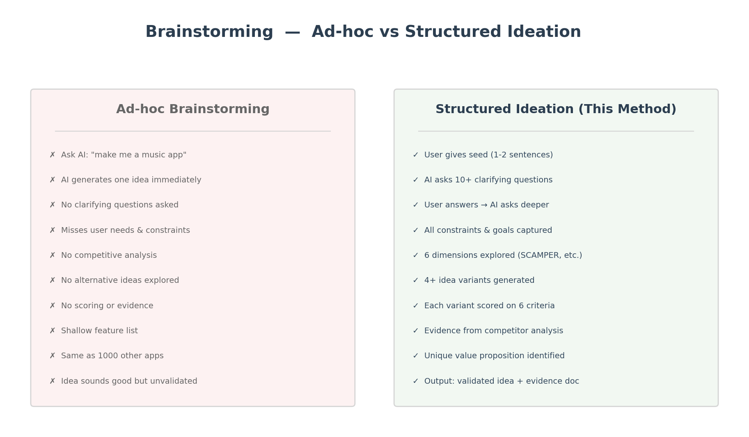
Figure 1: Ad-hoc brainstorming vs Structured Ideation — the difference

2. The Method: 5-Phase Structured Ideation
This method forces the AI to be a thinking partner, not a code monkey. The key innovation: AI ASKS questions before generating ideas.
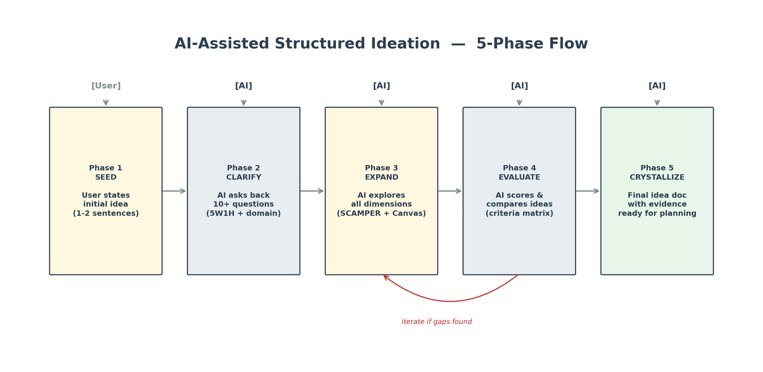
Figure 2: 5-Phase Ideation Flow — Seed, Clarify, Expand, Evaluate, Crystallize
Phase | Who Acts | What Happens | Output
1. Seed | User | States the initial idea in 1-2 sentences | Raw idea statement
2. Clarify | AI | Asks 10+ clarifying questions (5W1H + domain) | Complete context document
3. Expand | AI | Explores 6 dimensions: SCAMPER, competition, user journey, tech, business, risk | Idea variants + analysis
4. Evaluate | AI | Scores each variant on 6 criteria, compares with evidence | Scoring matrix + winner
5. Crystallize | AI | Produces final Idea Specification Document (12 sections) | Ready for Practice 2

3. Phase 1: SEED — The Starting Point
The user provides a short initial idea. The shorter, the better — the AI's job is to make it detailed, not yours.
How to Write a Good Seed
Quality | Bad Seed | Good Seed
Too vague | "Make me an app" | "I want a music app for discovering indie artists"
Too detailed | "Make a Flutter app with Firebase Firestore using BLoC pattern with...(500 words)" | "Music app using Flutter + Firebase, focus on social discovery"
No context | "Music app" | "Music app because I think Spotify misses indie artists"
Perfect | — | "I want to make a music streaming app using Flutter + Firebase that helps young people discover independent artists. Something like Spotify but for indie music."

The seed should be 1-3 sentences containing:
- WHAT you want to build (type of app/system)
- WHY you want it (the problem or gap)
- Optional: technology preference, inspiration app
The Prompt to Start
Copy this prompt to start a session with any AI:
PROMPT:
"I have an idea for a project and I need your help to develop it thoroughly.
But DO NOT start building or designing anything yet.
Instead, I need you to:
1. Read my initial idea below
2. Ask me AT LEAST 10 clarifying questions organized by category
(Who, What, Why, How, Domain-specific)
3. Wait for my answers before proceeding
4. After I answer, ask follow-up questions if anything is still unclear
5. Only proceed to brainstorming when you fully understand the scope
My idea: [YOUR SEED HERE]
Remember: ASK FIRST, don't assume. The more you understand,
the better the ideas will be."

4. Phase 2: CLARIFY — AI Asks Back
This is the most important phase. Instead of generating ideas, the AI asks structured questions to understand everything about your needs.
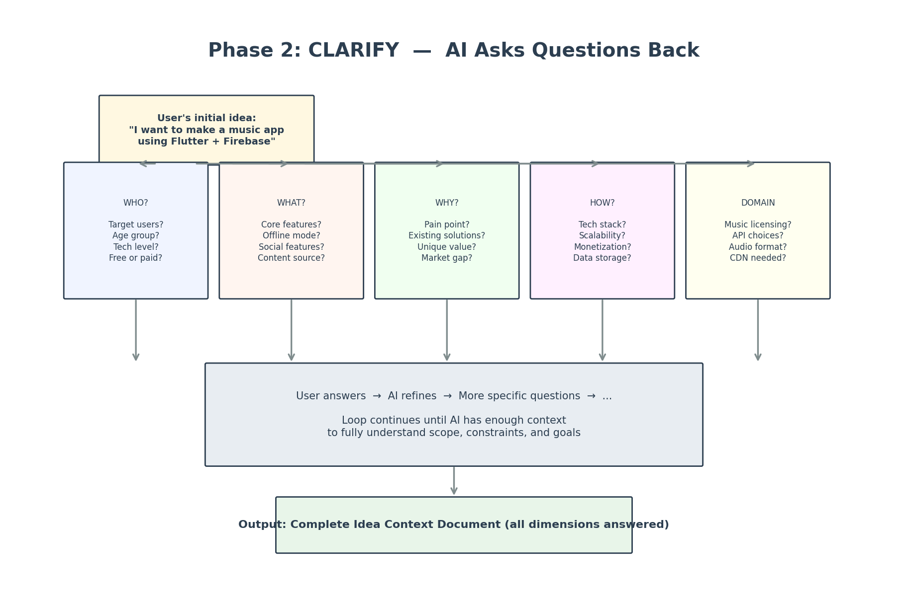
Figure 3: Phase 2 — AI asks questions in 5 categories (WHO/WHAT/WHY/HOW/DOMAIN)
The 5 Question Categories
Category | Example Questions | Why It Matters
WHO  (Target) | Who is the target user?  Age/demographics?  Tech comfort level?  Willing to pay? | Defines UX complexity, pricing, feature set
WHAT  (Features) | What are must-have features?  Offline mode needed?  Social features?  Content source (API, upload, crawl)? | Scopes the MVP vs full product
WHY  (Motivation) | What problem does this solve?  What existing apps do you NOT like?  What makes your idea different?  Is there market evidence? | Validates the idea has a reason to exist
HOW  (Technical) | Tech stack preference?  Platform (web, mobile, desktop)?  Scalability requirements?  Data storage (cloud, local)? | Determines architecture + feasibility
DOMAIN  (Specific) | For music: licensing? API costs? Audio format?  For e-commerce: payment gateway? Shipping?  For SaaS: pricing model? Multi-tenant? | Catches industry-specific constraints early

Multi-Round Dialogue
The AI should NOT stop at one round of questions. The key behavior is:
- Round 1: AI asks 10+ initial questions across all 5 categories
- User answers (can be brief)
- Round 2: AI follows up on unclear/broad answers with deeper questions
- User answers again
- Round 3 (if needed): AI confirms understanding and asks "anything I missed?"
Only when ALL categories are sufficiently answered does the AI proceed to Phase 3.
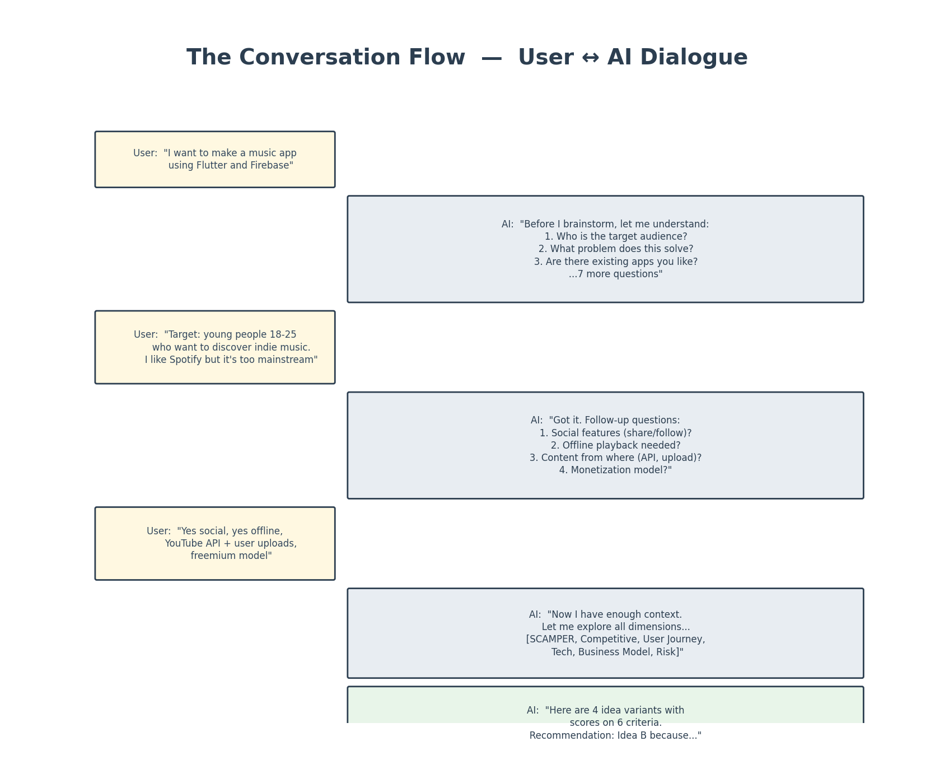
Figure 4: Example conversation — 3 rounds of User-AI dialogue

5. Phase 3: EXPAND — Exploring All Dimensions
With complete context from Phase 2, the AI now explores the idea across 6 dimensions. This ensures no angle is missed.
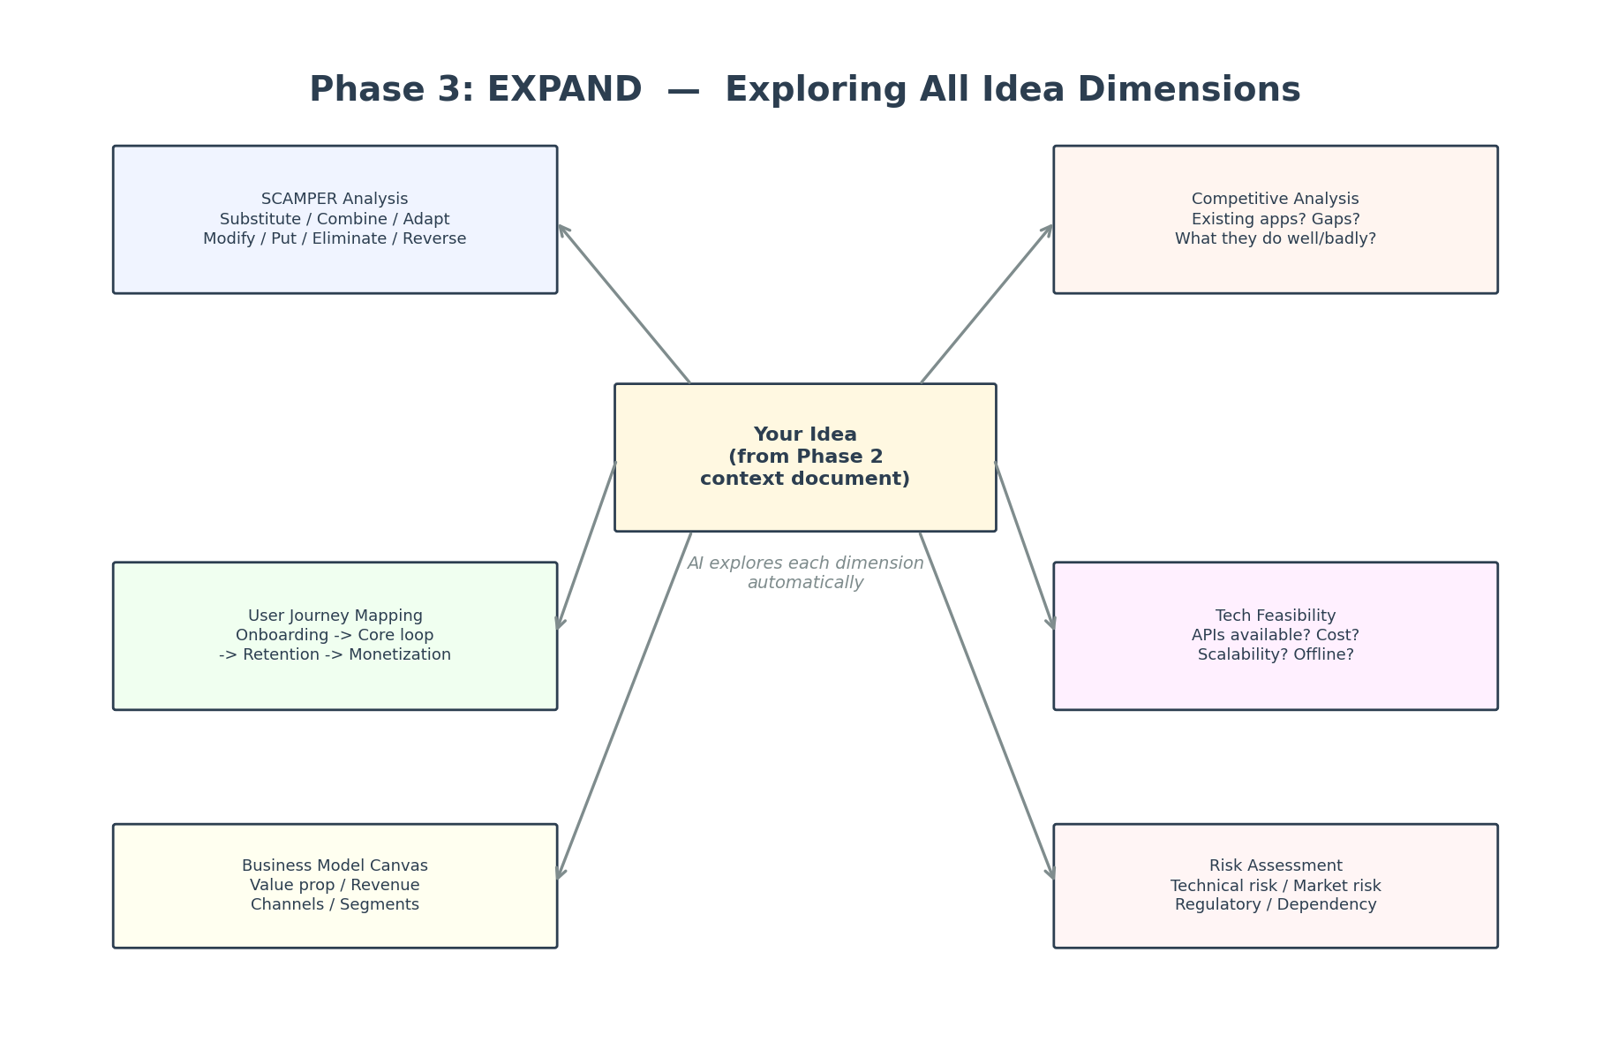
Figure 5: 6 dimensions explored from the central idea
The 6 Expansion Dimensions
5.1 SCAMPER Analysis
A creativity framework that generates variants of your idea:
Letter | Technique | Example (Music App)
S | Substitute | Replace streaming with podcast-style episodes about indie artists
C | Combine | Music + social story feature (Instagram-like but for songs)
A | Adapt | Adapt TikTok's algorithm for music discovery instead of video
M | Modify | Make playlists collaborative in real-time (like Google Docs)
P | Put to other uses | Use the engine for indie film/game soundtrack discovery
E | Eliminate | Remove the feed entirely — only curated weekly "drops"
R | Reverse | Artists pitch to listeners instead of listeners searching

5.2 Competitive Analysis
AI should research and compare existing solutions:
App | Strengths | Weaknesses | Your Opportunity
Spotify | Huge library, great algo | Algorithm favors mainstream | Focus on indie discovery
Bandcamp | Artist-first, direct pay | Bad UX, no social | Better UX + social layer
SoundCloud | User uploads, community | Cluttered, low quality | Curated quality control
Your App | ? | ? | Unique value proposition

5.3 User Journey Mapping
Map the complete user experience:
- Onboarding: How does a new user start? Signup flow? First experience?
- Core Loop: What does the user do daily? (discover -> listen -> save -> share)
- Retention: What brings them back? Notifications? New content? Social?
- Monetization: Free tier vs paid? In-app purchases? Artist subscriptions?
5.4 Technical Feasibility
Evaluate whether the idea can be built:
- Are all required APIs available and affordable?
- Is the tech stack appropriate for the requirements?
- What are the scalability constraints?
- Offline capabilities feasible?
5.5 Business Model Canvas
Quick business viability check:
- Value Proposition: what unique value do you offer?
- Revenue Streams: how will this make money?
- Customer Segments: who pays? Artists? Listeners? Both?
- Key Resources: music data, hosting, AI for recommendations?
5.6 Risk Assessment
Identify what could go wrong:
- Technical Risk: API dependency, performance, platform limitations
- Market Risk: is there actually demand? How to validate?
- Legal Risk: music licensing, copyright, data privacy
- Dependency Risk: what if YouTube API changes terms?
Prompt to Trigger Phase 3
PROMPT:
"Now that you fully understand my idea, explore it across 6 dimensions:
1. SCAMPER Analysis: generate at least 7 variants of the idea
2. Competitive Analysis: find 3-5 existing solutions, compare strengths/weaknesses
3. User Journey: map onboarding -> core loop -> retention -> monetization
4. Tech Feasibility: evaluate APIs, scalability, offline, cost
5. Business Model Canvas: value prop, revenue, segments, resources
6. Risk Assessment: technical, market, legal, dependency risks
For each dimension, be specific. Use actual app names, actual APIs,
actual numbers where possible. No generic statements."

6. Phase 4: EVALUATE — Score & Compare
From all the expanded ideas (original + SCAMPER variants + competitive gaps), select 3-5 strongest candidates and score them.
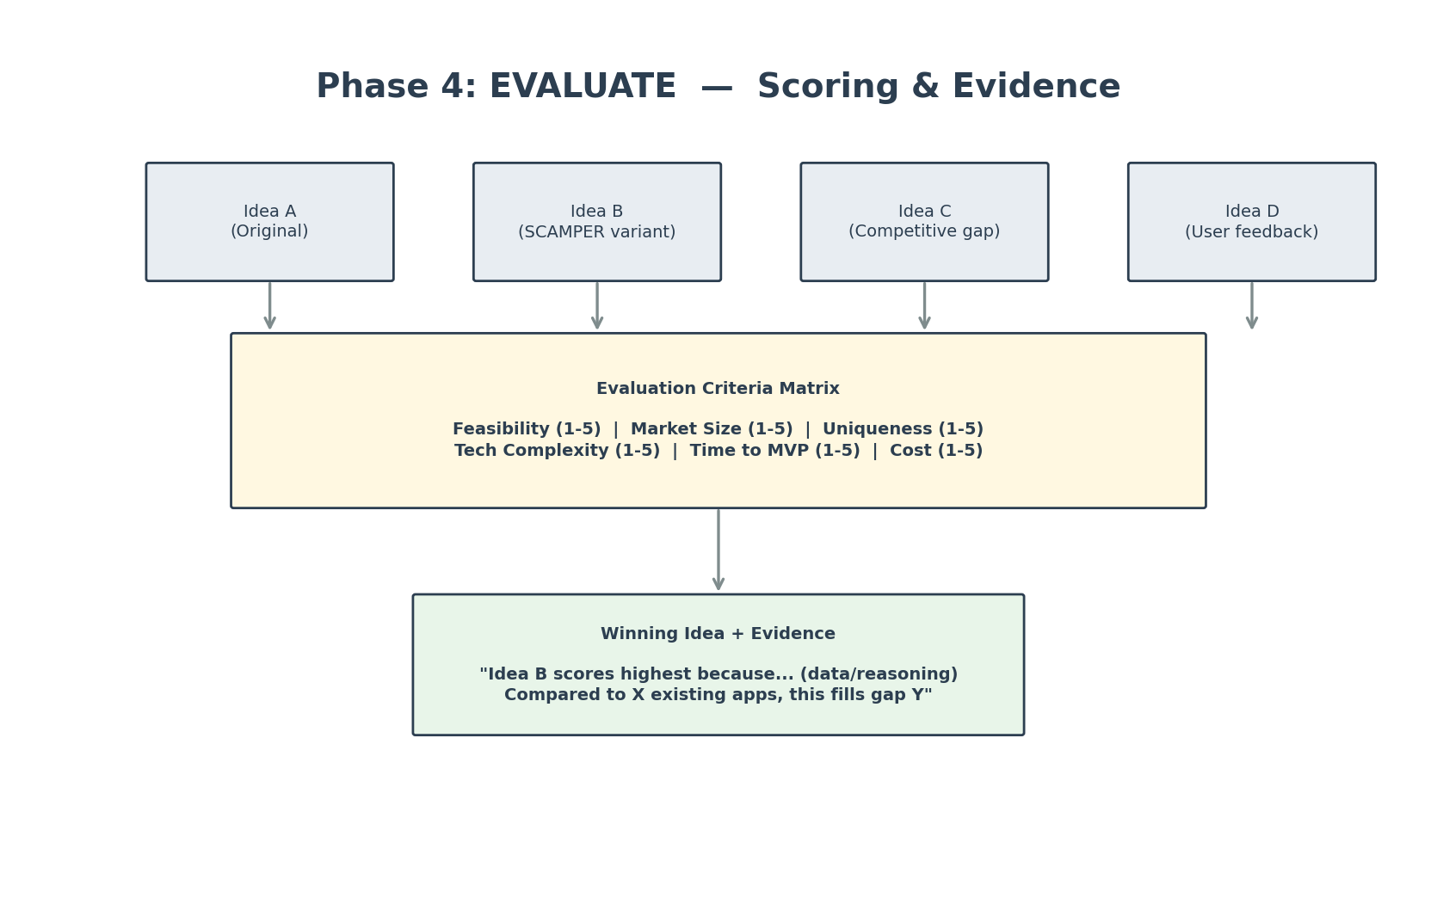
Figure 6: Evaluation — 4 ideas scored on 6 criteria -> winner selected
The 6 Evaluation Criteria
Criterion | Score | What It Measures
Feasibility | 1-5 | Can we actually build this with available tech/APIs/resources?
Market Size | 1-5 | How large is the potential user base? Evidence of demand?
Uniqueness | 1-5 | How different from existing solutions? Defensible advantage?
Tech Complexity | 1-5 | How hard to build? (1=very hard, 5=easy to implement)
Time to MVP | 1-5 | How quickly can a minimal version be built? (1=months, 5=days)
Cost | 1-5 | How expensive to build and run? (1=expensive, 5=cheap)

Example Scoring Matrix
Idea | Feasibility | Market | Unique | Tech | Time | Cost | TOTAL
A: Standard music app | 5 | 4 | 1 | 4 | 4 | 4 | 22
B: Indie discovery + social | 4 | 3 | 4 | 3 | 3 | 3 | 20
C: Artist-pitch-to-listener | 3 | 2 | 5 | 2 | 2 | 3 | 17
D: Curated weekly drops only | 5 | 3 | 4 | 5 | 5 | 5 | 27 (Winner)

The AI must explain WHY each score was given — not just assign numbers.
Scores alone are not enough. The AI should provide evidence: "Idea D scores highest on Time to MVP because it eliminates the need for a real-time streaming backend — only weekly batch uploads are needed."
Prompt to Trigger Phase 4
PROMPT:
"Take the best 4 ideas from your expansion and score each on these 6 criteria
(1-5 each): Feasibility, Market Size, Uniqueness, Tech Complexity, Time to MVP, Cost.
Present as a table with totals.
For each score, write 1 sentence explaining WHY that score.
Recommend a winner with a paragraph of evidence (not just 'highest score').
If any idea is close, explain the trade-offs."

7. Phase 5: CRYSTALLIZE — Final Document
The final output is a structured Idea Specification Document with 12 sections. This document is the INPUT for Practice 2 (Planning).
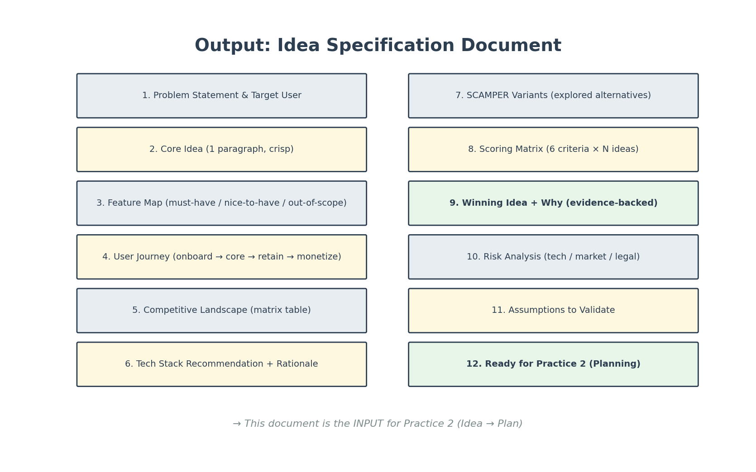
Figure 7: The 12-section Idea Specification Document
# | Section | Content
1 | Problem Statement | What pain point does this solve? For whom? Evidence of need.
2 | Core Idea | One crisp paragraph describing the concept.
3 | Target User | Demographics, tech level, willingness to pay, use frequency.
4 | Feature Map | Must-have (MVP) / Nice-to-have (v2) / Out-of-scope (never).
5 | User Journey | Step-by-step from first open to daily use to monetization.
6 | Competitive Landscape | Table comparing 3-5 competitors: strengths, weaknesses, your gap.
7 | Tech Stack | Recommended technologies with rationale for each choice.
8 | SCAMPER Variants | Alternatives explored and why the winner was chosen.
9 | Scoring Matrix | 6 criteria x N ideas with evidence for each score.
10 | Risk Analysis | Technical, market, legal, dependency risks + mitigations.
11 | Assumptions | What you're assuming is true but haven't validated yet.
12 | Next Step | "This document is ready for Practice 2: Idea to Plan."

Prompt to Trigger Phase 5
PROMPT:
"Compile everything we discussed into an Idea Specification Document with
these 12 sections: Problem Statement, Core Idea, Target User, Feature Map,
User Journey, Competitive Landscape, Tech Stack, SCAMPER Variants,
Scoring Matrix, Risk Analysis, Assumptions, Next Step.
Each section should be specific and evidence-backed.
The Feature Map should clearly separate must-have, nice-to-have, and out-of-scope.
The Competitive Landscape should be a comparison table, not prose.
End with: This document is the input for Practice 2 (Detailed Planning)."

8. Complete Prompt Chain (Copy & Use)
Here is the full sequence of prompts to run a complete ideation session. Copy each prompt in order into your AI conversation.
Phase 1  Seed | I have an idea for a project. DO NOT start building yet.  Ask me AT LEAST 10 clarifying questions organized by category (Who, What, Why, How, Domain).  Wait for my answers.  My idea: [YOUR IDEA]
Phase 2  Clarify | [Answer the AI's questions]  Then: "Based on my answers, do you have follow-up questions? Ask everything you need to fully understand."
Phase 2b  Confirm | "Summarize what you understand about my idea in 1 paragraph. Then list any remaining unclear points."
Phase 3  Expand | "Explore my idea across 6 dimensions: SCAMPER (7 variants), Competitive (3-5 apps), User Journey, Tech Feasibility, Business Model, Risk. Be specific — use real names, APIs, numbers."
Phase 4  Evaluate | "Score the top 4 ideas on: Feasibility, Market Size, Uniqueness, Tech Complexity, Time to MVP, Cost (1-5 each). Table + 1-sentence evidence per score. Recommend a winner with reasoning."
Phase 5  Crystallize | "Compile into a 12-section Idea Specification Document: Problem, Core Idea, Target User, Features (must/nice/out), User Journey, Competition, Tech Stack, SCAMPER, Scoring, Risks, Assumptions, Next Step."

9. Tips & Common Mistakes
Do
- Let the AI ask questions first. If it starts building immediately, stop it.
- Answer questions honestly — short answers are fine, the AI will follow up.
- Challenge the AI: "Are you sure? What about X competitor?"
- Ask the AI to play devil's advocate: "What would a critic say about this idea?"
- Request evidence: "Where is the data that supports this?"
- Use the SCAMPER variants — the best idea is often NOT the original one.
- Iterate: if the scoring matrix looks off, ask "Can you re-score with different weights?"
Don't
- Don't give the AI a 500-word idea — keep the seed short, let the AI expand.
- Don't accept the first answer — always ask "What alternatives exist?"
- Don't skip the question phase — it is the most valuable part.
- Don't trust scores without evidence — demand "Why did you score X as 3?"
- Don't use this for simple tasks — if you know exactly what you want, skip to Practice 2.
When This Practice Is Most Useful
Situation | Use This Practice? | Why
Vague idea, no clear plan | YES | This is exactly what it's for
Two competing ideas, need to choose | YES | The scoring matrix helps decide
Team brainstorm session | YES | Use AI as facilitator, project on screen
Clear idea, just need plan | Skip to Practice 2 | You already know what to build
Fix a bug or add a feature | No | Too specific for ideation

10. What's Next: Practice 2 & 3
The Idea Specification Document from Phase 5 is the INPUT for Practice 2:
Practice | Name | Input | Output
1 (this) | Structured Ideation | Short idea (1-2 sentences) | Idea Specification Document (12 sections)
2 (next) | Idea to Plan | Idea Specification Document | Detailed Implementation Plan (architecture, phases, files)
3 (last) | Plan to Code | Detailed Implementation Plan | Working code via AI prompts

Each practice builds on the previous one. The quality of Practice 3 (code) depends on the quality of Practice 2 (plan), which depends on the quality of Practice 1 (ideation). This is why we start here.

Report generated: 2026-04-16 | Practice 1 of 3: Structured Ideation | Video Editor

