MINI PROJECT – Jags-shopping

Step 1: Create the Project Directory
Purpose: Create a dedicated folder to store all project files.
Step 2: Create the index.html File
Purpose: Create the web page that will be served by NGINX.
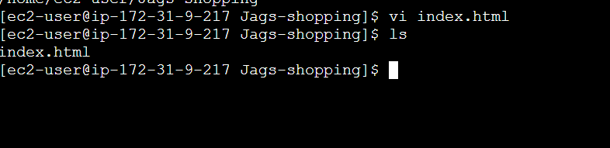
Step 3: Verified the index.html File
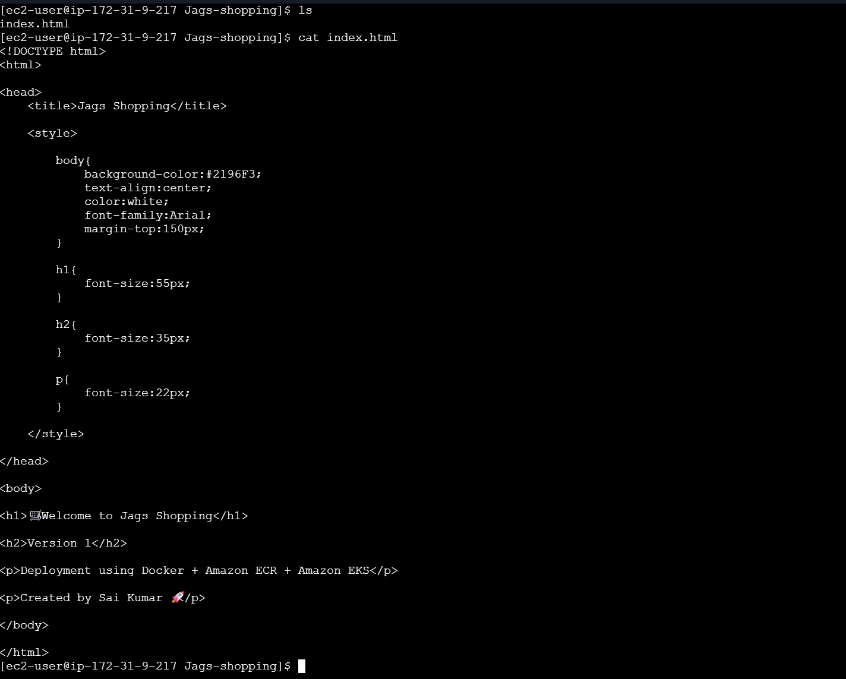
Step 4: Created the Dockerfile
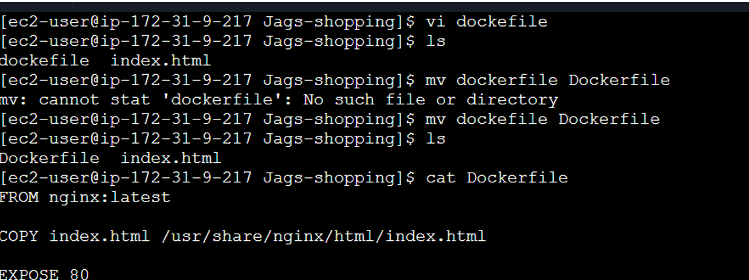

Step 5: Install Docker on the EC2 Instance
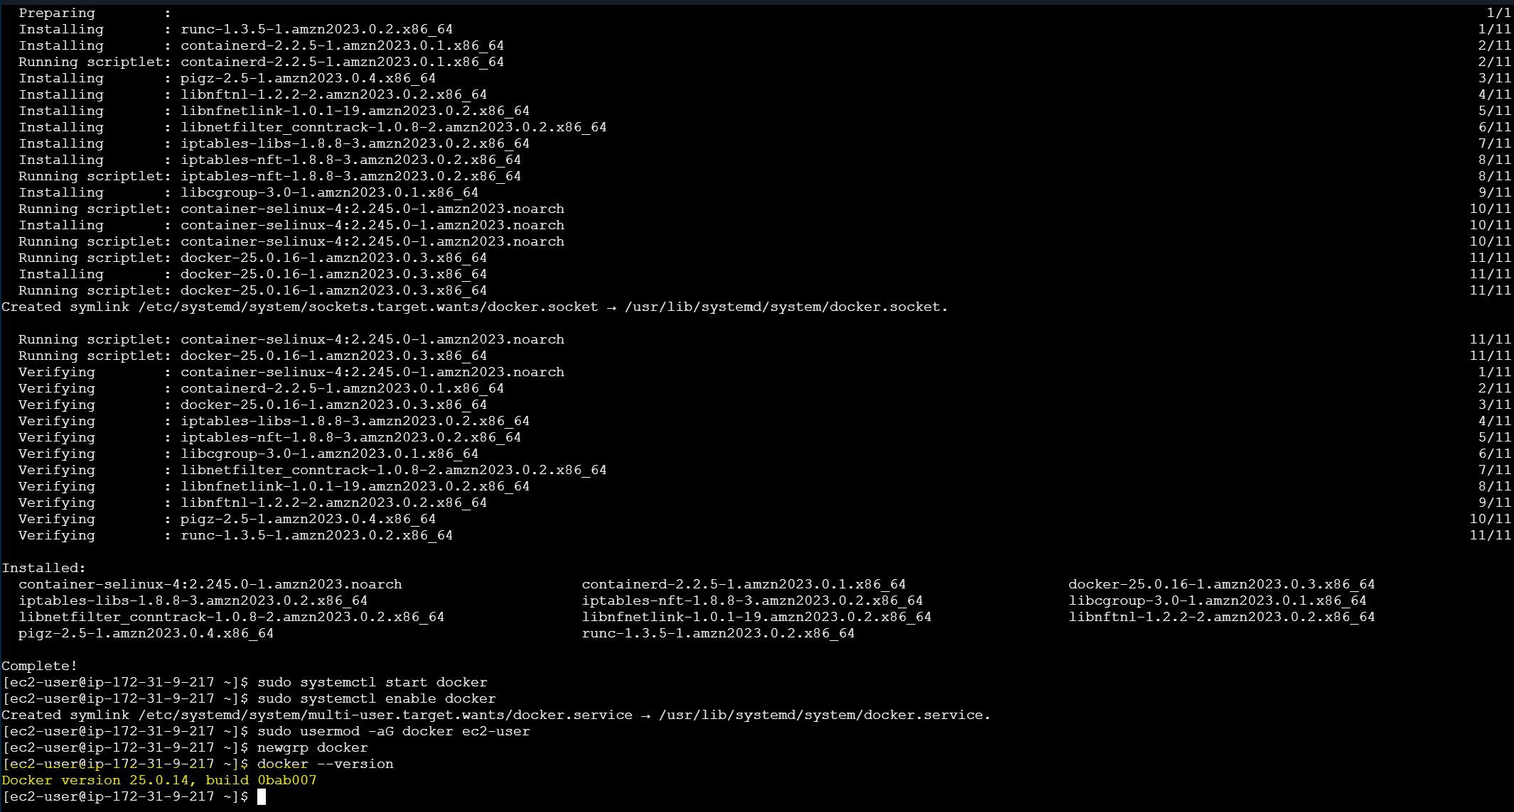
Step 6: Build the Docker Image (Version 1)
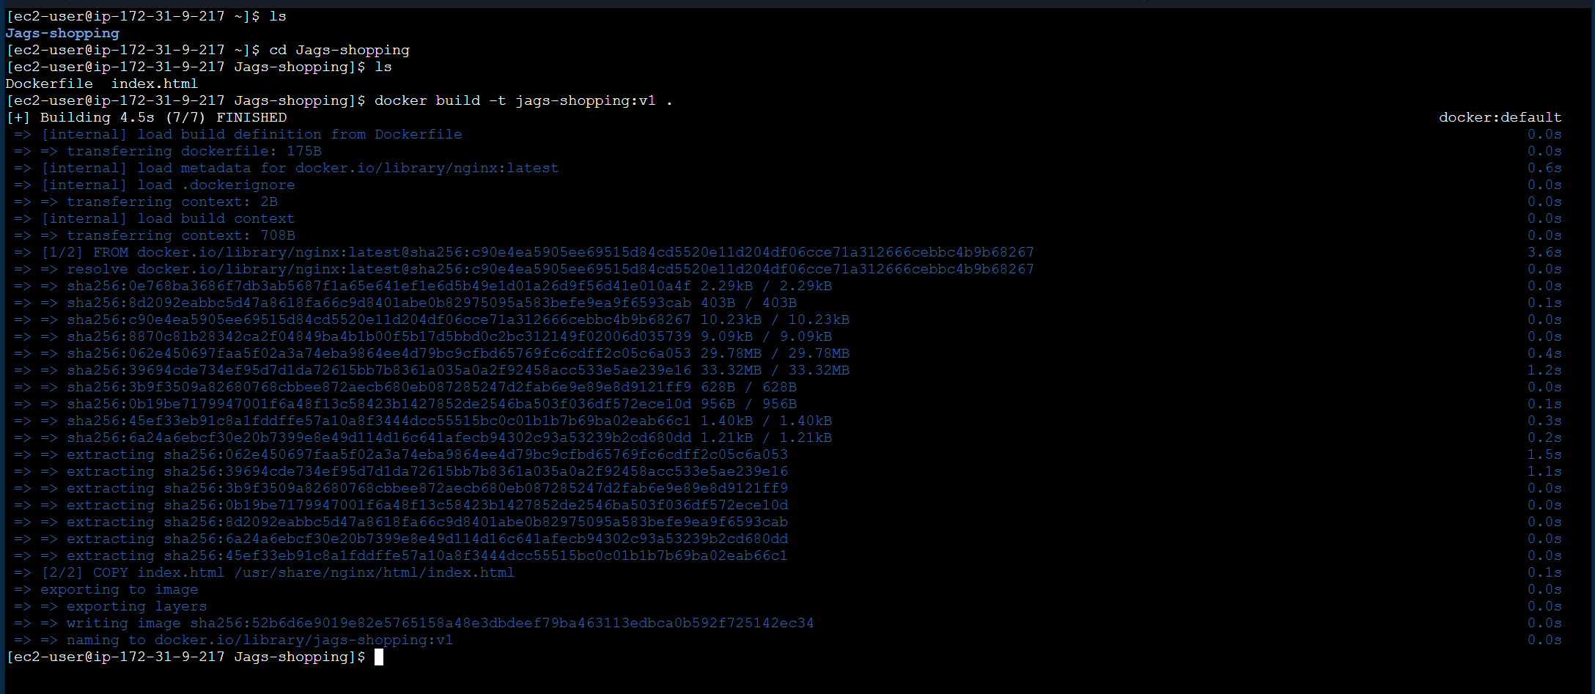
Step 7: During the Docker build process, Docker automatically downloads the nginx:latest image specified in the Dockerfile. NGINX acts as the web server for the application.
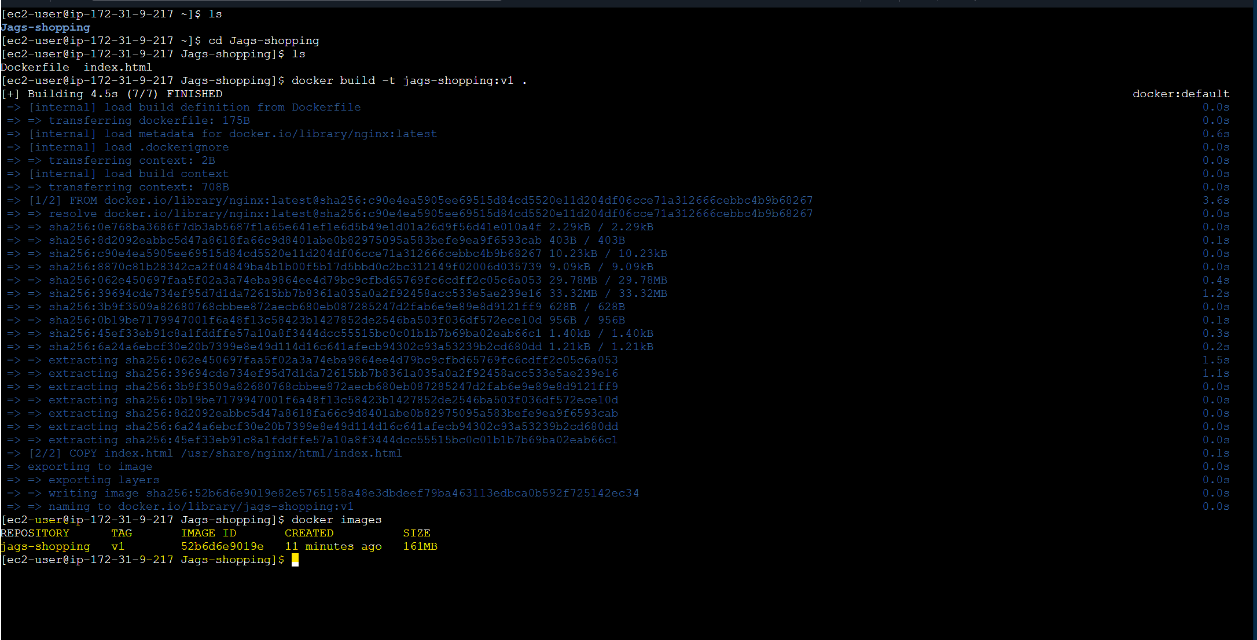
Step 8: Run the Docker Container and Verify It
Step 9: Authenticate Docker with Amazon ECR
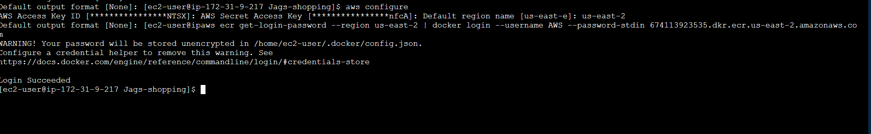
Step 10: Push the Docker Image to Amazon ECR
Step 11: Verify the Image in Amazon ECR
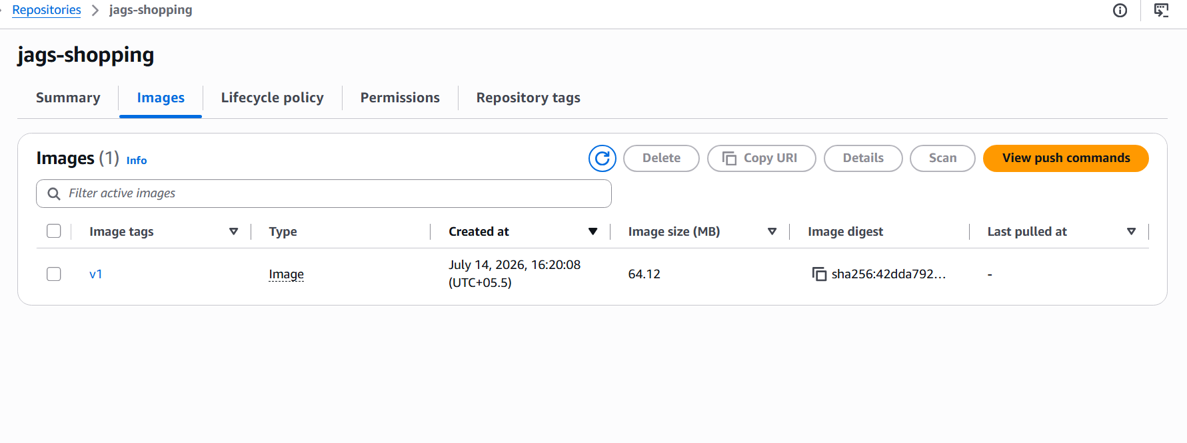
Step 12: Configure kubectl to Access the Amazon EKS Cluster
Note: The .kube/config file is created automatically by the aws eks update-kubeconfig command.
Step 13: Install and Verify kubectl
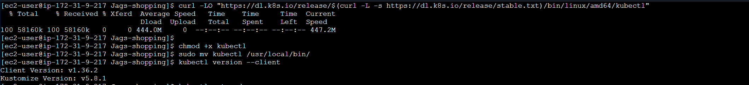
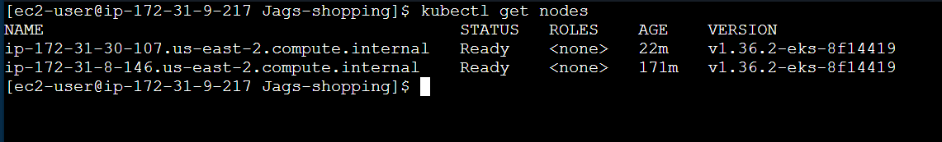
Step 14: Create deployment.yaml Using the Rolling Update Strategy
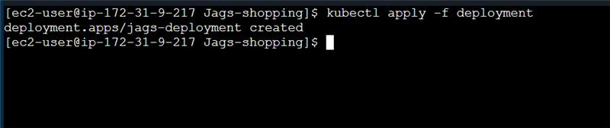
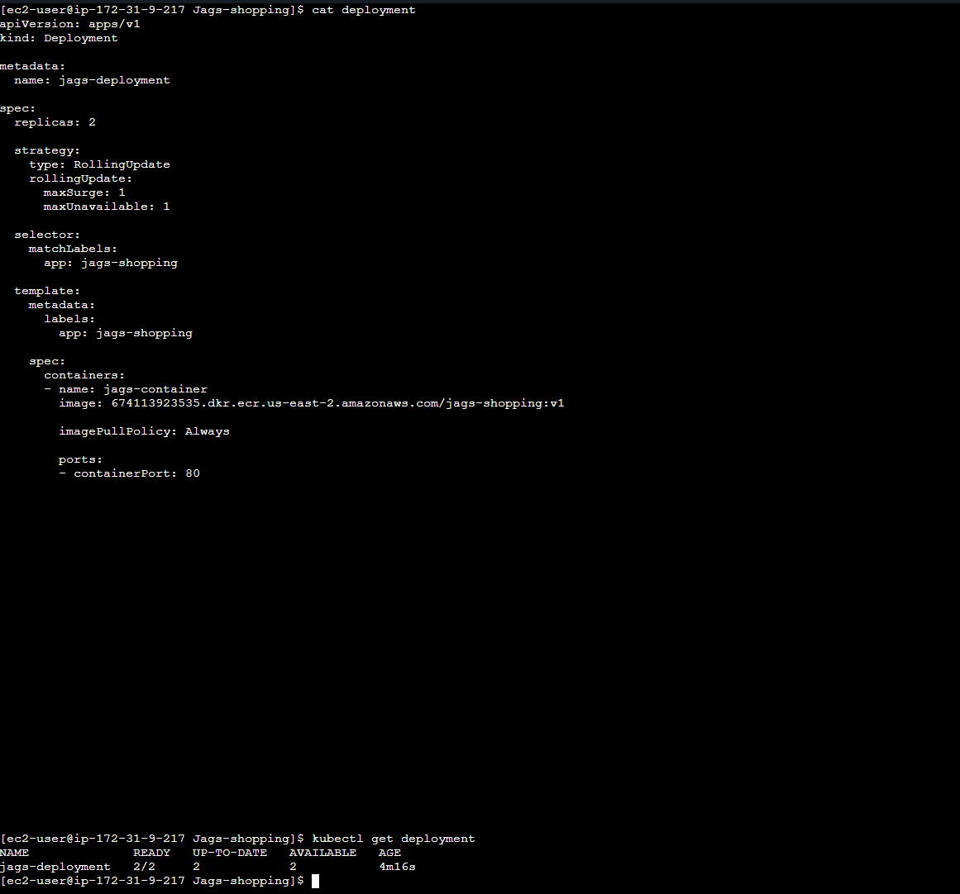

Step 15: Create service.yaml
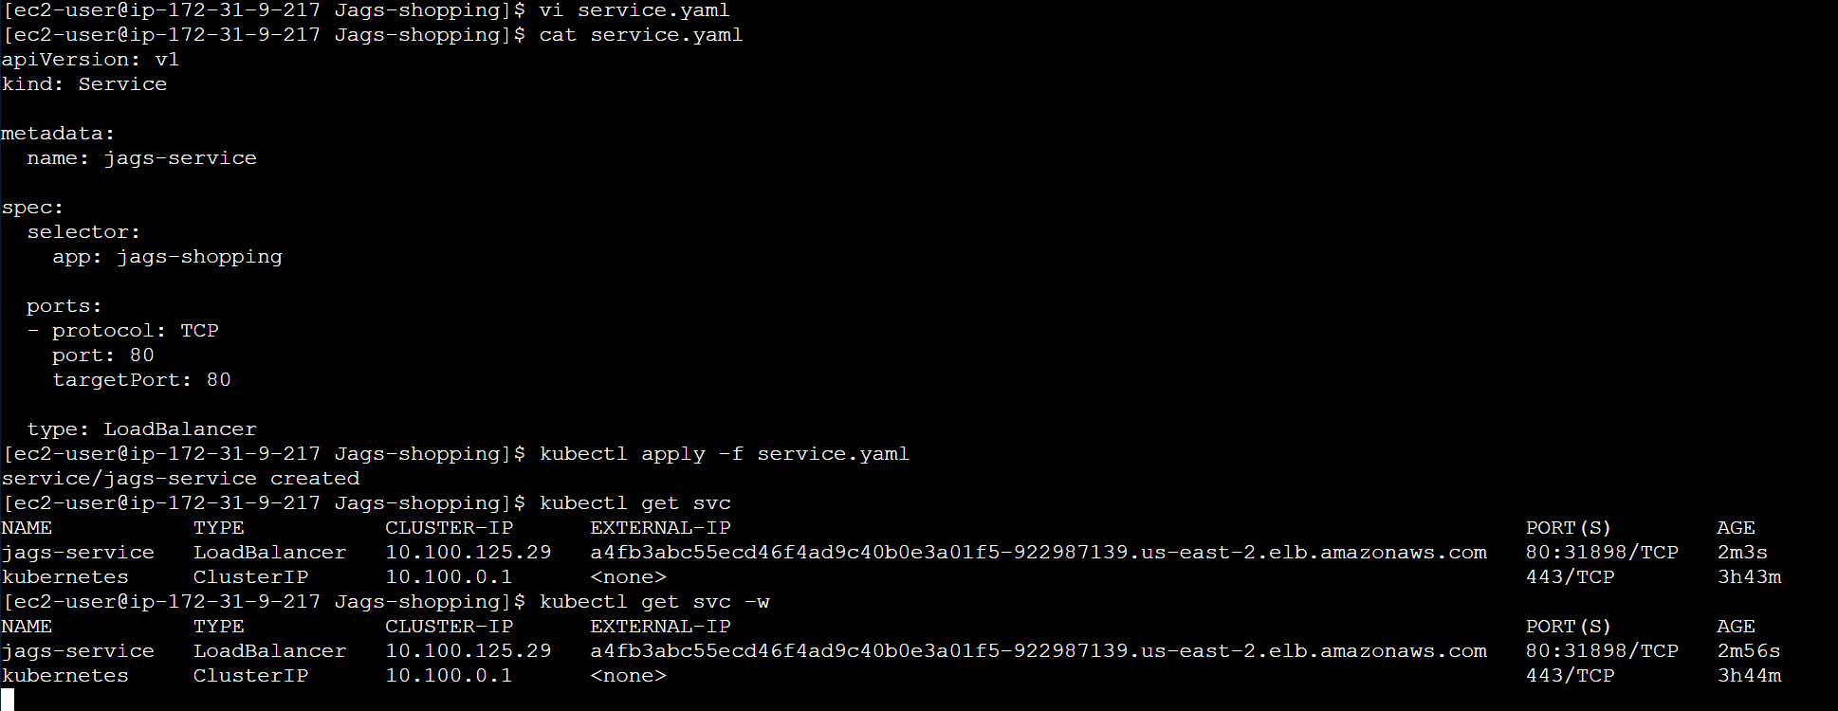
Step 16: Creating a Service of type LoadBalancer automatically provisions an AWS Elastic Load Balancer (ELB).
Note: A Load Balancer is created to expose your Kubernetes Service to users outside the cluster
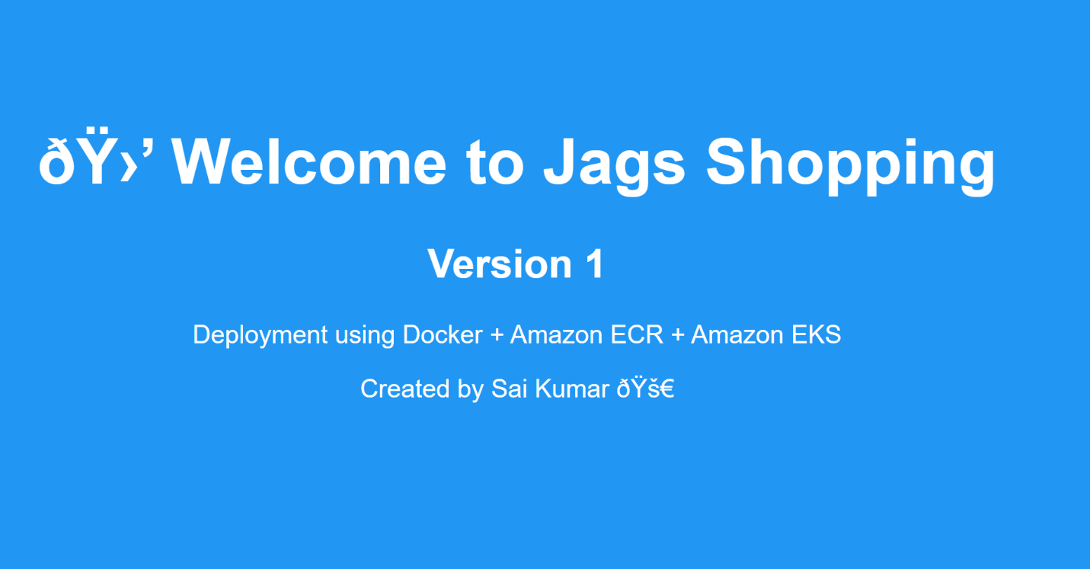
Step 17: Update the Application to Version 2
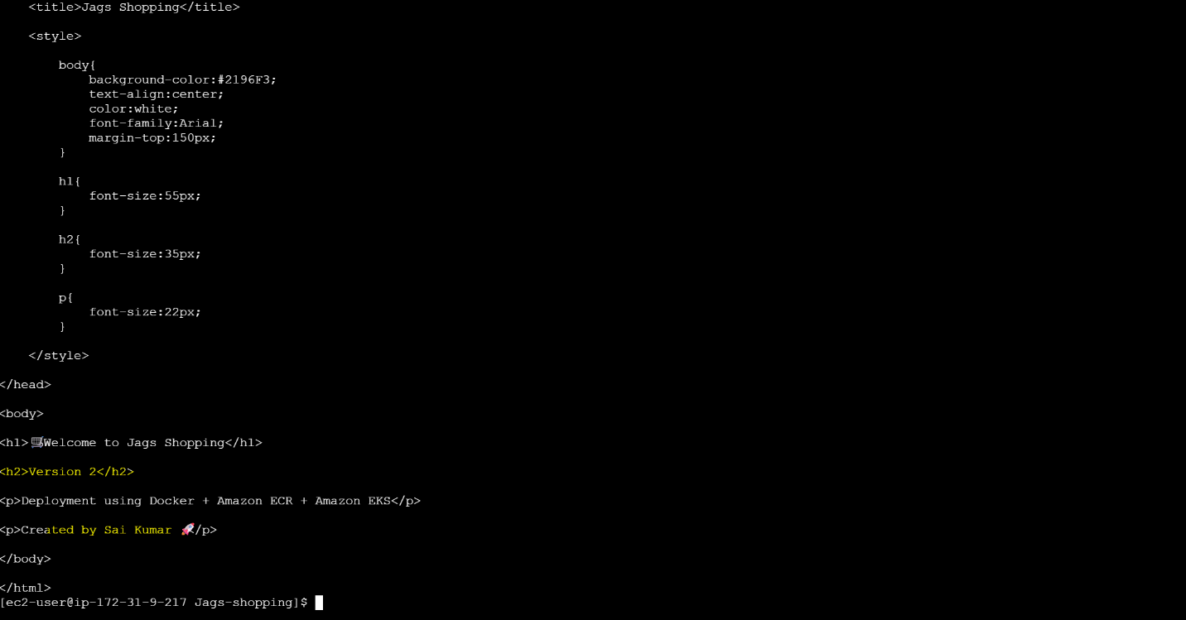
Step 18: Build the Version 2 Docker Image and Verify It
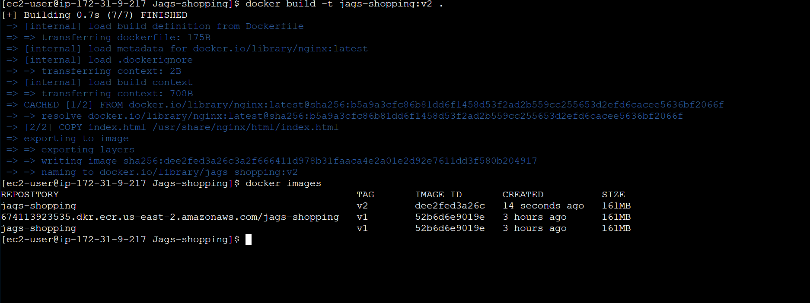
Step 19: Push the Version 2 Image to Amazon ECR
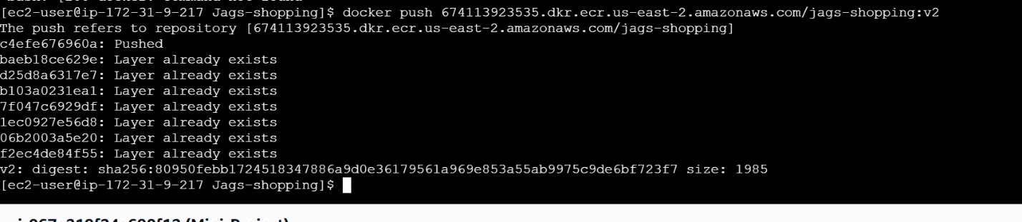
Step 20: Verify Version 2 in Amazon ECR
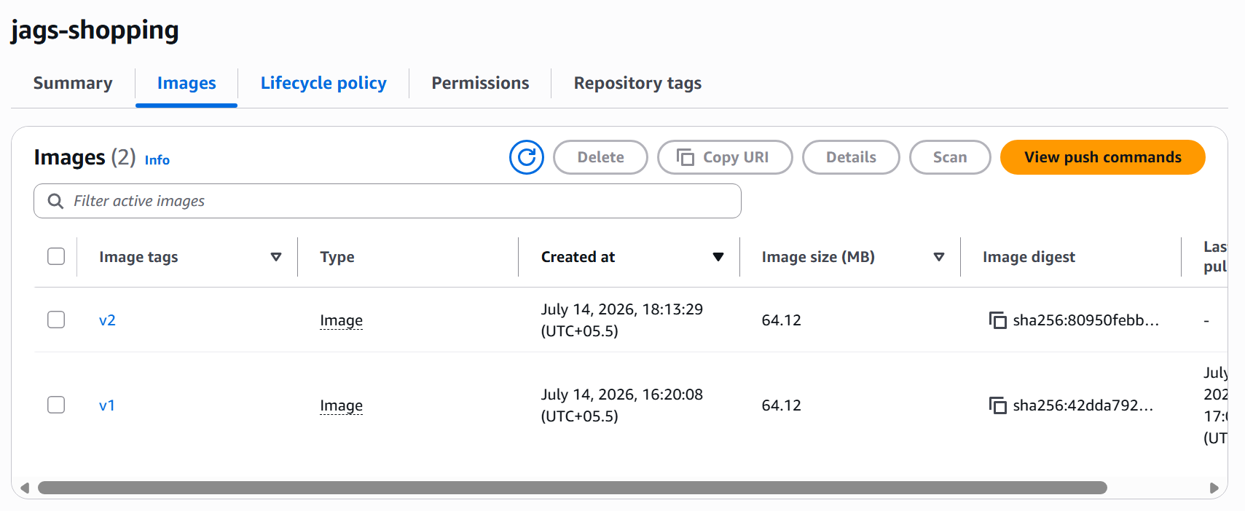
Step 21: Update the Deployment to Use the Version 2 Image
Note: Change only the image tag from v1 to v2.
Note: Don't change app version attribute just change image attribute because we need to edit in docker file not in Kubernets
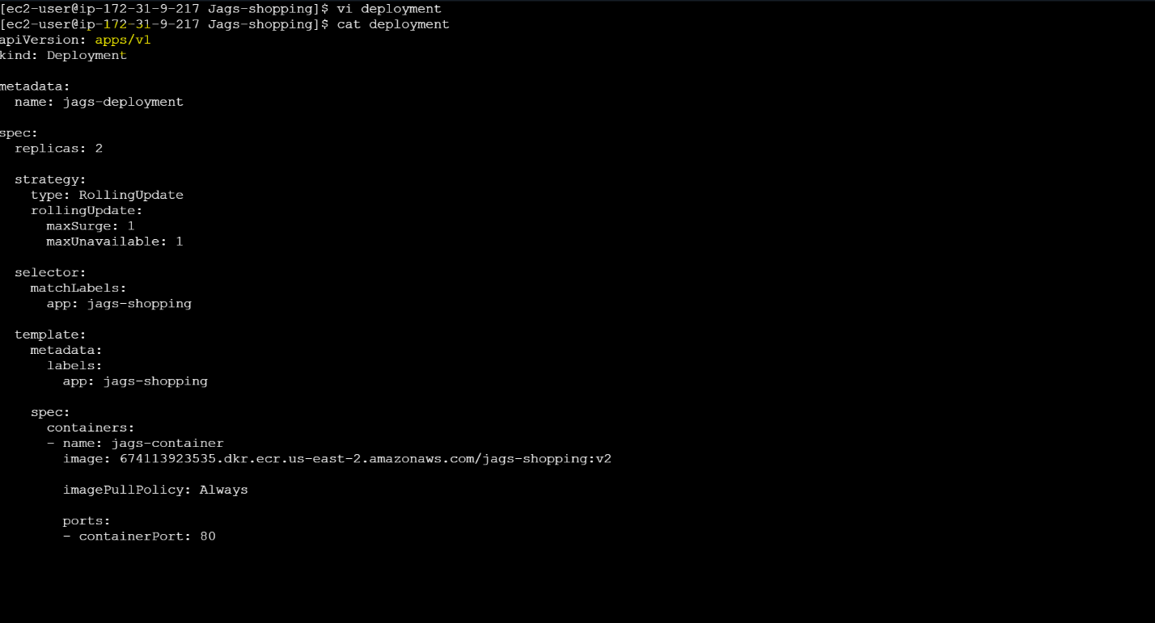
22. Important
The older version of pods are deleted and and v2 are running
NAME DESIRED CURRENT READY
jags-deployment-6f4ff48f7b 2 2 2 ← New ReplicaSet (v2)
jags-deployment-7988857959 0 0 0 ← Old ReplicaSet (v1)
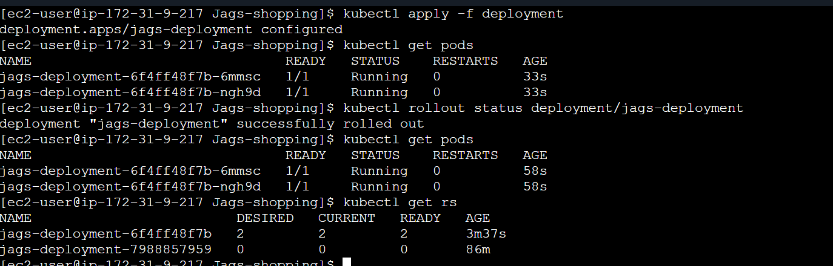
Step 23: Verify the Deployment
I have accessed load balancer endpoint IP and able to see v2
