Exploratory Data Analysis and Visualization for Agribusiness Insights
Week 3 Task: Crop performance, production trends and input (land) utilization in India

1. Objective
The objective is an in-depth exploratory data analysis (EDA) of agribusiness data from a publicly available source. The analysis looks for patterns, trends and relationships using descriptive statistics and visualizations, then proposes variables that may influence agribusiness outcomes and highlights where further analytical work would be most valuable. The focus is crop performance (yield), production trends and input utilization (cultivated area).

2. Dataset description and justification
Source: Government of India open data (data.gov.in), compiled on Kaggle as 'Crop Production in India' (https://www.kaggle.com/datasets/abhinand05/crop-production-in-india). File analysed: crop_production.csv.
After cleaning, the data holds 240,403 district-level records covering 33 states/UTs, 646 districts and 123 crops between 1997 and 2015.
Column | Meaning
State_Name / District_Name | Administrative location of the record
Crop_Year | Agricultural year of the record
Season | Kharif, Rabi, Summer, Autumn, Winter or Whole Year
Crop | Crop name
Area | Area under cultivation (hectares): the land-input measure
Production | Output in tonnes (coconut is in nuts and is excluded)
Yield (derived) | Production / Area, in tonnes per hectare: the crop-performance measure

Why this dataset:
- It comes from official government statistics, so it is publicly verifiable and free to use.
- It is granular (district x crop x season x year), which allows comparisons across place, crop and time.
- It directly supports the three themes in the brief: crop performance (yield), production trends (multi-year series) and input utilization (area under cultivation).
- It is large enough for robust statistics yet simple enough to explain every step.

3. Approach and methodology

3.1 Data cleaning
- Raw rows: 246,091. Missing values were concentrated in: Production (3730).
- Exact duplicate rows removed: 0. Rows with missing Area/Production dropped: 3,730.
- Rows with zero area removed (yield undefined): 0.
- Coconut rows excluded (1,958) because they are measured in nuts, not tonnes.
- Text columns were trimmed of whitespace (e.g. season labels carry trailing spaces).
- Final analysis set: 240,403 rows.
Years with far fewer records than typical (2015) look only partly reported, so they were left out of time-trend analyses to avoid false declines.

3.2 Descriptive statistics
For Area, Production and Yield the analysis computed count, mean, standard deviation, quartiles, median, skewness and kurtosis. Because agricultural quantities span several orders of magnitude, distributions were also inspected on a log10 scale, and non-parametric statistics were preferred where assumptions of normality fail. Outliers were flagged with the 1.5 x IQR rule on log-yield within each crop.

3.3 Visual and inferential techniques
- Histograms (raw vs log) for distribution shape; bar charts for rankings and concentration.
- Line charts with fitted linear trends (OLS regression) for temporal patterns.
- Box plots plus a Kruskal-Wallis test to compare yields across seasons.
- Log-log scatter plot with regression slope as an area-to-output elasticity; Spearman correlation matrix.
- Coefficient of variation (CV) of annual median yield as a simple stability / risk measure.
- Heatmap of median yield across the top states and crops to show geographic performance gaps.

4. Data quality and distributions
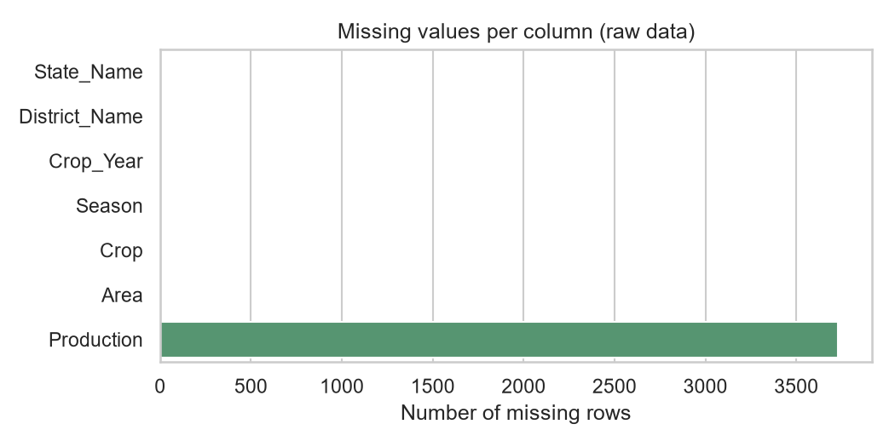
Figure 1: Missing values by column in the raw data.
Variable | Mean | Median | Std | Min | Max | Skew
Area | 12,148.64 | 600.00 | 51,005.68 | 0.10 | 8,580,100.00 | 47.7
Production | 46,565.51 | 705.00 | 400,847.44 | 0.00 | 37,158,000.00 | 29.1
Yield | 9.08 | 1.00 | 568.84 | 0.00 | 88,000.00 | 129.5

Interpretation. Production has a mean of 46,566 t but a median of only 705 t, and Area shows the same gap (mean 12,149 ha vs median 600 ha). With skewness of 29.1 for production, a few very large district-crop records dominate the averages, so medians and log scales describe the typical record better. About 2.95% of records (7,083) are yield outliers within their crop; some may be genuine high performers, others likely data-entry or unit errors, so they are kept but treated carefully (medians, log scale).
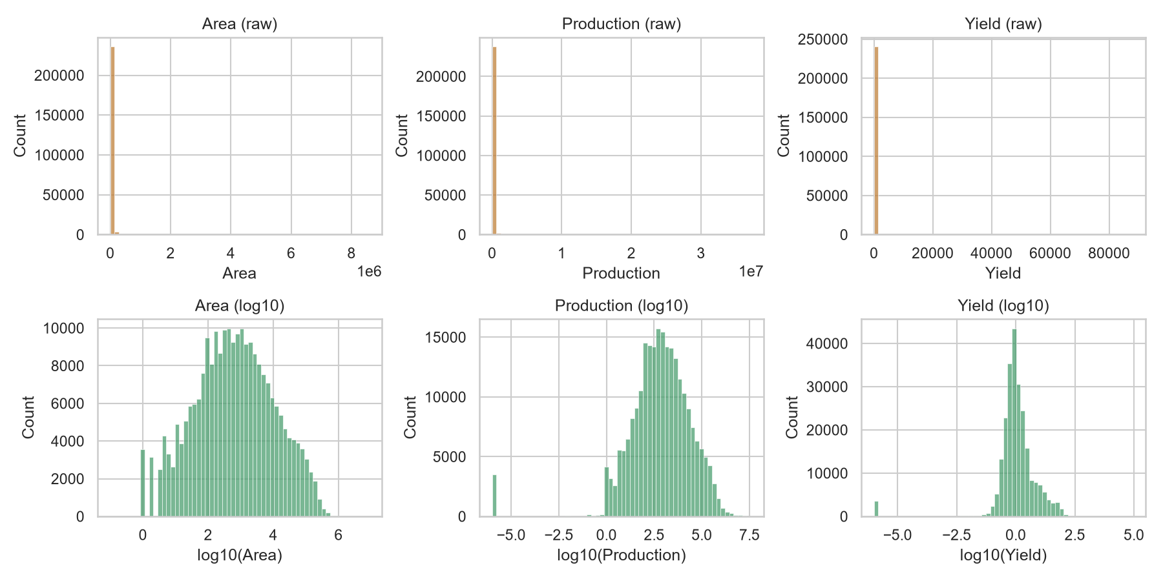
Figure 2: Distributions of Area, Production and Yield, raw (top) and log10 (bottom).

5. Production trends and market concentration
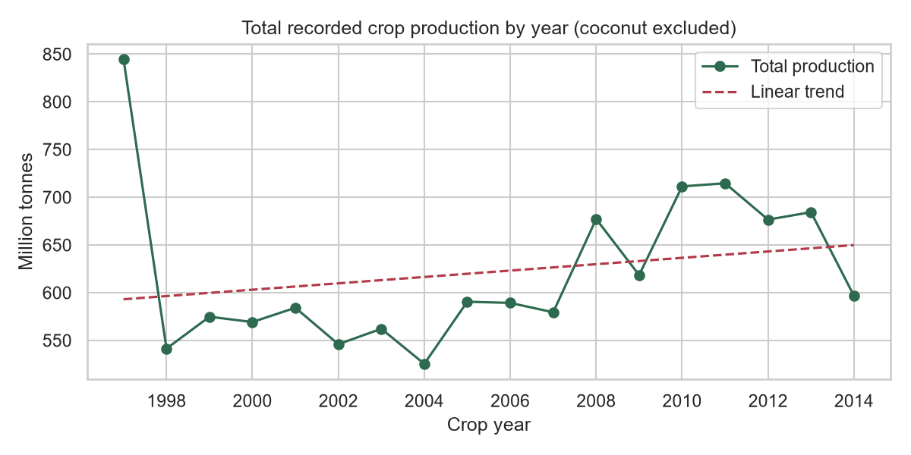
Figure 3: Total recorded production by year with linear trend.
Interpretation. Recorded production moved from 844.89 million tonnes in 1997 to 596.73 million tonnes in 2014 (-29%). The fitted trend is +3.34 Mt per year (R-squared 0.048) and is not statistically significant at the 5% level. Because coverage of districts can change between years, part of any rise may reflect reporting rather than real growth; this is flagged as a limitation.
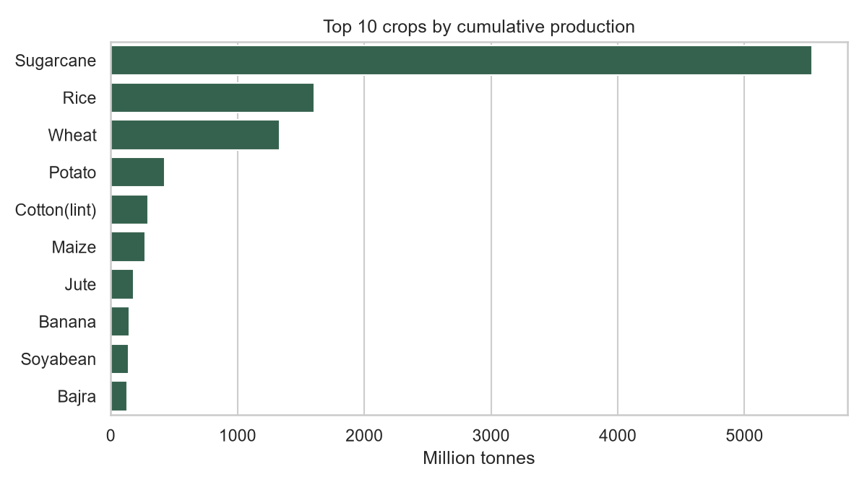
Figure 4: Top 10 crops by cumulative production.
Interpretation. Sugarcane is the largest crop by recorded tonnage (49.45% of the total), followed by Rice (14.34%) and Wheat (11.91%). The top three crops together make up 75.7% of tonnage. Tonnage favours bulky crops, so these shares show volume rather than value; agribusiness decisions should be weighted by price as well.
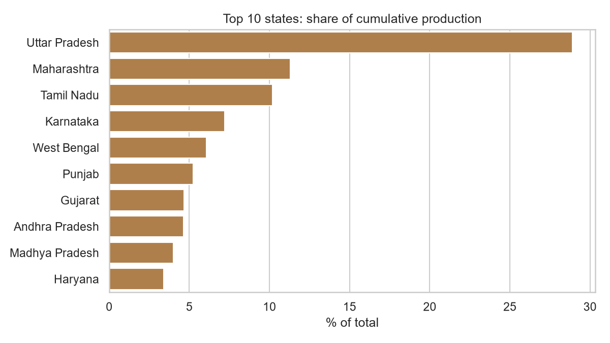
Figure 5: Share of cumulative production by state.
Interpretation. Production is geographically concentrated: the top five states account for 63.6% of output, led by Uttar Pradesh (28.89%) and Maharashtra (11.29%). For input suppliers, processors and logistics firms, these regions represent the densest demand and supply, while also meaning shared exposure to regional weather or policy shocks.

6. Crop performance (yield)
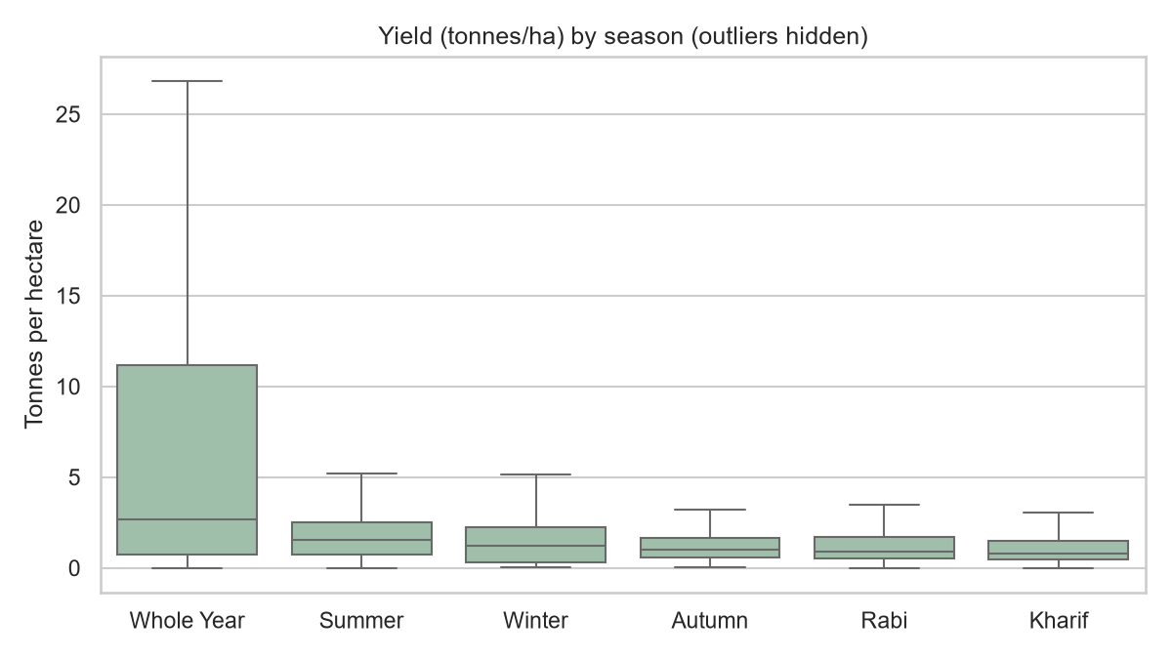
Figure 6: Yield by season.
Interpretation. Median yield is highest in the Whole Year season (2.66 t/ha) and lowest in Kharif (0.81 t/ha). A Kruskal-Wallis test gives H = 19901.43 and the difference in yield between seasons is statistically significant (p < 0.05). Note that season is partly a proxy for crop mix (different crops are grown in different seasons), so this should be read together with the crop-level views.
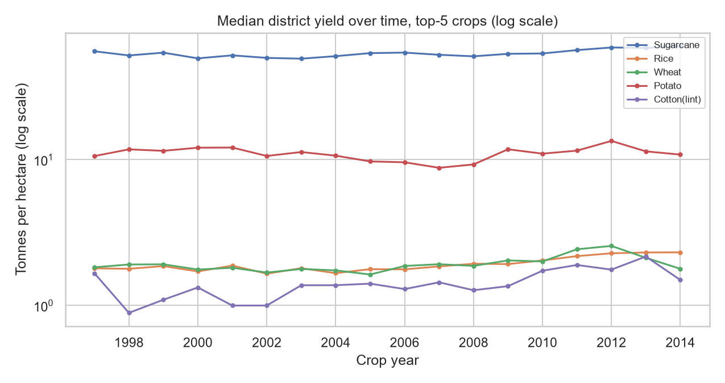
Figure 7: Median district yield over time for the top-5 crops.
Crop | Slope (t/ha/yr) | Change per year | p-value | Significant
Sugarcane | +0.377 | +0.70% | 0.005 | Yes
Rice | +0.033 | +1.71% | 0.000 | Yes
Wheat | +0.024 | +1.27% | 0.021 | Yes
Potato | +0.001 | +0.00% | 0.992 | No
Cotton(lint) | +0.041 | +2.90% | 0.003 | Yes

Interpretation. The top-5 crops show a significant upward yield trend for Sugarcane, Rice, Wheat, Cotton(lint); no clear trend (stagnation or noise) for Potato. Crops with stagnant yields are candidates for agronomic support, better seed varieties or extension services, whereas rising yields signal technology or input improvements that are working.
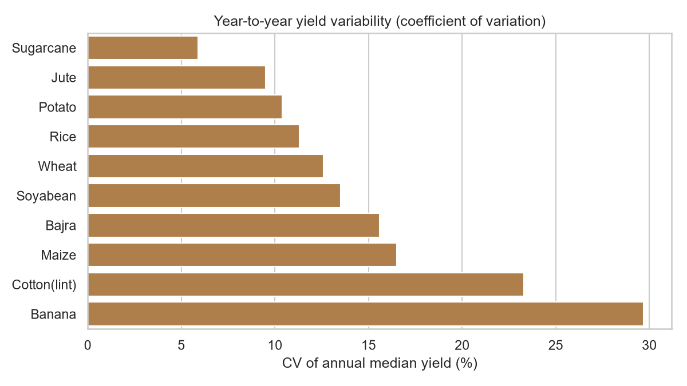
Figure 8: Year-to-year yield variability among top-10 crops.
Interpretation. Sugarcane has the steadiest yield (CV 5.9%), whereas Banana is the most variable (CV 29.7%). Higher variability implies higher production risk, relevant to contract farming, crop insurance pricing and procurement planning.
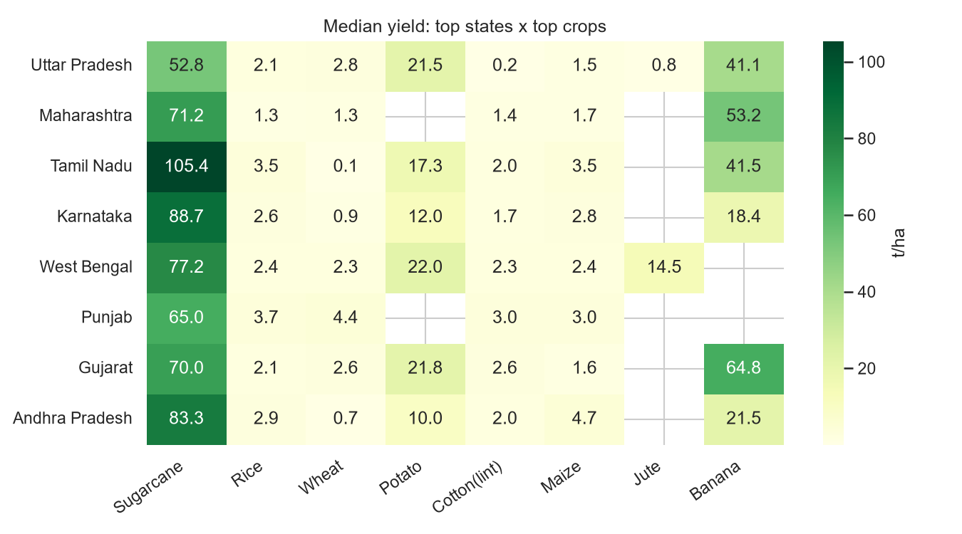
Figure 9: Median yield by state and crop (top 8 each).
Interpretation. Even within the same crop, yields differ widely by state. Among the displayed pairs the highest median yield is Sugarcane in Tamil Nadu (105.39 t/ha) and the lowest is Wheat in Tamil Nadu (0.05 t/ha). Gaps within the same crop point to differences in irrigation, soil, inputs and practice that could be closed, and so to where extension and input investments might earn the best return.

7. Input utilization: area versus production
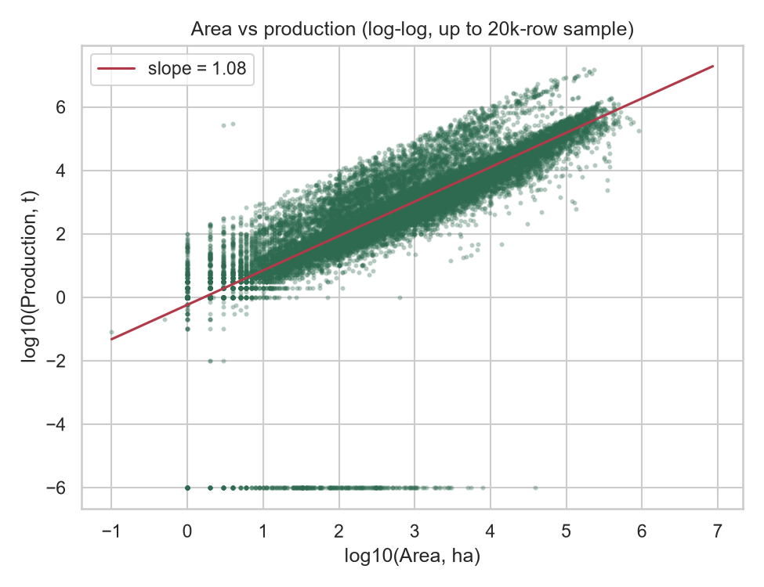
Figure 10: Area vs production (log-log).
Interpretation. Area and production are strongly rank-correlated (Spearman rho = 0.894). On the log-log scale the slope is 1.085 (R-squared 0.597), close to 1, meaning output scales almost proportionally with land. The R-squared shows that area alone explains about 60% of the variation in production on the log scale; the remainder is driven by crop type, yield level and other factors, which motivates the crop- and region-level analysis above.
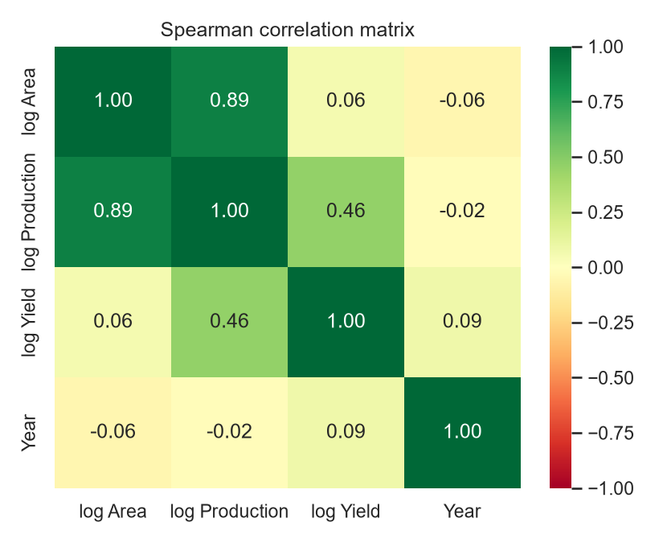
Figure 11: Spearman correlation matrix.
Interpretation. Year is only weakly related to log-yield (rho = 0.085), so across all crops pooled together there is little time-driven yield signal, which fits the crop-level picture: gains are crop- and place-specific rather than universal.

8. Key insights for agribusiness decisions
- Concentration: the top three crops make up 75.7% of tonnage and the top five states 63.6% of output. Supply-chain and processing investments will find scale in these hubs, but face correlated risk.
- Yield gaps: the same crop performs very differently across states, so closing gaps is likely a bigger lever than expanding area.
- Risk: yield volatility differs by crop (see Figure 8); contracts, insurance and storage should be priced by crop-specific risk.
- Land use: output scales with area (log-log slope 1.085), but area explains only part of production; productivity-enhancing inputs matter.
- Seasonality: yield and mix differ by season, which affects logistics, storage capacity and working-capital cycles.

9. Variables likely to influence agribusiness outcomes
Based on the patterns above, these are the variables worth adding or modelling next:
Variable | Why it matters | Possible public source
Rainfall / temperature | Main driver of year-to-year yield variability | India Meteorological Department
Irrigated area share | Likely explains state-level yield gaps | Land Use Statistics, Ministry of Agriculture
Fertilizer and seed use | Direct input-to-yield link | Fertiliser Association of India, data.gov.in
Market prices (MSP, mandi prices) | Converts tonnage into revenue and drives crop choice | Agmarknet, CACP
Soil type / quality | Explains within-state heterogeneity | Soil Health Card data
Season and crop type | Already shown to separate yield levels | In this dataset

10. Limitations and next steps
- The dataset records quantities, not prices or costs, so profitability cannot be assessed directly.
- Yield is derived (Production / Area); reporting errors in either field distort it. Outliers were retained.
- Correlation is not causation: season, crop and state effects are intertwined.
- Reporting coverage may vary across years and districts, which can distort trends.
- Next steps: merge weather and price data, fit a multivariable model (e.g. regression with crop and state fixed effects, or gradient boosting) for yield, and run forecasting for production planning.

11. Tools and methodology used
Tool | Purpose
Python 3 | Analysis language
pandas, NumPy | Data cleaning, aggregation, derived variables
SciPy | Spearman correlation, linear regression, Kruskal-Wallis test
Matplotlib, Seaborn | All charts
python-docx | Automatic generation of this report
Git / GitHub | Version control and sharing; full code and instructions in the repository

Reproducibility: run python src/eda.py then python src/build_report.py (see README.md).

