Predictive Modeling for Agribusiness Insights: Crop Yield Prediction
Week 4 Task: Development, tuning and evaluation of a predictive model for crop yield in India

1. Introduction and objectives
Agribusiness firms, lenders, insurers and policy makers all need a view of how much a crop is likely to yield before the harvest is in. This project simulates how data science is applied to that problem: it builds a predictive model that estimates the yield (tonnes per hectare) of a crop in a district, using historical records, and evaluates how well it would have performed on years it has never seen.
Objectives:
- Frame yield estimation as a supervised regression problem and justify the modeling approach.
- Engineer features from location, crop, season, land area and each series' own history.
- Compare a simple baseline against linear, bagged-tree and boosted-tree models; tune the best family.
- Evaluate honestly with a time-based hold-out, several metrics and an ablation of the history features.
- Interpret the model outputs for agribusiness decisions and discuss challenges and improvements.

2. Problem formulation and data
Target: crop yield = Production / Area (tonnes per hectare), modeled as log(1 + yield) because yields are strongly right-skewed and differ by orders of magnitude between crops (for example sugarcane versus pulses). Predictions are converted back to tonnes per hectare for reporting.
Data: 'Crop Production in India' (data.gov.in, compiled on Kaggle: https://www.kaggle.com/datasets/abhinand05/crop-production-in-india); file used: crop_production.csv. This is the same public dataset explored in Week 3. After cleaning and keeping fully reported years, the modeling table has 234,782 district-level records covering 104 crops and 33 states/UTs.

3. Assumptions
- Reported Area and Production are accurate enough that Production / Area is a valid yield; extreme values were treated as errors (see preprocessing).
- Coconut is excluded because it is recorded in nuts while all other crops are in tonnes.
- The scenario is a one-year-ahead forecast: when predicting year t, the model may use the observed yield of the same district, crop and season in earlier years, but never year t itself.
- Cultivated area for the target year is known at prediction time (sowing area is typically reported or estimated before harvest).
- Weather, irrigation, prices and input use are not in the dataset, so their effect appears only indirectly through location, season and past yield.
- Patterns in earlier years are assumed to remain broadly valid in the following years (no structural break).

4. Preprocessing steps
- Started from 246,091 raw rows. Text fields were trimmed, exact duplicates and rows with missing values or zero area were removed, leaving 236,881 rows.
- Extreme yield outliers (beyond 3 x IQR of log-yield within each crop) were removed: 1,541 rows. These are almost certainly unit or data-entry errors and would dominate squared-error losses.
- Years with far fewer records than usual look incompletely reported and are excluded: 2015.
- Categorical variables were one-hot encoded for the linear model and ordinal-encoded for tree models; unseen categories at prediction time are handled safely.
- Missing history values (first year of a series) are imputed with the median plus a missing-indicator for linear and random-forest models; gradient boosting handles missing values natively.
- Numeric inputs were standardised for the linear model only (trees do not need scaling).

5. Feature engineering and feature selection
Feature | Type | Reason
Crop | Categorical | Crop is the strongest single determinant of yield level
State_Name | Categorical | Captures regional agro-climate, soil and farming practice
Season | Categorical | Kharif / Rabi / Summer cropping conditions differ
Crop_Year | Numeric | Captures slow technology and productivity trends
log_area | Numeric (engineered) | Scale of cultivation; log tames the heavy skew
yield_lag1 | Numeric (engineered) | Same district-crop-season yield in the previous year
yield_prior_mean | Numeric (engineered) | Mean log-yield of all earlier years for that series

Leakage control: the two history features are built only from years strictly before the row's year, and the train/test split is by time, so no information from the test period is used in training.
Feature selection was done by domain reasoning (a deliberately small feature set) and verified afterwards with permutation importance on the held-out years. District name was not used as a feature because it has hundreds of levels and the district's own history already carries that information.

6. Modeling approach and rationale
Four model families were compared against a simple baseline, ordered from simple to flexible:
Model | Why it was included
Baseline: crop median | Minimum bar. Any useful model must beat 'predict the typical yield of this crop'
Ridge regression | Interpretable linear benchmark with regularisation against collinearity
Random forest | Bagged trees: captures non-linearity and interactions, robust to noise
Gradient boosting (HistGradientBoosting) | Usually the strongest on tabular data; native categorical and missing-value support; fast

Why regression on log-yield: the outcome is a continuous quantity, and modeling the log makes errors relative rather than absolute, which is what matters when crops range from under 1 to over 50 tonnes per hectare.

7. Model training, tuning and validation
Validation design: a time-based hold-out. Models were trained on 1997-2011 (197,786 records) and tested on 2012-2014 (36,996 records). A random split would mix years and overstate accuracy, because the future would leak into training. History features were available for 87.8% of test records.
Hyper-parameter tuning: randomized search (10 candidates, 3-fold cross-validation, 60,000 training rows, scored by mean absolute error on the log scale). Selected parameters:
Parameter | Value
l2_regularization | 0.1
learning_rate | 0.03416
max_iter | 400
max_leaf_nodes | 127
min_samples_leaf | 50

Cross-validated R-squared of the tuned model on the training subsample was 0.958 (standard deviation 0.002 across folds), indicating stable performance.

8. Performance metrics and evaluation criteria
Metric | What it tells us
MAE (t/ha) | Average size of the error in the crop's own units; easy to explain to farmers and buyers
RMSE (t/ha) | Like MAE but penalises large misses more; dominated by high-yield crops such as sugarcane
R-squared (log scale) | Share of variation in log-yield explained. Inflated by large differences between crops, so read with the improvement over baseline
Median absolute % error | Typical relative error of one prediction: the most intuitive accuracy measure here
Share within +/-25% | Share of predictions that land within a quarter of the true yield (practical usability)
Improvement over baseline | How much lower the error is than the crop-median baseline: the real measure of added skill

Success criteria used: (1) the model must beat the baseline on the unseen test years; (2) train and test performance must be close (no overfitting); (3) errors should be unbiased (residual mean near zero); and (4) performance should be reasonable across the major crops, not only on average.

9. Results
Model | MAE (t/ha) | RMSE (t/ha) | R2 (log) | Median % error | Within 25%
Baseline (crop median) | 2.20 | 6.86 | 0.812 | 36.4% | 35%
Ridge regression | 1.53 | 5.12 | 0.906 | 26.4% | 48%
Random forest | 1.14 | 4.59 | 0.915 | 15.1% | 67%
Gradient boosting (default) | 1.07 | 4.24 | 0.939 | 15.3% | 68%
Gradient boosting (tuned) | 1.03 | 4.03 | 0.939 | 14.7% | 68%
Gradient boosting (no history features) | 1.26 | 4.62 | 0.918 | 19.5% | 60%

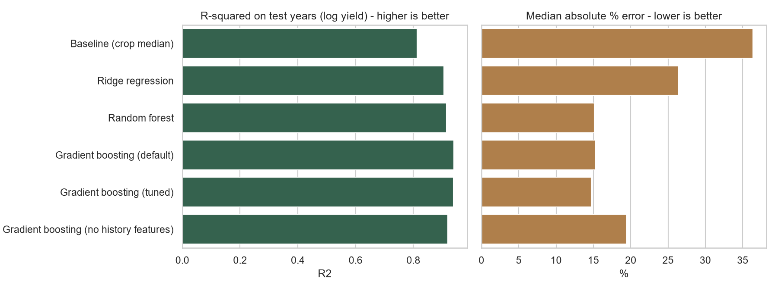
Figure 1: Model comparison on the held-out test years.
Interpretation. The best model is Gradient boosting (default). It reaches a median error of 15.3% and 68% of predictions fall within 25% of the actual yield. Its MAE is 1.07 t/ha versus 2.20 t/ha for the baseline, an error reduction of 51% in t/ha and 51% on the log scale. The high R-squared mainly reflects that crops differ enormously in yield level; the improvement over baseline is the fairer indicator of skill.
Ranked by log-scale MAE: Gradient boosting (tuned) (0.133) < Gradient boosting (default) (0.135) < Random forest (0.147) < Ridge regression (0.194) < Baseline (crop median) (0.277). Tree-based models can pick up non-linear effects and interactions between crop, state and season that a linear model cannot, which is why they are expected to lead; differences among the top models are small enough that simplicity and speed can legitimately drive the final choice.

9.1 Value of history features (ablation)
Removing the two history features from the tuned model raises its log-scale MAE from 0.133 to 0.162 (18% worse) and its median error from 14.7% to 19.5%. The past performance of a district-crop series is therefore a valuable predictor, which supports the design of the feature set.

9.2 Fit quality and residuals
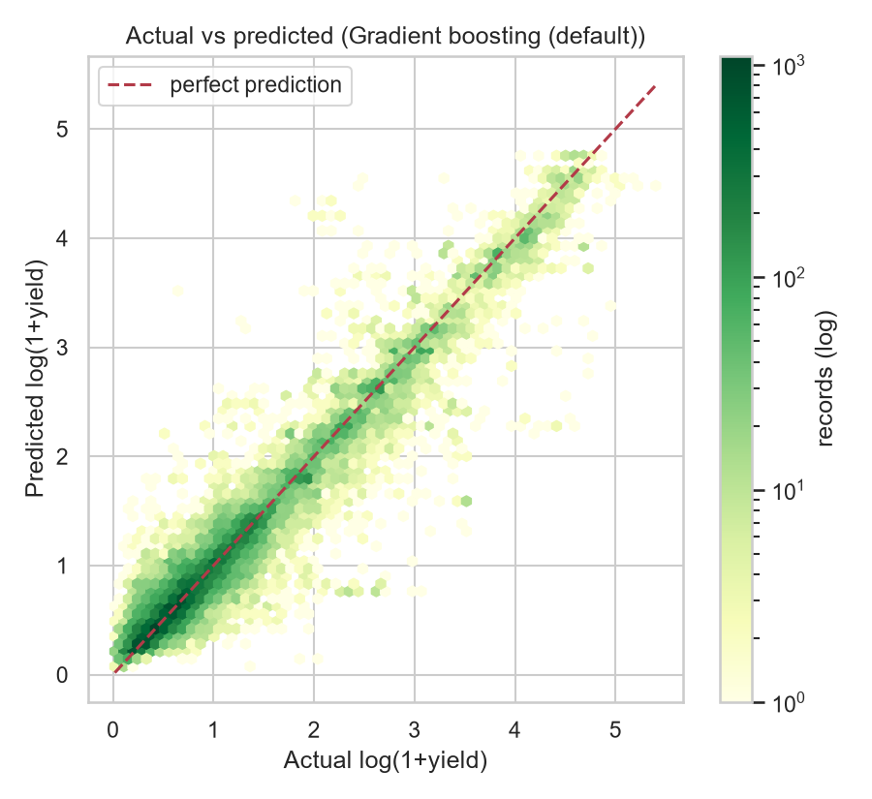
Figure 2: Actual versus predicted log-yield on test years.
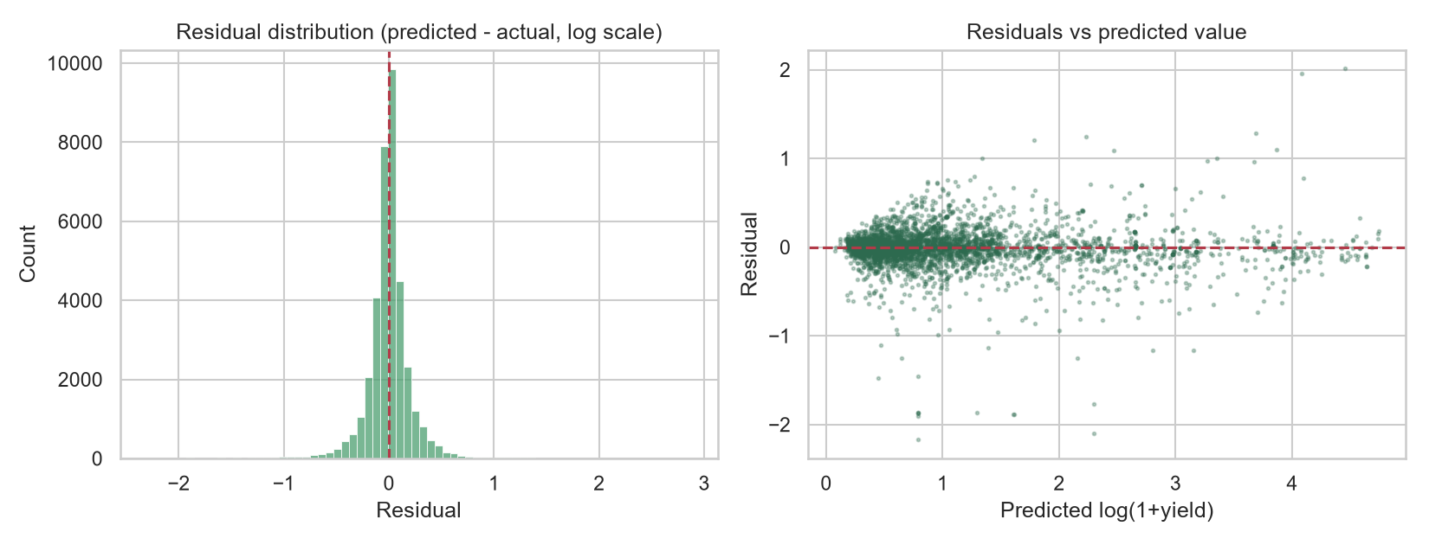
Figure 3: Residual distribution and residuals against predictions.
Interpretation. Points hugging the diagonal in Figure 2 indicate good agreement. The mean residual is -0.007 on the log scale (spread 0.228); a near-zero mean means the model is not systematically over- or under-predicting. Train R-squared is 0.971 against 0.939 on test (gap 0.032), which signals some overfitting; stronger regularisation or simpler trees would help.

10. Interpretation of model outputs for agribusiness
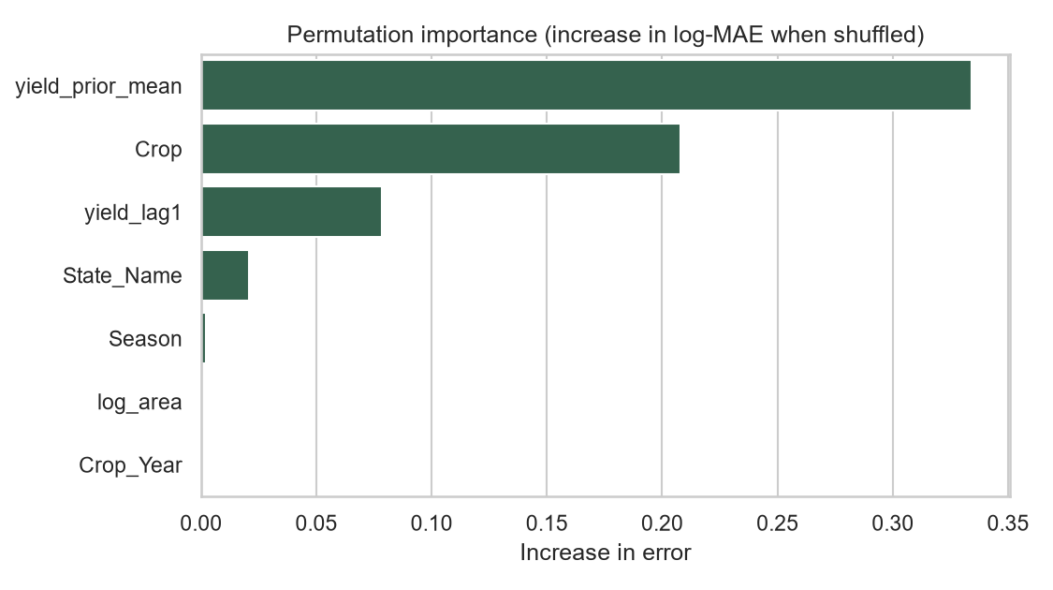
Figure 4: Permutation importance of each feature on test data.
Drivers of yield. Permutation importance measures how much the error grows when a feature is shuffled. The most influential features are yield_prior_mean (0.334), Crop (0.208), yield_lag1 (0.079). Features near zero add little once the others are known. These are associations learned from data, not causal effects.
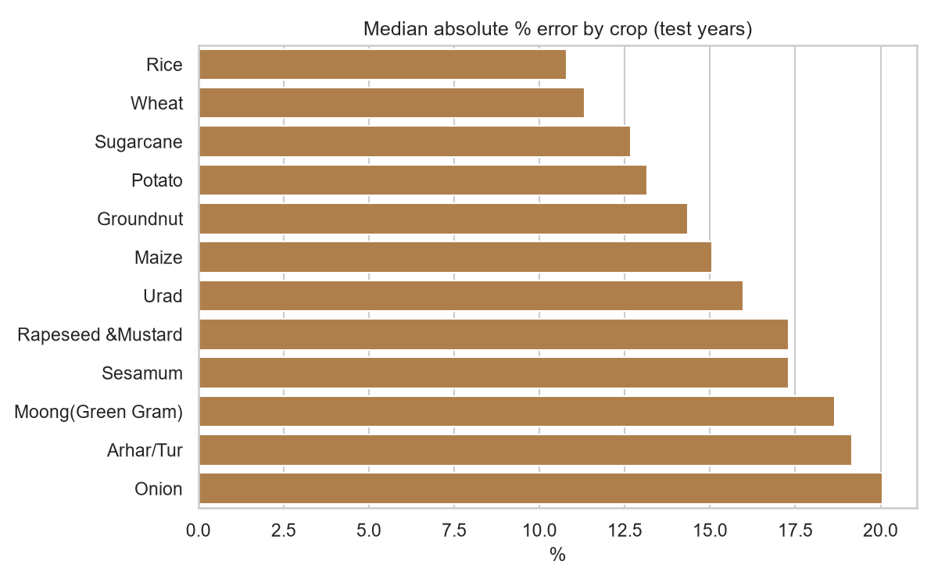
Figure 5: Median absolute percentage error by crop (test years).
Reliability by crop. The most predictable major crop is Rice (median error 10.8%) and the least predictable is Onion (20.1%). Predictions for high-error crops should carry wider safety margins.
How the model could be used in practice:
- Procurement and logistics: turn predicted yield x planned area into expected tonnage to plan storage, transport and processing capacity by district.
- Credit and insurance: flag district-crop combinations whose predicted yield is far below their history as higher risk, and size loans or premiums accordingly.
- Input suppliers: target seed and fertiliser outreach to areas where predicted yield lags the state benchmark.
- Planning with uncertainty: use the median error as a planning band (for example +/- the typical percentage error) rather than treating a prediction as exact.

11. Challenges encountered and strategies for improvement
Challenge | How it was handled / how to improve
Highly skewed target and large differences between crops | Log-transform the target; report relative errors; evaluate per crop
Outliers and likely data-entry errors | Removed 1,541 extreme rows with a per-crop IQR rule; next: validate against source reports
Risk of leakage through history features and random splits | History uses only earlier years; time-based hold-out
No weather, irrigation, price or input data | Largest opportunity: add rainfall, temperature, irrigated-area share and fertiliser use
Missing history for new district-crop series | Imputation with indicators / native handling; fall back to state-crop averages
Overfitting risk of flexible models | Cross-validated tuning, regularisation, train-vs-test comparison
Different crops have different error profiles | Fit crop-specific models or add prediction intervals (quantile regression)

Further improvement ideas: wider hyper-parameter search; ensembling several models; quantile or conformal prediction intervals; rolling-origin back-testing across many years; neighbouring-district features; and SHAP values for richer explanations.

12. Conclusion
A gradient boosting (default) model predicts district-level crop yield for unseen years with a median error of 15.3%, cutting error by about 51% relative to a crop-median baseline. Past yield of the same series is a useful input (removing it makes the log-scale error 18% worse), and the evaluation shows how reliable the model is overall and by crop. The main limitation is the absence of weather and input data; adding them is the clearest path to better accuracy.

13. Tools and reproducibility
Tool | Purpose
Python 3, pandas, NumPy | Data cleaning and feature engineering
scikit-learn | Pipelines, Ridge, Random Forest, HistGradientBoosting, search, metrics, permutation importance
Matplotlib, Seaborn | Charts
python-docx | Automatic generation of this report
Git / GitHub | Version control; code and instructions in the repository

Reproduce: python src/model.py, then python src/build_report.py (random seed fixed at 42).

