CT077-3-2-DSTR DATA STRUCTURES
Lab 11: Binary Tree
Part A: Binary Tree Exercises and Part B: Homework
Name: Ian Chin Jun Sheng
Student ID: TP076218
Intake Code: APU2F2602CS (AI)
Part A: Binary Tree Exercises
Question 1
The items are inserted in the given order (Monkey, Rat, Tiger, Dog, Cat, Elephant, Salmon, Zebra, Panda) as a binary search tree. Each new item is compared alphabetically with the current node: a smaller item goes to the left subtree and a larger item goes to the right subtree.
Binary tree
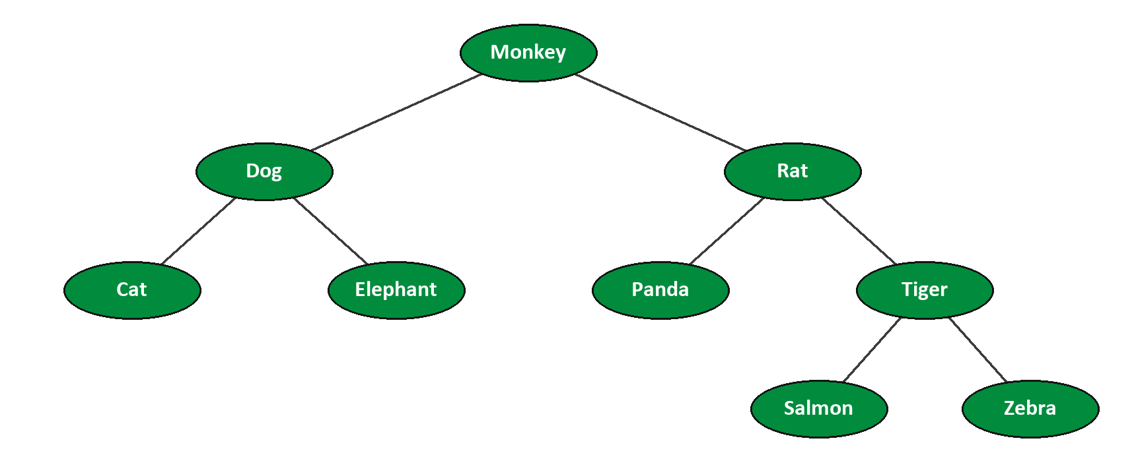
Question 2
a) Length of the path from Monkey -> Panda: Monkey -> Rat -> Panda, so the path length is 2 (two edges).
b) Height of the tree: 3, counted as the number of edges on the longest path from the root to a leaf (Monkey -> Rat -> Tiger -> Salmon or Zebra). Counted as the number of levels (nodes on that path), the height is 4, which is the value returned by the height() function in Questions 4 and 5.
c) Degree of node Rat: 2 (children are Panda and Tiger).
d) Degree of the tree: 2 (the maximum degree of any node in the tree).
e) Traversals:
Traversal | Result
Preorder | Monkey, Dog, Cat, Elephant, Rat, Panda, Tiger, Salmon, Zebra
Inorder | Cat, Dog, Elephant, Monkey, Panda, Rat, Salmon, Tiger, Zebra
Postorder | Cat, Elephant, Dog, Panda, Salmon, Zebra, Tiger, Rat, Monkey
Level order | Monkey, Dog, Rat, Cat, Elephant, Panda, Tiger, Salmon, Zebra
Question 3
// Lab 11 - Part A, Exercise 3 : build the animal binary search tree and display its traversals
#include <iostream>
#include <string>
using namespace std;

struct Node {
string name;
Node *left;
Node *right;
};

class binaryTree {
private:
Node *root;

void insert(Node *&node, string name) {
if (node == NULL) {
node = new Node;
node->name = name;
node->left = NULL;
node->right = NULL;
}
else if (name < node->name)
insert(node->left, name);
else
insert(node->right, name);
}

void preorder(Node *node) {
if (node != NULL) {
cout << node->name << " ";
preorder(node->left);
preorder(node->right);
}
}

void inorder(Node *node) {
if (node != NULL) {
inorder(node->left);
cout << node->name << " ";
inorder(node->right);
}
}

void postorder(Node *node) {
if (node != NULL) {
postorder(node->left);
postorder(node->right);
cout << node->name << " ";
}
}

void destroy(Node *&node) {
if (node != NULL) {
destroy(node->left);
destroy(node->right);
delete node;
node = NULL;
}
}

public:
binaryTree() {
root = NULL;
}

~binaryTree() {
destroy(root);
}

void insert(string name) { insert(root, name); }
void preorder() { preorder(root); cout << endl; }
void inorder() { inorder(root); cout << endl; }
void postorder() { postorder(root); cout << endl; }
};

int main() {
string animals[] = { "Monkey", "Rat", "Tiger", "Dog", "Cat",
"Elephant", "Salmon", "Zebra", "Panda" };
int size = sizeof(animals) / sizeof(animals[0]);

binaryTree tree;
for (int i = 0; i < size; i++)
tree.insert(animals[i]);

cout << "Preorder : "; tree.preorder();
cout << "Inorder : "; tree.inorder();
cout << "Postorder : "; tree.postorder();

return 0;
}
Program output
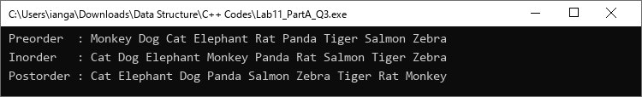
Question 4
// Lab 11 - Part A, Exercise 4 : animal binary search tree with height and node count
#include <iostream>
#include <string>
using namespace std;

struct Node {
string name;
Node *left;
Node *right;
};

class binaryTree {
private:
Node *root;

void insert(Node *&node, string name) {
if (node == NULL) {
node = new Node;
node->name = name;
node->left = NULL;
node->right = NULL;
}
else if (name < node->name)
insert(node->left, name);
else
insert(node->right, name);
}

void preorder(Node *node) {
if (node != NULL) {
cout << node->name << " ";
preorder(node->left);
preorder(node->right);
}
}

void inorder(Node *node) {
if (node != NULL) {
inorder(node->left);
cout << node->name << " ";
inorder(node->right);
}
}

void postorder(Node *node) {
if (node != NULL) {
postorder(node->left);
postorder(node->right);
cout << node->name << " ";
}
}

// height = number of nodes on the longest path from root to a leaf
int height(Node *node) {
if (node == NULL)
return 0;
return 1 + max(height(node->left), height(node->right));
}

int nodeCount(Node *node) {
if (node == NULL)
return 0;
return 1 + nodeCount(node->left) + nodeCount(node->right);
}

void destroy(Node *&node) {
if (node != NULL) {
destroy(node->left);
destroy(node->right);
delete node;
node = NULL;
}
}

public:
binaryTree() {
root = NULL;
}

~binaryTree() {
destroy(root);
}

void insert(string name) { insert(root, name); }
void preorder() { preorder(root); cout << endl; }
void inorder() { inorder(root); cout << endl; }
void postorder() { postorder(root); cout << endl; }
int height() { return height(root); }
int nodeCount() { return nodeCount(root); }
};

int main() {
string animals[] = { "Monkey", "Rat", "Tiger", "Dog", "Cat",
"Elephant", "Salmon", "Zebra", "Panda" };
int size = sizeof(animals) / sizeof(animals[0]);

binaryTree tree;
for (int i = 0; i < size; i++)
tree.insert(animals[i]);

cout << "Preorder : "; tree.preorder();
cout << "Inorder : "; tree.inorder();
cout << "Postorder : "; tree.postorder();
cout << endl;
cout << "Height of tree : " << tree.height() << endl;
cout << "Number of nodes : " << tree.nodeCount() << endl;

return 0;
}
Program output
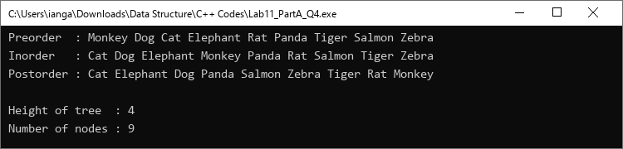
Question 5
The lab sheet does not provide weights, so an approximate average adult weight (in kg) is assigned to each animal:
Animal | Weight (kg) | Animal | Weight (kg)
Monkey | 25 | Elephant | 5000
Rat | 0.3 | Salmon | 4
Tiger | 220 | Zebra | 380
Dog | 30 | Panda | 100
Cat | 4.5 | Total | 5763.8

// Lab 11 - Part A, Exercise 5 : animal binary search tree with height, node count and total weight
#include <iostream>
#include <string>
using namespace std;

struct Node {
string name;
double weight; // in kg
Node *left;
Node *right;
};

class binaryTree {
private:
Node *root;

void insert(Node *&node, string name, double weight) {
if (node == NULL) {
node = new Node;
node->name = name;
node->weight = weight;
node->left = NULL;
node->right = NULL;
}
else if (name < node->name)
insert(node->left, name, weight);
else
insert(node->right, name, weight);
}

void preorder(Node *node) {
if (node != NULL) {
cout << node->name << " ";
preorder(node->left);
preorder(node->right);
}
}

void inorder(Node *node) {
if (node != NULL) {
inorder(node->left);
cout << node->name << " ";
inorder(node->right);
}
}

void postorder(Node *node) {
if (node != NULL) {
postorder(node->left);
postorder(node->right);
cout << node->name << " ";
}
}

// height = number of nodes on the longest path from root to a leaf
int height(Node *node) {
if (node == NULL)
return 0;
return 1 + max(height(node->left), height(node->right));
}

int nodeCount(Node *node) {
if (node == NULL)
return 0;
return 1 + nodeCount(node->left) + nodeCount(node->right);
}

double totalWeight(Node *node) {
if (node == NULL)
return 0;
return node->weight + totalWeight(node->left) + totalWeight(node->right);
}

void destroy(Node *&node) {
if (node != NULL) {
destroy(node->left);
destroy(node->right);
delete node;
node = NULL;
}
}

public:
binaryTree() {
root = NULL;
}

~binaryTree() {
destroy(root);
}

void insert(string name, double weight) { insert(root, name, weight); }
void preorder() { preorder(root); cout << endl; }
void inorder() { inorder(root); cout << endl; }
void postorder() { postorder(root); cout << endl; }
int height() { return height(root); }
int nodeCount() { return nodeCount(root); }
double totalWeight() { return totalWeight(root); }
};

int main() {
string animals[] = { "Monkey", "Rat", "Tiger", "Dog", "Cat",
"Elephant", "Salmon", "Zebra", "Panda" };
// approximate average adult weight of each animal in kg
double weights[] = { 25, 0.3, 220, 30, 4.5, 5000, 4, 380, 100 };
int size = sizeof(animals) / sizeof(animals[0]);

binaryTree tree;
for (int i = 0; i < size; i++)
tree.insert(animals[i], weights[i]);

cout << "Preorder : "; tree.preorder();
cout << "Inorder : "; tree.inorder();
cout << "Postorder : "; tree.postorder();
cout << endl;
cout << "Height of tree : " << tree.height() << endl;
cout << "Number of nodes : " << tree.nodeCount() << endl;
cout << "Total weight : " << tree.totalWeight() << " kg" << endl;

return 0;
}
Program output
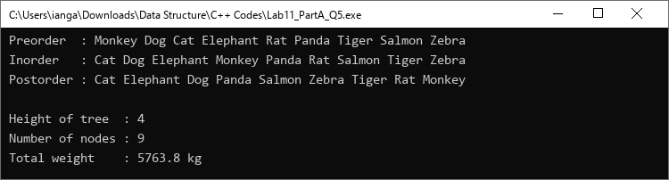
Part B: Homework
Question 1
Each car is stored as one node, using the Car ID as the key of the binary search tree. The cars are inserted in the order given in the table.
Binary tree (keyed by Car ID)
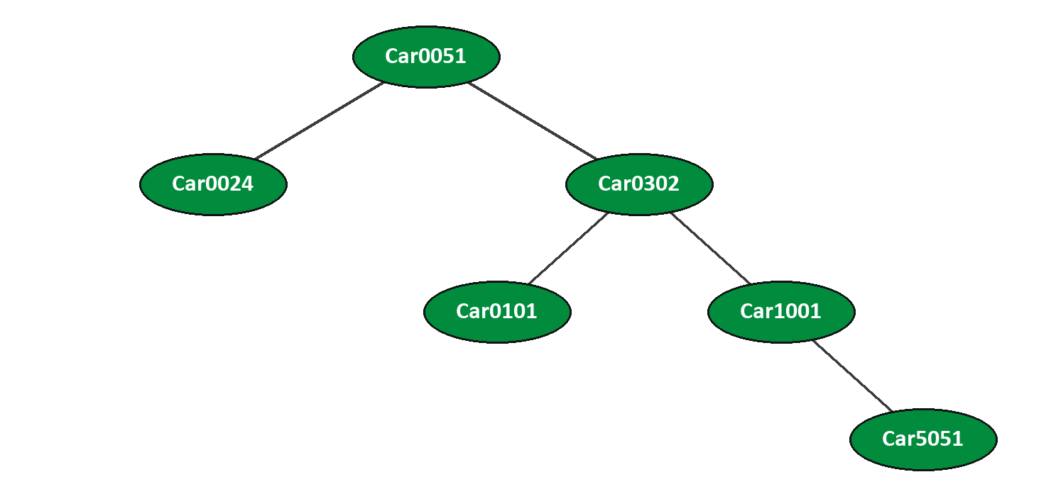
Source code
// Lab 11 - Part B, Homework 1 : car binary search tree (keyed by Car ID)
#include <iostream>
#include <iomanip>
#include <string>
using namespace std;

struct Car {
string id;
string brand;
string type;
string color;
double price;
int amount;
};

struct Node {
Car car;
Node *left;
Node *right;
};

class carTree {
private:
Node *root;

void insert(Node *&node, Car car) {
if (node == NULL) {
node = new Node;
node->car = car;
node->left = NULL;
node->right = NULL;
}
else if (car.id < node->car.id)
insert(node->left, car);
else
insert(node->right, car);
}

void printCar(Car car) {
cout << left << setw(9) << car.id << setw(9) << car.brand
<< setw(15) << car.type << setw(8) << car.color
<< right << setw(8) << car.price << setw(4) << car.amount << endl;
}

void preorder(Node *node) {
if (node != NULL) {
printCar(node->car);
preorder(node->left);
preorder(node->right);
}
}

void inorder(Node *node) {
if (node != NULL) {
inorder(node->left);
printCar(node->car);
inorder(node->right);
}
}

void postorder(Node *node) {
if (node != NULL) {
postorder(node->left);
postorder(node->right);
printCar(node->car);
}
}

// height = number of nodes on the longest path from root to a leaf
int height(Node *node) {
if (node == NULL)
return 0;
return 1 + max(height(node->left), height(node->right));
}

int nodeCount(Node *node) {
if (node == NULL)
return 0;
return 1 + nodeCount(node->left) + nodeCount(node->right);
}

double totalPrice(Node *node) {
if (node == NULL)
return 0;
return node->car.price + totalPrice(node->left) + totalPrice(node->right);
}

int totalAmount(Node *node) {
if (node == NULL)
return 0;
return node->car.amount + totalAmount(node->left) + totalAmount(node->right);
}

void destroy(Node *&node) {
if (node != NULL) {
destroy(node->left);
destroy(node->right);
delete node;
node = NULL;
}
}

public:
carTree() {
root = NULL;
}

~carTree() {
destroy(root);
}

void insert(Car car) { insert(root, car); }
void preorder() { preorder(root); }
void inorder() { inorder(root); }
void postorder() { postorder(root); }
int height() { return height(root); }
int nodeCount() { return nodeCount(root); }
double totalPrice() { return totalPrice(root); }
int totalAmount() { return totalAmount(root); }
};

int main() {
Car cars[] = {
{ "Car0051", "Proton", "X50", "White", 95000, 5 },
{ "Car0302", "Honda", "Civic", "Red", 135000, 3 },
{ "Car0024", "Toyota", "Yaris", "Red", 87900, 2 },
{ "Car0101", "Toyota", "Corolla Cross", "Yellow", 125700, 5 },
{ "Car1001", "Perodua", "MyVi", "Blue", 48700, 2 },
{ "Car5051", "Mazda", "X30", "Black", 115000, 1 }
};
int size = sizeof(cars) / sizeof(cars[0]);

carTree tree;
for (int i = 0; i < size; i++)
tree.insert(cars[i]);

cout << fixed << setprecision(0);

cout << "===== Preorder =====" << endl;
tree.preorder();
cout << endl << "===== Inorder =====" << endl;
tree.inorder();
cout << endl << "===== Postorder =====" << endl;
tree.postorder();

cout << endl;
cout << "Height of tree : " << tree.height() << endl;
cout << "Number of nodes : " << tree.nodeCount() << endl;
cout << "Sum of car prices : RM " << tree.totalPrice() << endl;
cout << "Sum of car amount : " << tree.totalAmount() << endl;

return 0;
}
Program output
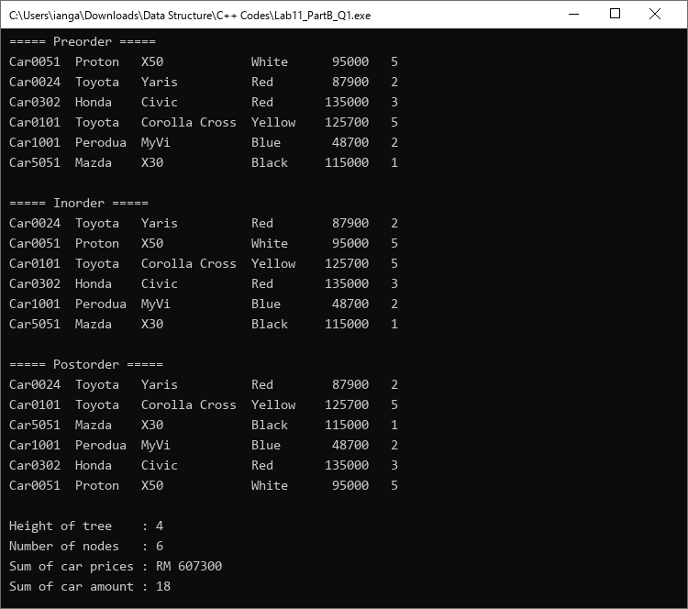
Summary
Item | Result
Height of the tree | 4 levels (3 edges): Car0051 -> Car0302 -> Car1001 -> Car5051
Number of nodes | 6
Sum of car prices | RM 607,300
Sum of car amount | 18

