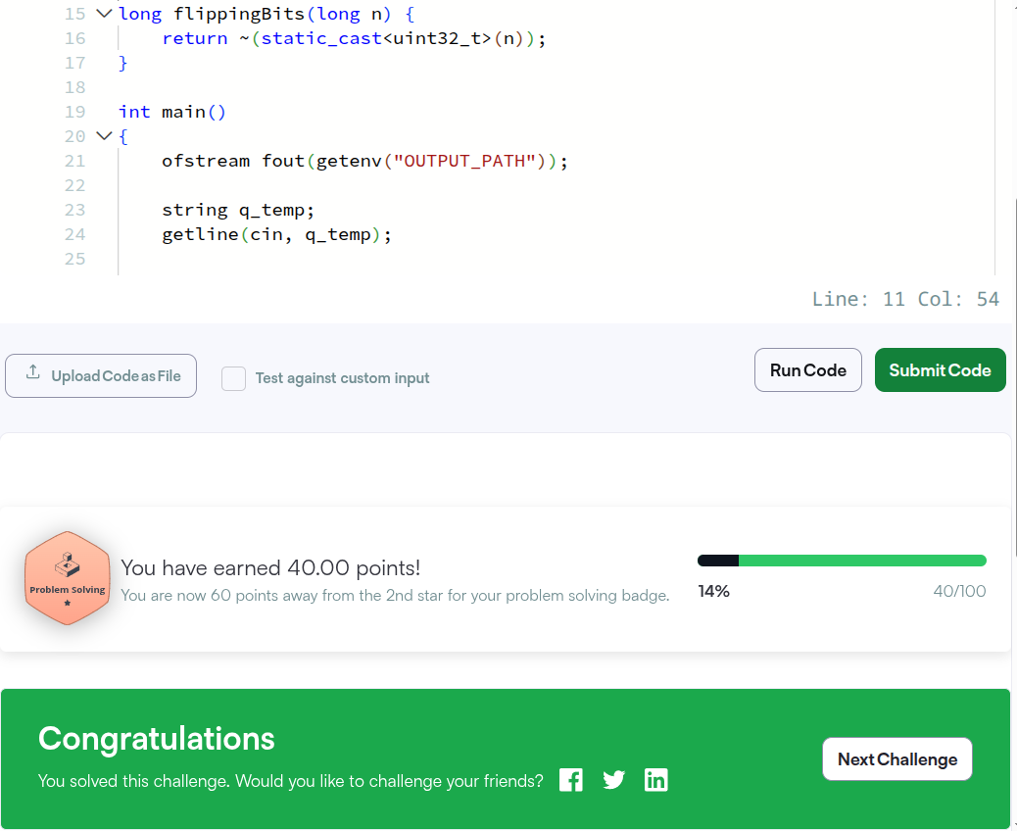
- Flipping Bits at https://www.hackerrank.com/challenges/flipping-bits/problem?isFullScreen=true
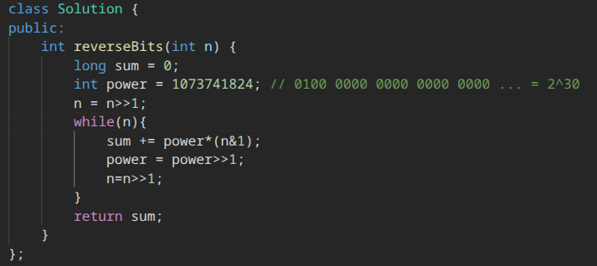
- Reverse Bits at https://leetcode.com/problems/reverse-bits/description/
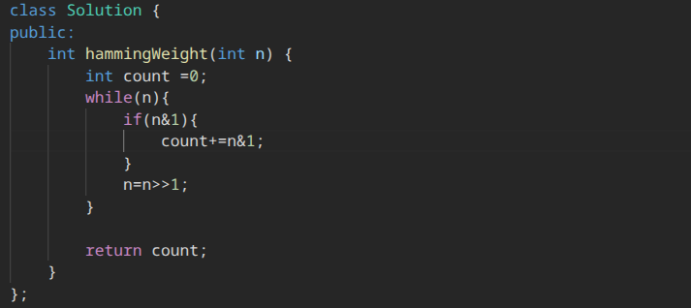
- Number of 1 Bits at https://leetcode.com/problems/number-of-1-bits/description/
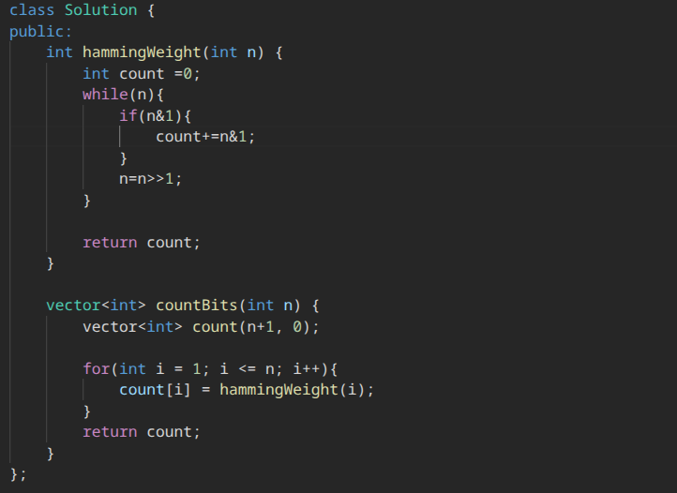
- Counting Bits https://leetcode.com/problems/counting-bits/
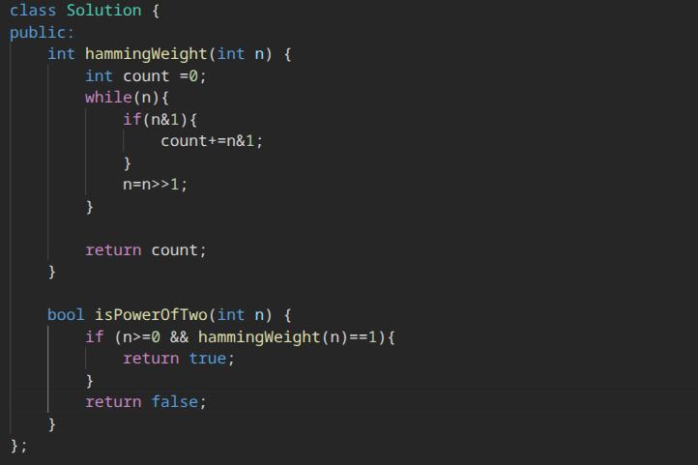
- Power of Two https://leetcode.com/problems/power-of-two/description/
