Group Activity
Project Ideation

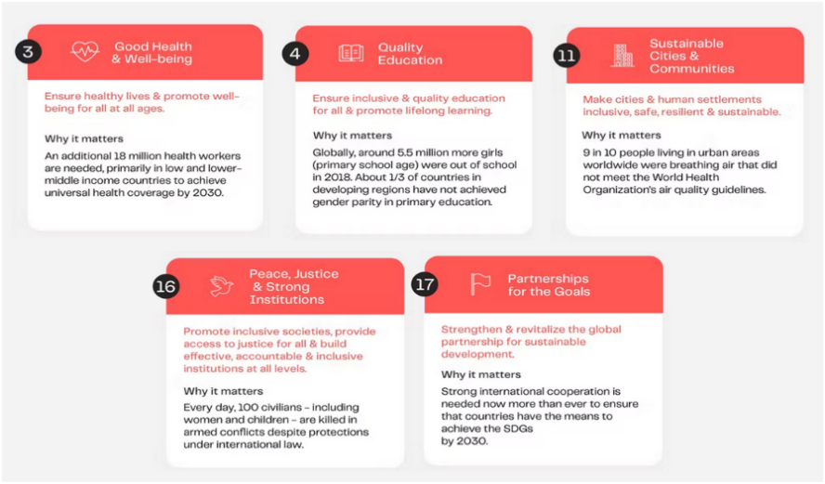
In this activity, student groups will identify a real-world problem, define a computing-based system or solution, and justify its feasibility and impact.

Instruction(s)

💡 Identify Domain of Interest
As a group, identify real-world problems in any relevant SDGs (refer to the CCIT Research Agenda) that could be addressed through the development of a computing-based system. Conduct brainstorming sessions to generate a minimum of 5 project ideas per group.

📍 Find a Problem or Gap
List real-world issues, inefficiencies, or unanswered research questions in that domain. Provide 10-15 reviews of related literature and/or studies. Cite appropriately your research findings and use proper IEEE reference styles.

🎯 Validate Feasibility and Originality
Evaluate each project ideas based on originality, feasibility, societal impact, and alignment with group skills. Identify and describe the intended target organization as “partner” for project implementation, intended users and their needs

📑Draft Your Project Idea
Write a working title and a 1–5 paragraph description covering:
- Background of Study
- Project Context, Purpose and Description
- Objectives of the Project
- Technology/Tools/Frameworks
- Expected Impact or Outcomes

Submission Note
Documents must be Submit/Upload (PDF file) in MS Teams submission link.

