Proposal

Basic information:

title: Honkai Star Rail Character

team members: 41047016s 吳銘恩 [ianandvivi310@gmail.com](mailto:ianandvivi310@gmail.com)

41047050S 林柏叡 raylin0722@gmail.com

41047022S 張鐙友 41047022s@gapps.ntnu.edu.tw

Overview:

The game has lots of different characters, and they have many attributes, but players can’t see some important attributes in the game if players don’t have characters, like: hp, atk, def…. To deal with this problem, we will build a data visualization that allows users to look at which character they want to know. Additionally, we will have some filter to find character faster, and use scatter plot to compare other character’ attributes.

Data and Data Processing:

data source: [Honkai Star Rail Character Dataset (kaggle.com)](https://www.kaggle.com/datasets/ridhopandhu/honkai-star-rail-character-data)

We will make bar chart of path and combat_type and use them to do the filter. After that, we use the filter to create scatter plot and users can choose attributes(atk, hp…) to regard them as the x and y axes. Lastly, users can check the point in the scatter plot to get more information about the charcter.

Usage scenarios & tasks:

Ian is a player and he see the character list in the game to find out the character he like. He wants to know the character’ attribute, but the game doesn’t give the information, so he comes to our website to see the information. He uses the filter of path and combat_type to find quickly the character he wants. Then, he regards hp and atk as the x and y axes to compare the character with the others. Finally, he check the point to see the character’ spd, taunt, max_energy….

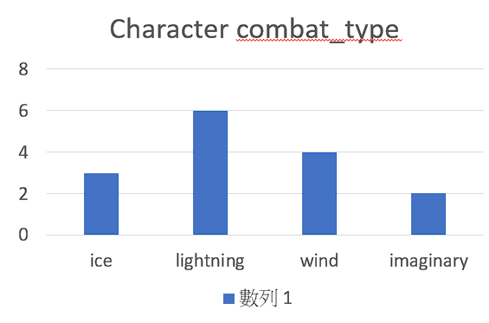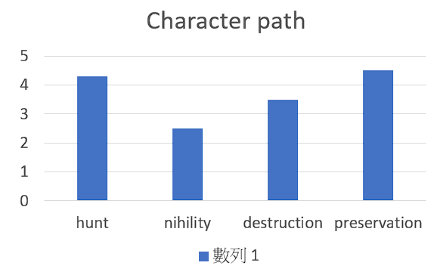Visualization Design & Sketch:

Users can click the bar to use that path or combat_type as filters.

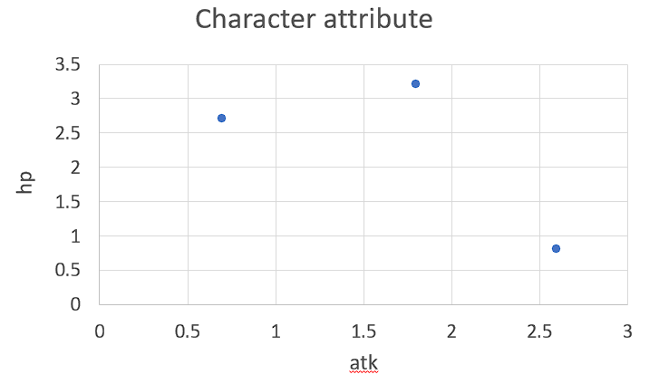

Then, the filtered data presents on the scatter plot to do the comparison.

If you click on a point on the scatter plot, the data associated with that point will be added to the comparison below. Clicking on two or more points will display a detailed data comparison below.

Work breakdown and schedule:

Character path graph: 3hr

Character combat_type graph: 3hr

Character attribute scatter graph: 4hr

Character detailed attribute table: 3hr

Adjust whole website: 2hr