**literature search blog**

*Research direction: user requirements research methods in user experience*

* Phase I

The two preliminary keywords for the direction of this research are 'user experience' and 'research methods'. The objective of the research was to systematically compile a methodology for analysing user requirements in the context of user experience through researching online literature.

At first, I chose to search for the 'Product design' and 'user requirement' keywords on the Proquest Ebook Center platform. Because I prefer to use Proquest Ebook Center than The Web of Knowledge.

After searching for articles in English using the keyword 'user experience, user requirement', I got 6015 articles. However, most of these articles did not have much relevance to my keywords at the title level.

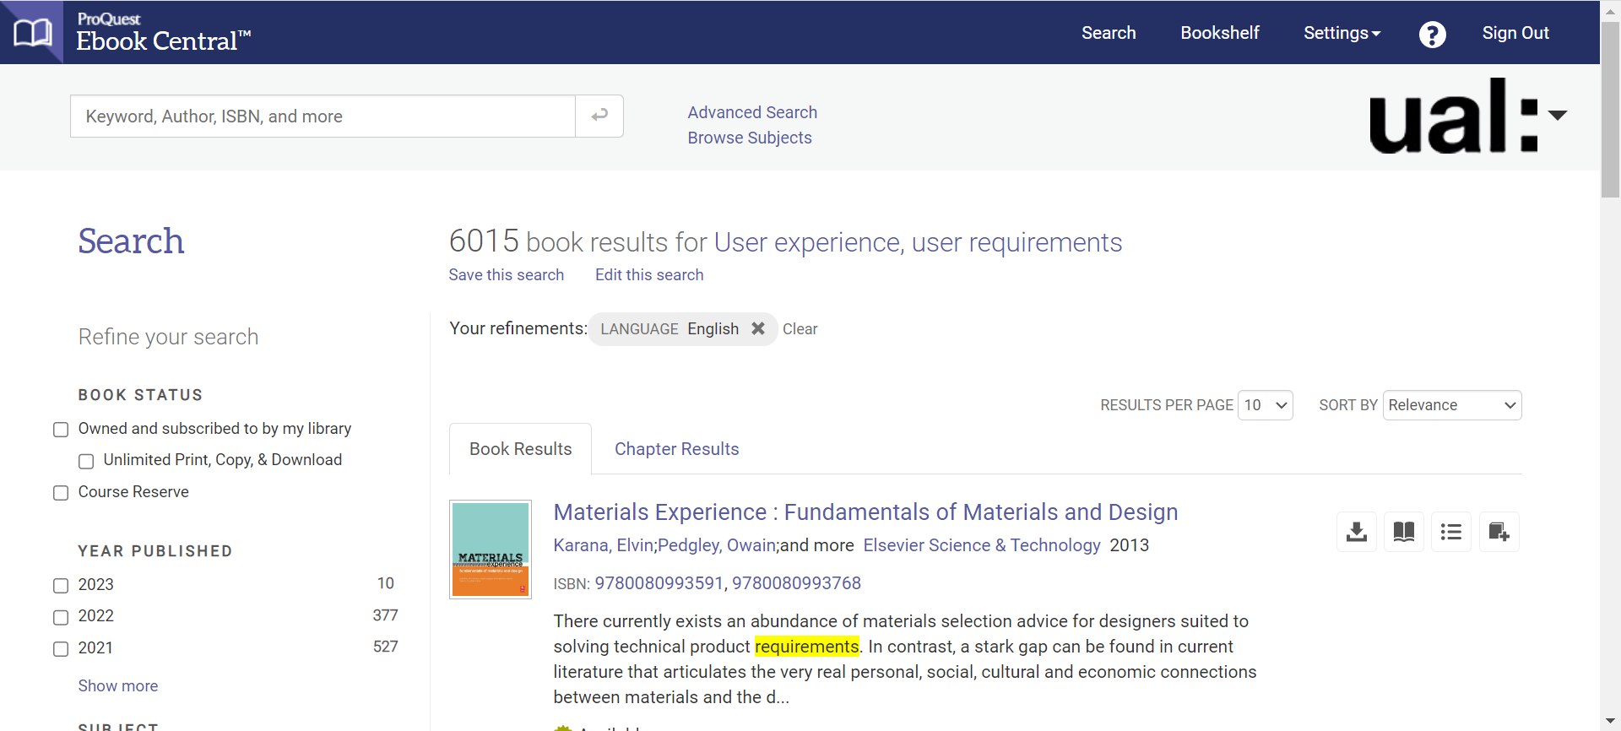

* Phase II

Perhaps there was a problem with the phrase 'research method', so I tried changing the keyword to 'user experience and research', again with English articles as the search term, and I got 7267 high matches. The problem was solved.

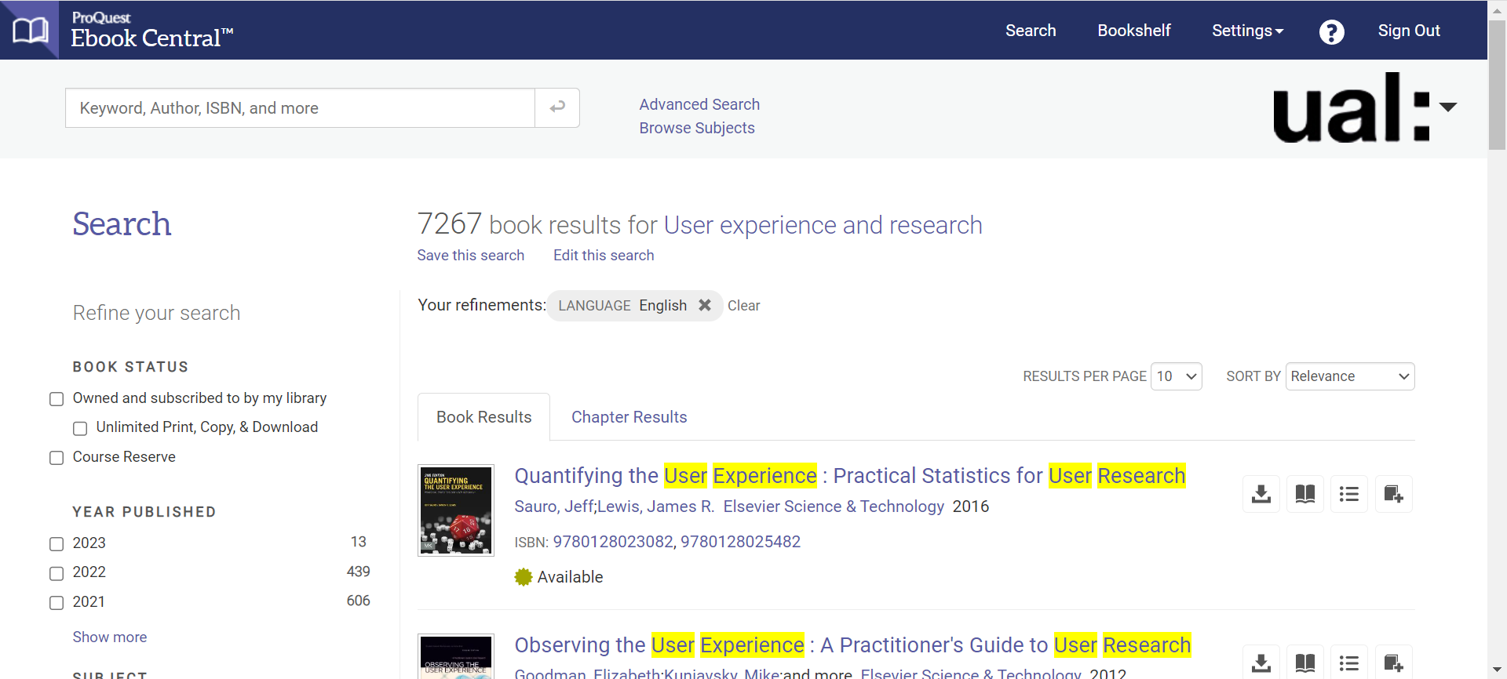

By this point, I was still getting too many search results. So I started to experiment with Helen Newing's strategy of adding additional qualifiers to filter the literature. I selected seven specific subject areas and the search was successfully narrowed down to 437 results with these criteria.

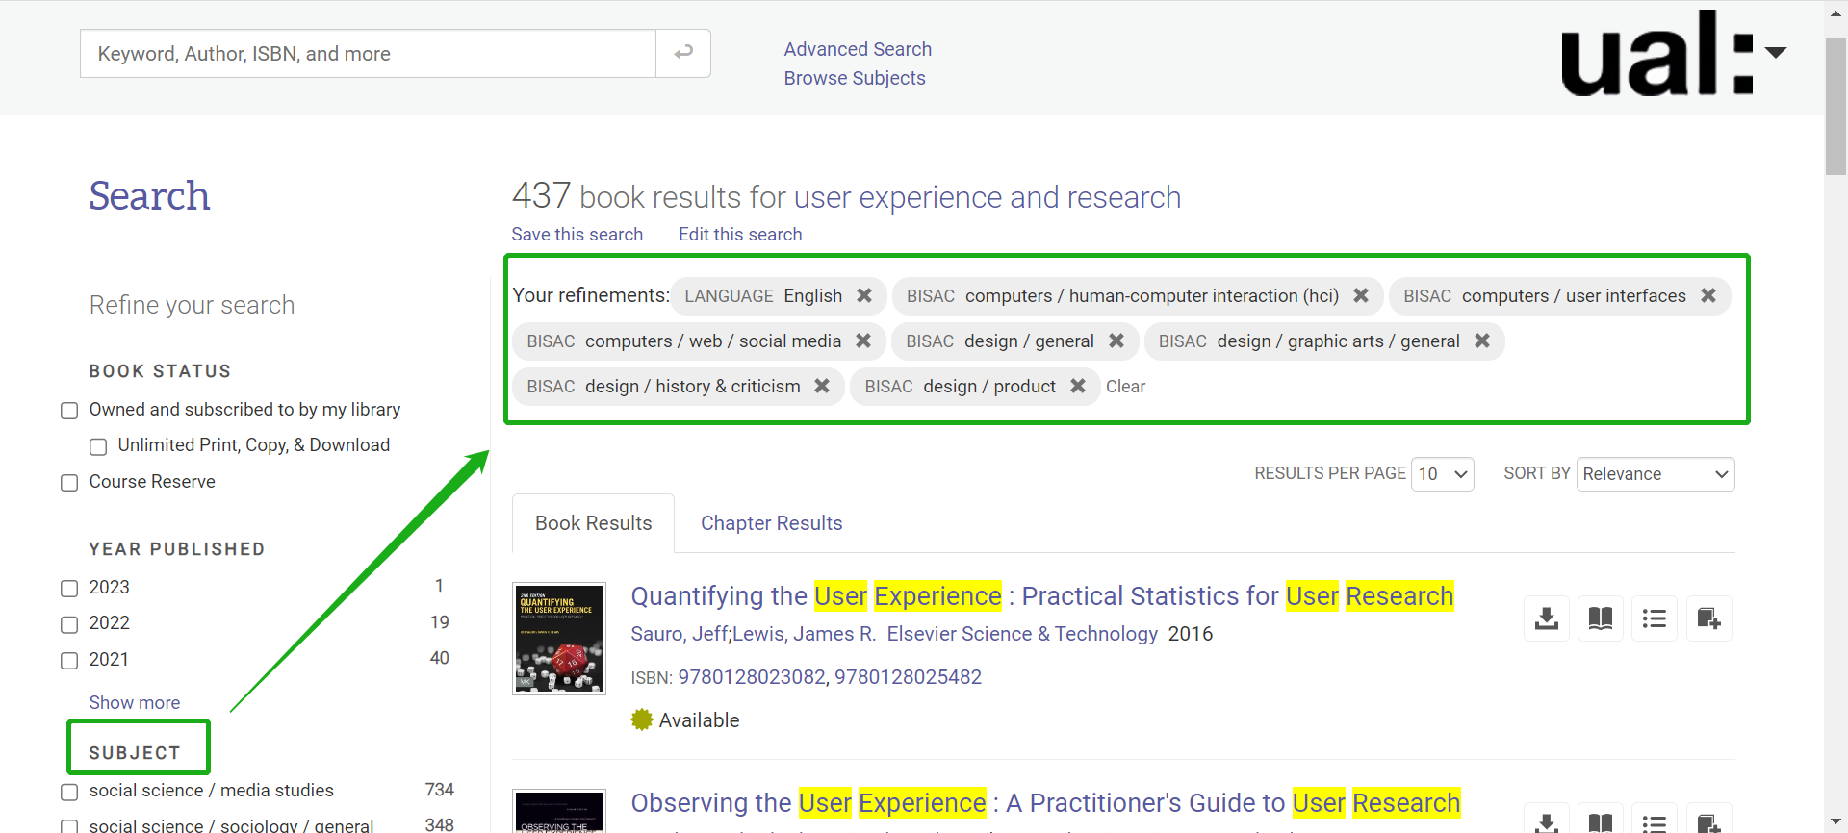

Obviously, there were still too many search results, so I limited the years of publication to between 2020 and 2023 and the search was successfully further narrowed down to 61. This search strategy worked, and it saved me a lot of time. I decided to start by browsing for articles from these three years and if there were no suitable articles in this, I would expand the year search.

* Phase III

Next I did a quick scan of the titles, descriptions and abstracts of the 61 papers. After a quick browse I selected 3 papers that were useful to me:

Hillmann, C 2021, UX for XR : User Experience Design and Strategies for Immersive Technologies, Apress L. P., Berkeley, CA.

Gage, M, & Murrell, S 2022, User Experience Research : Discover What Customers Really Want, John Wiley & Sons, Incorporated, Newark.

Soares, MM, Rebelo, F, & Ahram, TZ (eds) 2021, Handbook of Usability and

User-Experience : Methods and Techniques, Taylor & Francis Group, Milton.

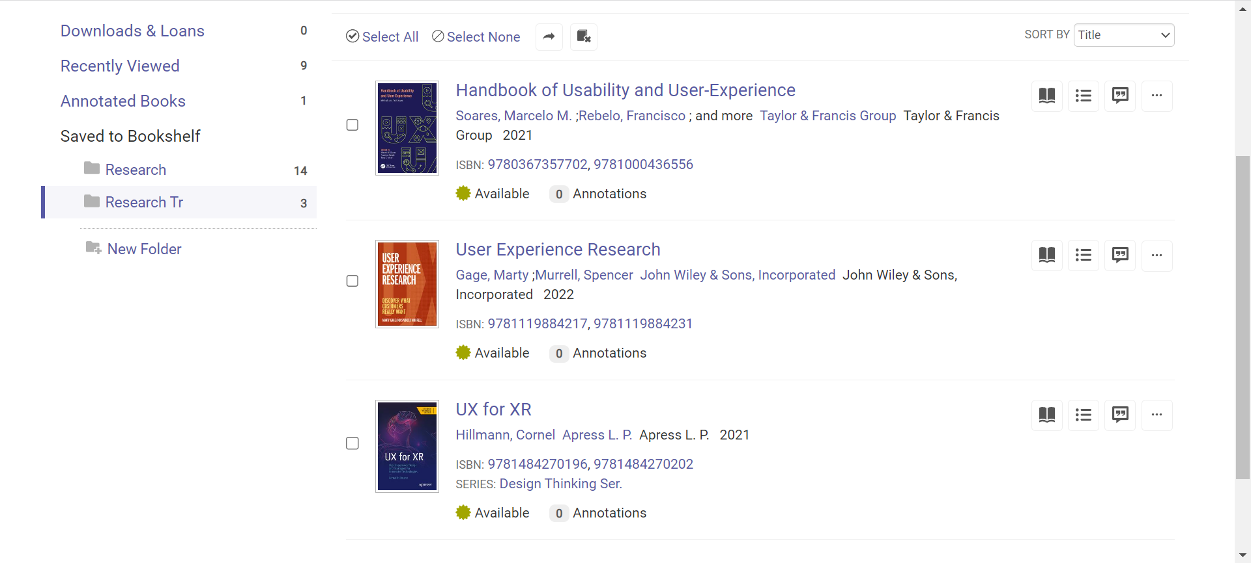

Handbook of Usability and User-Experience: Methods and Techniques would be a good tool book. I was thrilled to find User Experience Research: Discover What Customers Want, which was the best match for my search terms. Immersive Technologies is an additional technical area of interest to me, and therefore equally important.

Yihan Wang

22012298