[**DOING PHYSICS WITH PYTHON**](https://d-arora.github.io/Doing-Physics-With-Matlab/)

# QUANTUM MECHANICS

**BLACKBODY RADIATION**

**SUN, RED STAR, BLUE STAR**

**Ian Cooper**

matlabvisualphysics@gmail.com

**DOWNLOAD DIRECTORY FOR MATLAB SCRIPTS**

**qmSun.py**

[**GitHub**](https://github.com/D-Arora/Doing-Physics-With-Matlab/tree/master/mpScripts)

[**Google Drive**](https://drive.google.com/drive/u/3/folders/1j09aAhfrVYpiMavajrgSvUMc89ksF9Jb)

**BLACKBODY RADIATION**

The wave nature of electromagnetic radiation is demonstrated by interference phenomena. However, electromagnetic radiation also has a particle nature. For example, to account for the observations of the radiation emitted from hot objects, it is necessary to use a particle model, where the radiation is considered to be a stream of particles called **photons**. The energy of a photon, *E* is

1. **

The electromagnetic energy emitted from an object’s surface is called ***thermal radiation*** and is due a decrease in the internal energy of the object. This radiation consists of a continuous spectrum of frequencies extending over a wide range. Objects at room temperature emit mainly infrared and it is not until the temperature reaches about 800 K and above those objects glows visibly.

A **blackbody** is an object that completely absorbs all electromagnetic radiation falling on its surface at any temperature. It can be thought of as a perfect absorber and emitter of radiation. The power emitted from a blackbody, *P* is given by the **Stefan-Boltzmann law** and it depends only on the surface area of the emitter, *A* and its surface temperature, *T*

(2) 

A more general form of equation 2 is

1. 

where *ε* is the **emissivity** of the object. For a blackbody, *ε* = 1. When *ε* < 1 the object is called a **graybody** and the object is not a perfect emitter and absorber.

The amount of radiation emitted by a blackbody is given by **Planck’s radiation law** and is expressed in terms of the **spectral exitance** for **wavelength** or **frequency** *R*λ *or Rf* respectively

(4)  [W.m-2.m-1]

or

(5)  [W.m-2.s-1]

In the literature, many different terms and symbols are used for the spectral exitance. Sometimes the terms and the units given are wrong or misleading.

The **power radiated per unit surface of a blackbody**, *PA* within a wavelength interval or bandwidth, (*λ*1, *λ*2) or frequency interval or bandwidth (*f*1, *f*2) are given by equations 6 and 7

(6)  [W.m-2]

and

(7)  [W.m-2]

The equations 6 and 7 give the Stefan-Boltzmann law (equation 2) when the bandwidths extend from 0 to ∞.

**Wien’s Displacement law** states that the wavelength *λpeak* corresponding to the peak of the spectral exitance given by equation 4 is inversely proportional to the temperature of the blackbody and the frequency *fpeak* for the spectral exitance peak frequency given by equation 5 is proportional to the temperature

(8) 

The peaks in equations 4 and 5 occur in different parts of the electromagnetic spectrum and so

(9) 

The Wien’s Displacement law explains why long wave radiation dominates more and more in the spectrum of the radiation emitted by an object as its temperature is lowered.

When classical theories were used to derive an expression for the spectral exitances *R*λ and *Rf*, the power emitted by a blackbody diverged to infinity as the wavelength became shorter and shorter. This is known as the **ultraviolet catastrophe**. In 1901 Max Planck proposed a new radical idea that was completely alien to classical notions, electromagnetic energy is **quantized**. Planck was able to derive the equations 4 and 5 for blackbody emission and these equations are in complete agreement with experimental measurements. The assumption that the energy of a system varies in a continuous manner, i.e., it can take any arbitrary close consecutive values fails. Energy can only exist in integer multiples of the lowest amount or quantum, *h f*. ***This step marked the very beginning of modern quantum theory***.

A summary of the physical quantities, units and values of constants used in the description of the radiation from a hot object.

|  |  |  |  |
| --- | --- | --- | --- |
| **Variable** | **Interpretation** | **Value** | **Unit** |
| *E* | energy of photon |  | J, eV |
| *h* | Planck’s constant | 6.62608×10-34 | J.s |
| *c* | speed of electromagnetic radiation | 3.00x108 | m.s-1 |
| *f* | frequency of electromagnetic radiation |  | Hz |
| *λ* | wavelength of electromagnetic radiation |  |  |
| *T* | surface temperature of object |  | K |
| *A* | surface area of object |  | m2 |
| *σ* | Stefan-Boltzmann constant | 5.6696×10-8 | W.m-2.K-4 |
| *P* | power emitted from hot object |  | W |
| *ε* | emissivity of object’s surface |  |  |
| *Rλ* | spectral exitance: power radiated per unit area per unit wavelength interval |  | (W.m-2).m-1 |
| *Rf* | spectral exitance: power radiated per unit area per unit frequency interval |  | (W.m-2).s-1 |
| *kB* | Boltzmann constant | 1.38066×10-23 | J.K-1 |
| *bλ* | Wien constant: wavelength | 2.898×10-3 | m.K |
| *bf* | Wien constant: frequency | 2.83 kB *T* / *h* | K-1.s-1 |
| *λpeak* | wavelength of peak in solar spectrum | 5.0225×10-7 | m |
| *RS* | radius of the Sun | 6.96×108 | m |
| *RE* | radius of the Earth | 6.96×106 | m |
| *RSE* | Sun-Earth radius | 6.96×1011 | m |
| *I*0 | Solar constant | 1.36×103 | W.m-2 |
| *α* | Albedo of Earth’s surface | 0.30 |  |

**SIMULATION: THE SUN AND THE EARTH AS BLACKBODIES**

The Sun can be considered as a blackbody, and the total power output of the Sun *PS* can be estimated by using the Sefan-Boltzmann law, equation 2, and by finding the area under the curves for *R*λ and *Rf* using equations 6 and 7. From observations on the Sun, the peak in the electromagnetic radiation emitted has a wavelength, *λpeak* = 502.25 nm (green). The temperature of the Sun’s surface (photosphere) can be estimated from the Wien displacement law, equation 8.

The distance from the Sun to the Earth, *RSE* can be used to estimate of the surface temperature of the Earth *TE* if there was no atmosphere. The intensity of the Sun’s radiation reaching the top of the atmosphere, *I*0 is known as the **solar constant**

(10) 

The power absorbed by the Earth, *PEabs* is

(11) 

where *α* is the albedo (the reflectivity of the Earth’s surface).

Assuming the Earth behaves as a blackbody then the power of the radiation emitted from the Earth, *PErad* is

(12) 

It is known that the Earth’s surface temperature has remained relatively constant over many centuries, so that the power absorbed and the power emitted are equal, so the Earth’s equilibrium temperature *TE* is

(13) 

**Simulation using qmSun.py**

**Console output**

Sun: temperature of photosphere, T_S = 5770 K

Peak in Solar Spectrum

Theory: Wavelength at peak in spectral exitance

wL_peak = 5.02e-07 m

Graph: Wavelength at peak in spectral exitance

wL_peak = 5.04e-07 m

Theory: Frequency at peak in spectral exitance

f_peak = 3.39e+14 Hz

Graph: Frequency at peak in spectral exitance

f_peak = 3.40e+14 Hz

Total Solar Power Output

P_Stefan_Boltzmann = 3.79e+26 W

P_wL = 3.77e+26 W

P_f = 3.79e+26 W

IR / visible / UV

P_IR = 1.92e+26 W percentage 50.95

P_vis = 1.39e+26 W percentage 36.82

UV = 4.61e+25 W percentage 12.23

Sun - Earth

Theory: Solar constant I_O = 1.360e+03 W/m^2

Computed: Solar constant I_E = 1.34e+03 w/m^2

Surface temperature of the Earth, T_E = 254 K = -19 deg C

Execution time: 41.06

Without our atmosphere, the Earth’s temperature would be ~19 oC

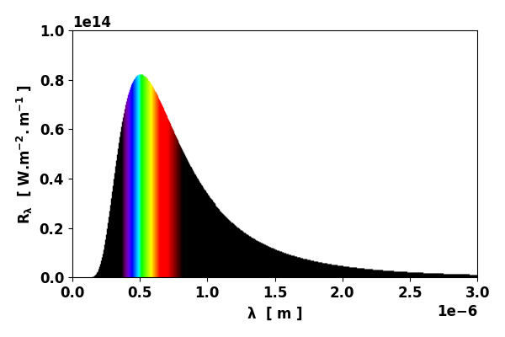

Fig. 1. Spectral exitance curve T = 5770 K

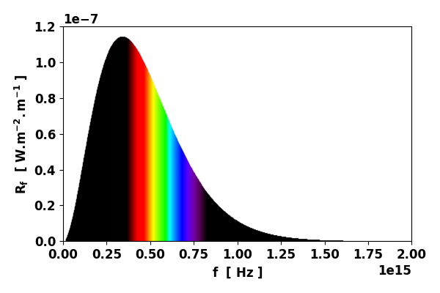

Fig. 2. Spectral exitance curve T = 5770 K

**SIMULATION:  STAR TEMPERATURES**

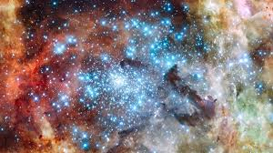

Stars approximate blackbody radiators and their visible color depends upon the temperature of the radiator. Our Sun with a photosphere temperature ~ 6000 K is a yellow-white star. The curves below are for a **blue** star (7000 K) and a **red** star (4000 K).

**BLUE STAR**

Total Solar Power Output

P_Stefan_Boltzmann = 8.22e+26 W

P_wL = 8.19e+26 W

P_f = 8.21e+26 W

IR / visible / UV

P_IR = 3.09e+26 W percentage 37.72

P_vis = 3.23e+26 W percentage 39.42

UV = 1.87e+26 W percentage 22.86

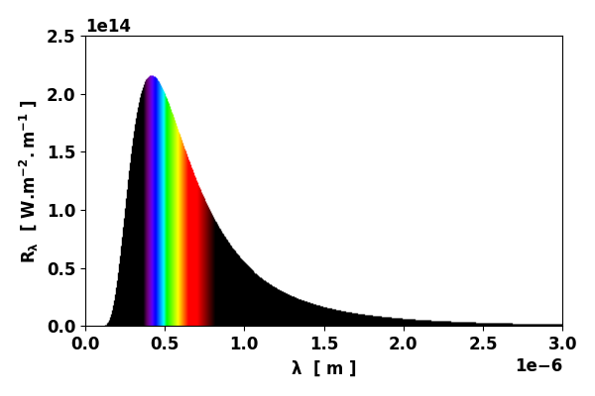

Fig. 3. Spectral exitance curve T = 7000 K

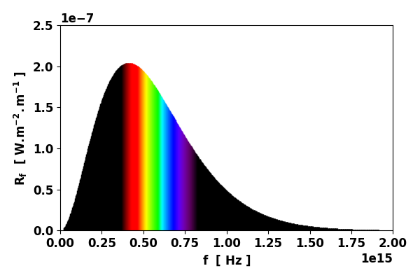

Fig. 4. Spectral exitance curve T = 7000 K

**RED STAR**

Total Solar Power Output

P_Stefan_Boltzmann = 8.76e+25 W

P_wL = 8.64e+25 W

P_f = 8.76e+25 W

IR / visible / UV

P_IR = 6.64e+25 W percentage 76.88

P_vis = 1.82e+25 W percentage 21.12

UV = 1.73e+24 W percentage 2.00

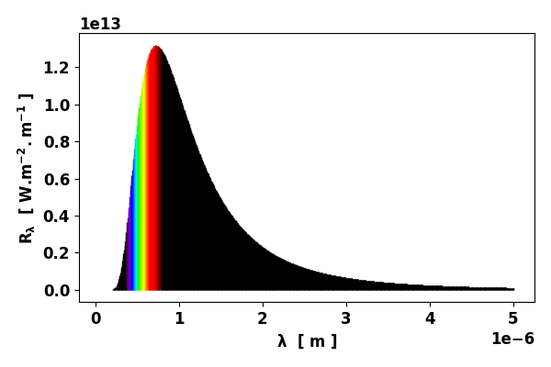

Fig. 5. Spectral exitance curve T = 4000 K

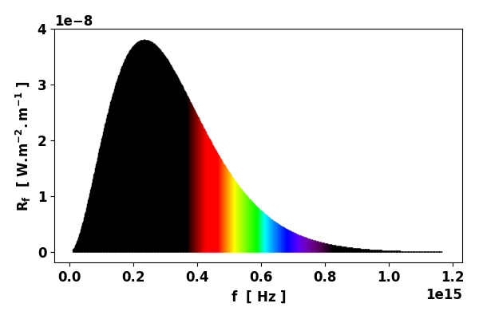

Fig. 6. Spectral exitance curve T = 4000 K

Comparison of radiation emitted by the stars.

|  |  |  |  |
| --- | --- | --- | --- |
|  | Red  Star | Sun  yellow-white | Blue  Star |
| Tstar [K] | 4000 | 5770 | 7000 |
| P [W] | 1x1026 | 4x1026 | 8x1026 |
| % IR | 77 | 51 | 38 |
| % visible | 21 | 37 | 39 |
| % UV | 2 | 12 | 23 |