Both Variance and standard deviation both measure the how a data set is spread.

**Variance** is a measure of how much the values in a data set differ from the average (mean). It shows the overall spread of the data by calculating the average of the squared differences between each value and the mean.

Formula

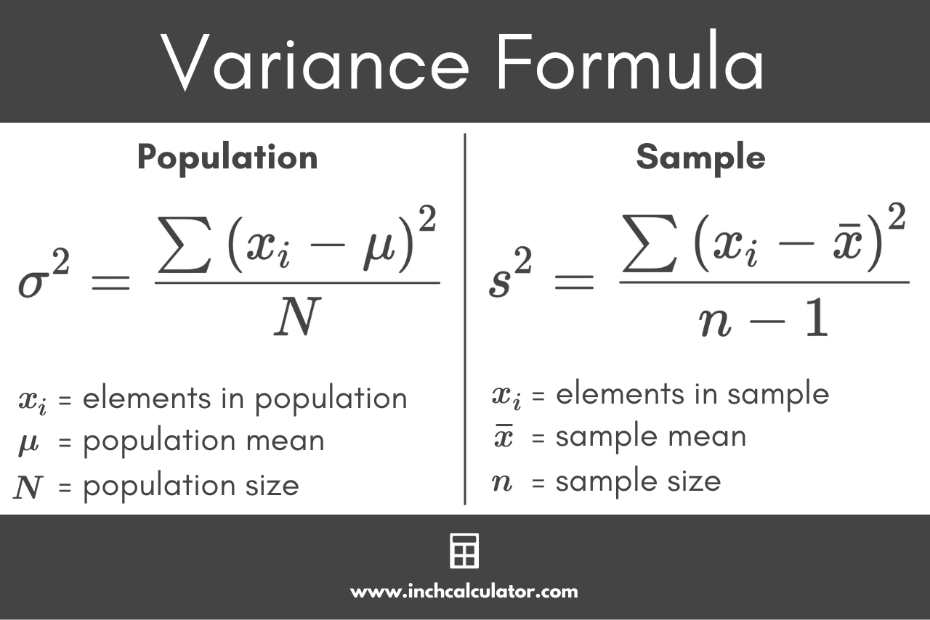

* n: number of data points in the sample
* xi: each individual data point
* x-: sample mean (average of the data points)

**Standard Deviation** is a measure of the typical amount a data point differs from the average. It gives an idea of how much the values in the data set tend to deviate from the mean.

Formula

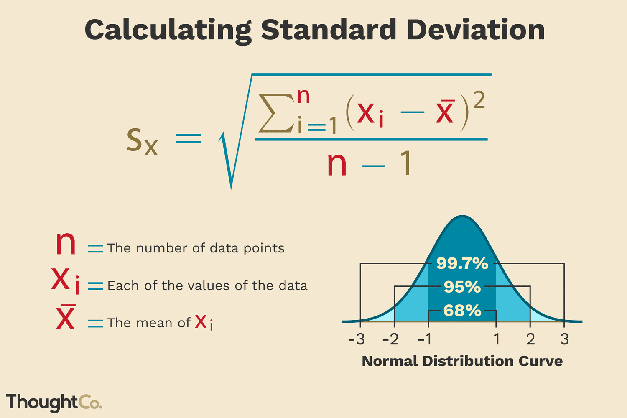

* n: number of data points in the sample
* xi: each individual data point
* x-: sample mean (average of the data points)

These formulas use n−1n-1n−1 instead of n to correct for bias, especially in small samples. This adjustment is known as **Bessel’s correction**, and it ensures that the sample variance and standard deviation provide better estimates for the population values.