University of Hertfordshire
6FTC2062 — BEng Individual Major Project (Part A)
Project Outline
Natural-Language Control of a Sub-250g Low-Cost Autonomous Drone
Design, construction and evaluation of a speech-driven UAV control system
Field | Detail
Formal Title | Natural-Language Control of a Sub-250g Low-Cost Autonomous Drone (final title to be agreed with Project Supervisor)
Student Name | [Your name]
Student ID | [Your ID]
Programme | [Your BEng programme]
Supervisor | [Supervisor name]
Date | 29 July 2026
Submission filename | LastName_FirstName_StudentID_Project_Outline.pdf

1. INTRODUCTION

1.1 Project Justification (What and Why)
Natural language is the most intuitive interface humans possess, yet controlling a small unmanned aerial vehicle (UAV) still requires trained operation of a two-stick radio transmitter. This creates a barrier to use for non-experts in applications such as indoor inspection, education and assistive robotics. This project investigates whether a spoken natural-language interface can provide reliable and safe control of a sub-250g drone, removing the need for manual piloting skill.
The sub-250g weight class is chosen for safety, accessibility and reproducibility. In Singapore, unmanned aircraft are regulated by the Civil Aviation Authority of Singapore (CAAS) under the Air Navigation Act and its associated Unmanned Aircraft rules [1]. Registration and pilot or operator licensing obligations scale with aircraft mass, with the key thresholds sitting well above the mass of this project's aircraft. By deliberately building well under 250g, the drone sits firmly within the lightest and most accessible regulatory tier, minimising administrative overhead for an academic prototype while remaining safe to test indoors. The low mass also directly reduces kinetic energy in a collision. In addition, 250g is an internationally recognised safety threshold, adopted by the UK CAA, the US FAA and EASA, so constraining the build to this class keeps the work comparable beyond Singapore.
The project is scoped around a low-cost build from individual components rather than a commercial off-the-shelf drone. This demonstrates full-stack engineering competence spanning mechanical assembly, flight-controller configuration, embedded communications and software integration; it exposes the open command and telemetry interfaces required to inject natural-language-derived commands, which closed commercial platforms do not; and it makes the work reproducible by others at low cost.
A central engineering challenge motivates the technical design. Commands such as “move forward one metre and land” are only meaningful if the aircraft can hold a stable position and execute measured movements indoors without GPS. This requires closed-loop position estimation from optical-flow and time-of-flight sensing [2] rather than the open-loop, timed control used by basic hobby firmware, and forms the core of what makes the project non-trivial.
The natural-language layer is itself suited to investigation. The project compares a lightweight rule-based intent parser against a language-model based parser, evaluating each on command-recognition accuracy, latency and robustness to phrasing variation, providing measurable research content alongside the engineering deliverable. The system therefore sits at the intersection of natural language processing, embedded systems and control, producing a working, safe, low-cost demonstrator that translates human speech into reliable drone behaviour.

1.2 Project Aims and Objectives (Deliverables)
Aim: To design, build and evaluate a sub-250g drone costing no more than US$150 that can be controlled through natural-language commands, executing safe and repeatable indoor flight manoeuvres.
Objectives (deliverables):
- Build and configure a sub-250g quadcopter from components running open-source flight firmware (ArduPilot), verified airworthy under manual control.
- Achieve GPS-denied position hold indoors using optical-flow and time-of-flight sensing, verified by hands-off stationary hover.
- Establish a bidirectional command and telemetry link between a host laptop and the aircraft over WiFi using the MAVLink protocol.
- Implement a natural-language pipeline (speech-to-text, intent parsing, command generation) mapping spoken instructions to a defined command set: takeoff, move, rotate, hold and land.
- Integrate the pipeline so that natural-language input produces correct autonomous flight behaviour, verified first in simulation and then on hardware.
- Evaluate the system on command-recognition accuracy (rule-based versus language-model parser), end-to-end latency, and position-hold and movement accuracy against measured ground truth.

1.3 Methodology (How)
The project follows an incremental, test-driven methodology that de-risks hardware and software independently before integration. Each stage carries a measurable pass criterion which must be met before the next begins. The system is partitioned into a ground segment and an air segment, as shown in Figure 1, and the software is structured as the layered pipeline shown in Figure 2.

1.3.1 System Architecture
All natural-language processing is performed on the host laptop; the aircraft carries no companion computer. This is a deliberate design decision: on-board language processing would require compute hardware whose mass and power draw are incompatible with both the 250g limit and the US$150 budget. The aircraft therefore receives only encoded MAVLink commands over a WiFi link, and returns telemetry on the same link.
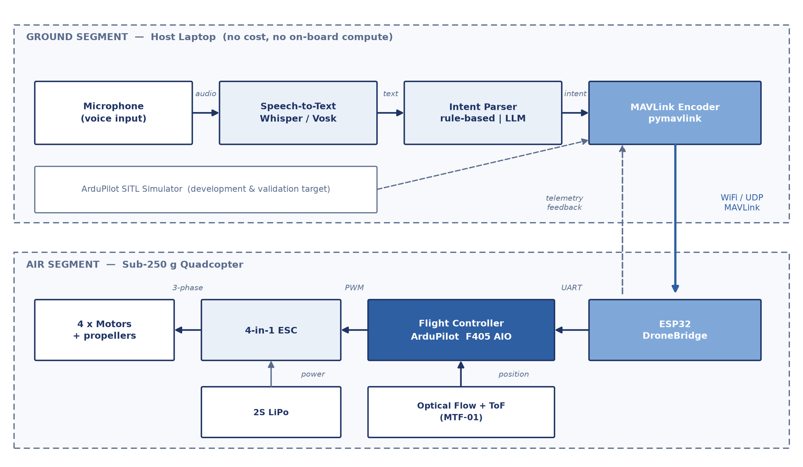
Figure 1: System block diagram. Voice input is processed entirely on the host laptop (ground segment) and transmitted as MAVLink messages over WiFi/UDP to the ESP32 bridge on the aircraft (air segment), which forwards them by UART to the ArduPilot flight controller. The optical-flow and time-of-flight sensor closes the position loop on board.

1.3.2 Software Architecture
The software is organised as a unidirectional command pipeline with a telemetry feedback path. Each layer has a single responsibility and a defined interface to the next, so that layers can be developed and tested in isolation. The two intent parsers are interchangeable behind a common interface, which is what makes the comparative evaluation in task T9 possible without altering the rest of the pipeline. A command validator sits between the parser and the protocol layer, clamping range, altitude and rate requests so that a misrecognised command cannot produce an unsafe manoeuvre.
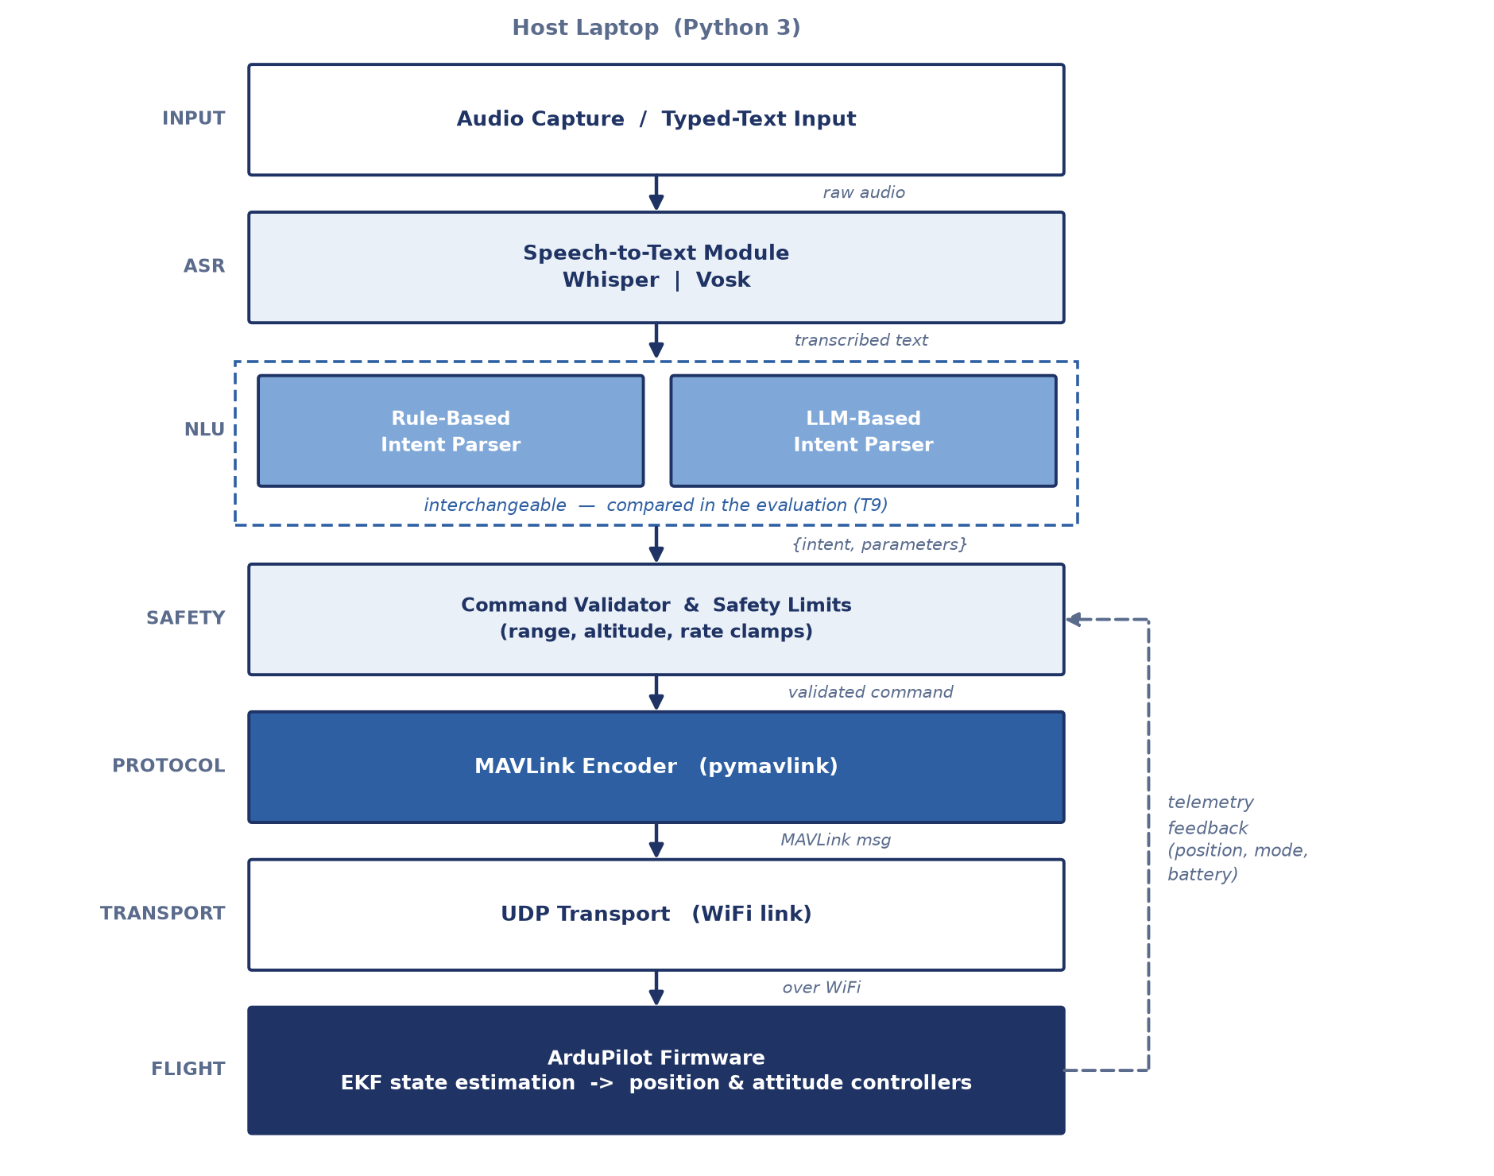
Figure 2: Software block diagram. Audio or typed text is transcribed, parsed into a structured intent, validated against safety limits, encoded as MAVLink by pymavlink and transmitted over UDP to the ArduPilot firmware. Telemetry returns to the validator to close the loop.

1.3.3 Development and Evaluation Approach
- Development approach. Software-in-the-loop first. The full natural-language to MAVLink pipeline is developed and validated against the ArduPilot SITL simulator before any command reaches a real motor, decoupling software progress from hardware lead times and crash damage.
- Hardware. A quadcopter assembled from a combined flight-controller and electronic-speed-controller board, four brushless motors, a 3–3.5 inch frame and a 2S lithium-polymer battery, as set out in Figure 1.
- Firmware. ArduPilot [3], selected over Betaflight and iNav for its mature MAVLink interface [4] and its support for non-GPS position-hold flight modes.
- Natural-language layer. Local speech-to-text (Whisper [5] or Vosk [6]) converts audio to text, and the two interchangeable intent parsers of Figure 2 emit a structured command that pymavlink converts into MAVLink messages.
- Evaluation. Recognition accuracy is measured over a scripted command corpus; movement accuracy is measured against a marked floor reference; latency is logged in software. The two parsers are compared quantitatively.
- Safety. All flight testing is conducted indoors with propeller guards fitted, using tethered and low-altitude first flights and a software kill-switch. See Section 4.

2. RESOURCE ANALYSIS
This section identifies the resources required to carry out the project. The full Project Resources Checklist is completed in consultation with the Project Supervisor and included as Appendix B for use by technical staff in planning resource provision.

2.1 Hardware Resources (Bill of Materials)
Target build cost: no more than US$150 (approximately S$200).
Item | Purpose | Est. cost (USD)
Flight controller + 4-in-1 ESC (F405 AIO) | Flight control, motor drive, MAVLink | 35
4 × brushless motors (1404 class) | Propulsion | 35
Frame, 3–3.5 inch | Airframe (3D-printed in-house if available) | 0–15
Propellers (with spares) | Thrust; spares essential for crash recovery | 5
Optical-flow + ToF sensor (e.g. MTF-01) | GPS-denied position hold | 25
ESP32 WiFi bridge (DroneBridge) | MAVLink telemetry link to laptop | 5
2 × 2S LiPo batteries | Power; second pack doubles test time | 18
Connectors, wire, heat-shrink, straps | Assembly consumables | 10
TOTAL |  | 135–148

2.2 Resources Required but Not Covered by the Build Budget
The following are required to complete the project and must be confirmed as available through the university laboratory before the bill of materials is committed:
- Soldering iron, solder and desoldering equipment.
- LiPo balance charger (approximately US$20) and a LiPo-safe charging and storage bag.
- Digital multimeter for continuity and voltage checks.
- 3D printer and filament, if the frame is to be printed rather than purchased.
- A safe indoor flying space. This is a hard requirement rather than a convenience: outdoor flight in Singapore is substantially constrained by CAAS restricted, protected and danger areas, so an indoor laboratory or netted area is essential to the project.
- Precision scale, to verify the airframe remains below the 250g design limit.

2.3 Software Resources
Every software tool required by the project is free or open-source and runs on the student's own laptop. The total software cost of the project is therefore US$0, and no cloud compute is purchased: the speech and language models run locally. The complete list is given in Table 1.
Software / Library | Role in the Project | Licence | Cost
Python 3 | Primary development language for the entire ground-segment pipeline | PSF | Free
ArduPilot | Flight-control firmware on the F405 flight controller | GPLv3 | Free
ArduPilot SITL | Software-in-the-loop simulator; primary development and test target before hardware exists | GPLv3 | Free
Mission Planner / QGroundControl | Ground control station for firmware flashing, parameter configuration and PID tuning | GPLv3 | Free
MAVLink / pymavlink | Command and telemetry protocol; Python bindings used to encode commands | LGPLv3 | Free
OpenAI Whisper | Local speech-to-text engine (primary candidate) | MIT | Free
Vosk | Offline speech-to-text engine (lightweight alternative, compared in T3) | Apache 2.0 | Free
DroneBridge for ESP32 | Firmware for the ESP32 WiFi-to-UART telemetry bridge | Apache 2.0 | Free
ESP-IDF / Arduino IDE | Toolchain used to flash the ESP32 bridge | Apache 2.0 | Free
NumPy, pandas, Matplotlib | Logging, analysis and plotting of accuracy and latency results | BSD | Free
FreeCAD + slicer (e.g. Cura) | Design and slicing of the 3D-printed airframe, if printed in-house | LGPL | Free
Git | Version control for firmware parameters, source code and report drafts | GPLv2 | Free
TOTAL SOFTWARE COST |  |  | US$0
Table 1: Software resources required. All items are free or open-source; licences are to be re-confirmed against each project's current release before submission.

3. SUSTAINABILITY ANALYSIS
This section assesses the environmental impact of the project and identifies actions taken to improve sustainability across the build, testing and end-of-life phases.

3.1 Environmental Impact
- Batteries. Lithium-polymer cells are the most significant environmental concern. They contain hazardous materials, present a fire risk if landfilled, and must not be disposed of as general waste. In Singapore, waste batteries and electronics fall under the Resource Sustainability Act and its regulated e-waste (Extended Producer Responsibility) scheme, with designated collection points for correct recycling.
- Electronic waste. Crashes during flight testing are the main source of avoidable e-waste, producing broken motors, propellers and occasionally flight controllers. Carbon-fibre frame material is not readily recyclable, whereas a 3D-printed PLA or PETG frame is repairable and reprintable.
- Energy. The physical footprint is small: a sub-250g aircraft consumes little energy per charge, and the natural-language models run locally on an existing laptop rather than on cloud GPU infrastructure, avoiding the substantially higher energy and carbon cost of large-scale cloud inference.

3.2 Actions Taken to Improve Sustainability
- Simulation-first development (ArduPilot SITL) minimises the number of physical test flights and therefore battery charge cycles, crashes and consequent e-waste.
- A modular, open-source hardware design is chosen so that components (flight controller, motors, sensor, battery) can be reused in future student projects rather than discarded at project end.
- Higher-quality propellers and propeller guards are purchased to reduce breakage and the associated stream of replacement waste.
- Rechargeable LiPo packs are used throughout; no single-use batteries are involved.
- A small local speech-to-text model is selected in preference to a large cloud model, reducing the energy cost of the natural-language pipeline.
- All LiPo cells and electronic components are routed to Singapore's designated e-waste recycling channels at end of life, rather than to general waste.
- Project documentation is published openly so the work is reproducible without others having to duplicate the prototyping effort and its material cost.

4. RISK, ETHICS AND THREAT ASSESSMENT
This section covers health and safety, ethical considerations and threats to project success. The completed Project Risk, Ethics and Threat Assessment Checklist is included as Appendix C.

4.1 Health and Safety
Hazard | Risk | Control Measure
Rotating propellers | Laceration to hands, face or eyes | Propeller guards fitted for all flight testing; propellers removed for all bench and configuration work; motors armed only in a cleared area with eye protection worn.
LiPo battery fire | Fire, burns, toxic fumes during charge, storage or after crash impact | Charge only in a LiPo-safe bag and never unattended; store at storage voltage; inspect after every crash and safely discard any swollen or damaged cell.
Loss of control / fly-away | Impact injury or property damage | Software kill-switch (disarm) available at all times; tethered and low-altitude first flights; testing confined to an enclosed indoor space with observers behind netting.
Soldering | Burns, inhalation of flux fumes | Use only after laboratory induction; fume extraction and ventilation; iron returned to its stand when not in use; adherence to laboratory rules.
Regulatory breach (CAAS) | Legal liability; endangerment of manned aviation | Indoor testing only; confirm the test site lies outside CAAS restricted, protected and danger areas and within height limits; verify current CAAS requirements before testing.
Lone working | Delayed response to an injury | Flight testing conducted only during staffed laboratory hours with a second person present.

4.2 Ethical Considerations
The core engineering system involves no human participants, no personal data and no animals, and is therefore expected to present low ethical risk. One aspect remains open at the time of writing. The comparative evaluation of the two intent parsers may be conducted either using the student's own voice only, or using voice command samples collected from other speakers to test robustness to accent and phrasing. If restricted to the student's own voice, no human-participant approval is required. If samples are collected from other people, those recordings constitute personal data, and the following will apply before any collection begins:
- School ethics approval will be sought and granted prior to any data collection.
- Written informed consent will be obtained from every participant, stating the purpose of the recording, how it will be stored and how it may be withdrawn.
- Recordings will be handled in accordance with Singapore's Personal Data Protection Act (PDPA): stored encrypted, accessible only to the student and supervisor, used solely for this evaluation, and deleted on completion of the project.
- Results will be reported in aggregate, anonymised form, with no identifiable audio reproduced in the report or presentation.
The decision between these two options will be taken at the start of the evaluation phase (task T9), allowing ample time for approval to be obtained if required.

4.3 Threats to Project Success
Threat | Likelihood / Impact | Mitigation
GPS-denied position hold (T7) underperforms or consumes excessive time. This is the single greatest threat to the project. | Medium / High | Schedule 30 hours and a ten-working-day window with following slack. Because the software strand is fully validated in simulation by day 20, a complete demonstrable result exists even if hardware position hold underperforms.
Hardware damage from crashes, or component shipping delays. | High / Medium | Order components in the first week with spare propellers and one spare motor. The software strand (T2–T4, T9) proceeds entirely independently of hardware availability.
No compliant indoor test space is available. | Low / High | Confirm laboratory space by day 5 as a gating item. SITL simulation serves as the demonstration fallback.
Budget overrun; charger and tooling are not covered by the US$150 parts budget. | Medium / Low | Confirm laboratory tooling availability before committing to purchases; print the frame in-house to release approximately US$15 of contingency.
Speech recognition accuracy is poor for the student's accent or in a noisy laboratory. | Medium / Medium | Evaluate both Whisper and Vosk in T3; a typed-text input path is retained so the intent parser can be evaluated independently of the acoustic front end.
Ethics approval delays the parser evaluation if external participants are recorded. | Low / Medium | Decide the evaluation design at the start of T9; the own-voice-only option requires no approval and is available as an immediate fallback.

5. PROJECT PLAN

5.1 Project Work Description
The work is decomposed into tasks that de-risk the software and hardware strands in parallel, with full validation in simulation before hardware integration. The schedule is expressed in working days, at five working days per week over a ten-week period, giving 50 working days in total. Two distinct quantities are reported for each task: estimated effort in hours (the labour required) and estimated duration in working days (the elapsed calendar allowance). These differ because the two strands run concurrently. No task exceeds ten working days, and each carries a measurable outcome that acts as its completion test. The corresponding Gantt chart, shaded by estimated duration in days, is provided in Appendix A.
Ref | Work Task | Effort (hrs) | Duration (days) | Days | Measurable Outcome
T1 | Requirements capture, literature review, finalise architecture and bill of materials | 20 | 5 | 1–5 | Bill of materials and architecture diagram approved by supervisor
T2 | Establish ArduPilot SITL and pymavlink development environment | 12 | 5 | 1–5 | Script commands a simulated aircraft to arm, take off and land
T3 | Build NLP pipeline: speech-to-text and rule-based intent parser | 25 | 10 | 6–15 | ≥ 90% correct intent classification on a 30-command test corpus
T4 | Integrate NLP pipeline with MAVLink in simulation | 18 | 5 | 16–20 | A spoken command drives correct simulated flight, end to end
T5 | Procure and assemble drone hardware; configure ArduPilot | 30 | 10 | 6–15 | Motors respond correctly in configurator; airframe verified below 250g
T6 | Manual hover testing (guarded, tethered) | 15 | 5 | 16–20 | Stable controlled hover achieved and recorded on video
T7 | Optical-flow position-hold tuning (highest risk) | 30 | 10 | 21–30 | Hands-off stationary hover with less than 0.5 m drift over 30 seconds
T8 | Deploy NLP pipeline to the physical aircraft over the WiFi link | 15 | 5 | 31–35 | “Take off, move one metre, land” executed from a spoken command
T9 | Implement language-model parser and run comparative evaluation | 20 | 10 | 31–40 | Accuracy and latency comparison table for both parsers
T10 | Final testing, data collection and report writing | 25 | 15 | 36–50 | Movement-accuracy and latency results collected; report draft complete
 | TOTAL | 210 | — | 50 working days elapsed
Table 2: Work breakdown. Effort is the labour estimate in hours; duration is the elapsed allowance in working days. The two strands overlap, so the durations sum to more than the 50 working days of elapsed project time.

5.2 Critical Path
The critical path runs T1 → T5 → T6 → T7 → T8 → T10, occupying all 50 working days. The natural-language strand (T2 → T3 → T4 → T9) runs in parallel and is deliberately not on the critical path, so that software progress is never blocked by hardware delays. The hardware and position-hold chain therefore determines project completion, and task T7, spanning working days 21 to 30, is the pivotal milestone.

6. REFERENCES
IEEE numeric style, as preferred for Engineering. In-text citations appear as bracketed numbers. Access dates and CAAS regulatory details are to be re-verified prior to submission.
[1] Civil Aviation Authority of Singapore, “Unmanned Aircraft: Rules and Regulations.” [Online]. Available: https://www.caas.gov.sg. [Accessed: 29-Jul-2026].
[2] D. Honegger, L. Meier, P. Tanskanen and M. Pollefeys, “An open source and open hardware embedded metric optical flow CMOS camera for indoor and outdoor applications,” in Proc. IEEE Int. Conf. Robotics and Automation (ICRA), 2013, pp. 1736–1741.
[3] ArduPilot Development Team, “ArduPilot Documentation.” [Online]. Available: https://ardupilot.org. [Accessed: 29-Jul-2026].
[4] MAVLink, “MAVLink Developer Guide.” [Online]. Available: https://mavlink.io. [Accessed: 29-Jul-2026].
[5] A. Radford, J. W. Kim, T. Xu, G. Brockman, C. McLeavey and I. Sutskever, “Robust speech recognition via large-scale weak supervision,” arXiv:2212.04356, 2022.
[6] Alpha Cephei, “Vosk Speech Recognition Toolkit.” [Online]. Available: https://alphacephei.com/vosk. [Accessed: 29-Jul-2026].

APPENDIX A: Gantt Chart (50 Working Days / 10 Weeks)
The schedule is shown in Figure 3. Each bar is shaded across the task's estimated duration in working days, at five working days per week over ten weeks. Bar labels give the duration in days, and the italic figure to the right of each bar gives the estimated effort in hours.
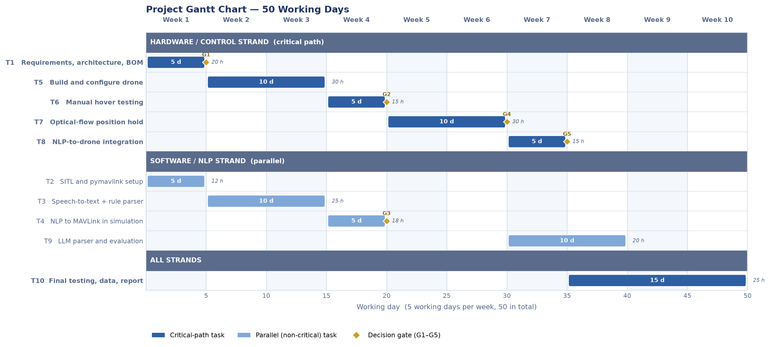
Figure 3: Project Gantt chart over 50 working days. Critical-path tasks (T1 → T5 → T6 → T7 → T8 → T10) are shown in dark blue and span the full 50 days; the parallel natural-language strand (T2, T3, T4, T9) is shown in light blue. Diamonds mark decision gates G1–G5, each falling on the final day of the task it gates.

Decision Gates
Gate | Day | Criterion | Action if Not Met
G1 | 5 | Architecture and bill of materials approved; laboratory space and tooling confirmed (T1) | Revise scope or component selection before any purchase
G2 | 20 | Manual hover achieved (T6) | Extend build and tuning; escalate to supervisor
G3 | 20 | Full NLP pipeline drives simulated flight correctly (T4) | Halt hardware integration; resolve software defects first
G4 | 30 | Hands-off position hold achieved (T7) — pivotal gate | Fall back to a simulation-based demonstration for T8 and reframe the hardware result as a documented limitation in the evaluation
G5 | 35 | Voice command executes correctly on the physical aircraft (T8) | Prioritise report and evaluation using simulation results

Slack and Contingency
The software strand completes task T4 on day 20 and has no committed work between days 21 and 30, allowing it to absorb slippage in the high-risk position-hold task T7. The gap between the end of T8 on day 35 and the completion of reporting on day 50 provides approximately ten working days of contingency against the two most likely sources of delay: position-hold tuning and crash repair.

APPENDIX B: Project Resources Checklist
The official Project Resources Checklist provided on Canvas must be completed in consultation with the Project Supervisor and inserted here. It is used by technical staff to plan resource provision and must reflect the Bill of Materials and laboratory resources set out in Section 2 of this outline.
[Insert completed Appendix B checklist here.]

APPENDIX C: Project Risk, Ethics and Threat Assessment Checklist
The official Project Risk, Ethics and Threat Assessment Checklist provided on Canvas must be completed and inserted here. It must be consistent with the health and safety, ethics and threat assessments set out in Section 4 of this outline.
[Insert completed Appendix C checklist here.]

