Injury data

Ian Bradbury

April 27 2015

## Get data

The data are located in P:.csv, as a CSV file extracted from the original SPSS database.

injury <- read.csv('P:/injury.csv')  
names(injury)

## [1] "age" "height" "weight" "BMI"   
## [5] "yrsinschooll" "gender" "beighton" "beightscore"   
## [9] "Fsquat" "slsquatL" "slsquatr" "downdog"   
## [13] "aslrl" "aslrr" "hipabdcontl" "hipabdcontr"   
## [17] "hipabdlscore" "hipadbrscore" "hipaddcontl" "hipaddcontr"   
## [21] "hipaddlscore" "hipaddrscore" "hamstringcont" "hamstringscore"  
## [25] "triplehopl" "triplehopr" "Flungecontl" "Fllungecontr"   
## [29] "latlungcontl" "latlungcontr" "PastInjury" "NonTraumSpn11"   
## [33] "NonTraumUQ12" "NonTraumLQ13" "TraumSpn21" "TraumUQ22"   
## [37] "TraumLQ23" "LQInjYorN" "BMI4" "HipABDL4"   
## [41] "HipABDR4" "HipADDL4" "HipADDR4" "HamsCont4"   
## [45] "TripHopL4" "TripHopR4" "VJHt4" "Beighton2"   
## [49] "Fsquat2" "SLSquatL2" "SLSquatR2" "DDog2"   
## [53] "ASLRL2" "ASLRR2" "ActiveMotion" "HipStability"   
## [57] "Power" "Flexibility" "MotorControl"

# Restrict to subset of interest  
  
injury.dmat <- injury[,c(1,4,7,9:16,19,20,23,25:30,38)]

## Missing data

There are many missing values in the data, so start by excamining the patterns 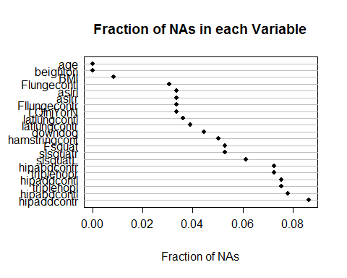 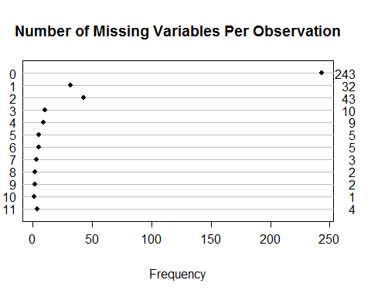 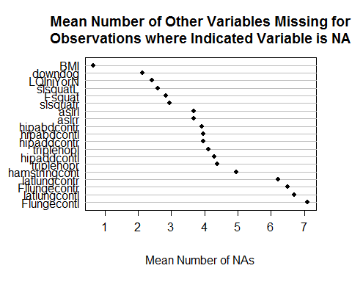 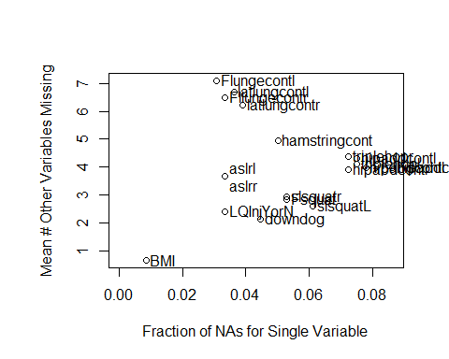 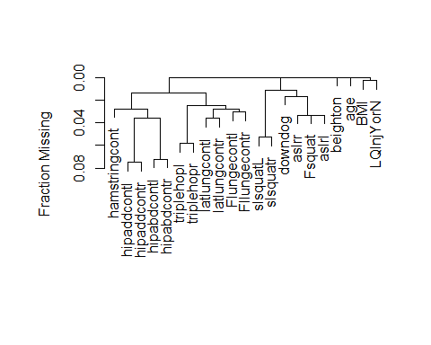

## Distribution of Injury by variable

describe(injury.dmat)

## injury.dmat   
##   
## 21 Variables 359 Observations  
## ---------------------------------------------------------------------------  
## age   
## n missing unique Info Mean   
## 359 0 7 0.92 19.07   
##   
## 17 18 19 20 21 22 23  
## Frequency 8 130 97 90 23 10 1  
## % 2 36 27 25 6 3 0  
## ---------------------------------------------------------------------------  
## BMI   
## n missing unique Info Mean .05 .10 .25 .50   
## 356 3 313 1 22.96 19.27 19.89 20.98 22.67   
## .75 .90 .95   
## 24.72 26.48 27.64   
##   
## lowest : 17.54 17.59 17.89 17.90 18.21  
## highest: 29.12 29.16 29.41 31.46 37.30   
## ---------------------------------------------------------------------------  
## beighton   
## n missing unique Info Mean .05 .10 .25 .50   
## 359 0 10 0.97 2.468 0 0 0 2   
## .75 .90 .95   
## 4 6 7   
##   
## 0 1 2 3 4 5 6 7 8 9  
## Frequency 98 46 67 32 43 32 21 12 4 4  
## % 27 13 19 9 12 9 6 3 1 1  
## ---------------------------------------------------------------------------  
## Fsquat   
## n missing unique Info Mean   
## 340 19 5 0.82 4.165   
##   
## 1 2 3 4 5  
## Frequency 11 22 54 66 187  
## % 3 6 16 19 55  
## ---------------------------------------------------------------------------  
## slsquatL   
## n missing unique Info Mean   
## 337 22 7 0.8 4.178   
##   
## -20 -10 1 2 3 4 5  
## Frequency 1 2 8 11 32 93 190  
## % 0 1 2 3 9 28 56  
## ---------------------------------------------------------------------------  
## slsquatr   
## n missing unique Info Mean   
## 340 19 6 0.81 4.206   
##   
## -20 1 2 3 4 5  
## Frequency 1 10 11 41 90 187  
## % 0 3 3 12 26 55  
## ---------------------------------------------------------------------------  
## downdog   
## n missing unique Info Mean   
## 343 16 6 0.94 3.356   
##   
## 0 1 2 3 4 5  
## Frequency 1 49 26 97 91 79  
## % 0 14 8 28 27 23  
## ---------------------------------------------------------------------------  
## aslrl   
## n missing unique Info Mean   
## 347 12 4 0.9 3.937   
##   
## 2 (15, 4%), 3 (95, 27%), 4 (134, 39%), 5 (103, 30%)   
## ---------------------------------------------------------------------------  
## aslrr   
## n missing unique Info Mean   
## 347 12 4 0.9 3.942   
##   
## 2 (13, 4%), 3 (102, 29%), 4 (124, 36%), 5 (108, 31%)   
## ---------------------------------------------------------------------------  
## hipabdcontl   
## n missing unique Info Mean .05 .10 .25 .50   
## 331 28 57 1 38.72 22.0 24.0 31.0 37.0   
## .75 .90 .95   
## 45.0 55.0 58.5   
##   
## lowest : 5 13 14 15 17, highest: 69 70 72 73 83   
## ---------------------------------------------------------------------------  
## hipabdcontr   
## n missing unique Info Mean .05 .10 .25 .50   
## 333 26 61 1 39.41 22.0 25.0 32.0 39.0   
## .75 .90 .95   
## 46.0 55.8 64.0   
##   
## lowest : 0 3 13 14 16, highest: 73 75 77 80 84   
## ---------------------------------------------------------------------------  
## hipaddcontl   
## n missing unique Info Mean .05 .10 .25 .50   
## 332 27 59 1 42.99 19.00 25.00 35.00 45.00   
## .75 .90 .95   
## 52.00 58.00 62.45   
##   
## lowest : 0 5 6 9 11, highest: 65 66 68 71 77   
## ---------------------------------------------------------------------------  
## hipaddcontr   
## n missing unique Info Mean .05 .10 .25 .50   
## 328 31 59 1 44.83 22.35 26.00 37.00 45.50   
## .75 .90 .95   
## 53.00 61.00 65.00   
##   
## lowest : 9 12 14 15 17, highest: 68 70 72 73 74   
## ---------------------------------------------------------------------------  
## hamstringcont   
## n missing unique Info Mean .05 .10 .25 .50   
## 341 18 52 1 30.16 12 17 21 30   
## .75 .90 .95   
## 39 45 50   
##   
## lowest : 2 5 6 7 8, highest: 53 55 57 68 80   
## ---------------------------------------------------------------------------  
## triplehopl   
## n missing unique Info Mean .05 .10 .25 .50   
## 332 27 153 1 202.4 137.6 155.1 172.0 196.0   
## .75 .90 .95   
## 232.0 258.9 271.4   
##   
## lowest : 112 116 120 123 124, highest: 291 293 299 302 386   
## ---------------------------------------------------------------------------  
## triplehopr   
## n missing unique Info Mean .05 .10 .25 .50   
## 333 26 130 1 203.5 144.0 154.0 174.0 198.0   
## .75 .90 .95   
## 233.0 261.6 276.0   
##   
## lowest : 124 126 127 128 129, highest: 296 297 298 304 405   
## ---------------------------------------------------------------------------  
## Flungecontl   
## n missing unique Info Mean .05 .10 .25 .50   
## 348 11 53 1 51.42 37.67 40.35 45.00 52.00   
## .75 .90 .95   
## 58.00 62.00 65.00   
##   
## lowest : 30 31 32 33 34, highest: 68 69 70 72 73   
## ---------------------------------------------------------------------------  
## Fllungecontr   
## n missing unique Info Mean .05 .10 .25 .50   
## 347 12 48 1 51.75 38 41 45 52   
## .75 .90 .95   
## 58 62 65   
##   
## lowest : 29 31 33 35 36, highest: 67 68 69 70 72   
## ---------------------------------------------------------------------------  
## latlungcontl   
## n missing unique Info Mean .05 .10 .25 .50   
## 346 13 45 1 51.39 41.25 43.00 46.00 51.00   
## .75 .90 .95   
## 56.75 61.00 63.00   
##   
## lowest : 35.0 36.0 37.0 38.0 38.5, highest: 65.0 66.0 67.0 68.0 70.0   
## ---------------------------------------------------------------------------  
## latlungcontr   
## n missing unique Info Mean .05 .10 .25 .50   
## 345 14 46 1 51.54 40.2 42.0 46.0 51.0   
## .75 .90 .95   
## 57.0 61.0 63.0   
##   
## lowest : 34.0 34.5 35.0 36.0 36.5, highest: 65.0 66.0 67.0 68.0 69.0   
## ---------------------------------------------------------------------------  
## LQInjYorN   
## n missing unique Info Sum Mean   
## 347 12 2 0.69 224 0.6455   
## ---------------------------------------------------------------------------

dd <- datadist(injury.dmat)  
options (datadist='dd')  
attach(injury.dmat)  
s <- summary(LQInjYorN ~ .,data=injury.dmat)  
print(s)

## LQInjYorN N=347, 12 Missing  
##   
## +-------------+-----------+---+---------+  
## | | |N |LQInjYorN|  
## +-------------+-----------+---+---------+  
## |age |17 | 7|0.8571429|  
## | |18 |124|0.5887097|  
## | |19 | 93|0.6129032|  
## | |20 | 90|0.6666667|  
## | |21 | 23|0.9130435|  
## | |22 | 9|0.7777778|  
## | |23 | 1|0.0000000|  
## +-------------+-----------+---+---------+  
## |BMI |[17.5,21.0)| 87|0.6666667|  
## | |[21.0,22.7)| 86|0.6976744|  
## | |[22.7,24.7)| 86|0.6279070|  
## | |[24.7,37.3]| 86|0.6046512|  
## | |Missing | 2|0.0000000|  
## +-------------+-----------+---+---------+  
## |beighton |0 | 95|0.6000000|  
## | |[1,3) |108|0.7129630|  
## | |[3,5) | 74|0.5945946|  
## | |[5,9] | 70|0.6571429|  
## +-------------+-----------+---+---------+  
## |Fsquat |1 | 11|0.7272727|  
## | |2 | 22|0.5000000|  
## | |3 | 53|0.7547170|  
## | |4 | 63|0.6349206|  
## | |5 |180|0.6277778|  
## | |Missing | 18|0.6666667|  
## +-------------+-----------+---+---------+  
## |slsquatL |-20 | 1|0.0000000|  
## | |-10 | 2|0.5000000|  
## | |1 | 8|0.3750000|  
## | |2 | 11|0.7272727|  
## | |3 | 29|0.6896552|  
## | |4 | 90|0.6888889|  
## | |5 |184|0.6358696|  
## | |Missing | 22|0.5909091|  
## +-------------+-----------+---+---------+  
## |slsquatr |-20 | 1|0.0000000|  
## | |1 | 10|0.7000000|  
## | |2 | 11|0.7272727|  
## | |3 | 40|0.6250000|  
## | |4 | 87|0.6781609|  
## | |5 |179|0.6256983|  
## | |Missing | 19|0.6842105|  
## +-------------+-----------+---+---------+  
## |downdog |0 | 1|1.0000000|  
## | |1 | 49|0.6326531|  
## | |2 | 25|0.7200000|  
## | |3 | 95|0.7052632|  
## | |4 | 88|0.5909091|  
## | |5 | 73|0.5890411|  
## | |Missing | 16|0.7500000|  
## +-------------+-----------+---+---------+  
## |aslrl |2 | 15|0.5333333|  
## | |3 | 92|0.5978261|  
## | |4 |129|0.6511628|  
## | |5 | 99|0.6969697|  
## | |Missing | 12|0.6666667|  
## +-------------+-----------+---+---------+  
## |aslrr |2 | 13|0.5384615|  
## | |3 |100|0.5700000|  
## | |4 |117|0.6410256|  
## | |5 |105|0.7333333|  
## | |Missing | 12|0.6666667|  
## +-------------+-----------+---+---------+  
## |hipabdcontl |[ 5,32) | 86|0.7325581|  
## | |[32,38) | 78|0.5897436|  
## | |[38,46) | 80|0.6250000|  
## | |[46,83] | 79|0.6202532|  
## | |Missing | 24|0.6666667|  
## +-------------+-----------+---+---------+  
## |hipabdcontr |[ 0,33) | 87|0.6781609|  
## | |[33,40) | 86|0.6627907|  
## | |[40,47) | 77|0.6363636|  
## | |[47,84] | 74|0.5945946|  
## | |Missing | 23|0.6521739|  
## +-------------+-----------+---+---------+  
## |hipaddcontl |[ 5,37) | 88|0.6704545|  
## | |[37,46) | 80|0.6375000|  
## | |[46,53) | 83|0.6626506|  
## | |[53,77] | 71|0.6056338|  
## | |Missing | 25|0.6400000|  
## +-------------+-----------+---+---------+  
## |hipaddcontr |[12,38) | 87|0.7126437|  
## | |[38,46) | 72|0.6111111|  
## | |[46,54) | 81|0.6419753|  
## | |[54,74] | 78|0.6025641|  
## | |Missing | 29|0.6551724|  
## +-------------+-----------+---+---------+  
## |hamstringcont|[ 2,22) | 86|0.7209302|  
## | |[22,31) | 99|0.6767677|  
## | |[31,39) | 63|0.6031746|  
## | |[39,80] | 82|0.5487805|  
## | |Missing | 17|0.7058824|  
## +-------------+-----------+---+---------+  
## |triplehopl |[112,173) | 81|0.6913580|  
## | |[173,197) | 82|0.5731707|  
## | |[197,233) | 81|0.7407407|  
## | |[233,386] | 80|0.5875000|  
## | |Missing | 23|0.6086957|  
## +-------------+-----------+---+---------+  
## |triplehopr |[124,175) | 81|0.6666667|  
## | |[175,199) | 84|0.6666667|  
## | |[199,234) | 78|0.6153846|  
## | |[234,405] | 81|0.6543210|  
## | |Missing | 23|0.5652174|  
## +-------------+-----------+---+---------+  
## |Flungecontl |[30.0,45.5)| 93|0.7849462|  
## | |[45.5,53.0)| 85|0.6235294|  
## | |[53.0,59.0)| 82|0.5853659|  
## | |[59.0,73.0]| 78|0.5897436|  
## | |Missing | 9|0.4444444|  
## +-------------+-----------+---+---------+  
## |Fllungecontr |[29.0,45.5)| 90|0.8111111|  
## | |[45.5,53.0)| 84|0.5833333|  
## | |[53.0,59.0)| 79|0.5949367|  
## | |[59.0,72.0]| 84|0.5952381|  
## | |Missing | 10|0.5000000|  
## +-------------+-----------+---+---------+  
## |latlungcontl |[35.0,46.5)| 87|0.7816092|  
## | |[46.5,52.0)| 87|0.6206897|  
## | |[52.0,57.0)| 78|0.5641026|  
## | |[57.0,70.0]| 84|0.6190476|  
## | |Missing | 11|0.5454545|  
## +-------------+-----------+---+---------+  
## |latlungcontr |[34.0,46.5)| 88|0.7727273|  
## | |[46.5,51.5)| 80|0.6000000|  
## | |[51.5,58.0)| 94|0.5957447|  
## | |[58.0,69.0]| 73|0.6164384|  
## | |Missing | 12|0.5833333|  
## +-------------+-----------+---+---------+  
## |Overall | |347|0.6455331|  
## +-------------+-----------+---+---------+

plot(s)

