Graphics Programming

# Lab 1, 2 and 3 Screenshots

## Ian Burke – G00307742

**Lab 1**

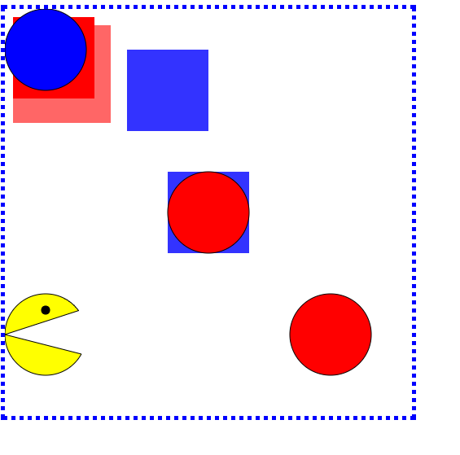

I got the pacman drawing going but still wasn’t perfect. His mouth is to wide and I wanted it to start in the center of the circle. So after messing around with the code I finally figured out that letting the radius equal to 0 for the start and ending angle worked!

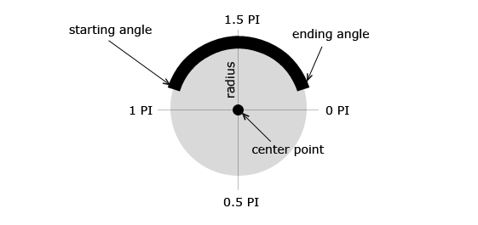

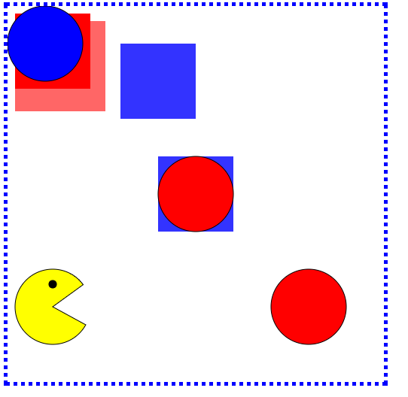

**Lab 2**

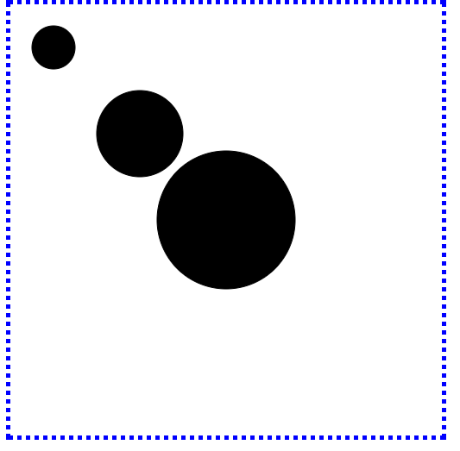

The seven sliced pizza

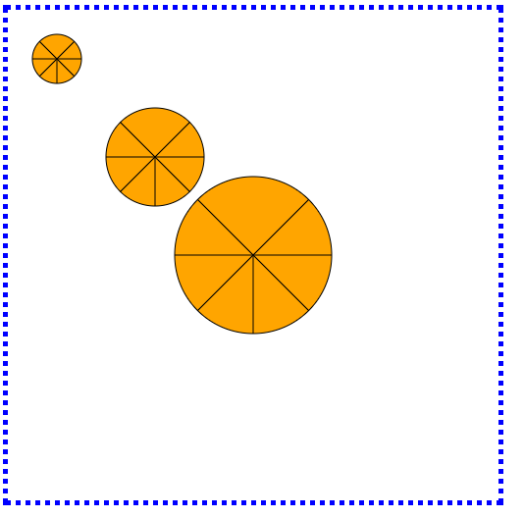

**Lab 3**

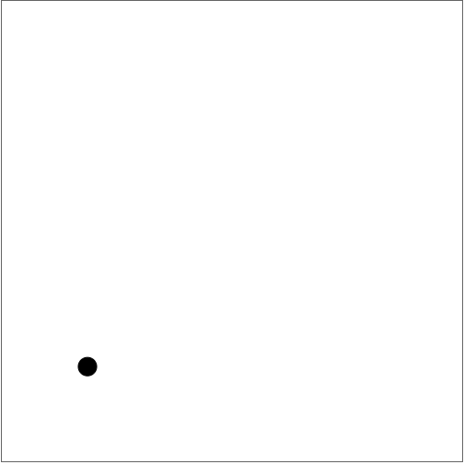

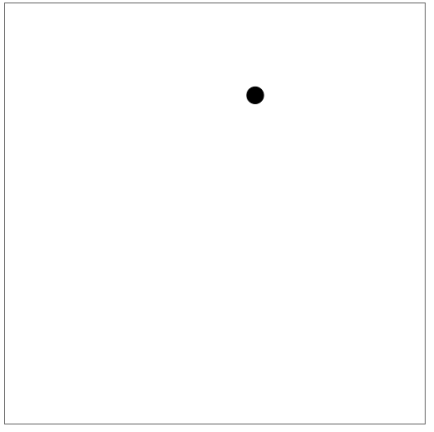

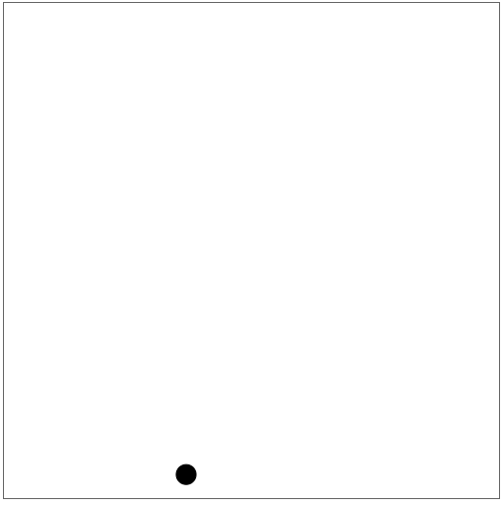

Adding the pizza to it..

