Installation and Configuration Manual

Ionic 2 and MEAN stack project

# Node and Ionic installation and configuration

**Step 1: Download and install Node.**

It’s recommended to pick Long Term Support (LTS) version 6 and not the current version 7 due to large changes that are not yet supported by Ionic.

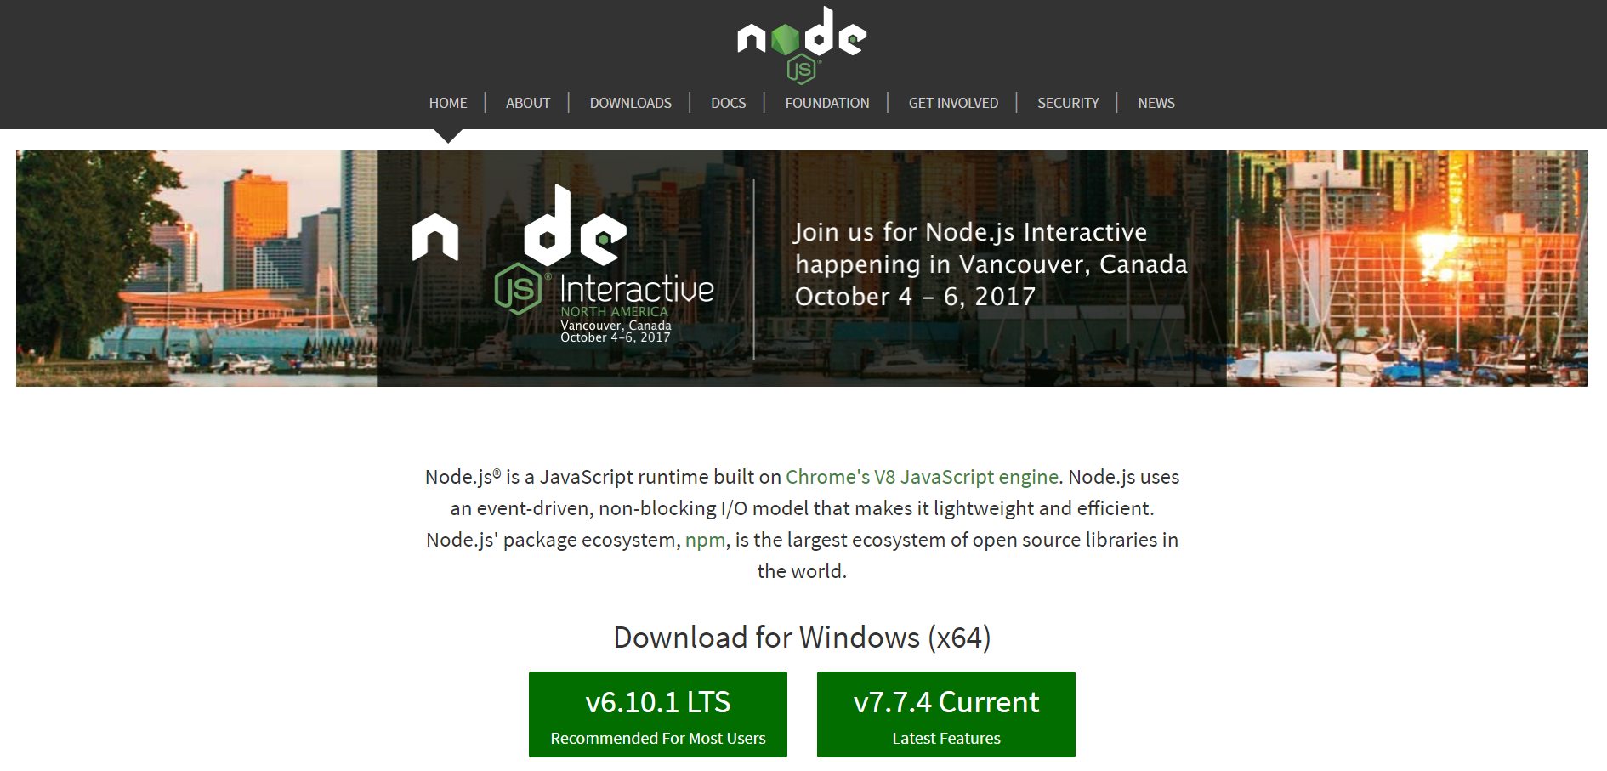

**Step 2: Once downloaded, go to the package and double click to run the installer. Then click next when the setup wizard window pops up.**

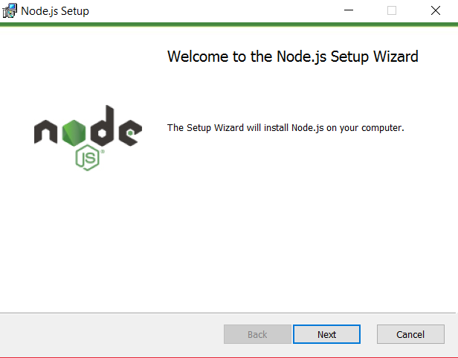

**Step 3: Tick the box and click next.**

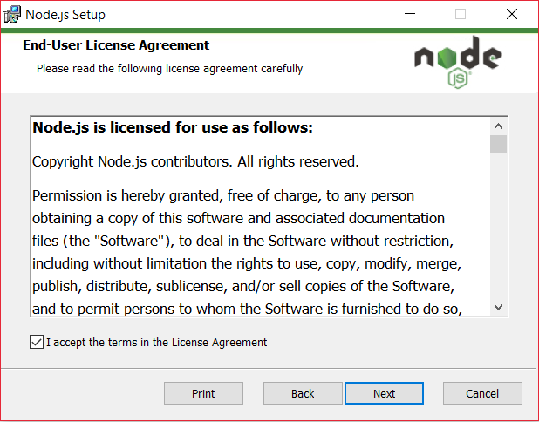

**Step 4: If you are happy with the destination folder then click next.**

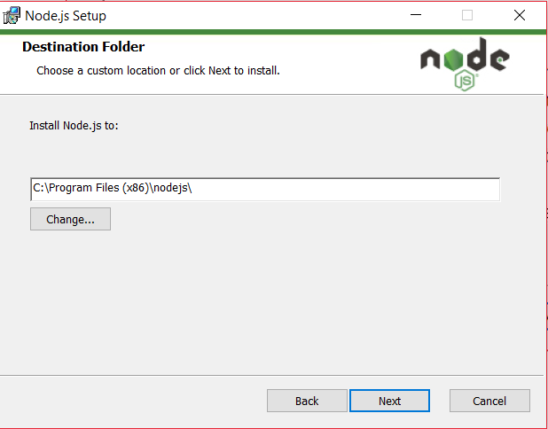

**Step 5: Click next.**

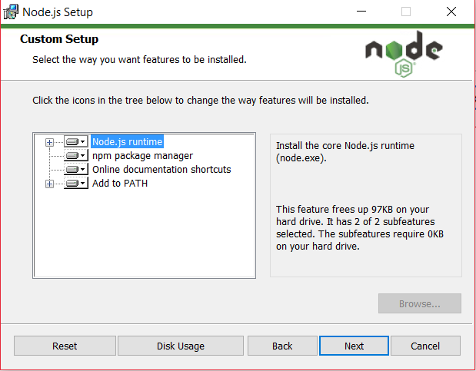

**Step 6: Click install.**

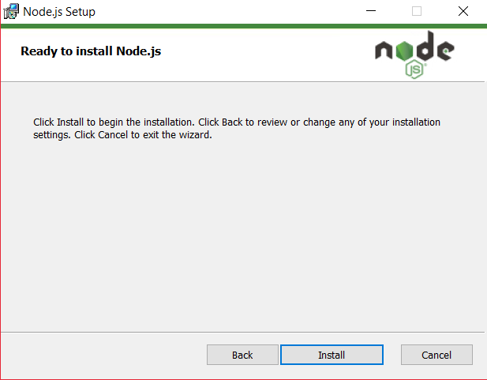

**Step 7: Next thing to do is install Cordova and Ionic. Before we start, If you are using Windows I would recommend using Cmder command terminal due to its ease of use compared to Windows command line. Download Cmder at** [**http://cmder.net/**](http://cmder.net/) **.**

**On the terminal enter the following command to install Ionic and Cordova. For MAC users only, add “sudo” in front of these commands to install utilities globally.**

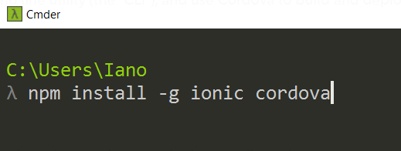

**Step 8: Create an Ionic project by entering the following command. - -V2 means Ionic Version 2**

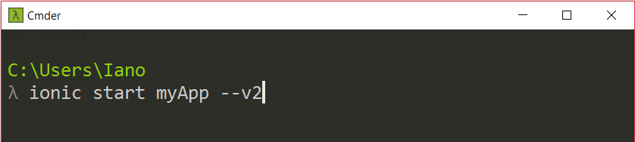

**Step 9: To run the app, either enter “ionic serve” or “ionic lab” depending on your preference.**

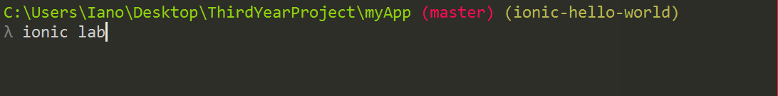

# MongoDB Installation and Configuration

**Step 1: Download MongoDB from MongoDB website.**

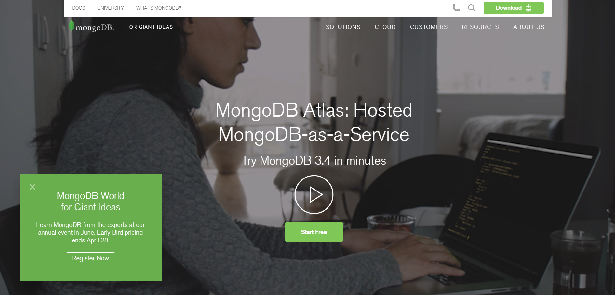

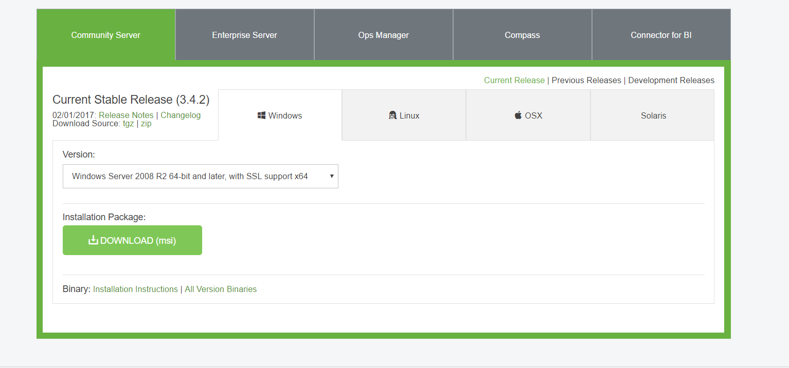

**Step 2: Double click on the downloaded file to run installer. When the installer window pops up, click next.**

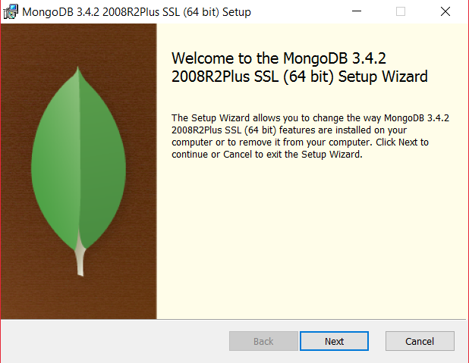

**Step 3: Tick the box and click next.**

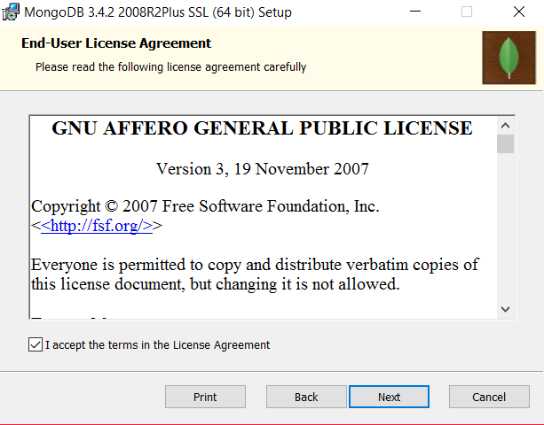

**Step 4: Click complete**

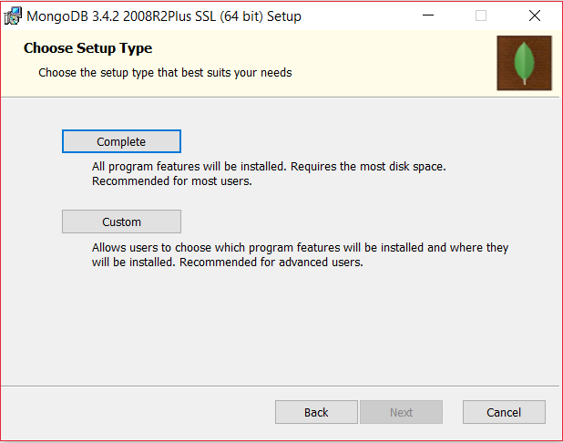

**Step 5: Click install.**

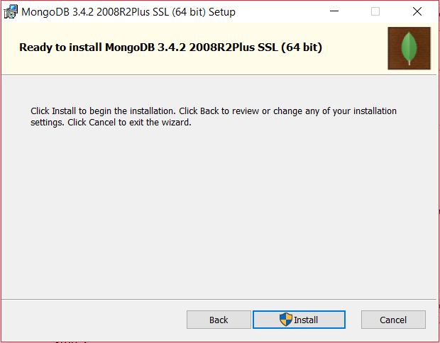

**Step 6: Create a database.**

Open CMD (Command line) and enter “CD/” to go to root directory

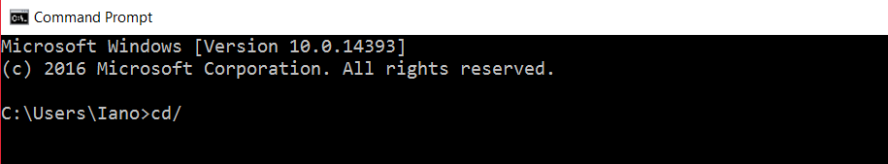

Then enter “Dir” to get a list or directories

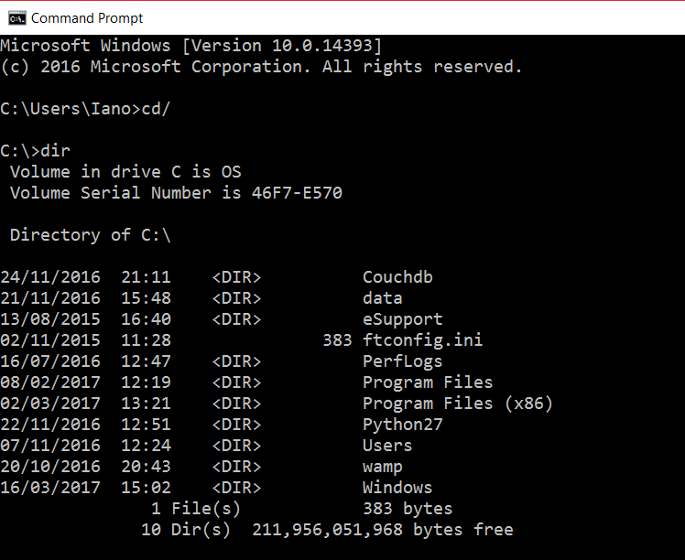

Enter CD “Program Files”

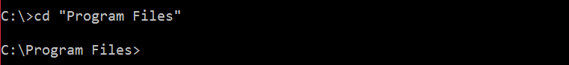

CD into MongoDB



Once in MongoDB directory, CD into Server

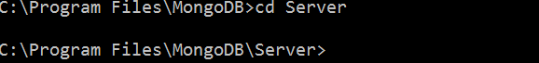

CD 3.4



CD into the binary folder (bin)



In the bin directory, you will find a list of Mongo executables. Mongo.exe and Mongod.exe will be used.

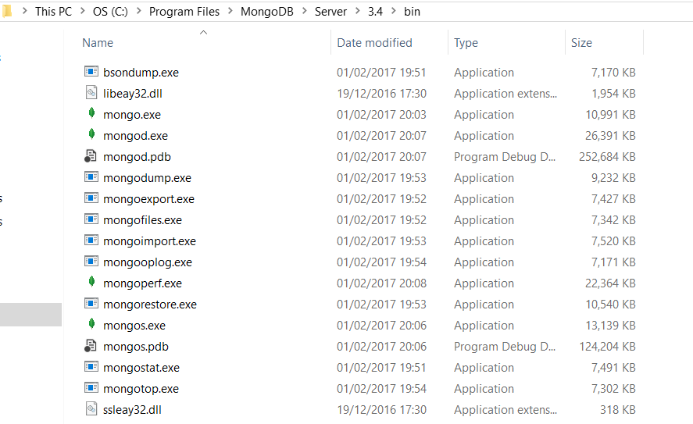

Before you start running the database server, you need to make a data directory for Mongo to store information. Create a folder called “data” and then create a folder called “db” inside the data folder.

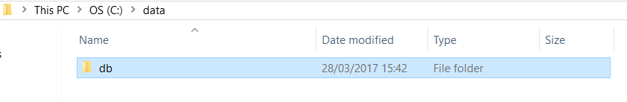

Once that is done, go back to the command line and enter the command below to run the database.





Once the server is running, leave the command terminal open in the background and open another command terminal. In the second command terminal, go to the bin folder in MongoDB as explained above and enter “Mongo”.



Client is running.

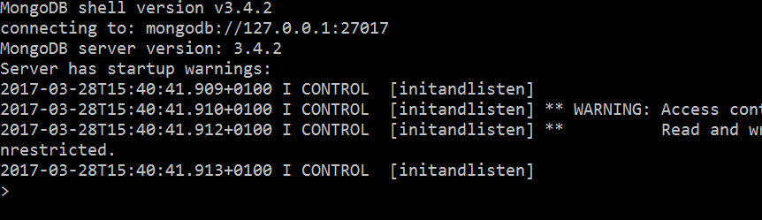

The server should get a connection from client.



Now we can create a database. On the client command terminal, enter “use NameOfDatabase “ to create a new database.



To display the database, we need to insert at least one document. Enter the following command



“outlet” is the name I have given to the document. Inside that document is a name.

Enter show dbs to display all of the databases.

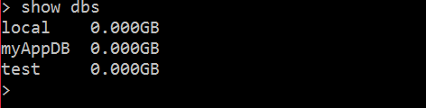

# Create the Server

The server will be made using Node and Express framework and will be separate to the front end Ionic 2 project.

**Step 1: Create a folder called server outside of your Ionic Project.**

**Step 2: Create a file called package.json inside of the server folder and type in the following:**

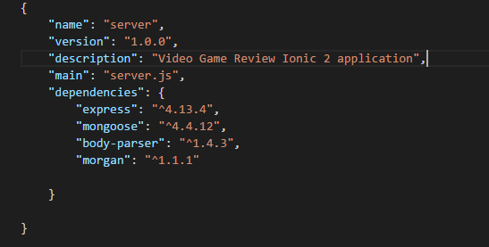

**For more information on package.json** <https://docs.npmjs.com/getting-started/using-a-package.json>

**Then open a command terminal and CD into the server folder. Then enter the npm install command to install the following dependencies above in the package.json file.**

**Step 3: Create a server.js file inside the server folder. This is the main file where you Configure the application, connect to the database, create mongoose models, define routes for RESTful API and define routes for the frontend application.**

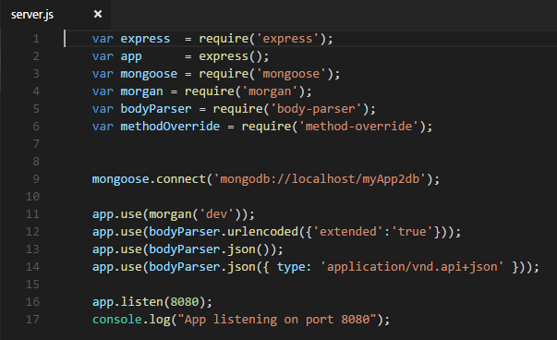

**Step 4: Once the server is configured, run it by the following command:**

*node server.js*