edi3 Notary Service 1.0 Specification

# Abstract

This document describes the technical specifications for notarisation of trade documents using open-source solution leveraging on Distributed Ledger Technology (DLT). This allows end users receiving the document to verify the provenance and integrity of the document.

The use of such technology offers several advantages.

* There is no proprietary lock-in; solution will be open-source which lowers barriers of entry to market
* There is no centralised infrastructure (governance/sovereignty); thus, there would not be any single entity in charge of the verification/data that eliminates the trust concern of which authority will have all the trade information in trade world especially when cross-border trading is involved
* Elevates automated trade document processing; allows for any parties in the supply chain to issue trade documents, and for anyone to quickly check the validity of a digital trade documents. This will in time make trade facilitation easier and smoother for the whole supply chain workflow
* Connecting the disconnected world (digital standard); allowing isolated eco-systems to be interoperable

# Introduction

Before digital transformation transpired, trade documents require a lot of administrative burden resulting in an increase in time and cost of manual verification. With the emergence of digital technologies in the trade world, it has changed the way we work and helped to improve operational efficiency across supply chains.

Trade has grown remarkably over the last century with the trade world having numerous isolated ecosystems. Such system isolations resulted in individual systems not being able to verify trade documents from other ecosystems.

Lack of trust in the data is another major contributing factor that hinders global trade facilitation and the move to true digitalization of the supply chain. Paperless initiatives are yet to be widely adopted. For example, in sea freight, Bill of Lading is still made up of three originals and require six copies and digitized formats are still unacceptable for many parties.[1]

There has always been an inherent lack of trust between buyers, sellers, supply chain participants, agencies and governments. Due to this layer of trust, work processes such as document verification is still heavily reliant on the use of papers.[2]

Current forms of digital document are neither tamper-proof nor have provenance, resulting in digitalised documents still falling back to the paper documents at some point of the supply chain flow. Thus, we need to have a solution that allows trade documents to be cryptographically trustworthy and can be verified independently.

A major cultural and paradigm shift in the trade world has taken shape since the introduction of Blockchain almost a decade ago. Blockchain, which is a form of DLT offers opportunities to increase reliability and security of trade transactions.[2]

As we embark into the Blockchain to facilitate greater transparency, portability of information and greater operational efficiency, trade documents can now be notarised digitally and allowed tracing on the provenance and verification of digitally issued documents. This notarisation makes use of a framework to format data so that it can be fingerprinted, and then notarised on a trusted platform, such as the Ethereum blockchain.

## Goals

The following are features that would faciliate on the suggested notarisation method:

* Standard wrapper for document (see JSON schema 3)
* Support multiple document types
* Verify issuer’s identity (provenance)
* Tamper-proof document integrity (integrity)
* Selective data disclosure (data obfuscation)
* Standard & best-practices for storage & transmission
* Support multiple backend (ETH/API/Private Blockchain)
* Compatible with W3C Verifiable Claims

## Use Cases

Trade documentation plays a vital role in international trade as it facilitates the smooth flow of goods and payments thereof across national frontiers. There are many trade documents in which we can categorise them into 2 main groups: - Non-transferable documents - Transferable documents

A non-transferable documents belongs to one person and cannot legally be given to another person and used by them. An example is an air ticket or Certificate of Non-Manipulation (CNM).

As for transferable documents, it can be transferred by one person to another, passing to the transferee the rights of the original holder. Transferable documents typically include bills of lading, and warehouse receipts.

With numerous trade documents involved in international trade, document verification is an essential process as it verifies the identity of the document signer to prevent fraud, and checks for awareness and volition. Thus we need a solution that allows document verification to be executed digitally and safely.

We also note that there are a couple of methods to digitalise notarisation such as electronic-signature, electronic notarisation, webcam notarisation and etc. Electronic notarisation will be discussed further to prove the verification mechanisam in a decentralised manner in which both Domain Name Server (DNS) and Token Registry are 2 unique blockchain solutions that can demostrate document verification for Non-Transferable Documents and Transferable Documents respectively.

### Domain Name Server (DNS)

DNS is the phonebook of the Internet, connecting web browsers with websites. By allowing the DNS system to be used as an identity registry, we allow the domain name owners to claim ownership of a Document Store smart contract on the Blockchain.

The DNS system is a key part of Internet infrastructure, and is a decentralised system - this means that there is a low barrier to entry and does not have a single point of failure. It allows issuers to simply tie their issuance to their domain name, (e.g example.openattestation.com). When a user views a certificate issued under this model, they will see “Document issued by example.openattestation.com”.

### Token Registry

Token Registry supports the construct of assets which can have ownership assigned to them. This is supported using Blockchain smart contracts to keep track of the owner of a particular asset. This solution will faciliate the title transfer requirements for Transferable Documents.

#### Non-transferable Document

##### Certificate of Non-Manipulation

A CNM, issued in the country of transit, provides documentary evidence that the goods have not been switched or modified during transit and that they retain the originating status of their country of export. Importers often use the certificate when transhipping goods.

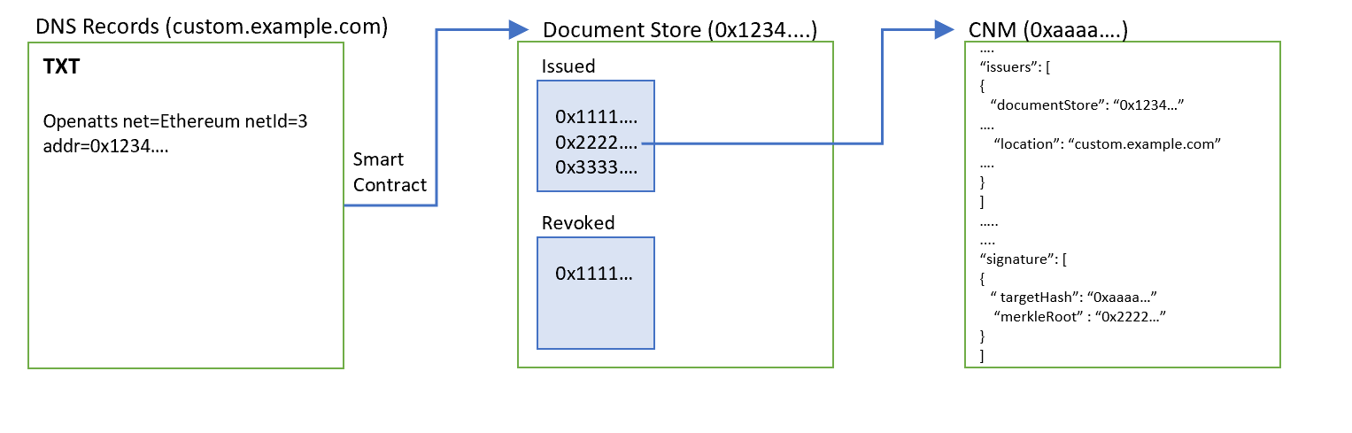

docs

###### Preconditions

* The issuer has a domain name which is custom.example.com.
* The issuer has deployed a document store smart contract on Ethereum.

###### Prove Ownership of Document Store

* Create TXT record to bind document store to domain.

###### Prove Document Issuance

* Publish the merkle root of the document onto the document store.

###### Verification

* Issuance Method
  + Check that merkle root of the document exists on the ‘Issued’ list on the document store.
  + Check that the merkle root of the document does not exist on the revocation (‘Revoked’) list of the document store.
* Integrity Method
  + Check that the document data’s hash is the ‘targetHash’;
  + Check the targetHash resolves to the merkle root using the proof (if any);
* Issuer Identity
  + Check that a TXT record exist on the domain claiming the ownership of the document store

#### Transferable Document

##### Bill of Lading

Bill of Lading allows the transmission of ownership of the goods through a simple endorsement.

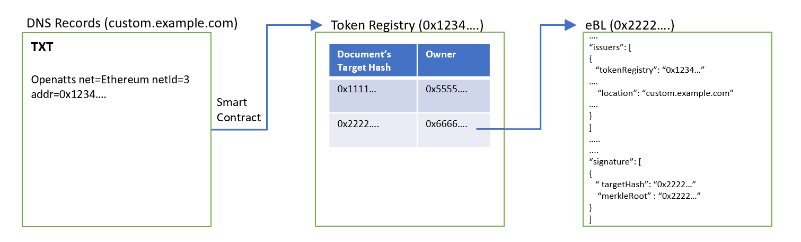

docs

###### Preconditions

* The issuer has a domain name which is custom.example.com.
* The issuer has deployed a token registry smart contract on Ethereum.

###### Prove Ownership of Token Registry

* Create TXT record to bind token registry to domain.

###### Prove Document Issuance

* Assign an owner to the corresponding document’s target hash.

###### Verification

* Issuance Method
  + Check that target hash of the document exists in the list of tokens in the token registry.
* Integrity Method
  + Check that the document data’s hash is the ‘targetHash’.
  + Check the targetHash resolves to the merkle root using the proof (if any).
* Issuer Identity
  + Check that a TXT record exists on the domain claiming the ownership of the token registry.

# Data Model

## JSON Schema

The document data model is defined using JSON Schema with the following definitions found in Annex A.

## JSON Schema Validator

A useful online tool JSON Schema Validator that can help to validate whether the document data conforms to the schema: https://www.jsonschemavalidator.net/

Just paste the content of the schema document on the left panel and enter the document data on the right. The tool will instantly validate the document String/Object and notify any potential errors.

An example of a passing validation:

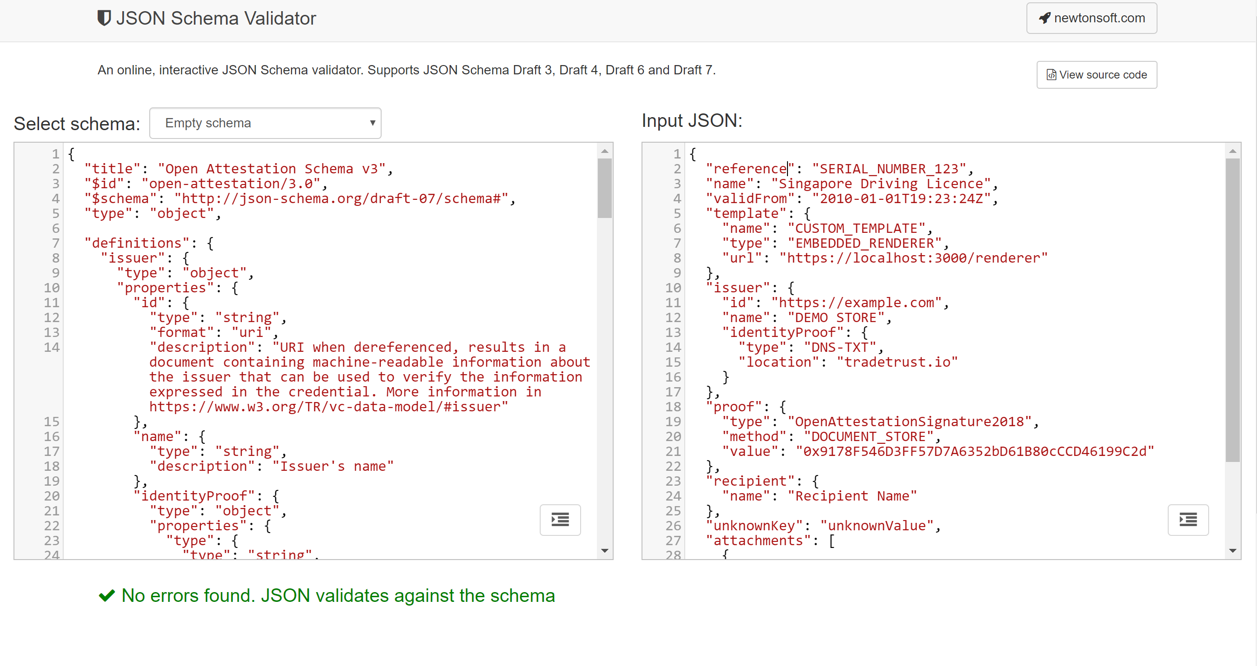

docs

An example of a failed validation:

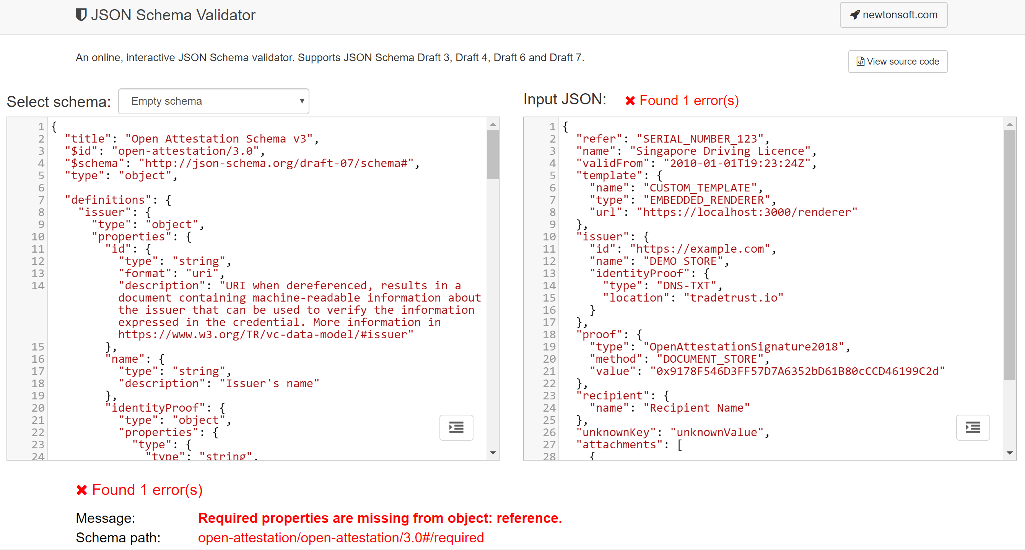

docs

# Basic Concept

## Verification Method

The purpose of the verifier is to provide a generic verification method to verify OpenAttestation(OA) documents. The verifier will provide default verification methods conforming to the standard verification process proposed in OpenAttestation yet providing opportunities for it to be extended.

### Overview of the verification methods

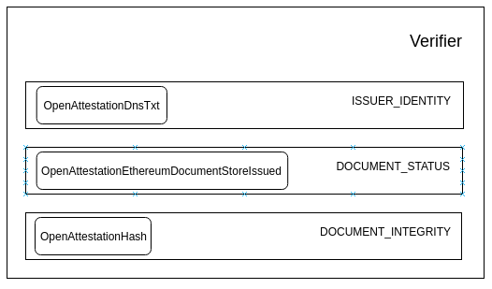

docs

A verifier is made up of multiple Verification Methods. In the diagram above, OpenAttestationDnsTxt, OpenAttestationEthereumDocumentStoreIssued and OpenAttestationHash are examples of Verification Methods provided.

The role of a verification method is to verify the OA document is valid against specific criterias. Since there are many types and versions of OA document, not all test should run against all types of OA document. For that reason, a test method is also defined to test if a method should run against a document. If the method is incompatible with the document type, it should skip the method.

As a result, a verification method should implement 3 abstract methods: verify, test and skip.

The verification method should return a VerificationFragment which states the status of the verification. The status key can have the following values:

* VALID: when the verification is successful
* INVALID: when the verification is unsuccessful
* ERROR: when an unexpected error is met
* SKIPPED: when the verification was skipped by the manager

#### test(document: Document): boolean

This function takes in an OA document and returns a boolean result that determines if this verification method is meant to be ran against the document.

In the case that the test passes, we should run the verify function. Otherwise, the skip function should be ran.

#### skip(): VerificationFragment

This function should be ran when the verification method is skipped for the given OA document. It will return the skipped VerificationFragment for the test.

An example of VerificationFragment that skips the DNS-TXT verification: { ```json “name”: “OpenAttestationDnsTxt”, “type”: “ISSUER_IDENTITY”, “status”: “SKIPPED”, “message”: “Document issuers doesn’t have "documentStore" or "token" property”

}  
  
#### verify(document: Document): VerificationFragment  
  
This function should be ran when the test passes. Running this function will execute the necessary computation to determine if the document passes the verification method.  
  
An example `VerificationFragment` of a passing test:  
  
```json  
{  
"name": "OpenAttestationEthereumDocumentStoreIssued",  
"type": "DOCUMENT_STATUS",  
"status": "VALID",  
"data": {  
 "details": [  
 {  
 "address": "0x007d40224f6562461633ccfbaffd359ebb2fc9ba",  
 "issued": true  
 }  
 ],  
 "issuedOnAll": true  
}  
}

An example VerificationFragment of a failed test:

{  
 "name": "OpenAttestationEthereumDocumentStoreIssued",  
 "type": "DOCUMENT_STATUS",  
 "status": "INVALID",  
 "message": "Certificate has not been issued",  
 "data": {  
 "details": [  
 {  
 "address": "0x20bc9C354A18C8178A713B9BcCFFaC2152b53990",  
 "error": "call exception (address=\"0x20bc9C354A18C8178A713B9BcCFFaC2152b53990\", method=\"isIssued(bytes32)\", args=[\"0x85df2b4e905a82cf10c317df8f4b659b5cf38cc12bd5fbaffba5fc901ef0011b\"], version=4.0.40)",  
 "issued": false  
 }  
 ],  
 "issuedOnAll": false  
 }  
}

### Verification Types

A Verification Type is a type label to a verification method. It specifies what type of verification the method is performing. The diagram above shows the 3 default verification types: ISSUER_IDENTITY, DOCUMENT_INTEGRITY and DOCUMENT_STATUS.

For the validity of the verification type to be true, the requirements must be met:

1. At least one method in that type should return VALID as the status.
2. All methods in the type should return either VALID or SKIPPED as the status.

### Verifier

The verifier is a function used to verify any OpenAttestation document. It returns a set of VerificationFragment from the different verification methods.

From the VerificationFragments we can then determine if the OA document is valid. The OA document is valid when all Verification Types has valid statuses.

## Default Verification Types and Methods

### Document Integrity (DOCUMENT_INTEGRITY)

The DOCUMENT_INTEGRITY type of verification methods ensure that the content of the issued document has not been modified since the document has been issued, with exception of data which has been removed using built-in obfuscation mechanism.

#### OpenAttestationHash

The OpenAttestationHash method checks the integrity of the document using the OpenAttestationSignature2018 method by digesting the content of the OA document and comparing it with the document’s targetHash.

In addition, if the targetHash does not match the merkleRoot of the document, the function also checks that the targetHash resolves to the merkleRoot using the given proofs.

### Document Status (DOCUMENT_STATUS)

The DOCUMENT_STATUS type of verification methods checks that the document has been issued and that it’s issuance status is in good standing. Methods of these types generally verifies the issuance status against a record maintained externally, ie Records on a Blockchain or API endpoints.

#### OpenAttestationEthereumDocumentStoreIssued

The OpenAttestationEthereumDocumentStoreIssued checks the issuance status of the document using OpenAttestationSignature2018 with DOCUMENT_STORE or TOKEN_REGISTRY methods.

Signature of OA Document using this method:

{  
 "proof": {  
 "type": "OpenAttestationSignature2018",  
 "method": "DOCUMENT_STORE",  
 "value": "0x9178F546D3FF57D7A6352bD61B80cCCD46199C2d"  
 }  
}

Such document uses a smart contract to store the issuance status of the document.

In the case of DOCUMENT_STORE smart contract, the check calls the method isIssued(merkleRoot) implemented on the Ethereum smart contract. It returns a valid VerificationFragment if the merkle root of the document has been marked as issued.

In the case of TOKEN_REGISTRY smart contract, the check calls the method ownerOf(targetHash) implemented on the Ethereum smart contract. It returns a valid VerificationFragment if the owner of the document is non-zero.

#### OpenAttestationEthereumDocumentStoreRevoked

The OpenAttestationEthereumDocumentStoreRevoked checks the revocation status of the document using OpenAttestationSignature2018 with DOCUMENT_STORE or TOKEN_REGISTRY methods, similar to OpenAttestationEthereumDocumentStoreIssued.

In the case of DOCUMENT_STORE smart contract, the check calls the method isRevoked(merkleRoot) implemented on the Ethereum smart contract. It returns a valid VerificationFragment if the merkle root of the document has not been marked as revoked.

### Issuer Identity (ISSUER_IDENTITY)

The ISSUER_IDENTITY type of verification methods checks and return the identity of the issuer. Methods of these types generally verify the identity of the issuer against a decentralised identity provider (ie DID, DNS, etc) or some centrally managed identity registry (ie Singapore’s OpenCerts Registry, Citizen Identity Registry, Business Identity Registry, etc).

#### OpenAttestationDnsTxt

The OpenAttestationDnsTxt method checks the identity of a document issuer using the DNS-TXT identity proof mechanism.

The sample provided below shows a document which claims that openattestation.com is the owner of the smart contract 0x9178F546D3FF57D7A6352bD61B80cCCD46199C2d, which in turn issued the said document:

{  
 "issuer": {  
 "id": "https://openattestation.com",  
 "name": "Open Attestation",  
 "identityProof": {  
 "type": "DNS-TXT",  
 "location": "openattestation.com"  
 }  
 },  
 "proof": {  
 "type": "OpenAttestationSignature2018",  
 "method": "DOCUMENT_STORE",  
 "value": "0x9178F546D3FF57D7A6352bD61B80cCCD46199C2d"  
 }  
}

The method checks against the DNS record of the domain to confirm the claimed relationship. A sample TXT record on openattestation.com to prove ownership of the contract 0x9178F546D3FF57D7A6352bD61B80cCCD46199C2d on Ethereum Ropsten network is provided below:

openatts net=ethereum netId=3 addr=0x9178F546D3FF57D7A6352bD61B80cCCD46199C2d

Upon confirming that the matching DNS TXT record on the domain, the verification method returns a valid VerificationFragment as the result.

In depth discussion of DNS-TXT method is described [in this blog post](https://blog.gds-gov.tech/opencerts-2-0-decentralised-issuer-identity-verification-fb7e2cae8295)

## Usage

To use the default verifier:

const document = "OA-Document";  
const verificationFragments = verify(document);  
const verified = isVerified(verificationFragments);

To extend the verifier with a custom name registry:

const document = "OA-Document-With-Custom-Identity-Proof";  
const customIdentityRegistry = "Custom-Verification-Method";  
const verificationFragments = verificationBuilder(document, [  
 ...defaultVerifiers,  
 customIdentityRegistry  
]);  
const verified = isVerified(verificationFragments);

# Decentralised Document Rendering

## Goal

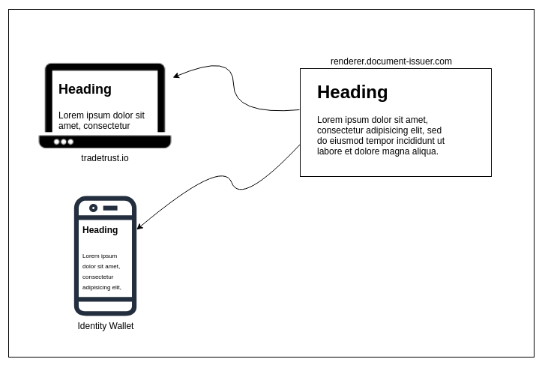

docs

The purpose of the decentralised document renderer is to allow OpenAttestation (OA) document issuers to style their documents without code change to the different implementations of the document viewer. It does so by embedding the website specified by the document issuers as an iframe or webview (for mobile apps) and sending the content of the OA document into the iframe.

## Frame-to-Frame Communication

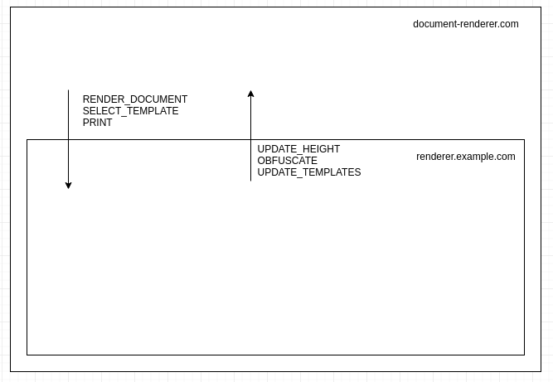

docs

Since the decentralised renderer is rendering a document dynamically, Actions are used to two-way communication between the parent frame (document-renderer.com) and the child frame (renderer.example.com).

All actions follow the same structure and are composed of type and payload

* type indicates the kind of action executed, for instance, RENDER_DOCUMENT to render a document. The type of action is mandatory
* payload indicates optional data associated with the type, for instance, the content of the document to render.

Examples of actions used:

const renderDocumentAction = {  
 type: "RENDER_DOCUMENT",  
 payload: {  
 document: documentToRender  
 }  
};  
  
const printAction = {  
 type: "PRINT"  
};

### From host to frame actions

The following list of actions are made for the host to communicate to the iframe (and thus must be handled by application embed in the iframe):

#### RENDER_DOCUMENT

This action sends the document data to the child frame to be rendered.

The payload is an object with 2 properties:

* document: (mandatory) document data as returned by getData method from @govtechsg/open-attestation
* rawDocument: (optional) Open Attestation document

Example:

const action = {  
 type: "RENDER_DOCUMENT",  
 payload: {  
 document: getData(document),  
 rawDocument: document  
 }  
};

#### SELECT_TEMPLATE

This action selects a template amongst the one provided by the decentralized renderer (A renderer may provide 1 to many different templates to display a document).

The payload is the tab id to display.

Example:

const action = {  
 type: "SELECT_TEMPLATE",  
 payload: "CUSTOM_TEMPLATE"  
};

#### PRINT

This action request for the template to process the print action by the browser.

Example:

const action = {  
type: "PRINT"  
const action = {  
 type: "PRINT"  
};

#### GET_TEMPLATES

This action returns the list of template tabs available on the document.

The payload is the document data as returned by getData method from @govtechsg/open-attestation

Example:

const action = {  
 type: "GET_TEMPLATES",  
 payload: getData(document)  
};

## From frame to host actions

The following list of actions are made for iframe to communicate to the host (and thus must be handled by application embedding the iframe):

### UPDATE_HEIGHT

This action provides the full content height of the iframe so that the host can adapt the automatically the size of the embedded iframe.

The payload is the full content height of the child iframe.

Example:

const action = {  
 type: "UPDATE_HEIGHT",  
 payload: 150  
};

### OBFUSCATE

This action provides the name of a field on the document to obfuscate. The value must follow path property.

The payload is the path to the field to be obfuscated.

Example:

const action = {  
 type: "OBFUSCATE",  
 payload: "a[0].b.c"  
};

### UPDATE_TEMPLATES

This action provides the list of templates that can be used to render a document. This is usually the response to the GET_TEMPLATES action.

Example:

const action = {  
 type: "UPDATE_TEMPLATES",  
 payload: [  
 {  
 id: "certificate",  
 label: "Certificate"  
 },  
 {  
 id: "transcript",  
 label: "Transcript"  
 }  
 ]  
};

# Selective Disclosure

## Goal

Selective disclosure allows for the holder of OA documents to present subsets of the document to be verified. It does so by allowing users to obfuscated data fields without compromising the integrity of the document.

To achieve this, we compute a hash over individually hashed and salted key-value pairs. During obfuscation, we will hash the salted key-value pair and store the hash in another location of the document.

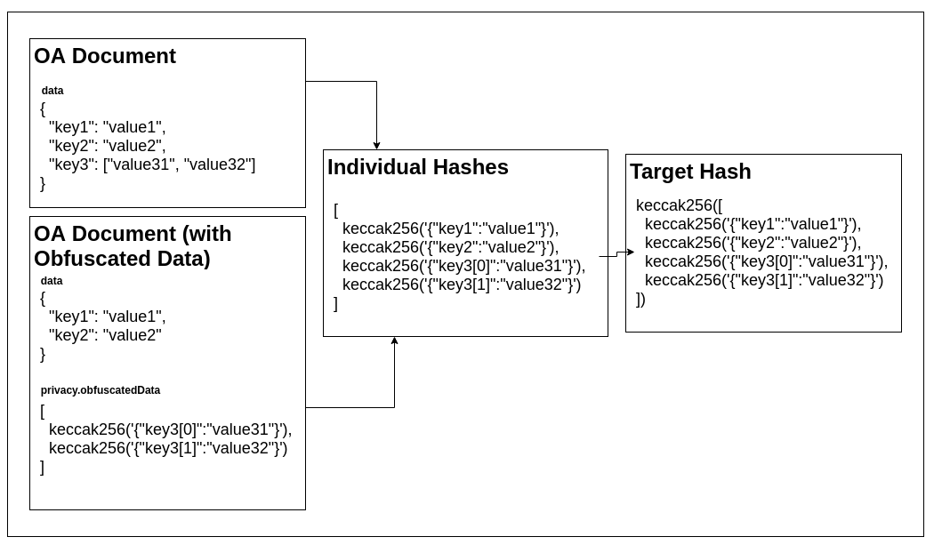

docs

During integrity verification, we will recompute the hash of the document by:

1. Nomalising the document into individual key-value pairs
2. Hashing each of the individual key-value pairs
3. Compute the target hash of the document

In this document, we will describe the steps to:

1. Prepare an OA document
2. Obfuscate a value on an issued OA document
3. Check the integrity of an issued OA document

## Preparing the document

### Salting the data

To generate an OA document, through a process known as document wrapping, each value is converted from its primitive type to a string with a UUID, the data type and the original value.

The UUID prevents rainbow table attacks on the value after it has been obfuscated and the type will help disambiguate the original data type.

Sample raw data input:

{  
 "reference": "document identifier",  
 "validFrom": "2010-01-01T19:23:24Z",  
 "name": "document owner name",  
 "template": {  
 "name": "any",  
 "type": "EMBEDDED_RENDERER",  
 "url": "http://some.example.com"  
 },  
 "issuer": {  
 "id": "http://some.example.com",  
 "name": "DEMO STORE",  
 "identityProof": { "type": "DNS-TXT", "location": "tradetrust.io" }  
 },  
 "proof": {  
 "type": "OpenAttestationSignature2018",  
 "value": "0x9178F546D3FF57D7A6352bD61B80cCCD46199C2d",  
 "method": "TOKEN_REGISTRY"  
 },  
 "key1": "value1",  
 "key2": "value2",  
 "key3": ["value3.1", "value3.2"],  
 "key4": { "key41": "value4.1", "key42": "value4.2" }  
}

Output after salt:

{  
 "reference": "2cc91073-3863-4db6-9f1a-b68665088caa:string:document identifier",  
 "validFrom": "ca425b5c-d25d-4a36-b0f7-e368fbbaf75d:string:2010-01-01T19:23:24Z",  
 "name": "c6864a9b-0367-4b8b-8cc5-f59cb6331f3d:string:document owner name",  
 "template": {  
 "name": "36a95964-fbe9-4c6d-ab6a-a5247c07f105:string:any",  
 "type": "45c266d0-3efe-4841-893c-96723cd7ddb5:string:EMBEDDED_RENDERER",  
 "url": "bbec168c-b9c3-4fb3-aa6f-3d1a1017f1e9:string:http://some.example.com"  
 },  
 "issuer": {  
 "id": "42b6991b-e4b5-444b-aba7-7ce97bbe8441:string:http://some.example.com",  
 "name": "da3fa13d-b0a9-4357-bd4c-4f3941304225:string:DEMO STORE",  
 "identityProof": {  
 "type": "e2039c5b-6cab-4679-9150-7266e34371a4:string:DNS-TXT",  
 "location": "684bb30d-a59e-4cc3-a8ed-44e6b72579d9:string:tradetrust.io"  
 }  
 },  
 "proof": {  
 "type": "bc64159e-90f3-4f0c-99bb-43818ff402e5:string:OpenAttestationSignature2018",  
 "value": "edd73480-3043-4cdc-aefd-f4ee21fc6a7f:string:0x9178F546D3FF57D7A6352bD61B80cCCD46199C2d",  
 "method": "6ae5877f-be97-47df-99f7-7464a5ca1cde:string:TOKEN_REGISTRY"  
 },  
 "key1": "c1ba53a6-68b8-421e-ac80-7d4b71ca8e52:string:value1",  
 "key2": "0356d74e-10cd-4cc1-b1ba-eab23f8bea3d:string:value2",  
 "key3": [  
 "44faf2a4-d16f-4945-8784-d2b8a088edc5:string:value3.1",  
 "18eaf71f-3b4a-4064-b8f5-79092c2e04aa:string:value3.2"  
 ],  
 "key4": {  
 "key41": "7e3b72f8-e521-4892-a26c-b56d3e2ab5cf:string:value4.1",  
 "key42": "c4f96a54-dda6-4fe2-9f49-bc77e8e19d02:string:value4.2"  
 }  
}

### Computing individual hashes

After the individual values have been salted, the entire data object is flattened, while preserving the hierarchical structure of the data within the individual keys.

In our implementation the library [flatley](https://www.npmjs.com/package/flatley) is used to flatten the object and [js-sha3](https://www.npmjs.com/package/js-sha3) is used to compute the keccak256 hash.

Output after flattening:

{  
 "reference": "2cc91073-3863-4db6-9f1a-b68665088caa:string:document identifier",  
 "validFrom": "ca425b5c-d25d-4a36-b0f7-e368fbbaf75d:string:2010-01-01T19:23:24Z",  
 "name": "c6864a9b-0367-4b8b-8cc5-f59cb6331f3d:string:document owner name",  
 "template.name": "36a95964-fbe9-4c6d-ab6a-a5247c07f105:string:any",  
 "template.type": "45c266d0-3efe-4841-893c-96723cd7ddb5:string:EMBEDDED_RENDERER",  
 "template.url": "bbec168c-b9c3-4fb3-aa6f-3d1a1017f1e9:string:http://some.example.com",  
 "issuer.id": "42b6991b-e4b5-444b-aba7-7ce97bbe8441:string:http://some.example.com",  
 "issuer.name": "da3fa13d-b0a9-4357-bd4c-4f3941304225:string:DEMO STORE",  
 "issuer.identityProof.type": "e2039c5b-6cab-4679-9150-7266e34371a4:string:DNS-TXT",  
 "issuer.identityProof.location": "684bb30d-a59e-4cc3-a8ed-44e6b72579d9:string:tradetrust.io",  
 "proof.type": "bc64159e-90f3-4f0c-99bb-43818ff402e5:string:OpenAttestationSignature2018",  
 "proof.value": "edd73480-3043-4cdc-aefd-f4ee21fc6a7f:string:0x9178F546D3FF57D7A6352bD61B80cCCD46199C2d",  
 "proof.method": "6ae5877f-be97-47df-99f7-7464a5ca1cde:string:TOKEN_REGISTRY",  
 "key1": "c1ba53a6-68b8-421e-ac80-7d4b71ca8e52:string:value1",  
 "key2": "0356d74e-10cd-4cc1-b1ba-eab23f8bea3d:string:value2",  
 "key3.0": "44faf2a4-d16f-4945-8784-d2b8a088edc5:string:value3.1",  
 "key3.1": "18eaf71f-3b4a-4064-b8f5-79092c2e04aa:string:value3.2",  
 "key4.key41": "7e3b72f8-e521-4892-a26c-b56d3e2ab5cf:string:value4.1",  
 "key4.key42": "c4f96a54-dda6-4fe2-9f49-bc77e8e19d02:string:value4.2"  
}

Once the data object has been salted and flattened, each key-value pair will be hashed.

In the example above, we will apply the keccak256 hash on the object {"key4.key41":"7e3b72f8-e521-4892-a26c-b56d3e2ab5cf:string:value4.1"} which will yield c3edad333f0829b92a82cd3c09b7795b0f00f07dfbbfc5ff8779272d1eaba3a8.

Once this function has been applied to all the keys, the output hashes will be sorted and stored in an array.

Output after all hashing individual keys (sorted):

[  
 "1b61eaed9b46a53c530ca7cbe1ed54621e9478b86efb445a932f3cb38d6a97da",  
 "28e72c3815a932b137f3dc0d9d9fa101d6d7477793acf5adcb5f34f0901c3811",  
 "2a73ae2d0e942748f632130c530e4d3eb0e91dcf8e560c52586ecf2cf84daefd",  
 "32559f7f05f498d2ffe89345a379fa6619cd20466474386b26ac8b328b28e03e",  
 "5464490fed778a23505a0da8cb8ffa8ebf47b85fa221f544d0757a96e5be315d",  
 "5c51bab9dda34200e24a5bf46ce39a82561515239f869d444cd7b458bb986483",  
 "6b19136bf4ff28c270b913786c329c6c1186857a5fb5b9897bc4bdf00f95041d",  
 "6ec1924f5f25afe82b01ed108775ab27125b0e7277687a1c1acef27ce34cb189",  
 "87da7c3a74118736144688664ffa621e7e39837c23719a0b4c88ee0fa0b08357",  
 "88c680973e4c58095b222aabfe2d62ffe8bf3a9dacccb6cea112805abdb2d475",  
 "91788b66ce30099e244d180bc18ce16b98de48598cd2ebf9f1cc7c508dc1b65e",  
 "9e029d96b11e4f4e4a37cb3bf03bf3af854b8ea059686945072f02c215e0aba6",  
 "a0b0a1e5992ad724ce101921001d9de2ff08a64c65d9e92b47142eb76fa03618",  
 "c04833e08f6a0d17cb8388db75dec3b07c603be118a1303f68332ae7eef26db5",  
 "c3edad333f0829b92a82cd3c09b7795b0f00f07dfbbfc5ff8779272d1eaba3a8",  
 "c6daa8acbd7b7591d6ea0055a6de3827b953ea3e295c024fc31c167cac1f112d",  
 "d8b26580983759e8cad2bcfd10dffdf375cd49b1e5d7b4424d7698216b683218",  
 "e3494dd41622c560a2df8cf9051f75a27ef651c46826e3eef6382187825794d5",  
 "f29d9f500d3843f547158fcd8b69b67406ad492621d9702a7903062f86ef97b0"  
]

### Computing document’s targetHash

Finally, with the array of sorted hashes, keccak256 is applied again on the stringified array to obtain the targetHash of the document.

keccak256(  
 JSON.stringify([  
 "1b61eaed9b46a53c530ca7cbe1ed54621e9478b86efb445a932f3cb38d6a97da",  
 "28e72c3815a932b137f3dc0d9d9fa101d6d7477793acf5adcb5f34f0901c3811",  
 "2a73ae2d0e942748f632130c530e4d3eb0e91dcf8e560c52586ecf2cf84daefd",  
 "32559f7f05f498d2ffe89345a379fa6619cd20466474386b26ac8b328b28e03e",  
 "5464490fed778a23505a0da8cb8ffa8ebf47b85fa221f544d0757a96e5be315d",  
 "5c51bab9dda34200e24a5bf46ce39a82561515239f869d444cd7b458bb986483",  
 "6b19136bf4ff28c270b913786c329c6c1186857a5fb5b9897bc4bdf00f95041d",  
 "6ec1924f5f25afe82b01ed108775ab27125b0e7277687a1c1acef27ce34cb189",  
 "87da7c3a74118736144688664ffa621e7e39837c23719a0b4c88ee0fa0b08357",  
 "88c680973e4c58095b222aabfe2d62ffe8bf3a9dacccb6cea112805abdb2d475",  
 "91788b66ce30099e244d180bc18ce16b98de48598cd2ebf9f1cc7c508dc1b65e",  
 "9e029d96b11e4f4e4a37cb3bf03bf3af854b8ea059686945072f02c215e0aba6",  
 "a0b0a1e5992ad724ce101921001d9de2ff08a64c65d9e92b47142eb76fa03618",  
 "c04833e08f6a0d17cb8388db75dec3b07c603be118a1303f68332ae7eef26db5",  
 "c3edad333f0829b92a82cd3c09b7795b0f00f07dfbbfc5ff8779272d1eaba3a8",  
 "c6daa8acbd7b7591d6ea0055a6de3827b953ea3e295c024fc31c167cac1f112d",  
 "d8b26580983759e8cad2bcfd10dffdf375cd49b1e5d7b4424d7698216b683218",  
 "e3494dd41622c560a2df8cf9051f75a27ef651c46826e3eef6382187825794d5",  
 "f29d9f500d3843f547158fcd8b69b67406ad492621d9702a7903062f86ef97b0"  
 ])  
);

Result:

"51d6b872aae578d6a4b7decd4370f50b73b5729d8357f3057e240c10bae64ab2"

### Assembling the OA document

Once the targetHash of the document is calculated, it can be appended to the document under the signature object.

Example of wrapped OA Document:

{  
 "version": "open-attestation/3.0",  
 "data": {  
 "reference": "2cc91073-3863-4db6-9f1a-b68665088caa:string:document identifier",  
 "validFrom": "ca425b5c-d25d-4a36-b0f7-e368fbbaf75d:string:2010-01-01T19:23:24Z",  
 "name": "c6864a9b-0367-4b8b-8cc5-f59cb6331f3d:string:document owner name",  
 "template": {  
 "name": "36a95964-fbe9-4c6d-ab6a-a5247c07f105:string:any",  
 "type": "45c266d0-3efe-4841-893c-96723cd7ddb5:string:EMBEDDED_RENDERER",  
 "url": "bbec168c-b9c3-4fb3-aa6f-3d1a1017f1e9:string:http://some.example.com"  
 },  
 "issuer": {  
 "id": "42b6991b-e4b5-444b-aba7-7ce97bbe8441:string:http://some.example.com",  
 "name": "da3fa13d-b0a9-4357-bd4c-4f3941304225:string:DEMO STORE",  
 "identityProof": {  
 "type": "e2039c5b-6cab-4679-9150-7266e34371a4:string:DNS-TXT",  
 "location": "684bb30d-a59e-4cc3-a8ed-44e6b72579d9:string:tradetrust.io"  
 }  
 },  
 "proof": {  
 "type": "bc64159e-90f3-4f0c-99bb-43818ff402e5:string:OpenAttestationSignature2018",  
 "value": "edd73480-3043-4cdc-aefd-f4ee21fc6a7f:string:0x9178F546D3FF57D7A6352bD61B80cCCD46199C2d",  
 "method": "6ae5877f-be97-47df-99f7-7464a5ca1cde:string:TOKEN_REGISTRY"  
 },  
 "key1": "c1ba53a6-68b8-421e-ac80-7d4b71ca8e52:string:value1",  
 "key2": "0356d74e-10cd-4cc1-b1ba-eab23f8bea3d:string:value2",  
 "key3": [  
 "44faf2a4-d16f-4945-8784-d2b8a088edc5:string:value3.1",  
 "18eaf71f-3b4a-4064-b8f5-79092c2e04aa:string:value3.2"  
 ],  
 "key4": {  
 "key41": "7e3b72f8-e521-4892-a26c-b56d3e2ab5cf:string:value4.1",  
 "key42": "c4f96a54-dda6-4fe2-9f49-bc77e8e19d02:string:value4.2"  
 }  
 },  
 "privacy": {  
 "obfuscatedData": []  
 },  
 "signature": {  
 "type": "SHA3MerkleProof",  
 "targetHash": "51d6b872aae578d6a4b7decd4370f50b73b5729d8357f3057e240c10bae64ab2",  
 "proof": [],  
 "merkleRoot": "51d6b872aae578d6a4b7decd4370f50b73b5729d8357f3057e240c10bae64ab2"  
 }  
}

## Obfuscating a value

To obfuscate a value in the OA document, one simply hash the key-value pair with keccak256 and store the resulting hash in privacy.obfuscatedData. This method can be used to obfuscate multiple key-value pairs in the document data file.

For example to obfuscated key4.key41:

keccak256(  
 JSON.stringify({  
 "key4.key41": "7e3b72f8-e521-4892-a26c-b56d3e2ab5cf:string:value4.1"  
 })  
);

Resulting hash:

c3edad333f0829b92a82cd3c09b7795b0f00f07dfbbfc5ff8779272d1eaba3a8

This hash will then be appended to the original OA document and the object that has been obfuscated will be removed:

{  
 "version": "open-attestation/3.0",  
 "data": {  
 "reference": "2cc91073-3863-4db6-9f1a-b68665088caa:string:document identifier",  
 "validFrom": "ca425b5c-d25d-4a36-b0f7-e368fbbaf75d:string:2010-01-01T19:23:24Z",  
 "name": "c6864a9b-0367-4b8b-8cc5-f59cb6331f3d:string:document owner name",  
 "template": {  
 "name": "36a95964-fbe9-4c6d-ab6a-a5247c07f105:string:any",  
 "type": "45c266d0-3efe-4841-893c-96723cd7ddb5:string:EMBEDDED_RENDERER",  
 "url": "bbec168c-b9c3-4fb3-aa6f-3d1a1017f1e9:string:http://some.example.com"  
 },  
 "issuer": {  
 "id": "42b6991b-e4b5-444b-aba7-7ce97bbe8441:string:http://some.example.com",  
 "name": "da3fa13d-b0a9-4357-bd4c-4f3941304225:string:DEMO STORE",  
 "identityProof": {  
 "type": "e2039c5b-6cab-4679-9150-7266e34371a4:string:DNS-TXT",  
 "location": "684bb30d-a59e-4cc3-a8ed-44e6b72579d9:string:tradetrust.io"  
 }  
 },  
 "proof": {  
 "type": "bc64159e-90f3-4f0c-99bb-43818ff402e5:string:OpenAttestationSignature2018",  
 "value": "edd73480-3043-4cdc-aefd-f4ee21fc6a7f:string:0x9178F546D3FF57D7A6352bD61B80cCCD46199C2d",  
 "method": "6ae5877f-be97-47df-99f7-7464a5ca1cde:string:TOKEN_REGISTRY"  
 },  
 "key1": "c1ba53a6-68b8-421e-ac80-7d4b71ca8e52:string:value1",  
 "key2": "0356d74e-10cd-4cc1-b1ba-eab23f8bea3d:string:value2",  
 "key3": [  
 "44faf2a4-d16f-4945-8784-d2b8a088edc5:string:value3.1",  
 "18eaf71f-3b4a-4064-b8f5-79092c2e04aa:string:value3.2"  
 ],  
 "key4": { "key42": "c4f96a54-dda6-4fe2-9f49-bc77e8e19d02:string:value4.2" }  
 },  
 "privacy": {  
 "obfuscatedData": [  
 "c3edad333f0829b92a82cd3c09b7795b0f00f07dfbbfc5ff8779272d1eaba3a8"  
 ]  
 },  
 "signature": {  
 "type": "SHA3MerkleProof",  
 "targetHash": "51d6b872aae578d6a4b7decd4370f50b73b5729d8357f3057e240c10bae64ab2",  
 "proof": [],  
 "merkleRoot": "51d6b872aae578d6a4b7decd4370f50b73b5729d8357f3057e240c10bae64ab2"  
 }  
}

## Check integrity of the document

To check the integrity of the document, we simply:

1. Flatten the data object
2. Hash individual key-value pairs
3. Append and sort the hash from (2) with the hashes from privacy.obfuscatedData
4. Compute the keccak256 hash for the results from (3)
5. Check that the resulting hash from (4) matches the targetHash

## Implementation

[OpenAttestation](https://github.com/Open-Attestation/open-attestation)

# References

OA Schema V3 - https://github.com/Open-Attestation/open-attestation/blob/56231b83b6bd0b6bb164bdd830fc02886b578ec1/src/schema/3.0/schema.json

Verifier Manager Model - https://github.com/Open-Attestation/oa-verify/pull/74

DNS Identity Proof - https://blog.gds-gov.tech/opencerts-2-0-decentralised-issuer-identity-verification-fb7e2cae8295

W3C VC - https://www.w3.org/TR/vc-data-model/

[1] [UN/CEFACT White Paper on Data Pipeline](https://www.unece.org/fileadmin/DAM/cefact/GuidanceMaterials/WhitePaperDataPipeline_Eng.pdf) ↩

[2] [UN/CEFACT White Paper on Technical Application of Blockchain to UN/CEFACT deliverables](https://www.unece.org/tradewelcome/un-centre-for-trade-facilitation-and-e-business-uncefact/outputs/guidance-material/doc.html) ↩

# Annex

## A: JSON Schema Definition

{  
 "title": "Open Attestation Schema v3",  
 "$id": "open-attestation/3.0",  
 "$schema": "http://json-schema.org/draft-07/schema#",  
 "type": "object",  
  
  
  
 "definitions": {  
 "issuer": {  
 "type": "object",  
 "properties": {  
 "id": {  
 "type": "string",  
 "format": "uri",  
 "description": "URI when dereferenced, results in a document containing machine-readable information about the issuer that can be used to verify the information expressed in the credential. More information in https://www.w3.org/TR/vc-data-model/#issuer"  
 },  
 "name": {  
 "type": "string",  
 "description": "Issuer's name"  
 },  
 "identityProof": {  
 "type": "object",  
 "properties": {  
 "type": {  
 "type": "string",  
 "enum": ["DNS-TXT"]  
 },  
 "location": {  
 "type": "string",  
 "description": "Url of the website referencing to document store"  
 }  
 },  
 "additionalProperties": false,  
 "required": ["type", "location"]  
 }  
 },  
 "required": ["id", "name", "identityProof"],  
 "additionalProperties": false  
 }  
 },  
  
  
  
 "properties": {  
 "@context": {  
 "type": "array",  
 "items": {  
 "type": "string",  
 "format": "uri"  
 },  
 "description": "List of URI to determine the terminology used in the verifiable credential as explained by https://www.w3.org/TR/vc-data-model/#contexts"  
 },  
 "id": {  
 "type": "string",  
 "format": "uri",  
 "description": "URI to the subject of the credential as explained by https://www.w3.org/TR/vc-data-model/#credential-subject"  
 },  
 "reference": {  
 "type": "string",  
 "description": "Internal reference, usually serial number, of this document"  
 },  
 "name": {  
 "type": "string",  
 "description": "Human readable name of the credential"  
 },  
 "type": {  
 "type": "array",  
 "items": {  
 "type": "string"  
 },  
 "description": "Specific verifiable credential type as explained by https://www.w3.org/TR/vc-data-model/#types"  
 },  
 "validFrom": {  
 "type": "string",  
 "format": "date-time",  
 "description": "Date and time when a credential becomes valid."  
 },  
 "validUntil": {  
 "type": "string",  
 "format": "date-time",  
 "description": "Date and time when a credential becomes valid."  
 },  
 "issuer": { "$ref": "#/definitions/issuer" },  
  
  
  
 "template": {  
 "type": "object",  
 "properties": {  
 "name": {  
 "type": "string",  
 "description": "Template name to be use by template renderer to determine the template to use"  
 },  
 "type": {  
 "type": "string",  
 "description": "Type of renderer template",  
 "enum": ["EMBEDDED_RENDERER"]  
 },  
 "url": {  
 "type": "string",  
 "description": "URL of a decentralised renderer to render this document",  
 "pattern": "^(https?)://"  
 }  
 },  
 "required": ["name", "type", "url"],  
 "additionalProperties": false  
 },  
 "proof": {  
 "type": "object",  
 "properties": {  
 "type": {  
 "type": "string",  
 "description": "Proof method name as explained by https://www.w3.org/TR/vc-data-model/#types",  
 "enum": ["OpenAttestationSignature2018"]  
 },  
 "method": {  
 "type": "string",  
 "description": "Proof open attestation method",  
 "enum": ["TOKEN_REGISTRY", "DOCUMENT_STORE"]  
 },  
 "value": {  
 "description": "Proof value for issuer(s)",  
 "type": "string"  
 }  
 },  
 "required": ["type", "method", "value"],  
 "additionalProperties": false  
 },  
 "recipient": {  
 "type": "object",  
 "properties": {  
 "name": {  
 "type": "string",  
 "description": "Recipient's name"  
 }  
 },  
 "additionalProperties": true  
 },  
 "attachments": {  
 "type": "array",  
 "items": {  
 "type": "object",  
 "properties": {  
 "filename": {  
 "type": "string",  
 "description": "Name of attachment, with appropriate extensions"  
 },  
 "type": {  
 "type": "string",  
 "description": "A valid evidence type as explained by https://www.w3.org/TR/vc-data-model/#types"  
 },  
 "mimeType": {  
 "type": "string",  
 "description": "Mime-type of attachment",  
 "enum": ["application/pdf", "image/png", "image/jpeg"]  
 },  
 "data": {  
 "type": "string",  
 "description": "Base64 encoding of attachment"  
 }  
 },  
 "required": ["filename", "mimeType", "data", "type"],  
 "additionalProperties": false  
 }  
 }  
 },  
  
  
  
 "required": ["reference", "issuer", "template", "proof", "name", "validFrom"],  
 "additionalProperties": true  
}

## Intellectual Property

All material published on edi3.org including all parts of this specification remain the intellectual property of the contributor. However, contributors should participate on the basis that the specification IP may be incoprporated into a UN/CEFACT standard and, in that case, the IP rights will transfer to the UN as per the [UN/CEFACT IPR Policy](https://www.unece.org/fileadmin/DAM/cefact/cf_plenary/plenary12/ECE_TRADE_C_CEFACT_2010_20_Rev2E_UpdatedIPRpolicy.pdf).

## License

This Specification is free software; you can redistribute it and/or modify it under the terms of the GNU General Public License as published by the Free Software Foundation; either version 3 of the License, or (at your option) any later version. See http://www.gnu.org/licenses.

## Change Process

This document is governed by the [2/COSS](http://rfc.unprotocols.org/spec:2/COSS/) (COSS).

## Language

The key words “MUST”, “MUST NOT”, “REQUIRED”, “SHALL”, “SHALL NOT”, “SHOULD”, “SHOULD NOT”, “RECOMMENDED”, “MAY”, and “OPTIONAL” in this document are to be interpreted as described in RFC 2119.

## Glossary

|  |  |
| --- | --- |
| Phrase | Definition |
|  |  |

## Dependencies

This specification depends on the following specifications

* spec 1
* spec 2

The following specifications depends on this specification

* spec 1
* spec 2

## Related Information

*put a list of any relevant referneces here, and link to them from the appropriate part of the specification*