edi3 Certificates 1.0 Specification

## Introduction

Regulatory processes often involve certificates that assert compliance of a shipment with some specification or legislative framework. For example

* A Certificate of Origin (CoO) is issued by an accredited body on behalf of an exporter and is required by the importing regulator. It asserts that the goods in a consignment conform to the terms of a Free Trade Agreement (FTA) and so may attract concenssional duty terms.
* A Certifictae of Non Manipulation (CoNM) is issued by an accredited body on behalf of a transhipment port/country and it asserts that goods in a consignment were not altered during transhipment.
* A PhtoSanitary certificate is issued by an accredity authority on behalf of an exporter of food products and is required to meet the food safety standards of the importing regulator.
* And dozens of others.

In most cases certificates are about a consignment of goods. Accordingly, the edi3 approach to defining the data model of certifictaes is to “attach” certificate data to the existing UN/CEFACT trade and transport data models.

## Goals

To publish a consistent suite of data models and state lifecycles for various certifictaes used to satisfy regulatory processes and to support the [Inter Customs Ledger](https://edi3.org/icl/) project.

## Status

* This specification is in draft state. This means that design consensus has been reached and the specification is ready for implementation verification.

## Glossary

|  |  |
| --- | --- |
| Phrase | Definition |
| CoO | Certificate of Origin |
| CoNM | Certificate of Non Manipulation |
| FTA | Free Trade Agreement |
| RDM | Reference Data Model |

## Licence

All material published on edi3.org including all parts of this specification are the intellectual property of the UN as per the [UN/CEFACT IPR Policy](https://www.unece.org/fileadmin/DAM/cefact/cf_plenary/plenary12/ECE_TRADE_C_CEFACT_2010_20_Rev2E_UpdatedIPRpolicy.pdf).

This Specification is free software; you can redistribute it and/or modify it under the terms of the GNU General Public License as published by the Free Software Foundation; either version 3 of the License, or (at your option) any later version. See http://www.gnu.org/licenses.

## Change Process

This document is governed by the [2/COSS](http://rfc.unprotocols.org/spec:2/COSS/) (COSS).

## Language

The key words “MUST”, “MUST NOT”, “REQUIRED”, “SHALL”, “SHALL NOT”, “SHOULD”, “SHOULD NOT”, “RECOMMENDED”, “MAY”, and “OPTIONAL” in this document are to be interpreted as described in RFC 2119.

# Certificate Of Origin

## Data Model

The Certificate of Origin (CoO) Data model is drawn from the UN/CEFACT Buy-Ship-Pay reference data model and conforms to the edi3 [UML profile specification](https://edi3.org/specs/edi3-uml-profile/master/)

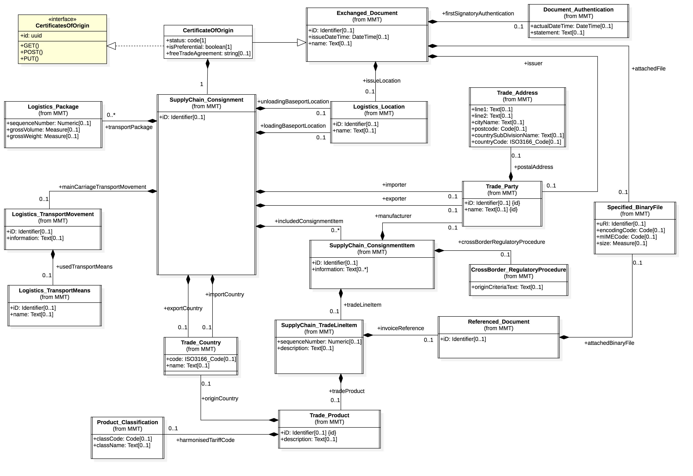

CoO

## State Lifecycle

The certificate state lifecycle is shown below. The “status” property of the “CertificateOfOrigin” entity in the API model MUST equal one of these values.

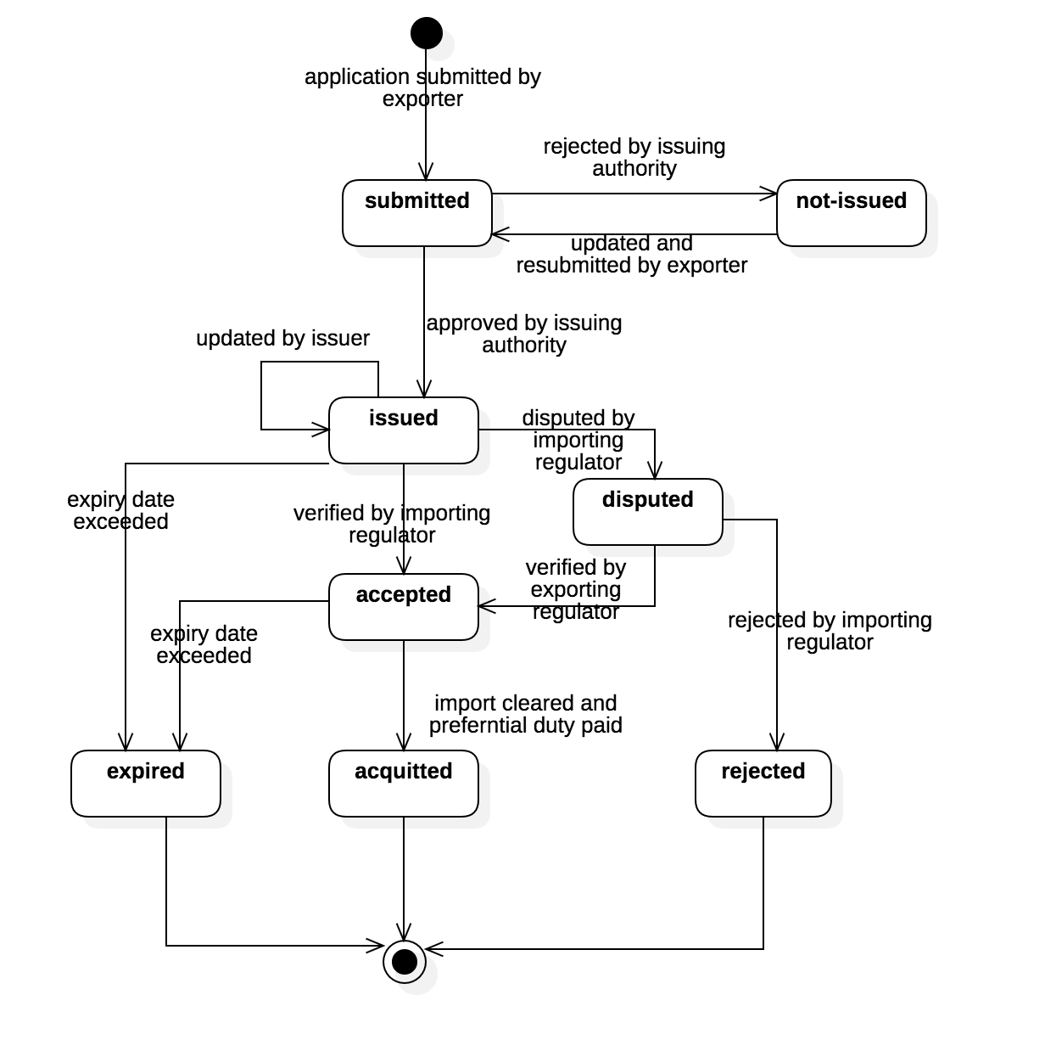

CoO Lifecycle

## API Specification

The Data Model has been used to generate a [CoO REST API specification](https://edi3.org/specs/edi3-regulatory/develop/certificates/CertificateOfOrigin.html) in accordance with the [Open API3.0](https://github.com/OAI/OpenAPI-Specification/blob/master/versions/3.0.0.md) standard.

# Certificate of Non Manipulation

To be completed

# Related Material

* [CHAFTA CoO Template PDF](chafta-coo-template.pdf)
* [JAEPA CoO Template](jaepa-coo-template.pdf)
* [CoO data mapping UN / WCO Excel](CertificateOfOriginDataElementMapping.xlsx)