Capstone Data Overview

1. Location Data for New York
   1. This data, obtained from the IBM skills network, will allow me to group the restaurants into neighborhoods and calculate the density of neighborhoods.
   2. 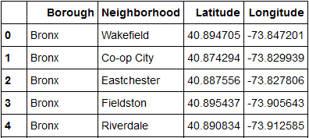
2. Restaurant Data
   1. This data, obtained from the Foursquare API, will allow me to determine the density of restaurants in a neighborhood, as well as calculate the least common cuisines in the neighborhood.
   2. 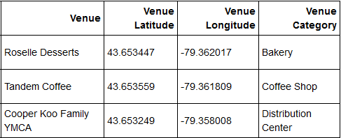
3. Cuisine frequency
   1. This data, calculated using the count of categories by neighborhood, will allow me to determine which types of cuisine are not common in a neighborhood.
   2. 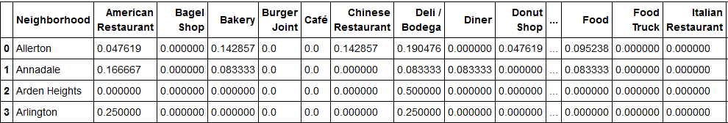
4. Restaurant density
   1. This data, calculated using the scaled number of restaurants per neighborhood, will allow me to determine how many restaurants already exist in a particular neighborhood.
   2. 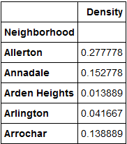
5. Combined Dataframe
   1. This data, created by merging the previous two dataframes, is what will be fed into the KNN algorithm to group neighborhoods by density and cuisine deficits.
   2. 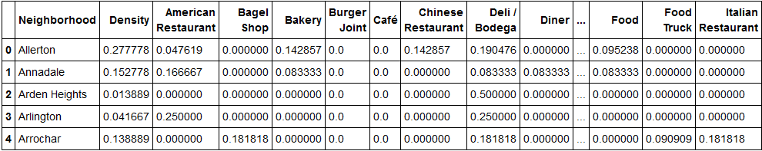
6. Final Dataframe
   1. This data, created using the cluster labels from the KNN algorithm and by calculating the lowest cuisine frequency values from the previous step, will be used to determine which clusters have the most demand for food, using density, and what kinds of cuisine they still do not have.
   2. 