**Arduino-based Automated Plant Soil Monitoring and Water Control System**

An Undergraduate Capstone Project Presented to the

Institutional

Committee of Our Lady of Lourdes College Foundation

Daet, Camarines Norte

In Partial Fulfilment of the Requirements

for the Degree of Bachelor of Science

in Information and Technology

Barcelona, John Kenneth L.

Obusan, Ian Clifer P.

Oligo, Roseleny R.

2022

**Executive Summary**

Gardening is an everyday occurrence in our lives. It is a hobby for those who have a green thumb. These individuals are commonly referred to as "plantitas" or "plantitos." Nowadays, soil monitoring and adequate water supply are critical in order for plants to grow. However, when people are not at home or on vacation, watering the plants are unstable. As a result, there is a possibility that the soil of the plants will be dry and the plants will not grow or will die especially during dry season.

For those who have garden and house plants, the researchers proposed an Arduino-based automated plant soil monitoring and water control system. This capstone project will contribute to the improvement of the traditional method of watering plants. This system will detect soil humidity and supply water to plants that requires it. The researchers searched for related studies and brainstormed on how it works and what technologies will be applicable to used.

The gathered information by the researchers were the basis of this study when it comes to its functionalities. In order for the proposed system to work effectively and efficiently, it requires the following devices namely soil moisture sensor, water pump, relay module, battery, power source, water source, cable, tube, wire, LCD display, and Arduino board.

Table of Contents

List of Figures, List of Tables, List of Notations

**CHAPTER 1**

**INTRODUCTION**

**Project Context**

People benefits greatly from plants in numerous ways. By organically purifying the air and creating oxygen, plants contribute to a healthy atmosphere. The presence of plants indoors is quite popular.

However, many people used to grow plants in mold or mud pots and set them on windowsills owing to civilization and lack of space. This plant needs standard breeding practices including watering and the correct quantity of sunlight to support life and growth.

Not enough hydration of the plants is the primary concern in modern gardening. They must physically pour water into the plants even if there is water available, and they must wait until the plants are adequately hydrated. However, if they are not at home, they cannot carry out this action. People frequently forget to water their plants owing to their hectic daily schedules, which causes the plants to become ill and eventually die. The lack of water resources is also the largest issue facing modern society, as agriculture requires a lot of water and is a labor-intensive industry. That’s why ‘Arduino-based Automated Plant Soil Monitoring and Water Control System’ is the solution.

The wise use of water resources cannot be stressed enough. In order to do this task automatically, a system is needed. An automated system for watering plants measures and estimates the soil moisture before supplying the water the plant needs. In addition to maintaining the health of the plants, it reduces excessive water usage.

**Purpose and Description**

The researchers proposed an Arduino-based plant soil monitoring and water control system for household plantitas and plantitos. This will help them to water their plants automatically and use water efficiently without taking much of their precious time.

For those who have a small garden and house plants, the researchers proposed an Arduino-based automated plant soil monitoring and water control system. This capstone project will contribute to the improvement of the traditional method of watering plants. These automated plants soil monitoring and water control systems will detect soil humidity and supply water to plants that requires it. The researchers searched for related studies and brainstormed on how it works and what possible technologies will be used.

The proposed system has a soil moisture sensor that will detect the moisture of the soil then send data to the Arduino and then the Arduino will control the respective pump through a relay module. An OLED display will display the status of the operation. The motors are powered by two AA batteries while the Arduino can be powered through a USB port or a 9v battery.

The Arduino-based Automated Plant Soil Monitoring and Water Control System is used to monitor the soil and control the water that is needed in the plants. It is significant in every household because time management is very important especially when you have a hectic schedule and have no time to water your plants. Conserving water is also an important aspect in our battle to fight against climate change. Reducing our water usage lessens the energy required to process and deliver it to homes, businesses, farms, and communities, which, in turn, helps to reduce pollution and conserve fuel resources.

**Objectives**

The objective of this capstone project is to develop an Arduino-based Automated Plant Soil Monitoring and Water Control System for household plants.

Specifically, the researchers aimed the following:

1. To easily determine the soil humidity
2. To control water supply in plants.
3. Save time in watering plants.
4. To save plants from being dry and improve its lifetime.
5. To apply different devices that could easily monitor soil humidity and control water distribution in the plants.

**Scope and Limitations**

The focus of this study is to develop an Arduino-based automated soil monitoring and water control system. Regardless of soil type, the proposed system will monitor its humidity and water the plants if the soil is detected to be dry.

In terms of limitations, the researchers will only focus on indoor houseplants. In addition, a certain number of plants can only be accommodated dependent on the number of sensors the Arduino can manage. The distribution of water to all house plants remains the same, even though the sensor detects excessively dry soil. The water source is a refillable container that will need to be refilled every once in a while.

CHAPTER 2

**REVIEW OF RELATED LITERATURE AND STUDIES**

This chapter covers the associated literature and studies obtained by the researchers from local and foreign sources to assist the development of the proposed system. Synthesis, theoretical and conceptual frameworks are also discussed in this chapter.

**Local Literature**

Velasco, R.M.A., (July 2019). Technology is working its way into farming, with an array of wireless, app-driven devices (Hammill, 2017). Most of these control systems have the ability to regulate the frequency of irrigation, recording every minute and the duration. Advancements in sensor technology to measure or estimate moisture in soil have taken place with time.

Metro Manila (CNN Philippines, August 2020)— With many stuck in quarantine due to the pandemic, some have picked up new hobbies to keep themselves busy and productive. Home-cooked dishes and baking projects have likely filled our social media feeds in the past few months, but one other trend has also stood out— indoor planting and gardening. Photos of house plants tucked into stylish, decorative pots have popped up online, inspiring locked down citizens to start their own journey to becoming plant parents. It also helps that growing plants inside your home comes with benefits for both your physical and mental health.

Metro Manila (CNN Philippines, March 2018) — San Miguel Corporation (SMC) is doing its part in saving the environment by way of water conservation. In a release Wednesday, SMC said it has saved 4 billion liters of water – an amount equivalent to the daily use of 137,000 households. This development happened a year after the company announced it was going to cut its water consumption by 50 percent across all of its businesses. Since that announcement, SMC has reduced water use by 14% across its food, beverage, packaging, power, fuels and petrochemicals, and infrastructure businesses.

Tingzon, R., Aborde, M., (April 2022). Farmers are always finding ways to have a sustainable food source to sustain daily life; experts like indoor farming introduce some solutions. However, indoor farming needs to have a controlled environment that can grow the plant, the indoor farm also needed to have a monitoring application that will monitor the environment of the plants, nowadays there is more application specifically designed for specific plants, and it is hard to integrate to our garden. Therefore, agriculture should smartly surmount these issues. Vividly, few talks over the internet, radio, and television on smart climate agriculture can eventually provide sustainable agricultural productivity and income.

Maala, G., (June 2021). High-tech gardening gizmos modernize how we take care and communicate with our greeneries. As the demand for gardening tools and gadgets is growing more than ever, you might also be curious about high-tech pots and their features. Pots with innovative features perhaps intensify the connection between plants and a person who has a heart for them.

**Foreign Literature**

Soumen Banerjee, Jyotsna Kumar Manda (2021) explained that in the Smart Plant Monitoring System, the DHT11 (Temperature and Humidity sensor) and BMP180 (Barometric Pressure/Temperature/Altitude Sensor) sensor senses various environmental parameters and send signal to the micro-controller. The soil moisture sensor will sense the moisture of the soil and sends the signal to the micro-controller whenever the moisture level goes up or down. LEDs give outputs in different conditions of the moisture content in soil and there is a relay drive circuit which act as switch to control the pump for supplying water from the water source. Whenever the pump get signal that there is low moisture present in the soil it will automatically start. When the moisture level will maintain in the soil automatically the pump will stop. Here the pump is connected to +12 V power supply (connected only to the pump and to the Relay driver system).

Zakiah Ayop, Nurul Azma Zakaria, (2018), stated that irrigation is an artificial application of watering the land for agricultural production. The requirement of water to the soil depends on soil properties such as soil moisture and soil temperature. Effective irrigation can influence the entire growth process and automation in irrigation system using modern technology can be used to provide better irrigation management. In general, most of the irrigation systems are manually operated. These traditional techniques can be replaced with automated techniques of irrigation in order to use the water efficiently and effectively. Conventionally, farmers will present in their fields to do the irrigation process. Nevertheless, nowadays farmers need to manage their agricultural activity along with other occupations. A sensor based automated irrigation system provides promising solution to farmers where the presence of a farmer in field is not compulsory during irrigation process.

Elangovan, R. et al (2018) discussed A Plant Monitoring and Gardening System using IoT about the automation in a field of planting and reducing the manual work and improving the parameters needed for the proper plant growth without an interference of human being.

Athani, S. et al (2017) discussed Soil Moisture Monitoring using IoT enabled Arduino sensors with neural networks for improving soil management for farmers and predict seasonal rainfall for planning future harvest in North Karnataka-Indiato install a computerized or automatic technique to measure the moisture content in the soil and monitoring the parameters using different technology and constructing the system which is economical to the end users.

Singh & Saikia, (2017), Considered automated watering techniques and found out that the Arduino based sensors have been utilized for the plant watering system and automated irrigation systems.

**Local Studies**

The Digital Garden System by Roderick Tingzona & Meljohn Abordeb (April 18, 2022) provides a controlled environment for the plant using the sensor. The DHT11 humidity and temperature sensor provide data on plant conditions stored in the DGS database. The data transmitted to the Blynk mobile application via the Node MCU ESP8266 WIFI module. Then, the web browser shows the data. The configured mobile application controls the adjustment of LED grow light intensity and displays local video streaming of the plant inside the box garden. The Digital Garden system utilized hydroponics techniques to grow the plant in a controlled environment. So even individuals can plant vegetables like lettuce and strawberry in their own offices or condominium.

Lamsen, F.C., Favi, J.C., Castillo, B.H.,(Dec 13, 2021)**,** focused on the development of an automatic irrigation system for an indoor garden that uses a moisture sensor to detect the soil humidity and an Arduino microcontroller to regulate the flow of water that irrigates the garden. Specifically, the study achieved to identify the system requirement necessary to develop the proposed project and build the proposed project with suitable features. The study also aimed to determine the major issues and challenges related to system implementation, perform tests and evaluate the accuracy of the proposed project. Researchers made use of a system methodology called Systems Development Life Cycle (SDLC), which was used as a guide in developing the project. This methodology involved four phases: planning, analysis, design, and implementation.

In the Plant Monitoring System (2021), the soil moisture sensor, sun exposure sensor and the temperature sensor are connected to the Arduino Uno board through a signal conditioning and comparator circuit. When the analog signals from the sensors are transmitted to the signal conditioning and comparator circuit, the signals will be conditioned (amplified and filtered using Op-Amp) and converted to digital signal using an ADC that will now be processed by the Arduino board.

Based on Ballacillo, John Zyrez T., Basi, Bryan, Joshua O., Bermas, Ryan M., & Tejada, Matthew Ryan (March 2, 2018, their studies intend to help the farmers manage their farm by introducing an Arduino - Based Automated Water Sprinkler with Temperature and Outdoor Humidity Monitoring that is based on the time, and the temperature of the environment. The water sprinkler works via water pump that is connected with their water source. Since local farms intend to have a variety of plants, the researchers will record a plant profile. This system will also recognize the type of plant by the use of the recorded plant profile. This system is scheduled by the farmers either manually using buttons and automatically using sensors, when to release water to the field. Only a certain amount of water is released depending on the amount indicated by the farmer. This system will also have the ability to monitor the temperature and the humidity of the environment. If the temperature exceeds the indicated temperature, this system will trigger its alert system to notify the farmers and will automatically release water to the plants. This system can also notify the farmers when to harvest the crops planted in the farm. With this kind of system, farmers won’t need to go and check the plants every day to water the field. They would just have to set the time when to dispense water, the amount of water to be dispensed, the maximum temperature to consider, and the time for their harvest. For monitoring purposes, farmer shall check the monitoring screen installed in their houses for them to be notified by the system’s actions.

Marcelo, L., Fernandez, J., Santos, E., Estrella, J., Hernando, C. & Bobis, D., (2020). It is timely that today’s generation is up to new innovations. High-end technologies and growing community of artificial intelligence, and automation in the field of Agriculture is not new to this. Agriculture, and most commonly pertaining to plants and irrigation is before of manual planting and watering, farmers spend most of their time checking and watering their fields. Making it hard for them because it requires a lot of effort just to secure the soil is well moisten for not enough moisture to the soil can lead to plants not having enough water which will result for it to die. Automated Plant Irrigation with Message Alert is the next generation of farming techniques, now it would automatically be operated depending on the need of the soil. As soon as the Soil Moisture senses that the soil is not moisten enough, the water pump will automatically turn on until the desired moisture is reached then it will also automatically turn off after. It is executed by the Arduino Uno; power source is not a problem because it can be of any source of direct current voltage. Let us not forget the function of the Message Alert System, from the word itself “message” it will send the owner a message of update when the water pump turns on and off. Generally, the status of the plant’s irrigation can be monitored away from the site and will no longer have to stay long outside under the heat of the sun, and for sure will lessen the burden of work for the owner. Also included is the LED Display that shows the status of the soil. All of these are being operated by the Arduino Uno in association with relay and of course the sensor itself. The benefits of automation are boundless. It can help ease burdens and purposively works to the extent of every user’s comfort.

M V C Caya, A H Ballado Jr., K C Arrogante, R A J Biagtan, P G S. Cueto and B G R Sarmiento (2018). The Philippines water allotment in agriculture sector for its irrigation is one of the highest, next to the industrial and domestic uses. In a 2007 report, the agriculture sector consumed around 85.27% of the country’s water supply. Also, it was found that agriculture yielded wastewater about 29% of the total wastewater in the country. It also predicts a water deficit will occur in 2025, that only 1,907 cubic meters of fresh water would be available for each person per year.

The Internet of Things (IoT) is motivated by growth of the Internet through the addition of physical objects combined with an ability to provide smarter services to the environment through the acquisition of data. The use of IoT allows objects to be controlled remotely over a network, creating an opportunity for an interaction between the physical world and computer-based systems which provides many economic benefits. According to a 2013 CISCO publication [2], only 0.06% of things that could be connected are connected which means that only about 10 billion things out of the 1.5 trillion are connected. By 2020, there will be an estimate of 31 billion-50 billion autonomous internet-connected devices but the Internet of things lack technical standards. According to reports, 26% of the IT opportunities associated with the Internet of things will be driven by the need to improve the customer’s experience, and 21% will be driven by the need of more innovations.

The study is the applications of IoT in the field of agriculture particularly in the area of irrigation system. There are already some studies [3-7] implement the concept of IoT in the fields of agriculture that realized the significance of the technology. Thus, this work focuses on an irrigation system that controls the water distribution and determines the amount of water to provide for a given area in the farm.

The soil moisture sensor, sun exposure sensor and the temperature

sensor are connected to the Arduino Uno board through a signal

conditioning and comparator circuit. When the analog signals from

the sensors are transmitted to the signal conditioning and

comparator circuit, the signals will be conditioned (amplified and

filtered using Op-Amp) and converted to digital signal using an

ADC that will now be processed by the Arduino board.

The soil moisture sensor, sun exposure sensor and the temperature

sensor are connected to the Arduino Uno board through a signal

conditioning and comparator circuit. When the analog signals from

the sensors are transmitted to the signal conditioning and

comparator circuit, the signals will be conditioned (amplified and

filtered using Op-Amp) and converted to digital signal using an

ADC that will now be processed by the Arduino board.

The soil moisture sensor, sun exposure sensor and the temperature

sensor are connected to the Arduino Uno board through a signal

conditioning and comparator circuit. When the analog signals from

the sensors are transmitted to the signal conditioning and

comparator circuit, the signals will be conditioned (amplified and

filtered using Op-Amp) and converted to digital signal using an

ADC that will now be processed by the Arduino board.

**Foreign Studies**

Magdum, Pratiksha R., Herwade, Aliya P., et al., (July 24, 2020) stated that this kind of intelligent soil moisture control system helps to control the moisture level of the field and supply the water if required. In this research embedding a control system into an automatic water pump controller depend upon the moisture of the soil. This system also ability to detect the level of methane gas in the green house. The intelligent soil moisture control system in agricultural greenhouse designed in the research had wonderful effort of man-machine interface, it is very simple, cheap and convenient high degree of automation system. Not only that this system helps to prevent wastage of water. This system is a prototype, which makes this self-sufficient, watering itself from a reservoir.

An automated watering and irrigation system byVighnesh B. Patil and Ahmed B. Shah (December 2019)can supply water to the crops when needed as well as adjust the amount of water supplied depending on the soil moisture content. The sensors sense moisture content by sending an electrical current through the soil and measuring the output resistance. Since water conducts electricity, the output resistance determines the amount of water present in the soil. Whenever, the resistance increases, it means that the moisture content of the soil has dropped. The system uses an Arduino Uno microcontroller as its core control system. A 4 module, 5V relay is connected to the Arduino. This relay is used to actuate the two solenoid valves and the pump. The two soil moisture sensors (EC-1258) are also connected to the Arduino. There is a water supply to the solenoids through a pump which draws water from a reservoir. The Wi-Fi module (ESP-8266) is also connected to the Arduino. The Arduino is supplied power through a power bank operating at 5V DC. The relay and soil moisture sensor use the same pass through 5V DC from the Arduino board. The Wi-Fi module operates on 3.5V DC provided by the Arduino board’s 3.5V pin. The pump and solenoid valves are provided with a separate supply by a single 12V, 4A DC connection.

Ruzell Ramirez, Edzel Agulto, Ziran Zhang, Steven Glaser, Victor Ella, and Joseph Hermocilla (October 2021) studied about Development of a real-time wireless sensor network-based information system for efficient irrigation of upland and lowland crop production systems. Their study developed a real-time web-and WSN-based information system for efficient irrigation water management and automation of drip-irrigated upland crop and intermittently-irrigated lowland crop production systems. The web-based system uses Flutter and DART, which is an open-source software development kit that is used to develop applications for Android, iOS, Linux, Mac, Windows, Google Fuchsia, and the web. The WSN-based system uses state-of-the-art hardware and sensors for real-time monitoring of soil moisture, water level and weather conditions. The sensors are wirelessly connected in a low- power mesh network that sends data to a central server. The sensor readings are uploaded to the web application via MQTT, which generates charts and graphs for data analysis. The sensor readings were compared with measurements from conventional instruments. The system in this study can improve irrigation efficiencies under both upland and lowland crop production systems, minimize water losses and improve agricultural productivity.

With the study of Marielle Aringo, Camille Martinez, Orlando Martinez, and Victor Ella, (2021) about Development of Low-cost Soil Moisture Monitoring System for Efficient Irrigation Water Management of Upland Crops, they explained that with the advancement of information and communication technology, various types of soil moisture sensors have been developed. Coupled with data loggers, these sensors could prove useful in monitoring soil moisture in upland crop production areas which in turn could be used for efficient irrigation water management. However, most of these sensors are costly and unaffordable to most farmers in developing countries. Hence, a low-cost soil moisture monitoring system intended to facilitate irrigation water management in upland crop production systems was developed in this study. The device was built with a capacitive soil moisture sensor, an ESP8266 Wi-Fi mini board, and a datalogging shield with RTC. Soil moisture measurements are transmitted via ESP-NOW to a server which also uses an ESP8266 Wi-Fi mini board. The low-cost soil moisture monitoring system was evaluated based on its measurement of volumetric water content and transmission of data via ESP-NOW. The performance of the capacitive soil moisture sensor was compared with the ICT International MP306 soil moisture sensor. Statistical analyses showed that volumetric water contents measured by the capacitive soil moisture sensor are comparable to those of the MP306 soil moisture sensor, thus conceived as a low-cost alternative to the high-end sensor. Moreover, test results on the range of ESP-NOW showed that data can be successfully transmitted over long distances. Hence, the low-cost soil moisture monitoring system may be integrated with other technologies to enable irrigation scheduling and automation for efficient irrigation water management in upland crop production systems.

Edzel Agulto and Victor Ella (October 2021), the evolution of smart phones has necessitated the development of mobile applications designed to perform a wide variety of functions. In the field of agriculture, mobile applications are currently used to monitor environmental parameters such as ambient temperature, humidity, soil moisture, water level, among others. A mobile application intended to monitor irrigation-related parameters and to control solenoid valves for irrigation automation was developed in this study. The mobile application was written using Flutter software development kit, and the Dart programming language. The mobile application communicates with the cloud server using a REST API written in JavaScript. The data acquired from the cloud server are presented as the current sensor reading and graphs. On the other hand, the mobile application controls the solenoid valves by sending designated bytes of data to the cloud server. The mobile application developed in this study was designed to be integrated with both low-cost sensors and the Smartmesh IP sensors to enable real-time monitoring and data visualization, and facilitate irrigation scheduling and manual irrigation control. The mobile application developed in this study may be used for efficient irrigation water management of upland crop production systems and for agricultural modernization in the Philippines and other developing countries. It was based on Development of mobile application for wireless sensor networks for efficient irrigation water management.

**Synthesis**

Athani (2017) discussed that using technology to automate soil monitoring is economical to the end user, while Ramirez, Agulto, Zhang, Glaser, Ella, and Hermocilla (2021) found out that automation of irrigation has increased agricultural productivity. Ayop and Zakaria (2018) has also stated that automation has allowed the effective and efficient use of water, while Agulto and Ella (2021) stressed enough the importance of automation in saving and using water productively. These literatures and studies together confirmed, together with our study, that automation in water management plays a huge part in not just saving people’s time and increasing overall productivity but also allowing for better water management in terms of cost-effectiveness and water conservation to help the environment.

Ramirez, Agulto, Zhang, Glaser, Ella, and Hermocilla (2021) study developed a web-based system, while Tingzona & Abordeb (2022) and Agulto and Ella (2021) devised a mobile-based system to automate their plant watering system. Our system, on the other hand, is Arduino-based and is intended to work in a local environment. Ayop & Zakaria (2018), Athani (2017), and Aringo, Martinez, C., Martinez, O., and Ella (2021) has focused on developing an automatic irrigation system that is more flexible and is more large-scale-oriented, while our system is tailored only for a small-scale number of house plants limited by the number of analog inputs in the Arduino board.

**Theoretical Framework**

Figure 1 depicts a Soil Moisture Sensor-Based Irrigation System by ELECTROSAL (2018) which uses a PIC microcontroller which is programmed to receive input signal from the soil by the soil moisture sensor. This is prepared by using two stiff metallic rods or a special PCB with 2 separate tracks inserted into the field. The connections from that are interfaced to the control unit. The proposed system uses an op-amp as comparator which is interfaced between the sensing arrangement and microcontroller. If the microcontroller receives any signal from moisture sensor, then it produces an output to drive a relay for operating the water pump. An LCD is also interfaced to the microcontroller to display the status of the soil and water pump.

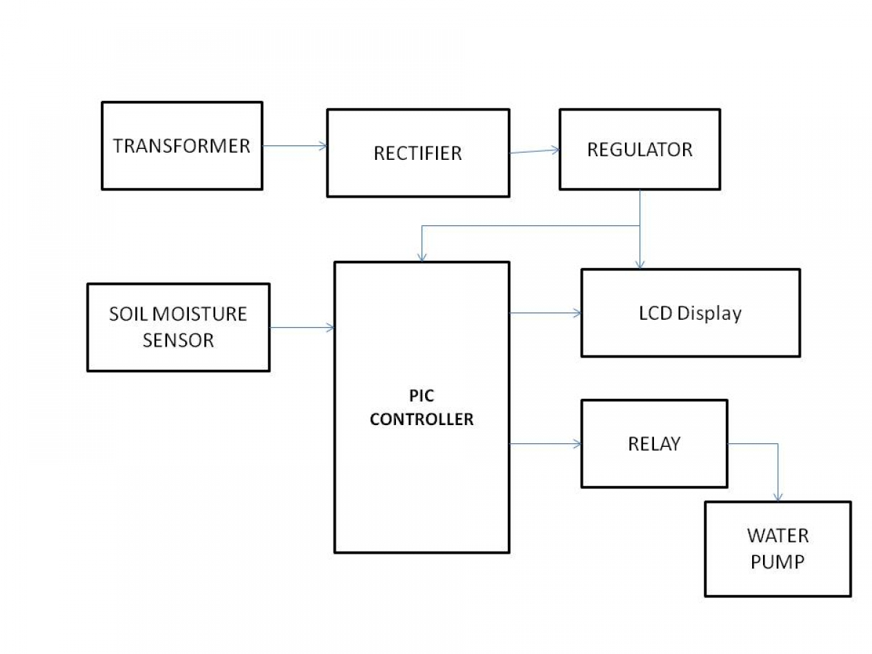

Figure 1. Theoretical Paradigm

**Conceptual Framework**

This section presented the concept and the processes of Arduino-based Automated Plant Soil Monitoring and Water Control System.

Figure 2 shows the Conceptual Framework of the study. The input is the microcontroller, soil sensor, pump, relay, and battery that will be used in the system. The research process includes calculating the data to control the OLED display and give instructions on the relay module. The motor will then draw power based on the allowed time of the relay module, and will provide water on the respective soil. The output is when the plants are watered.

INPUT PROCESS OUTPUT OUTCOME

**Sensor**

**Calculate Data**

**Control OLED Display**

**Instruct Relay Module**

**Draw power into motor**

**Automated Watering of Plants**

Figure 2. Conceptual Paradigm

**CHAPTER 3**

**TECHNICAL BACKGROUND**

The proposed system will allow people to cater the needs of their household plants efficiently without taking much of their time. The researchers will use a capacitive soil moisture sensor that will measure the level of moisture in the soil and send the data to an Arduino board. The Arduino board will then be responsible for the logic code written in C++ defined by the researchers which will instruct a relay module to trigger the pump in a water source to provide water to plants via a tube. The code will also control the OLED display to show the current status of the system. The logic code is designed to activate the pump for only a few seconds to give the moisture sensor the time it needs to adjust in detecting soil moisture. The motors will be powered by two AA batteries while the Arduino will run from a 9V battery.

Table 1: User Requirements

|  |  |
| --- | --- |
| **Users** | **Requirements** |
| Plantitos/Plantitas | Owned Plants |

Table 1shows the user requirements for the system we are going to develop.

Table 2: Hardware Requirements

|  |  |
| --- | --- |
| **Hardware** | **Requirements** |
| Computer/Laptop  Windows 10/11 64 bit  4GB RAM | Used to build the system. |
| Arduino Board (Arduino Uno) |
| Water Pump |
| Relay Module |
| Soil Moisture Sensor |
| Tube |
| Wire |
| Battery (9V AA) |
| OLED Display |

Table 2shows the hardware requirements for developing the system.

Table 3: Software Requirements

|  |  |
| --- | --- |
| **Software** | **Requirements** |
| Windows 10/11 (64 bit) | This is the OS that will be used to install the Arduino IDE |
| Arduino IDE | This will be used to program the system |

Table 3shows the software requirements for developing the system.

**CHAPTER 4**

**Methodology, Results and Discussion**

This chapter offered the methodology, findings, and analysis for the Arduino-Based Plant Soil Monitoring and Water Control System. It covers the following topics: requirements analysis, requirements analysis process, requirements analysis technique, requirements documentation, development and testing, prototype description, implementation plan, and result.

**A. Requirements Analysis**

The research team's functional information served as the foundation for the study. Reliable user demands and expectations include controlling the water delivery to indoor plants and monitoring soil conditions. This is to guarantee that the suggested method operates successfully and effectively.

**Requirements Analysis Process**

This software analysis process involves the following steps/phases:

1. Eliciting Requirements

Owners of indoor plants were the intended market for the proposed Arduino-based plant soil monitoring and water control system. They just embedded the sensor in the ground, and the sensor will track soil moisture and show the results on an LCD. When a sensor senses that the soil is getting too dry, it automatically waters the plants until they have enough water.

1. Analyzing Requirements

In order to acquire information that would help determine the appropriate need needed, the researchers interviewed a few owners of indoor plants. According to the data acquired from the interviews, the owners of indoor plants noted that it will be very beneficial to them, thus it ought to be fully functional before the implementation phase. Because this idea saves time compared to the conventional method of manually watering the plants, indoor plant owners are also in favor of its implementation.

1. Requirements Modelling

Use Case Diagram

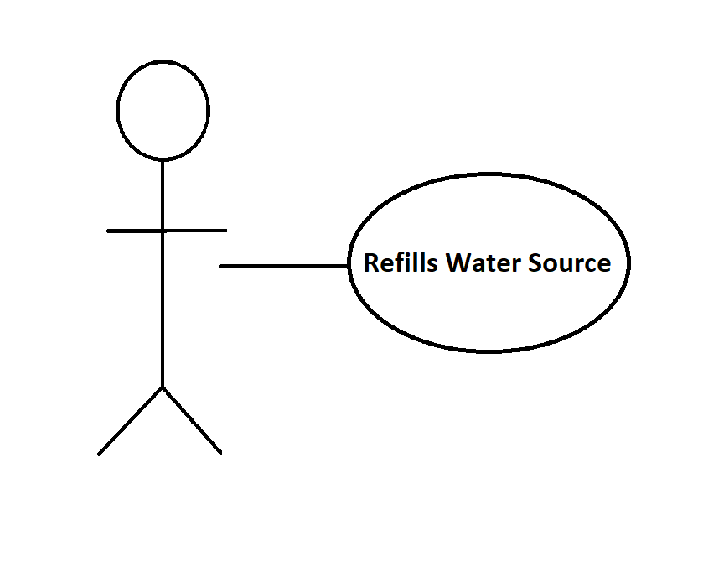

**Process Specification Example**

Number 1

Name Refills Water Source

**Description Pour water into water source.**

The user should refill the water source when needed.

The water volume of the water source is increased.

**Input Data Flow**

User pours water into water source.

The water source is filled with water.

1. Review and Retrospective

This step is conducted to reflect on the previous iteration of requirements gathering in a bid to make improvements in the process going forward.

|  |  |  |
| --- | --- | --- |
| What Worked Well | What can be Improved | Suggestions |
| • Group Brainstorming  • Detecting Soil Moisture | • Clarity on the requirements  • Battery lifespan | • Probe further with the client on requirements.  • Optimize code and implement sleep-device logic. |

Table 1

**B. Requirements Analysis Technique**

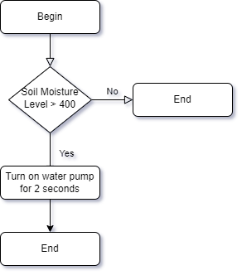

Figure I. Requirement Analysis Flowchart

**C. Requirements Documentation**

An Automated Plant Watering and Soil Moisture System have allowed homeowners to automatically water their household plants in an efficient way of time and resources. This will help not only in time management of the homeowner but also conserving water by only watering the plants when it is needed which helps the environment and society.

**Design of Software, Systems, Products and/or Processes**

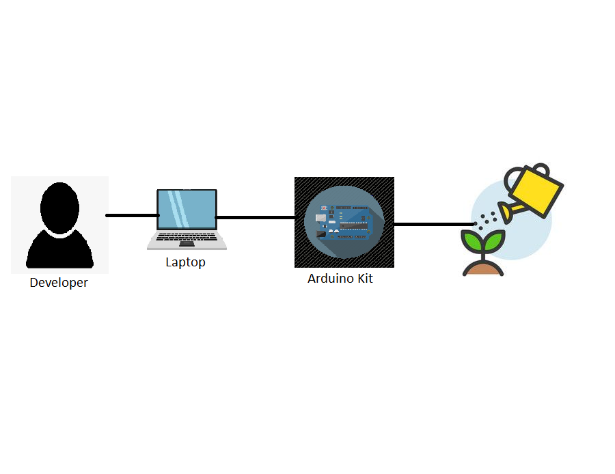

**C.II. Development and Testing**

The proposed system was developed in Arduino 2022 using C++ programming language.

First Test : We tested the code logic by substituting the soil moisture sensor with manual input, the water pump with an LED, and the LCD display with string outputs in serial monitor.

Second Test : We then installed the soil moisture sensor, LCD, and water pump. The system works only when we disable the water pump. Substituting the water pump with an LED makes the system works properly. We then concluded that it was the motor’s electrical noise that is messing with our system.

Third Test : We installed a decoupling capacitor into the motor to lessen the electrical noise. The system now works but is inefficient in using power.

Fourth Test : We improved the logic code and implemented a sleep-device interval between checks.

Fifth Test : Further testing ensured that the system is working properly.

**Description of Prototype**

The Automated Plant Soil Monitoring and Watering System is used for watering homeowner’s plants automatically. The system will detect soil moisture level. The system will then decide if the soil moisture level is enough. If it is not, then it will instruct the relay module to turn on the water pump for a short time. The relay module will draw power from the batteries into the water pump for the given duration. After that, the system will sleep the device in order to conserve energy for a certain amount of time. It will perform checks from time to time to ensure that the plants are well hydrated.

**D. Implementation Plan**

The researchers assembled the device that will be used in a common household. Then the researchers install the device into the plant and connect it to a water and power source. The researchers will then conduct a dry run of the system and test if it’s working.

**Implementation Results**

Researchers receive a comprehensive and sheer fact report regarding the project through the implementation result. Researchers are able to determine how the initiative will benefit the engaged households and plants by recording the project's successes.

**CHAPTER 5**

**Recommendations**

This chapter presents the recommendations made by the researcher based on the results of the tests and survey acquired in the study. Also, these recommendations are made for further improvement of the project.

The following recommendations were offered based on the work accomplished during this project.

⦁ The researchers recommends that the system should be able to fully sleep to further lower the power usage of the device.

• A more aggressive decoupling technique should be implemented to further lower the electrical noise generated by the water pump.

• Proper use of resistors should be installed to improve the lifespan of the components involved in the system.

• A backup-up power plan for the Arduino board should be considered to avoid unnecessary downtime when there is power outage.

• Further researches and improvement shall be made to allow the users to be able to control the soil moisture detection level and the amount of water to be involved.

• The researchers highly recommends that the future researchers to seek further towards improving the efficiency of power usage, flexibility, customization, and control of the system.

Appendices

- Relevant Source Code

- Evaluation Tool or Test Documents

- Sample Input/Output/Reports

- Users Guide

- Process/Data/Information Flow

- Screen Layouts

- Test Results

- Sample Generated Outputs

- Pictures showcasing the data gathering, investigation done (e.g floor plan, layout, building,

etc.)

- One-Page Curriculum Vitae per team member