SQLRunner – A SQL Query Tool
Ian F. Darwin
http://www.darwinsys.com

SQLRunner
SQLRunner is a “fall-back” tool that lets you work at the raw SQL command level. This is an advanced topic and should only be used by (or made available to) those familiar with the intricacies of SQL commands and the details of your database; like a sharp knife, this tool is very useful in the hands of a skilled chef, but a slip of the fingers here can be quite messy...
SQLRunner was written by Ian Darwin, and is distributed under a liberal free-software, open-source license.

Using SQLRunner
SQLRunner is available both as a standalone program and as a GUI tool embedded in other applications; the standalone version can run either as a “command line” or “console” application or with a GUI (the command line version is not further described here). In the standalone case you will have some kind of launch application or shell script / batch file to start it. In the latter case there will normally be a menu entry under the Tools menu. In either case you (or the surrounding application) must ensure that any drivers you will need are available on your CLASSPATH.
SQLRunner begins with the GUI window shown below. The first thing you should do is select which database connection you wish to use.
In the standalone version, the list of Connections is controlled by editing your $HOME/.db.properties file; this is a standard Java properties file, with four lines per connection. For example:
demo.DBDriver=com.ibm.db2.jcc.DB2Driver
demo.DBURL=jdbc:db2://host.domain.tld:30080/TCPDB
demo.DBUser=dbmanager
demo.DBPassword=top secritt

For security reasons you may well not want to store the database passwords in a file in your home directory. If the password is omitted, it will be prompted for; SQLRunner will not write this password back to the configuration file. There is a “Prompt for Password” checkbox that is only needed if you make a mistake or the password has been changed and you haven't updated your db properties file yet.
A GUI is usually provided for controlling this list in the embedded version.
The basic steps to using SQLRunner are to type a command in the top (SQL Command) window and click the Run button; the results are displayed in the bottom (SQL Results) window. To save you some typing, there is a “Statement Template” mechanism that will insert a template of a SELECT, INSERT or UPDATE SQL statements (just select the template you want and click “Apply Template”; the selected template will replace the current Input Statement.
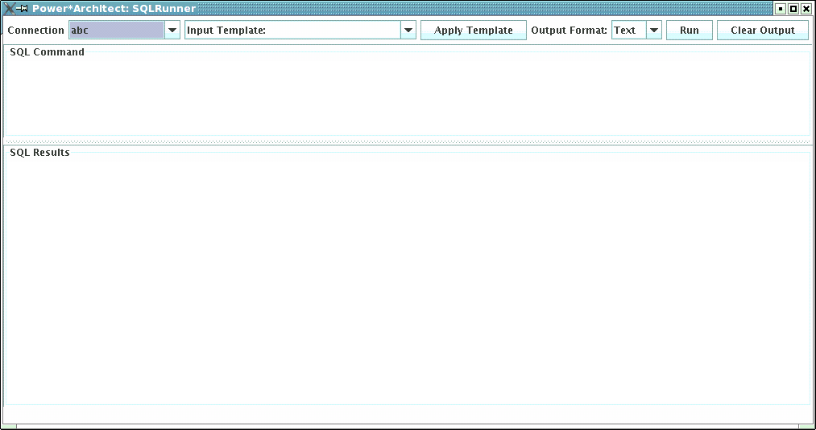
The command can actually be one of two kinds: either one of a half-dozen escape commands listed below, or, anything that is valid input to your database's command interface (e.g., SQL commands to programs such as psql or SQL*Plus™).
The escape sequences are:
\dt Describe list of all tables
\dtT Describe column names of table named T
\mX Set the mode, where X is the first letter of the mode (t for text, s for SQL, h for HTML or x for XML; not needed in the embedded version because the GUI has a control for this)
\oF (Command-line version only) Send output to the given file instead of the screen (though you can usually just view the output and copy-and-paste to save parts of it into a file.
\q Exit the program (not supported in embedded versions).
SQL Statements are entered one at a time, can be more than one line long, and need not end with a semicolon. Some drivers allow you to send multiple SQL commands if you separate them with semicolons; this is not recommended because only one of them will get reported on. SQL statements are not interpreted by SQLRunner itself, so anything that the given database and driver accepts can be used. For example, with Oracle™, you can use PL*SQL™ statements. With most drivers you should be able to use stored procedures. Each SQL statement is executed in its own transaction context, that is, changes are committed immediately (so be careful!).

Output (Results) Window
Command Output in the chosen format (see below) appears in the SQL Output window. A scrollbar will appear if the information cannot all be seen at once.
A visual indication of the success or failure of the command is displayed below the output: green for success, red for failure. As well, failures will be accompanied by a pop-up window containing details on the failure.
The Clear Output button clears the contents of the output window.

Output Formats
There are several output modes for the display of SQL “select” results: text, SQL, HTML and XML (output from the escape commands are always displayed as plain text). Text mode is the default, and is primarily a raw display format. SQL output is most useful with the output of a SELECT statement; it will generate SQL that will attempt to re-create the data in another database. HTML mode generates an HTML table to display the results of a Select. XML format is similar but may be used for exporting data into other applications.
For example, with SQL mode selected, a “select * from anecdotes” (a table in a bookstore web site's database, used to display a casual quotation about books) looked like this:
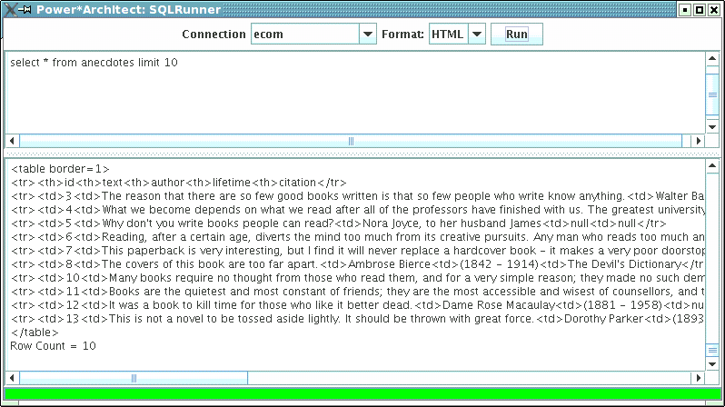
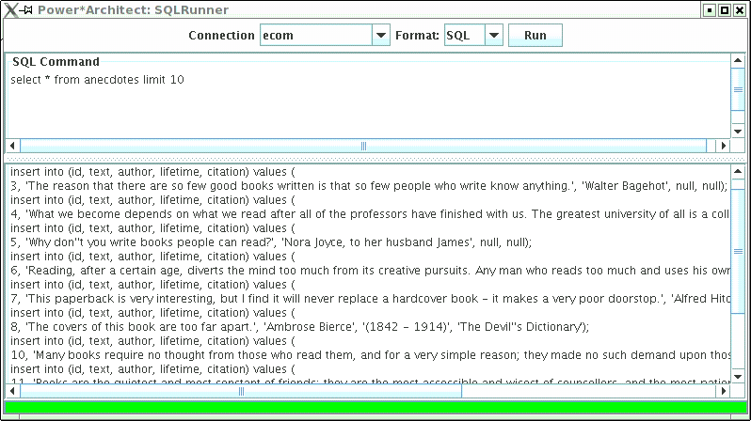
This could, as you can see, be used to create a SQL script to re-create the contents of the database. In fact, some developers use SQLRunner primarily for this purpose: to create stable test databases from “live” data that was created by their application.
You can view this same data in HTML just by changing the Format selection to HTML and clicking the Run button again:
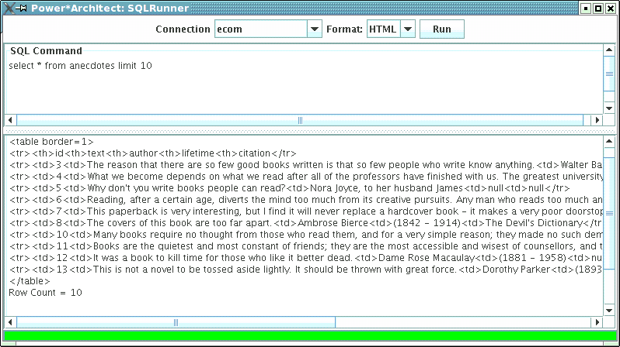
When copied and pasted into an HTML file and viewed in a browser, the output looked like this:
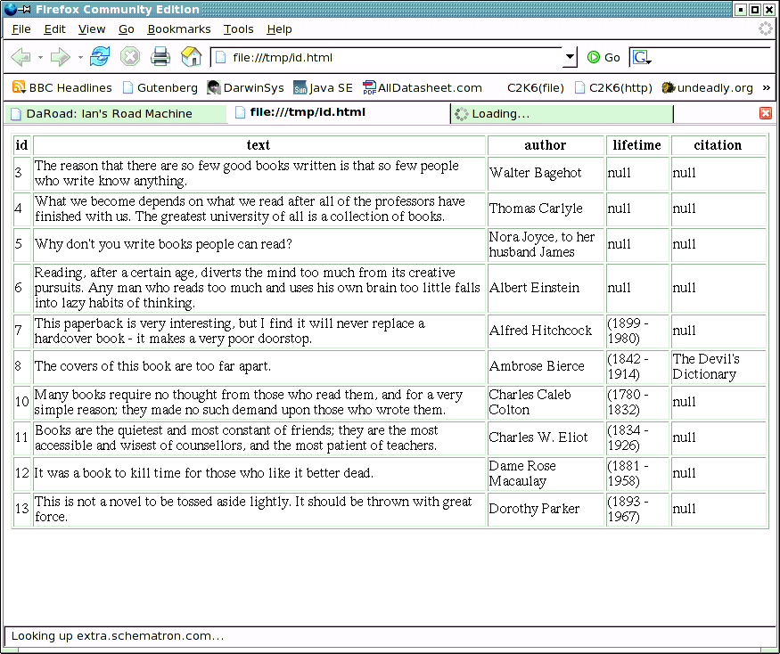
With a bit of formatting, or even a CSS style sheet, this HTML page could be made usable.

TODO List
The program is still in development, and there are some improvements that could be made. There is a TODO file in the source tree listing areas suggested for further development.

