Changes to put jpademo on MySQL

By Chris Mawata

Start MySQL workbench
Single click Local Instance MySQL
Right click in the schema area to make a pop up come up with the choice to "Create Schema"

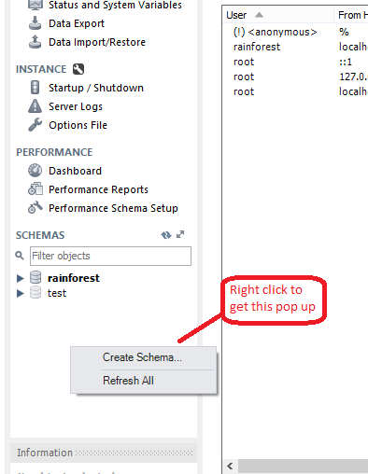

Click on "Create Schema"

In the next dialog enter jpademo.db for the name of the schema

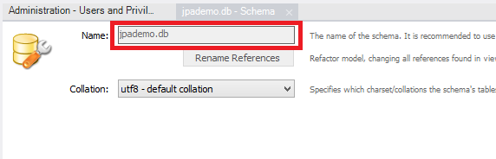

Click Apply [It is bottom right]
In the next dialog with title Apply Sql Script to Database click "Apply"
Next dialog should say that the SQL script was successfully applied to the database
Click Finish in that dialog

To create the account, click on "Users and Privileges"

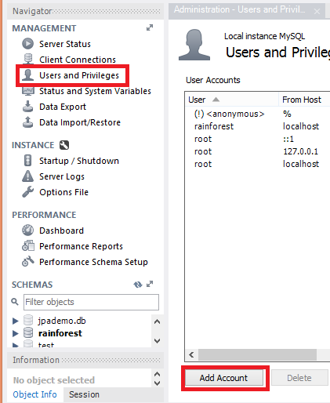

Click on the "Add Account" button at the bottom of the Users and Privileges dialog
Edit the details for the account
Login Name: student
Authentication Type Standard
Limit to Hosts Matching %
Password: student

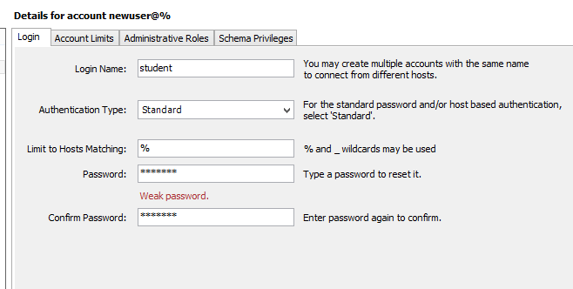

Click Apply
[There should now be an account called student in the list of user accounts)

With the student account highlighted click on the Schema Privileges tab

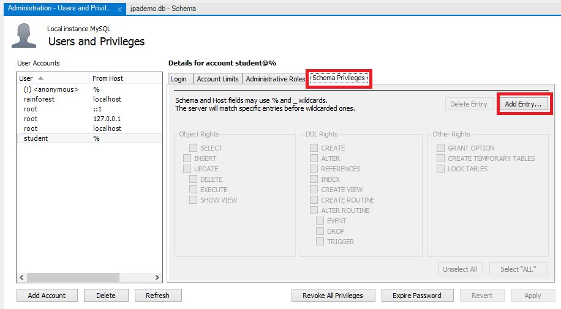
Click the Add Entry button

In the New Schema Privilege Definition dialog click the Select schema: radio button, highlight jpademo.db, and click OK

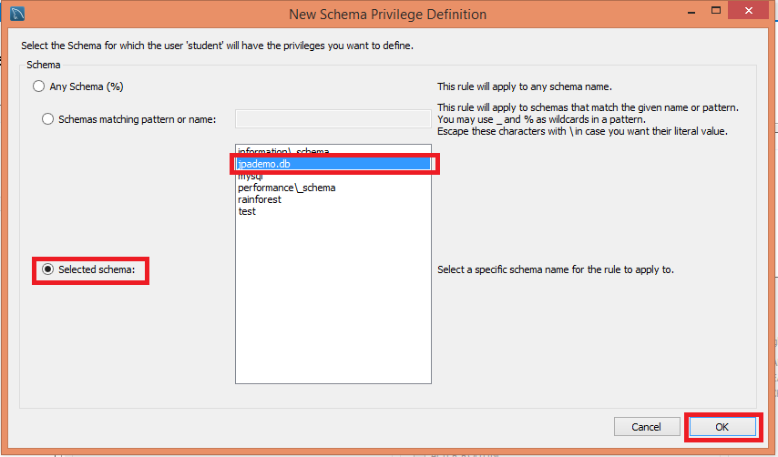
In the dialog that follows click Select “ALL” and “Apply”

You can now close the MySQL workbench

In the pom.xml add an entry for the MySQL driver

<dependency>
<groupId>mysql</groupId>
<artifactId>mysql-connector-java</artifactId>
<version>5.1.33</version>
</dependency>

In the META-INF/persistence.xml make sure you have this in the persistence unit (you should only need to un-comment the relevant parts):

<persistence-unit name="jpademo">

<provider>org.eclipse.persistence.jpa.PersistenceProvider</provider>
<exclude-unlisted-classes>false</exclude-unlisted-classes>
<properties>
<property name="eclipselink.logging.level" value="INFO" />
<property name="eclipselink.target-database" value="MySQL"/>
<property name="eclipselink.ddl-generation"
value="drop-and-create-tables" />
<property name="javax.persistence.jdbc.driver"
value="com.mysql.jdbc.Driver" />
<property name="javax.persistence.jdbc.url"
value="jdbc:mysql://localhost:3306/jpademo.db"/>
<property name="javax.persistence.jdbc.user" value="student" />
<property name="javax.persistence.jdbc.password" value="student" />
</properties>
</persistence-unit>

