Ian Doarn

3/24/2020

COMP 4270

Programming Project 1

1. 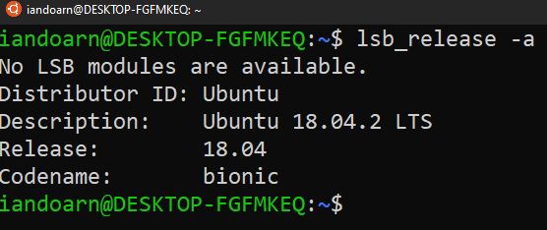

Installed from Windows Subsystem for Linux

1. 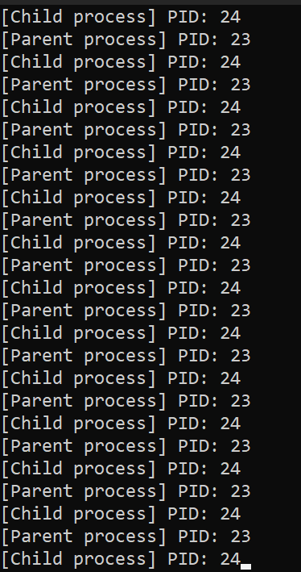
2. 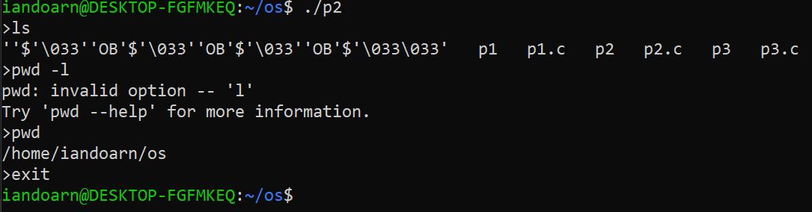
3. 