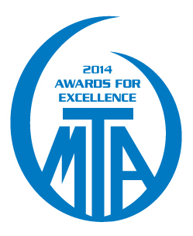
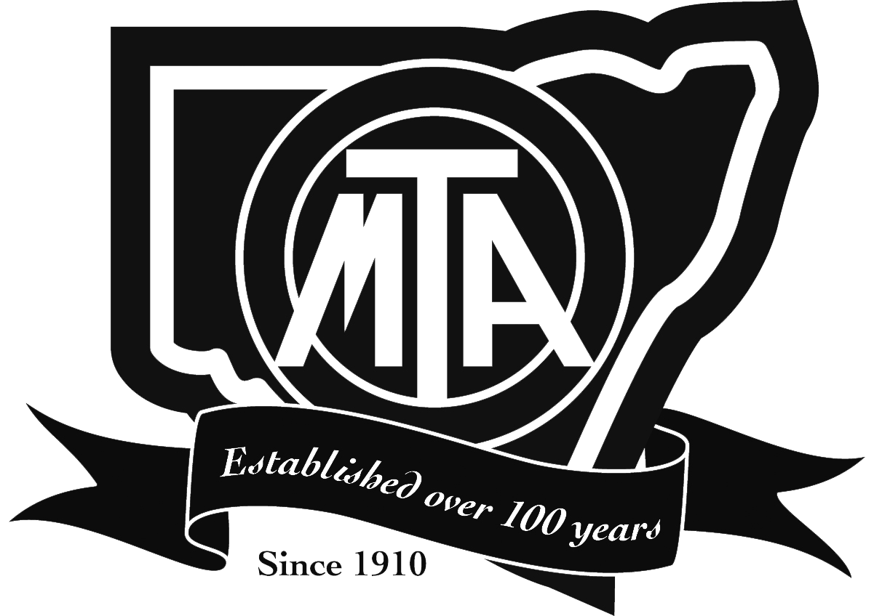
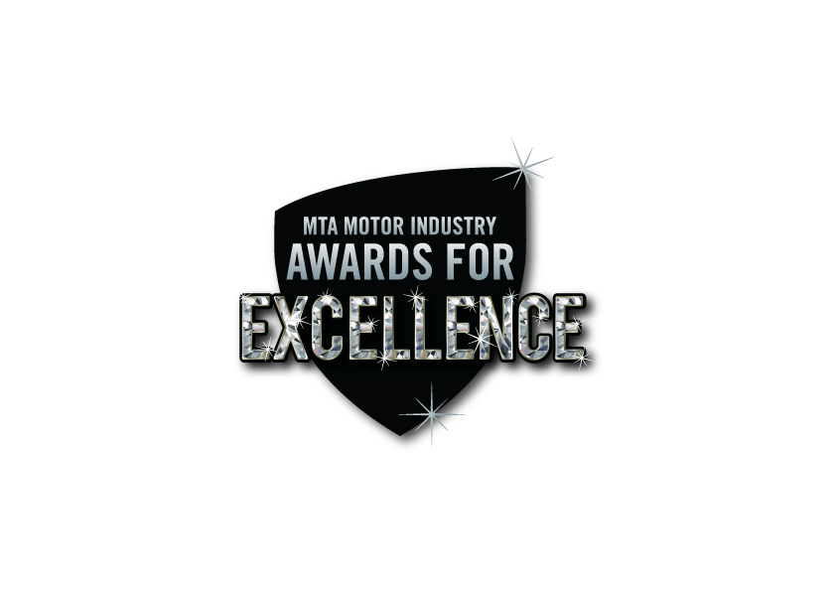

MTA AWARD CATEGORIES

New South Wales New Vehicle Dealer of the Year
This award is open to the new vehicle sales department of a dealership. In accordance with the criteria, entries for this award are judged on outstanding achievements in new vehicle sales operations regarding customer service and the display and presentation of the vehicles and the premises.

New South Wales Used Vehicle Dealer of the Year
This award is open to used vehicle dealers in the used vehicle sales department of vehicle traders. In accordance with the criteria, entries for this award are judged on outstanding achievements in used vehicle sales operations regarding customer service and the display and presentation of the vehicles and the premises.

New South Wales Farm Machinery Dealer of the Year
This award is open to farm machinery dealers throughout NSW. This award recognises excellence in business operation, customer service and the quality of equipment sold.

New South Wales Motorcycle Dealer of the Year
This award is open to motorcycle sales dealers. This award recognises excellence in sales operations, customer service and display and presentation of the vehicles and the premises.

New South Wales Commercial Vehicle Business of the Year
This award is open to commercial vehicle sales and service businesses. In accordance with the criteria, entries for this award are judged on new car sales operation and service and recognising excellence in customer service, display and presentation of the vehicles and the premises.

New South Wales Body Repair Business of the Year
This award is open to the body repair sector of the motor industry. In accordance with the criteria, entries from this demanding area of the industry are judged on excellence in the associated specialised processes of auto body repair.

New South Wales Under Body Repair Business of the Year
This award is open to businesses specialising in the underbody repairs and maintenance of motor vehicles. In accordance with the criteria, entries for this award are judged on excellence in steering, suspension, exhaust and brake underbody repairs and maintenance.

New South Wales New & Used Parts Business of the Year
This award is open to businesses specialising in the new and used parts sales In accordance with the criteria, entries for this award are judged on excellence in sales of parts, presentation and customer service.

New South Wales Tyre Dealer of the Year
This award is open to tyre specialist businesses. The award acknowledges this important sector’s contribution to motor vehicle safety.

New South Wales Engine Reconditioner Business of the Year
This award is open to businesses specialising in motor vehicle engine reconditioning. In accordance with the criteria, entries for this award are judged on the quality of the specialised rebuilding processes.

New South Wales Auto Electrician Business of the Year
This award is open to auto electrical businesses. Recognising the importance staying ahead of rapidly changing technologies in this specialised sector of the motor industry, this award seeks to provide a standard for excellence in auto electrical repair and service.

New South Wales Dismantler Business of the Year
This award is open to dismantler businesses. In accordance with the criteria, entries for this award are judged on the operations in the increasingly critical role of recycling motor cars in our society.

New South Wales Automatic Transmission Specialist Business of the Year
This award is open to automatic transmission specialist businesses. The award is judged on the level of transmission repair service using extensive and complex electrical and mechanical equipment.

New South Wales Radiator Specialist Business of the Year
This award is open to radiator specialist businesses. In accordance with the criteria, entries for this award are judged on outstanding achievements in the increasingly complex cooling system repair services.

New South Wales Mechanical Repair Business of the Year
This award is open to mechanical repair businesses. In accordance with the criteria, entries for this award are judged on outstanding achievements in this specialised sector of the motor industry.

New South Wales Service Station Association Division Member of the Year
This award is open to SSA Division member businesses. In accordance with the criteria, entries for this award are judged on outstanding achievements in this specialised sector of the motor industry. Including premises, environmental policies and customer service.

New South Wales New Apprentice of the Year
“New Apprenticeships” provide a pathway to a nationally recognised qualification. “New Apprenticeships” is the term applied to both apprenticeships and traineeships. Apprenticeships and traineeships are jobs that combine work with training. Work based training for apprentices and trainees is provided by employers at the workplace with additional structured training delivered by TAFE or a Register Training Organisation such as MTA NSW.

MTA Green Stamp Environmental Member of the Year

MTA gives this award to those members who demonstrate a commitment to Workplace Environmental matters and best practices.

MTA Work Health & Safety Member of the Year
MTA gives this award to those members who demonstrate a commitment to Work Health & Safety matters in the work, and have taken substantive moves to meet Legislative compliance.

MTA Metropolitan Member of the Year
This award goes to a MTA metropolitan member for continued support of the Association and the industry by promoting the MTA to other participants in the industry and demonstrating outstanding leadership within the industry through professional practices and high quality customer service.

MTA Country Member of the Year
This award goes to a MTA country member for continued support of the Association and the industry by promoting the MTA to other participants in the industry and demonstrating outstanding leadership within the industry through professional practices and high quality customer service.



