
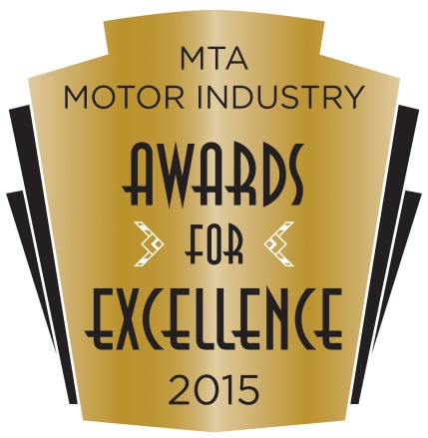
2015 MTA NSW
Motor Industry Awards
Nomination Form

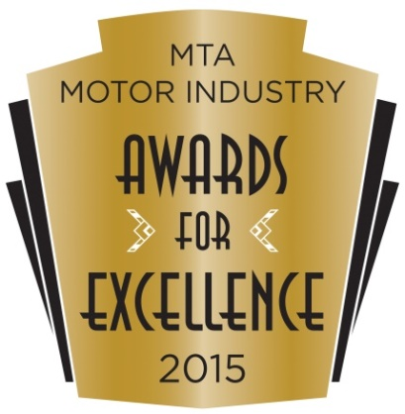
2015
Nomination
Form

Category you wish to nominate for:

CONTACT DETAILS:

Trading Name of Business:
Address of business:
Contact Person:
Telephone: Fax:
Email Address:

BUSINESS DETAILS:

Number of people employed by the business:

1-3 4-6 7-10 11-15 16-50 51+

Number of years your business been operating:

1 year 2 years 3 years 4-7 8-15 More than 15

Are you the original owner? : No – when did you purchase the business?

1 year 2 years 3 years 4-7 8-15 More than 15

What is the annual turnover of the business?:
Under $250,000 $250,000-$500,000 $500,000-$1 million
$1 million-$3million more than $3 million

BUSINESS OUTLINE:
Describe the products and services your business provides:

Describe the history of your business:

BUSINESS FEATURES:

Which method do you use to promote your business, please include short description?
        - Word of Mouth
        - Advertising
        - Merchandising
        - Direct Client Contact
        - Loyalty Programs

Describe the level of customer service and the quality of products your business provides

Describe how your business supports the local community

Describe how your business supports the motor industry

What are your Goals regarding?
Business Growth

Employee expansion

Detail the successes and achievements of your business during the last 12 months

Do you employ apprentices or trainees?

If yes how many [ ] and what years?

Describe your approach to staff training

Describe the incentives provided to staff

What process do you use to ensure customers are satisfied with your business?

Check list …

Photos of business premises inside and out, including staff?
Please provide at least two quality photographs of your business to be shown on the big screen during the Award evening. These photos may be enclosed in an envelope and included along with your entry, alternatively you may email the photographs, make sure you include your business name and category name.
Email: events@mtansw.com.au

Additional Materials:
Newspaper articles
- Promotional / Marketing Materials
- Thank you letters / customer testimonials
- Newspaper clippings
- Business / marketing plans & goals

Entries close 18th September 2015
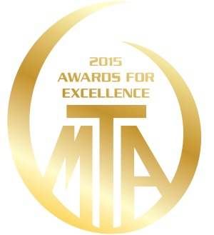
rewarding excellence in the motor industry

