
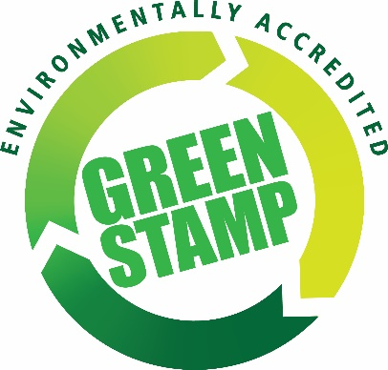
2016 Green Stamp Environmental Award Nomination Form

Member Number
Contact Name
Business Name
Type of Business
Phone Number
Email address

To be eligible to enter this award, please answer the following questions and submit the Nomination Form (along with any additional information or photos) to Nicole Patten at MTA (fax 02 9016 909 or mail PO Box 715, Burwood 1805) by 16th September 2016].

1. Has your business been awarded the MTA Green Stamp Accreditation?
Yes No
If yes, please advise which level you have received: Level 2 Level 3

2. List one environmental initiative that has been implemented within the past year to improve the environmental performance of the business.
EXAMPLES: waste reduction, staff training, purchase of spill kits, bunding around workshop or liquid storage areas, efficient equipment investment or any other initiative.

____________________________________________________________________________________________________________________________________________________________________
____________________________________________________________________________________________________________________________________________________________________
__________________________________________________________________________________

3. List the types of waste that are separated and collected for approved disposal or recycling.
EXAMPLES: waste oil, old paint, cardboard, scrap metal or any other type of waste material.
*Copies of receipts must be included to prove that collection is being conducted by a licenced contractor.

____________________________________________________________________________________________________________________________________________________________________
____________________________________________________________________________________________________________________________________________________________________
__________________________________________________________________________________

4. List the ways energy consumption is reduced.
EXAMPLES: energy efficient globes, skylights, equipment turned off afterhours, investment in efficient technology or any other method of reducing energy consumption.

____________________________________________________________________________________________________________________________________________________________________
____________________________________________________________________________________________________________________________________________________________________
__________________________________________________________________________________

5. List the ways water consumption is reduced.
EXAMPLES: rain water collection, water recycling, water flow reducers, dual flush toilets or any other method of reducing water consumption.
____________________________________________________________________________________________________________________________________________________________________
______________________________________________________________________________________________________________________________________________________________________________________________________________________________________________________
__________________________________________________________________________________

6. List the ways that the businesses’ environmental values are promoted to employees.
EXAMPLES: staff training, signage, staff involvement in environmental planning, display of environmental policy or any other method.
______________________________________________________________________________________________________________________________________________________________________________________________________________________________________________________
____________________________________________________________________________________________________________________________________________________________________
__________________________________________________________________________________

7. List the ways that the businesses environmental values are promoted to your customers and the wider community.
Examples: your green marketing opportunities and developing your green corporate image.
____________________________________________________________________________________________________________________________________________________________________
____________________________________________________________________________________________________________________________________________________________________
____________________________________________________________________________________________________________________________________________________________________

8. How does your business plan to go above and beyond in the name of environmental management in the future?
Examples: food waste being composted, energy audits, measuring your carbon footprint, using green power, solar panels, greywater recycling.

*This can include initiatives that the business does not yet undertake, but are planned for future implementation.
____________________________________________________________________________________________________________________________________________________________________
______________________________________________________________________________________________________________________________________________________________________________________________________________________________________________________
__________________________________________________________________________________

