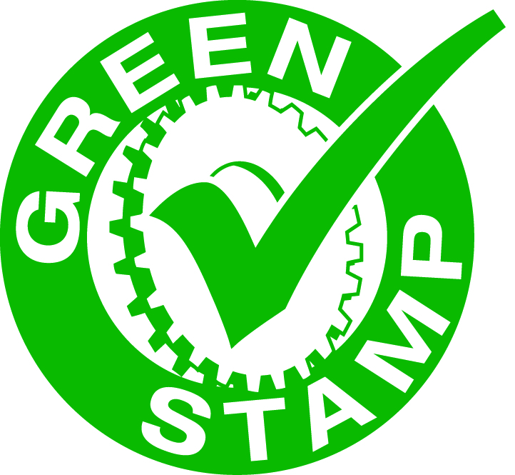
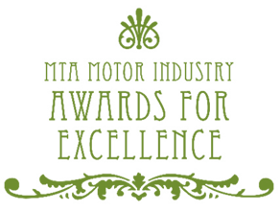
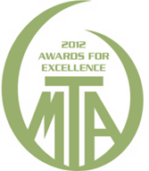

2012 Green Stamp Plus Environmental Award Nomination Form

Member Number Contact Name
Business Name
Type of Business Phone Number

To be eligible to enter this award, please answer the following questions and submit the Nomination Form (along with any additional information or photos) to Nicole Smith at MTA (fax 02 9211 0231 or mail Locked Bag 5012, Darlinghurst NSW 2010) by 11th July 2012].

1. Has your business completed an environmental compliance assessment within the past year?
EXAMPLES: a self-completed checklist, an MTA Envirocheck or any other check.
❒ Yes  No

2. Has your business been rewarded Green Stamp Plus Accreditation?
❒ Yes  No
If yes, please advise which level you have received: Level 1  Level 2  Level 3 

3. List one environmental initiative that has been undertaken within the past year to improve your environmental performance.
EXAMPLES: waste reduction, staff training, purchase of spill kits, bunding around workshop or liquid storage areas, efficient equipment investment or any other initiative.

____________________________________________________________________________________________________________________________________________________________________
____________________________________________________________________________________________________________________________________________________________________
__________________________________________________________________________________

4. List the types of waste that are separated and collected for approved disposal or recycling instead of being put into landfill.
EXAMPLES: waste oil, old paint, cardboard, scrap metal or any other type of waste material.

____________________________________________________________________________________________________________________________________________________________________
____________________________________________________________________________________________________________________________________________________________________
__________________________________________________________________________________

5. List the ways energy consumption is reduced.
EXAMPLES: energy efficient globes, skylights, equipment turned off afterhours, investment in efficient technology or any other method of reducing energy consumption.

____________________________________________________________________________________________________________________________________________________________________
____________________________________________________________________________________________________________________________________________________________________
__________________________________________________________________________________

6. List the ways water consumption is reduced.
EXAMPLES: rain water collection, water recycling, water flow reducers, dual flush toilets or any other method of reducing water consumption.
____________________________________________________________________________________________________________________________________________________________________
______________________________________________________________________________________________________________________________________________________________________________________________________________________________________________________
__________________________________________________________________________________

7. List the ways that the businesses’ environmental values are promoted to employees.
EXAMPLES: staff training, signage, staff involvement in environmental planning, display of environmental policy or any other method.
______________________________________________________________________________________________________________________________________________________________________________________________________________________________________________________
____________________________________________________________________________________________________________________________________________________________________
__________________________________________________________________________________

8. List the ways that the businesses environmental values are promoted to your customers and the wider community?
Examples: your green marketing opportunities and developing your green corporate image.
____________________________________________________________________________________________________________________________________________________________________
____________________________________________________________________________________________________________________________________________________________________
____________________________________________________________________________________________________________________________________________________________________

9. How does your business go above and beyond in the name of environmental management?
Examples: food waste being composted, energy audits, measuring your carbon footprint, using green power.
____________________________________________________________________________________________________________________________________________________________________
______________________________________________________________________________________________________________________________________________________________________________________________________________________________________________________
__________________________________________________________________________________

The MTA is running the Green Stamp Plus program in New South Wales and the Australian Capital Territory. For more information please visit www.greenstamp.mtansw.com.au or call MTA on 02 9213 4231.

