MTA Motor Industry State Awards
2012 Awards for Excellence

Are you the next
MTA / Pro Visual Publishing
Occupational Health & Safety
Member of the Year?

The MTA/Pro-Visual Publishing Occupational Health & Safety Member of the Year is awarded to those members who demonstrate a commitment to Occupational Health & Safety (OHS) matters in the workplace, and have taken substantial actions to meet legislative requirements.

The award will be presented at the MTA Motor Industry State Awards night on the 22nd September 2012 at the WatervieW, Bicentennial Park, Sydney Olympic Park

Pro-Visual Publishing and the MTA understand that achieving and maintaining best practice in OHS involves a lot of effort. For this reason the winner of the MTA/Pro-Visual Publishing Occupational Health & Safety Member of the Year award will receive the prestigious MTA member trophy and will be interviewed about their success with the article being published in the MTA E-Journal.

The winning company will also have the use of the Occupational Health &
Safety Member of the Year Award logo on their email signature, stationery and marketing materials to publicise their achievement of this prestigious award.

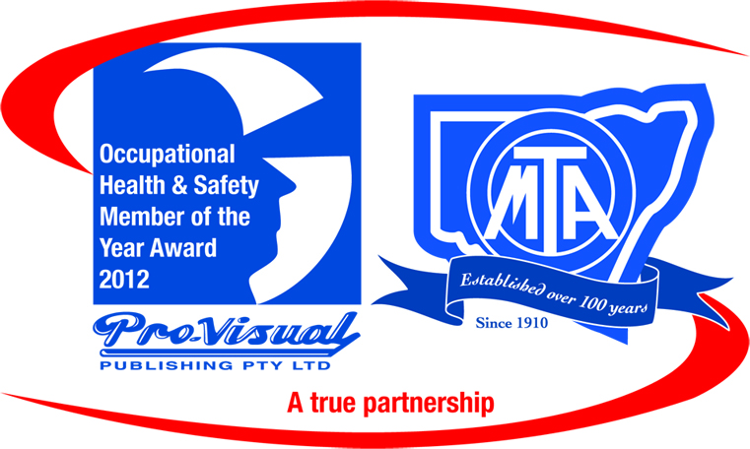

To be eligible to enter this award, please answer the following questions:

1. Compliance with OHS obligations requires a risk management approach.
Have you conducted at least one hazard identification in your business during the last 12 months?

2. Have you conducted any OHS training (this can include induction of the new staff) during the last 12 months?

3. List one OHS initiative undertaken during the last 12 months to promote OHS amongst staff? (Answer could include display and discussion of Pro-Visual chart/s, meeting/s held, introduction of new OHS policy, video education etc.)

4. How have employees been involved in OHS initiatives in the workplace?
a. Hazard identification 
b. Meetings 
c. Carried out risk assessments 
d. Other, please specify

5. Have you utilised the Pro-Visual Publishing/MTA automotive industry workplace safety charts in any area of your business? If yes, can you give an example as to how and why this has benefited your workplace?

6. Are there any other comments you wish to add to support your nomination?

Additional information may be attached
Pro-Visual Publishing produces the Body Repairers Guide to Workplace Safety and the Automotive Mechanics Guide to Workplace Safety.

The charts are distributed at no cost to MTA members and are designed to assist in the implementation of OHS systems within the workplace. Information appearing on each chart is updated annually to ensure the most relevant OHS issues are covered.

Terms and Conditions: 1.This award is open to all members of MTA NSW. 2. Entries must be completed online or faxed or posted to: Nicole Smith, MTA NSW by 11th July 2012.

Please fill in your entry form and return to:
Nicole Smith
Fax: 9211 0231
Locked Bag 5012
Darlinghurst NSW 2010

