The web application is designed with a modern look and feel with an aim to extend the participant's visit thus, hopefully, to increase the size of the results set for the research. A blue colour scheme was selected to be calming and subconsciously promote openness.

The home page of the site is an article from Reuters corpus, which can be refreshed to select another random article. It should be noted that this might be the same as before. The site features an extensive about page to give the participant a context and understanding of the research intended to be carried out. This page also contains a social sharing link for promotion of the site in various mediums across the Internet, for example: Social Media. It was decided that rather than utilise the sharing frameworks for specific mediums, which may cause exclusion, that a link would allow for customisation and the participants own comments depending on their choice audience to share with.

The application stores participant's IP addresses to facilitate the filtering of the data set, should it be discovered that Spam has contributed greatly to outweigh the real participant's results. As such, the users are informed of this through a privacy statement and it is then their decision as to whether they continue to participate in the research.

It is intended that the participant does not have knowledge as to which keyword or phrase belongs to which production method, though it may become clear as to which are generated by chance. In order to achieve this, the keywords are presented in alphabetical order, with care to ensure that the database may still be updated with the correct column references. The application also merges duplicate keywords should this occur; for example if generation method X produces the same keyword as method Y then one instance of the keyword would be displayed to the participant, however the corresponding database fields would be selected or unselected in each instance based on the participant's input. This processing is handled server-side with no trace left on the client side for viewing either on a rendered page, or within the source code for the render.

Before a participant is able to submit the web form, they must have interacted with the form in some way. This is intended to both increase the complexity which automated or participant-created Spam entries may be created, and to reduce the risk of accidental submission. The participant may select from options of 1 - selecting from the list, or 2 - selecting no items from the list. Should they select option 1 and not make selections the form will not submit, as it is intended that at least one keyword or phrase be selected. Along with this, it is possible to alter which of these choices the participant wishes to make by selecting the other. However, if selections were previously made they are retained to reduce frustration caused should this change be accidental. If the new choice is option 2 the selected items alteration is prevented and visually reflects that the participant's choice is now to select none of the keywords or phrases.

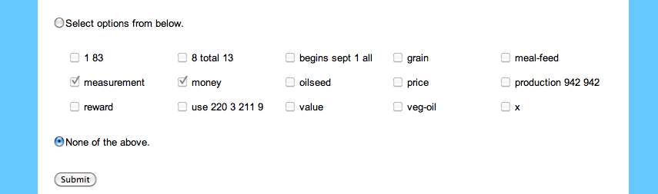

Figure 1 – Greyed out remembered selections

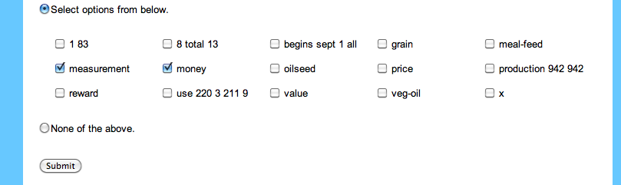

Figure 2 – Changeable selections