# Title

Generalists link peaks in the shifting adaptive landscape of Australia’s dragon lizards

Ian G. Brennan1,2,3,*, Natalie Cooper3, Joanna Sumner4, Sarin Tiatragul1,   
Leonardo G. Tedeschi5, Elizabeth S. Broady1, Jane Melville4, J. Scott Keogh1

Affiliations:  
1Division of Ecology & Evolution, The Australian National University, Australia

2Museum and Art Gallery of the Northern Territory, Australia

3Science Group, Natural History Museum, United Kingdom

4Museums Victoria Research Institute, Melbourne, Australia  
5National Biodiversity DNA Library, Commonwealth Scientific and Industrial Research Organisation, Australia

*Corresponding author

Email Addresses:

ian.brennan@anu.edu.au

natalie.cooper@nhm.ac.uk

jsumner@museum.vic.gov.au

sarin.tiatragul@anu.edu.au

leonardo.goncalvestedeschi@csiro.au

elizabeth.broady@anu.edu.au

jmelv@museum.vic.gov.au

scott.keogh@anu.edu.au

Statement of Authorship:

Conceptualization, IGB, JSK, NC; sampling, LGT, JS; data collection ESB, JT, IGB; data curation, IGB, ESB; methodology, NC, IGB; analysis IGB, ST; writing - original draft, IGB; writing - reviewing & editing, all authors; funding acquisition, JSK.

Data Accessibility: All data and code are available on GitHub at www.github.com/IanGBrennan/Amphibolurinae

Running Title: Generalists link adaptive peaks

Keywords: adaptive landscape, macroecology, macroevolution, phylogenomics

Article Type: Letter

Word Counts: abstract (224), main text (5146)

Number of: references (66), figures (4), tables (0), text boxes (0)

# Abstract

The adaptive landscape is one of biology’s most flexible and intuitive general concepts. This multidimensional space enables us to map individuals, populations, and species to an evolutionary topography, teasing apart what distinguishes entities from one another. A common exercise is clustering species into adaptive peaks which highlight regions of explored trait space, often considered trait optima or adaptive zones. Typically this reveals broad regions of unpopulated and suboptimal trait space that must be traversed between peaks, however, these evolutionary pathways remain poorly understood. Here we use new sequence-capture and linear morphological datasets to investigate the evolution of the adaptive landscape in a group of highly visible and charismatic reptiles: Amphibolurinae dragon lizards (Family Agamidae). We generate a well-supported time-calibrated phylogenomic tree from >5,000 nuclear markers for more than 360 specimens across 176 dragon species, including undescribed diversity, and provide new insights into the diversification of a group that includes iconic species like the frilled-neck lizard, thorny devil, and bearded dragon. By investigating the multivariate morphological evolution of dragon lizards we show that the colonization of Australia was followed by rapid morphological expansion. While the ancestral amphibolurine was likely tree-living, the evolution of the morphological landscape was facilitated by a transition to a generalist form and then subsequent transitions to more specialized ecomorphs. These results provide evidence of an evolutionary pathway for adaptive diversification in a continental radiation.

# Introduction

The adaptive landscape has become an indispensable tool for considering and visualizing evolutionary spaces. In adapting Sewall Wright’s (1932) genotypic fitness landscape to a phenotypic space, GG Simpson (1944) provided evolutionary biologists a shared vocabulary and conceptual bridge between micro- and macroevolution (Arnold et al. 2001). At local scales (species or populations) landscapes help us to map form to fitness. However, at broader scales (species, genera, families) landscapes (often called morphospaces or functional trait spaces) tell us about the density and position of peaks, and how communities or clades map to phenotypic space. This can be valuable in determining the cost of moving between phenotypes, or comparing the morphological limits of different clades. Importantly, phenotypic landscapes are dynamic and can vary through time in their characteristics (Marshall 2014), dictating the persistence and evolution of the species which they represent. As a result, we can use data from those species to infer parameters of, and changes to, the landscape.

Despite how it is often visualized (2D, 3D), the adaptive landscape was never limited to only two or three dimensions. Instead, landscapes can be multidimensional and here the concept intersects with Hutchinson’s (1957) idea of the niche hypervolume. In multidimensional space we can assess the volume and density of individual peaks, probe the depths of multidimensional valleys, or detect holes in the landscape hypervolume (Blonder 2016). Higher dimensionality may also provide paths between peaks that might not be identifiable with fewer dimensions. The complex topography of the landscape, including holes, dictates viable paths from existing morphologies into new ones. As such, the ideas of adaptive radiation and ecological opportunity have long been entwined with Simpson’s view of movement across the landscape (Yoder et al. 2010). With advances in computational power, development of more complex comparative methods, and larger phenotypic datasets, we can begin to unravel historical changes to the adaptive landscape and evolutionary responses that helped develop new forms (Harmon et al. 2005). Importantly, we can ask which axes facilitate/promote movement into new phenotypic space, and if changes to the landscape are associated with shifts in traits such as ecology, habitat, geographic range, and opportunity.

While evolutionary biologists have been visualizing the adaptive landscape and determining the relative heights of peaks since Simpson, comparatively little empirical attention has focused on the movement of lineages to populate new peaks and the evolution of the landscape through time (but see Marshall 2014; Burin et al. 2023). This is due in part to the necessity of a high dimensional dataset, well-resolved phylogeny, and an appropriate organismal group. Here we investigate patterns of adaptive landscape change and the role of ecology and expanding ranges in the morphological evolution of Australo-Papuan agamid lizards. Amphibolurine agamids consist of ~130 species with varied and diverse ecologies, habitat preferences, and highly imbalanced biogeographic richness. The majority of species (~110 spp.) are endemic to Australia, where their distributions span the continent’s driest deserts and wettest rainforests. Their morphologies reflect these diverse habitats, ranging from forest dragons cloaked in spines, squat desert pebble mimics, and include iconic species such as the frilled-neck lizard (*Chlamydosaurus*) and thorny devil (*Moloch*). To match, they show a range of ecologies from cryptic arboreal species to sand dune burrowers. Unique ecomorphologies such as these provide an ideal opportunity to study the tempo and mode of evolution and the processes driving phenotypic change.

To address the evolution of the amphibolurine adaptive phenotypic landscape, we started by generating a sequence-capture dataset to reconstruct the phylogenetic relationships of Australo-Papuan dragon lizards. To investigate morphological diversity we collected an extensive phenotypic dataset of 19 linear measurements that summarize broad axes of variation across the head, body, limbs, and tail. We use phylogenetic comparative methods to assess the tempo and mode of trait evolution and from this present a picture of the evolution of amphibolurine dragon lizards. Across the dragon body, many traits show temporally and phylogenetically heterogeneous evolutionary histories. Those traits with evidence of varied evolutionary processes often exhibit large shifts in trait changes coincident with new morphologies. These morphological jumps are better described by biased directional changes which suggest selection, rather than increased evolutionary rates. Lastly, we identify that the diversity of forms of Australian dragons likely evolved from generalist ancestors which fill space in the adaptive surface and act as intermediates connecting an otherwise patchy landscape.

# Materials and Methods

*Taxon Sampling*

We assembled a sequence-capture dataset across 309 amphibolurine dragon lizards representing 120 of 136 currently recognized species, with a focus on Australian taxa (115 of 117 spp.). This sampling covers all 16 genera and many recognized subspecies (Table S1). We included outgroup representatives from all agamid subfamilies and used tuatara (*Sphenodon punctatus*) and chicken (*Gallus gallus*) to root the tree (368 total samples).

*Molecular Data Collection and Processing*

Molecular sampling implemented the Squamate Conserved Loci (SqCL) kit (Singhal et al. 2017), which comprises ~5,000 ultra-conserved elements (UCEs), ~400 anchored hybrid enrichment loci (AHEs), and ~40 legacy genes commonly used in squamate molecular phylogenetics. Sample collection and laboratory preparation, including extraction, shearing, size selection, library generation, and hybridization capture were completed as part of the Australian Amphibian and Reptile Genomics initiative (AusARG) under the Phylogenomics Working Group following the protocol outlined in Tiatragul et al. (2023).

Raw sequence reads are available from the Bioplatforms Australia Data Portal (https://data.bioplatforms.com/organization/ausarg). We processed raw sequence data using the *pipesnake* workflow (Brennan et al. 2024). A list of all software and versions used is included in the Supplement. In brief, the pipeline concatenates individual read files, then removes duplicate reads via BBMAP (Bushnell 2014), trims adapters and barcodes with TRIMMOMATIC (Bolger et al. 2014), identifies read pairs with PEAR (Zhang et al. 2014), removes off-target reads with BBMAP, assembles reads to contigs with SPAdes (Prjibelski et al. 2020), maps contigs to targets with BLAT (Kent 2002) and extracts the best hit for each target, carries out preliminary alignments with MAFFT (Katoh & Standley 2013), before refining the alignments with GBLOCKS (Talavera & Castresana 2007), estimates locus trees with IQ-TREE2 (Minh et al. 2020), and a species tree with weighted ASTRAL hybrid (Zhang & Mirarab 2022). *pipesnake* is a highly reproducible workflow that provides consistent results with little user input.

*Phylogenetic Analyses*

We estimated individual genealogies for our sequence-capture data (n=5441) under maximum-likelihood in IQ-TREE2 allowing the program to assign the best fitting substitution model using ModelFinder (Kalyaanamoorthy et al. 2017), then perform 1,000 ultrafast bootstraps (Minh et al. 2013). We then estimated the species tree using the coalescent-consistent methods wASTRAL-hybrid and ASTRAL-IV, using IQ-TREE2 gene trees as input. We used two ASTRAL methods to take advantage of the way wASTRAL-hybrid weights branch lengths and support values in estimating the species tree, and how ASTRAL-IV allows multiple individuals per species and estimates both internal and terminal branch lengths in substitutions-per-site (as opposed to coalescent units for internal branch lengths and static terminal branch lengths in wASTRAL). To quantify topological signal from individual gene trees we calculated gene concordance factors using IQ-TREE2 and focused on intergeneric relationships using a single representative for each genus.

*Divergence Dating*

To estimate divergence times among taxa we applied a series of fossil and secondary calibrations in MCMCTree (Rannala & Yang 2007) as outlined in the Supplement and Table S2. We started by trimming our ASTRAL tree down to a single representative for each ingroup species or subspecies for input. We reduced our molecular data to exonic markers in the AHE loci, then estimated raw genetic distances from alignments to use as a proxy for evolutionary rate. We removed the fastest 5% and slowest 5% of loci to avoid issues with extreme rate heterogeneity, removed third codon positions from all loci, then partitioned the remaining loci into three partitions using AMAS (Borowiec 2016).

For each partition we ran MCMCTree with usedata = 3 to get the approximate likelihoods and branch lengths using *baseml* (dos Reis & Yang 2011), then concatenated the out.BV files together. We then ran four replicate MCMCTree analyses on the gradient and Hessian (in.BV file; *usedata = 2*), each for 20k burnin generations before collecting 20k samples at a sampling frequency of 100 generations (2,020,000 total generations). We compared mcmc files for stationarity and convergence (ESS of all parameters > 200), combined them using logCombiner, and used this combined mcmc file to summarize divergence times on our tree (*print = -1* in .ctl file). To validate our priors we ran an additional analysis (*usedata = 0*) to run explicitly from the prior calibrations and determine our effective priors for comparison against our posterior age estimates. We then plotted the applied priors against effective priors (priors as a result of multiple interacting priors from *usedata = 0*) and posterior estimates to ensure appropriate behavior of the MCMCTree analyses (Fig.S1).

To take advantage of all available morphological and phylogenetic information we incorporated three additional New Guinean *Hypsilurus* species into our dated tree used for trait evolution analyses. *Hypsilurus godeffroyi*, *H. papuensis*, and *H. nigrigularis* were added to our MCMCTree output using *bind.tip* in *phytools* (Revell 2024), based on the topology and ages estimated from a recent phylogenomic investigation of Squamata (Title & Singhal et al. 2024).

*Morphological Data Collection*

We collected 19 linear measurements for 128 amphibolurine lizard species from 482 museum samples (x̄ = 5 per spp., min. = 1, max. = 8). Linear measurements were collected by one author (IGB) using Mitutoyo digital calipers (product 500-763-20). These measurements aimed to capture the gross morphology of the lizard body plan and are distributed across the head, body, limbs, and tail (Fig.S2). Definitions of trait measurements and adjustments are summarized in Table S3. Data processing and analyses were carried out in R (R Core Team 2024).

*The Evolution of Morphological Diversity*

To identify the mode of individual morphological traits we fit a series of models ranging from an unbiased random walk to rate-variable and trended. The most basic model—Brownian Motion (BM)—allows phenotypes to evolve through incremental random change. The most complex—*BayesTraits V4*’s fabric model (Pagel et al. 2022)—also follows a process of gradual change, but allows rates to shift at discrete points (changes in *evolvability*, 𝑣) on the tree and allows traits to change rapidly along individual branches through directed evolution (*trends*, β). Using *BayesTraits V4* we fit these models and their derivatives (*fabric* with no 𝑣 parameter, *fabric* with no β parameter) and estimated their marginal likelihoods using a stepping-stone sampler (500 stones each for 5,000 generations).

*BayesTraits V4* implements a reversible-jump MCMC sampler, which we specified to run for 100 million generations with 10 million generations of burnin. We summarized the output to check for convergence with a custom script *Scripts/processBTVarRates.R*, and verified that all parameters had reached effective sample sizes (ESS) > 200. To verify model fit and consistency among runs we ran four separate runs for each trait. Individual model outputs (...*VarRates.txt*) were summarized using the *FabricPostProcessor* software and independent runs were combined using *MergeFabric*. Significant evolvability (𝑣) and trend (β) shifts had to occur in all four runs.

To track trait values at internal nodes we logged values from the MCMC chain using the *AddTag* and *AddMRCA* features in *BayesTraits* by generating custom control files using functions defined in the Supplement. We also used this script to generate reasonable priors on the root state and rate by fitting a single rate BM model using *GEIGER* (Pennell et al. 2014). We summarized posterior estimates of ancestral trait values under varied models using custom scripts included in the Supplement. To track the evolution of dragon morphospace through time we reduced observed and estimated ancestral values to three principal component axes and fit multidimensional hypervolumes using *hypervolume* (Blonder et al. 2018). We then extracted the volume and density of hypervolumes at 0.5 million year intervals. To understand morphological distances between observed and estimated (ancestral) taxa/optima we measured Euclidean distances. We visualized functional morphological spaces using the package *funspace* (Pavanetto & Puglielli 2024)

To identify adaptive peaks across the multidimensional landscape (i.e., morphological regimes) we used an OU-based method that accounts for correlation among traits (*PhylogeneticEM*; Bastide et al. 2018). We used two different datasets as input. The first included all 19 non-overlapping morphological traits. Due to the strong correlation of some traits (Fig.S3) we generated a second dataset by reducing dimensionality through principal components analysis (PCA) and choosing the top six principal component axes which accounted for >90% of the cumulative variance, where each component explained >2%. We fit the models across a number of shift values (K=0-15) and a grid of 30 alpha values (a=0-5) to both datasets. For consistency, we fit a variety of additional schemes to test the reliability of our results, and those are explored further in the Supplement. After identifying the preferred number of optima (either 5 or 12; see Results; also called regimes) we used these as discrete characters for *RandomForest* (Liaw & Wiener, 2022) analysis to categorize ancestral taxa according to contemporary optima. Assigning species to ecological guilds is fraught with subjectivity so we relied on our morphological regimes to identify clusters of species that map loosely to existing ecological categorizations (e.g. arboreal, terrestrial) following the discussion of these species in Melville & Wilson (2019). RandomForest confusion (error) rates for almost all contemporary optima were sufficiently low (<10%) and so we predicted the morphological regime of ancestral taxa (nodes) based on trait values estimated by the best fitting model for each trait.

# Results

*Molecular Data Collection and Processing*

Sequence capture using the SqCL kit resulted in assembly of 5441 targets. New sampling recovered a median of 5118 loci, with a concatenated and aligned sequence length of >6 Mbp (Fig.S4). Additional sequence statistics are included in the Supplement.

*Phylogenetic Analyses*

Coalescent-consistent topologies estimated by wASTRAL-hybrid and ASTRAL-IV are well resolved with high support across most branches of the tree, including good resolution among genera and major clades (Fig.1; Fig.S5). Internal branches separating the Australian genera are short and consecutive rapid splits show high levels of incomplete lineage sorting resulting in low gene concordance factors (Fig.S6). This is notable in the positions of the *Moloch*/*Chelosania* and *Lophosaurus* clades and placement of *Tropicagama*. Additional areas of conflict are limited to interspecific placements of the *Ctenophorus fordi* group, the *Pogona minor* group, and the *Diporiphora pallida* group. In agreement with a recent study (Bruton et al. 2025) we find *Ctenophorus* (*Cryptagama*) *aurita*—a highly morphologically derived lineage—nested within *Ctenophorus*. Our phylogeny also supports the assignments of a number of frequently confused arid and savannah species, upholding the genera *Amphibolurus, Gowidon, Lophognathus,* and *Tropicagama*. We also provide strong evidence that unites *Rankinia*—the world’s highest latitude dragon—with *Pogona*. Beyond the Amphibolurinae, we also provide a strongly supported estimate of subfamilial relationships in the Agamidae. We recover a sister relationship between the Agaminae and Draconinae, which together are the sister to the Amphibolurinae. The next closest relatives are the Hydrosaurinae, followed by the Uromastycinae, and lastly the Leiolepidinae (Fig.1)

*Divergence Dating*

Amphibolurines appear sometime in the late Cretaceous (~75 mya), separating from their sister the Agaminae/Draconinae. The crown split among amphibolurines does not occur until much later, at the Eocene/Oligocene boundary ~34 mya. Cladogenetic events occur rapidly at the base of the amphibolurine tree, with the major splits among Australian groups all occurring between 30-25 mya. With the exception of the clade comprising *Chlamydosaurus, Lophognathus,* and *Amphibolurus*, all extant genera were established by the mid-Miocene ~15 mya. Rapid speciation events towards the base of the amphibolurine tree obscure some relationships, likely a result of quick successive splits in <600 ky (Fig.1).

*Phenotypic Evolution*

Of 19 morphological traits, 10 are best fit by the rate-variable and trended model from fabric, including the summary trait encapsulating size (Table S4). The remaining nine traits are best fit by a random walk model (Brownian Motion). Traits with greater variance and disparity are more likely to fit the *fabric* model (Fig.S7). Ancestral trait values for the 10 traits best fit by *fabric* were extracted and summarized from the mcmc output files. Ancestral trait values for the remaining nine traits were estimated under Brownian Motion. This provided a complete trait matrix for living and ancestral species which we used to quantify ancestral morphologies. Morphospace shows a heterogeneous pattern of expansion with a steep increase from 30-20 million years, before a period of little expansion from 20-10 million years, and another increase in volume from 10 million years to present (Fig.S8).

Multi-optima OU models identify either 5 or 12 morphological regimes. We refer to these regimes by the primary ecological habits of their members (arboreal, terrestrial, generalist) or the clade to which they belong (*Tympanocryptis, Moloch*), and consider how these morphological assignments map to ecology in the Discussion. Our multi-optima solutions are nested with the same 5 optima identified in the more conservative model and in the liberal 12 optima model. These optima correspond to arboreal taxa at the base of the tree (*Hypsilurus, Lophosaurus, Chelosania*), two separate terrestrial clades (*Tympanocryptis*, *Ctenophorus*), a generalist Australian semiarboreal group (*Amphibolurus*, *Gowidon*, *Intellagama*, *Tropicagama*, *Lophognathus, et al.*), and the unique *Moloch* (Fig.2; Fig.S9). More liberal models add optima which largely correspond to genera (e.g. *Diporiphora*, *Pogona* + *Rankinia*) and outlier species (*Chlamydosaurus kingii*, *Cryptagama aurita*, *Diporiphora superba*) and optimally identify 12 peaks (Fig.S10). These clusters are largely visible when looking at raw morphological distances among taxa (Fig.S11).

In both optima scenarios (k = 5, k = 12), RandomForest predictions suggest an arboreal-type ancestor for the Amphibolurinae with some uncertainty (k = 5, 66% assignment to arboreal; k = 12, 58%). The core Australian amphibolurine ancestor (most recent common ancestor of *Intellagama* and relatives) is estimated to fit the regime comprising semiarboreal generalists, however, its immediate ancestor is estimated as fitting the arboreal regime. The amphibolurine MRCA is estimated to have trait values most similar to *Chlamydosaurus*, *Intellagama*, and *Physignathus* (Fig.S11,S12).

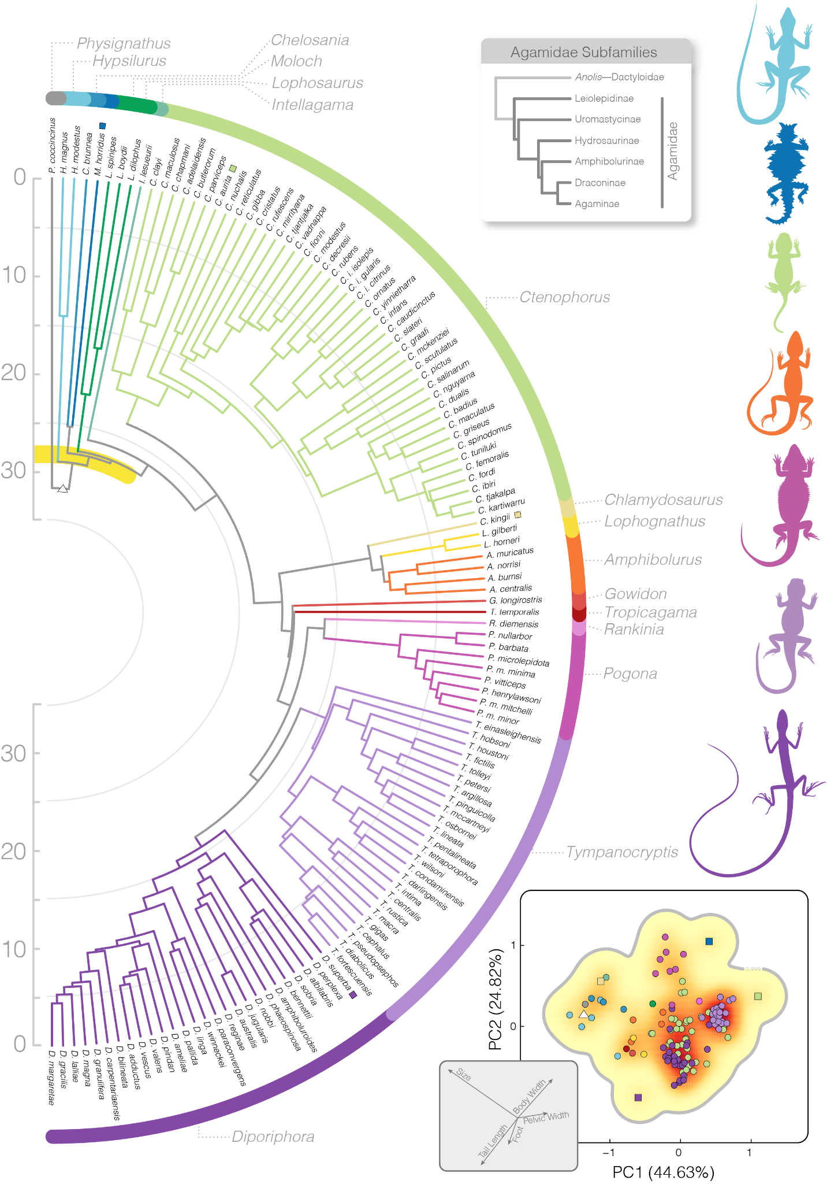

Figure 1. Species-level timetree of the Amphibolurinae, color-coded by genus. The ASTRAL species tree time-calibrated with MCMCTree shows a rapid Oligocene divergence of most major amphibolurine groups. A yellow band highlights the series of rapid splits early in the history of this group. Inset bottom right shows the spread of species in two-dimensional morphospace (also colored by genus) and primary axes of variation. *Diporiphora* (dark purple) and *Tympanocryptis* (light purple) highlight dense clusters of morphospace, contrasting with morphological outliers indicated by squares in the morphospace and on the tree (*D. superba*, *M. horridus*, *C. aurita*). The estimated root morphotype is indicated by a triangle. Inset top right shows relationships among agamid subfamilies and color-coded dragon drawings at right (not to scale) highlight some of the morphological diversity of this group. White circles on the tree denote local posterior probabilities <0.95.

# Discussion

The diversity of organismal forms in nature are not distributed evenly across the possible phenotypic space. Instead, observed phenotypes often cluster in discrete regions of morphospace, a result of genetic, functional, and/or developmental constraints (Deline et al. 2018). These clumps of morphologically similar organisms identify peaks in the adaptive landscape. Through time, the adaptive landscape may change as conditions vary and species go extinct, persist, and proliferate. The invasion of a new geographic region provides us the opportunity to observe how the adaptive landscape evolves, and to identify the tempo and mode with which new regions of the landscape become populated. Amphibolurinae dragon lizards are an ideal system to evaluate this. Our findings suggest that dispersal of dragon lizards into Australia facilitated a marked expansion in the morphological landscape. This exploration was driven first by a transition from an arboreal to a generalist ancestor and later into specialized ecomorphologies. Major morphological transitions were aided by focused evolution resulting in the rapid change of traits.

*Phylogenomics of the Amphibolurinae*

Dragon lizards (Agamidae) are a charismatic and diverse group of ~600 species found across Africa, Asia, and Oceania. They are diurnal and often brightly colored and territorial, making them visible and familiar. One subfamily, the Amphibolurinae, extends out of Asia into Australia and New Guinea. Here they reach their greatest ecomorphological extremes, ranging from burrowing species that live along the salt-crusted edges of desert lake-beds to semiaquatic species that patrol the eastern watercourses. While some species are familiar, such as the bearded dragons and frilled-neck lizards, to date, phylogenetic understanding of the group has been limited in genetic scope and focused within genera (Macey et al. 2000; Melville et al. 2001, Hugall et al. 2008; Shoo et al. 2008; Melville et al. 2018; Chaplin et al. 2020; Fenker et al. 2024). Our new sequence-capture dataset provides a well-supported estimate of the relationships among all 17 amphibolurine genera and more than 88% of described species.

Relationships among some (Streicher et al. 2016; Burbrink et al. 2020; Title et al. 2024) or all (Welt & Raxworthy 2022) agamid subfamilies have been estimated from different phylogenomic datasets, but have not previously been discussed. Our topology differs from that of Welt & Raxworthy (2022) in the placement of the Leiolepidinae and Uromastycinae at the base of the tree, and the stepwise (rather than sister) relationship between the Hydrosaurinae and Amphibolurinae. The topology we present has biogeographic implications, suggesting an Asian and not African origin for the group. This is further supported by fossil evidence of the Priscagamidae which were stem-acrodonts of east Asia, and the ~99 myo *Protodraco* from Myanmar (Wagner et al. 2021) which is potentially the oldest known acrodont. The debate over an Asian or African origin of agamids is mirrored in other Australian squamate groups such as pythons (Esquerre et al. 2020), monitor lizards (Brennan et al. 2021), and elapid snakes (Keogh 1998). One possible explanation for differences in the subfamily topology is the expanded molecular dataset presented here. Reanalyzing a UCE-only dataset however, returns a topology identical to our SqCL estimate, suggesting other factors (e.g. alignment parameters, substitution models) are likely causing the differences in topology.

While the Amphibolurinae as a group date back to the Cretaceous, their living diversity is less than half that age. The split between the sole Asian species *Physignathus* and the remaining Australo-Papuan diversity occurred around the Eocene/Oligocene transition, and was closely followed by rapid diversification over the next ten million years (Fig.1). This is consistent with paleontological evidence from Australia which suggests fossils assignable to *Intellagama* are relatively common in the early-to-middle Miocene deposits of the Riversleigh World Heritage Area (Covacevich et al. 1990). The rapid divergence of Australian species from their forest-dwelling relatives in New Guinea resulted in a series of very rapid branching events which can prove challenging for phylogenetic methods. These deep and rapid splits occur over just a few hundred thousand years and highlight a period of dramatic ecomorphological change. Following this period of radiation, the diversification of the group is far slower, more homogeneous, and dictated by three major groups: *Ctenophorus* (41 spp.), *Diporiphora* (28 spp.), and *Tympanocryptis* (26 spp.). This pattern of speciation slow-down is consistent with theory around adaptive radiations and dispersal into new regions (Harmon et al. 2010; Schluter 2000; Simpson 1944; Yoder et al. 2010).

*Mapping Morphology to Ecology*

The adaptive landscape of amphibolurine dragons is dispersed and patchy, with peaks that largely correspond to recognized genera. Connecting these peaks are generalist semiarboreal forms that appear to facilitate the transition into more extreme morphological space and new ecologies. Obvious phenotypic peaks relate to strongly arboreal (*Hypsilurus*, *Lophosaurus*) and terrestrial species (*Tympanocryptis*, *Ctenophorus*). However, intermediate forms that are adept at both running and climbing fill the morphological space and unite the more disparate peaks of the landscape (*Amphibolurus, Gowidon, Lophognathus, Tropicagama,* et al.). These generalist taxa are either lumped under a single broad adaptive peak (when k=5 optima; Fig.S9) or two peaks (when k=12 optima; Fig.S10). This is important because these intermediate morphologies appear common (~50% of species richness), are distributed across the entire continent in all habitat types, and provide a theoretical link between more extreme morphological forms. The idea of generalists as a bridge between morphotypes is not exclusively a reflection of how we generate morphospaces. In dragon lizards this process is informed by the branching pattern of the phylogeny. Specialist forms often descend from morphologically intermediate ancestors, and in some cases are nested deeply within generalist clades. For example the stout rock-dwelling *Diporiphora bennetti* and gracile hummock grass living *Diporiphora* *adductus* likely both evolved from a more typical amphibolurine morphology seen in their closest relatives.

Linking morphology to ecology however, is not always so clear. This may be the result of a many-to-one mapping where varied morphologies enable the same ecology (Wainwright et al. 2005; Moen 2019). For example, taxa such as *Lophosaurus*, *Chelosania*, and *Diporiphora superba* are all obligately arboreal and highly specialized dragons, however, these taxa map to either two or three discrete adaptive zones (Fig.2) and use arboreal spaces differently. *Diporiphora superba* is an extremely gracile species with a long tail, small head, and long slender limbs that it uses to move through shrubs. *Lophosaurus* species similarly have long tails and limbs, but have large heads and deep, laterally compressed bodies and generally perch vertically on tree trunks. *Chelosania* also show a narrowing of the body but have short sturdy limbs and a relatively short tail for a species that is almost never found outside of the canopy where they often use horizontal branches. In this situation, convergence on a specialized lifestyle is met with only incomplete morphological similarity. This may be due to a number of reasons including phylogenetic inertia resisting selection (Blomberg & Garland 2002). This idea is relevant when considering the ecology of the ancestral amphibolurine. Our analyses suggest this ancestor was likely morphologically similar to the arboreal *Lophosaurus* and *Hypsilurus*, but also to *Physignathus* and *Intellagama*—two species that are considered semiaquatic(Fig.SX12). These last two species are similar enough that they were considered congeneric for over 150 years and are often called “water dragons”. Despite their preferred habitat, they fit most morphological descriptors of a tree-living dragon. We flag this to note the imperfect mapping of morphology to ecology and uncertainty in estimating ancestral states.

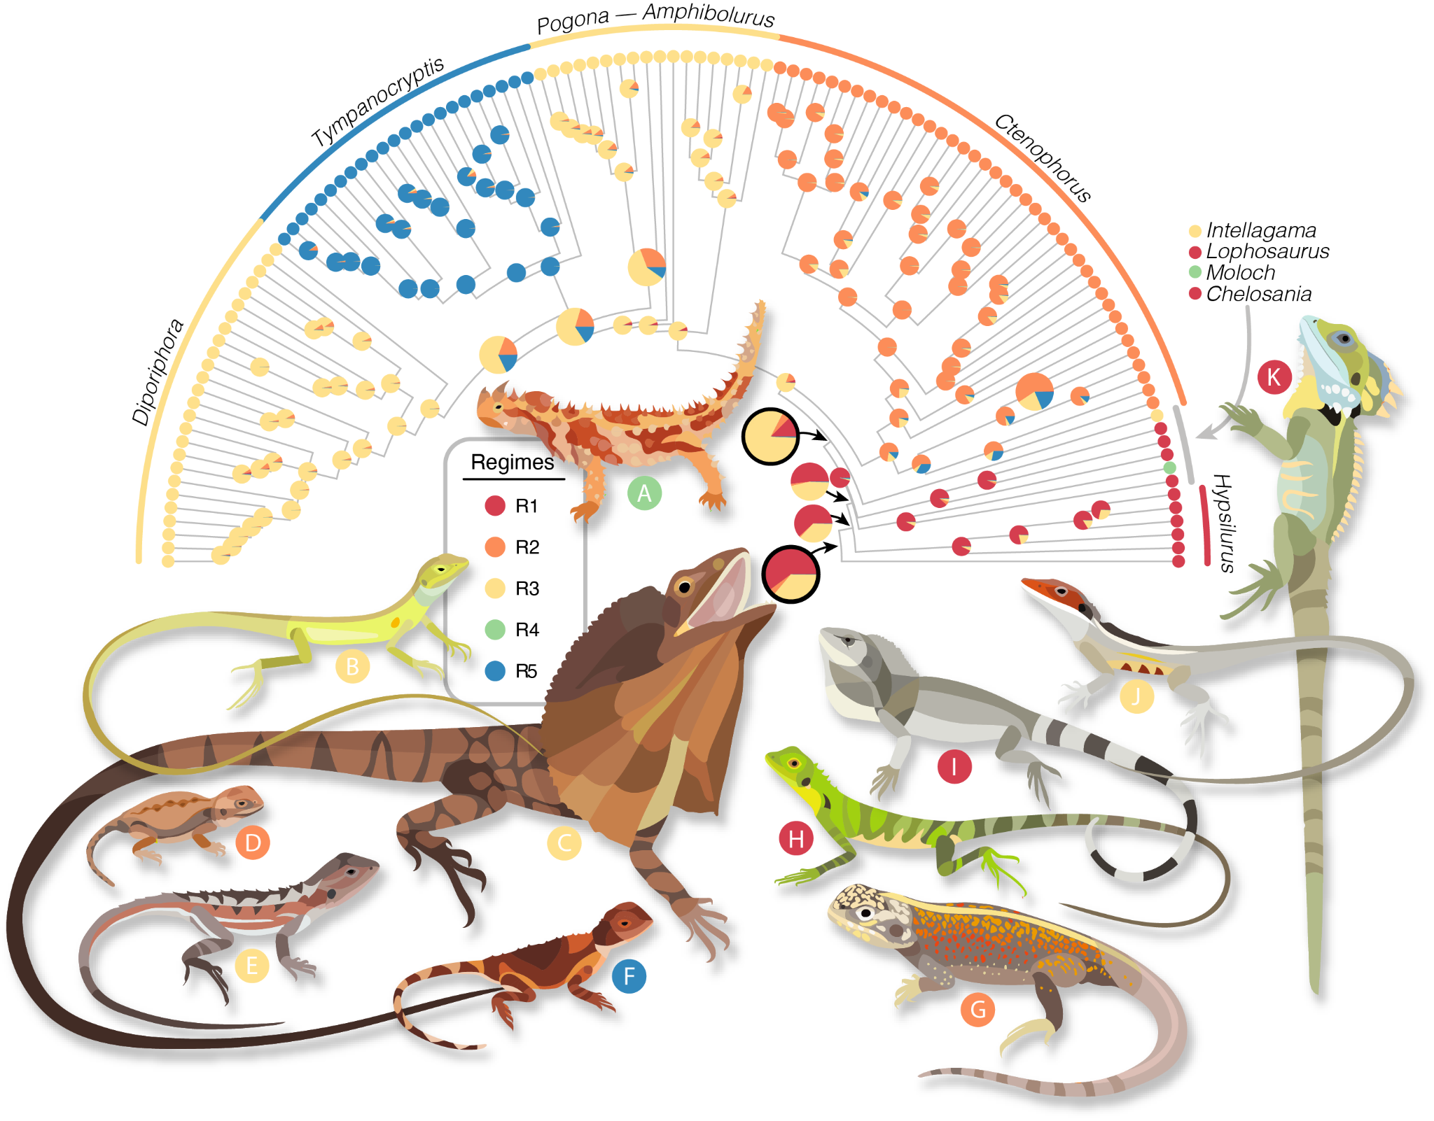

Figure 2. The adaptive morphological zones of amphibolurine dragons highlight a diversity of forms. Colored regimes were identified under a multi-optima OU model in *PhyloEM* and applied to ancestral taxa using *randomForests*. The tree shows the preferred 5 regime model estimated from all 19 size corrected morphological traits and likelihoods for ancestors as estimated by *randomForest*. Two regimes (blue, orange) map to obligately terrestrial groups. The red regime highlights primarily arboreal species and the morphologically similar *Physignathus*. Yellow indicates a diverse clade of primarily generalist species. The amphibolurine most recent common ancestor (MRCA) is estimated as a *Hypsilurus/Lophosaurus-*like arboreal dragon and the Australian MRCA is estimated as a semiarboreal generalist lizard (both indicated with black outlined pie). Illustrated species are (A) *Moloch horridus,* (B) *Diporiphora superba,* (C) *Chlamydosaurus kingii,* (D) *Ctenophorus aurita,* (E) *Rankinia diemensis,* (F) *Tympanocryptis pseudopsephos,* (G) *Ctenophorus reticulatus,* (H) *Hypsilurus modestus,* (I) *Chelosania brunnea,* (J) *Gowidon longirostris,* (K) *Lophosaurus boydii*.

*The Evolving Adaptive Landscape*

The transition from wet closed-canopy rainforests in Asia and New Guinea towards new and different environments in Australia presents a prime case for ecological opportunity (Collar et al. 2010; Gray et al. 2019a). Among the newly available habitats, dragons encountered sparse open forests, grasslands, sandy and stony deserts, and rocky escarpments, which are all but absent across Malesia. By expanding their geographical range, dragon lizards also extended the adaptive landscape to enable new forms that took advantage of these habitats (Yoder et al. 2010). This extension provided opportunity for new peaks located in distant regions of morphospace. To traverse that space however, required deterministic trends in trait evolution that suggest selection on individual or suites of traits (Figs.3,4). In dragon lizards, this may have first resulted in a transition from an arboreal form to a generalist form. Our analyses indicate that this occurred rapidly and dramatically, resulting in a multivariate shape change dozens of times greater than expected (Fig.3 highlight 5). The resulting form likely had shorter limbs and tail, a wider body, and shorter snout as it spent less time in the trees (Fig.4). From generalist forms amphibolurines were able to further explore morphological extremes. This includes repeated transitions towards small-bodied terrestrial forms (*Ctenophorus aurita*, *Rankinia*, *Tympanocryptis*), (Fig.4), and moves back towards elongate arboreal forms (*Diporiphora superba*, *Chlamydosaurus*). In this way, generalists negate the need to cross wide fitness valleys in the adaptive landscape. Instead, species can explore across ridges or broad fitness peaks to reach distant morphospaces. This provides more evidence that transitions across the landscape from specialist to specialist are uncommon and likely require an intermediate form.

In our investigation across the dragon lizard body plan, we identify varied modes of evolution among and within traits. In the simplest sense, the evolution of dragon morphology is dictated by both a gradual diffusion process away from stable peaks and infrequent shifts in the evolutionary rate or trait mean. Perhaps most exciting about these findings is how rare these shift events are. To explain the disparate morphological landscape of dragons less than 10% of branches need multivariate trait change that exceeds Brownian expectations. We can see this when looking across the morphospace, where discrete regions are heavily occupied (Fig.1). These high density areas indicate slow evolutionary rates or constrained evolution (i.e. Ornstein Uhlenbeck), as has been previously identified in *Diporiphora* (Smith et al. 2010). Stable peaks populated by many closely-related species highlight diffusion as the most frequent pathway for change among species. In comparison, rare evolutionary shifts are concentrated around changes among adaptive zones. These shifts are nested and temporally staggered resulting in a dynamic adaptive landscape that does not reflect the archetypical tempo or mode of an adaptive radiation. This complex mosaic of evolutionary modes helps to reconcile Simpson’s idea of quantum evolutionary change (few, extreme changes) with Darwin’s ideas of gradualism (frequent, small changes) (Simpson 1944; Charlesworth et al. 1982).

The morphological evolution of dragon lizards has been a heterogeneous process, varying temporally, phylogenetically, and across traits. Broadly, dragons have gone through periods of early and late expansion in the morphological hypervolume, bookending a period of little innovation during much of the Miocene (Fig.S8). Looking across all species, we identify that the primary axes for variation are through change in absolute size and tail length (Fig.S7). This is immediately apparent when comparing large tree dragons (*Hypsilurus magnus*: SVL >200 mm, tail length >600 mm) to pebble-mimicking dragons (*Ctenophorus aurita*: SVL <40 mm, tail length <35 mm; *Tympanocryptis cephalus* group: SVL <60 mm, tail length <90 mm). Elaboration in size and tail length beyond other traits is a pattern seen in other squamate clades (Brennan et al. 2024; Meiri 2010), but dramatic changes are not limited to these axes. Instead, amphibolurines show exceptional variation in many traits and greater than expected diversity relative to other iguanians (Gray et al. 2019a; Gray et al. 2019b). Most trait trends appear associated with habitat type (Thompson & Withers 2005; Collar et al. 2010), such as broader heads and wider bodies in terrestrial groups or longer limbs and snouts in arboreal species. But others are harder to quantify and likely associated with defense or communication, like the frill of *Chlamydosaurus* or fixed and erectable crests in many species. Harder yet to explain is the tremendous novelty of *Moloch*, a lizard commonly called the thorny devil for the keratinous spines that cover its body. Despite their familiarity, *Moloch* remain enigmatic in many ways. They likely pre-date the Australian deserts in which they wander (Pepper & Keogh, 2021). They exclusively eat ants. And they have undergone such a profound evolutionary modification that they are nearly unrecognizable as agamids. In expanding into this new adaptive zone, the thorny devilhas stretched the morphological space, representing just one of many exciting peaks in the landscape of dragon lizards.

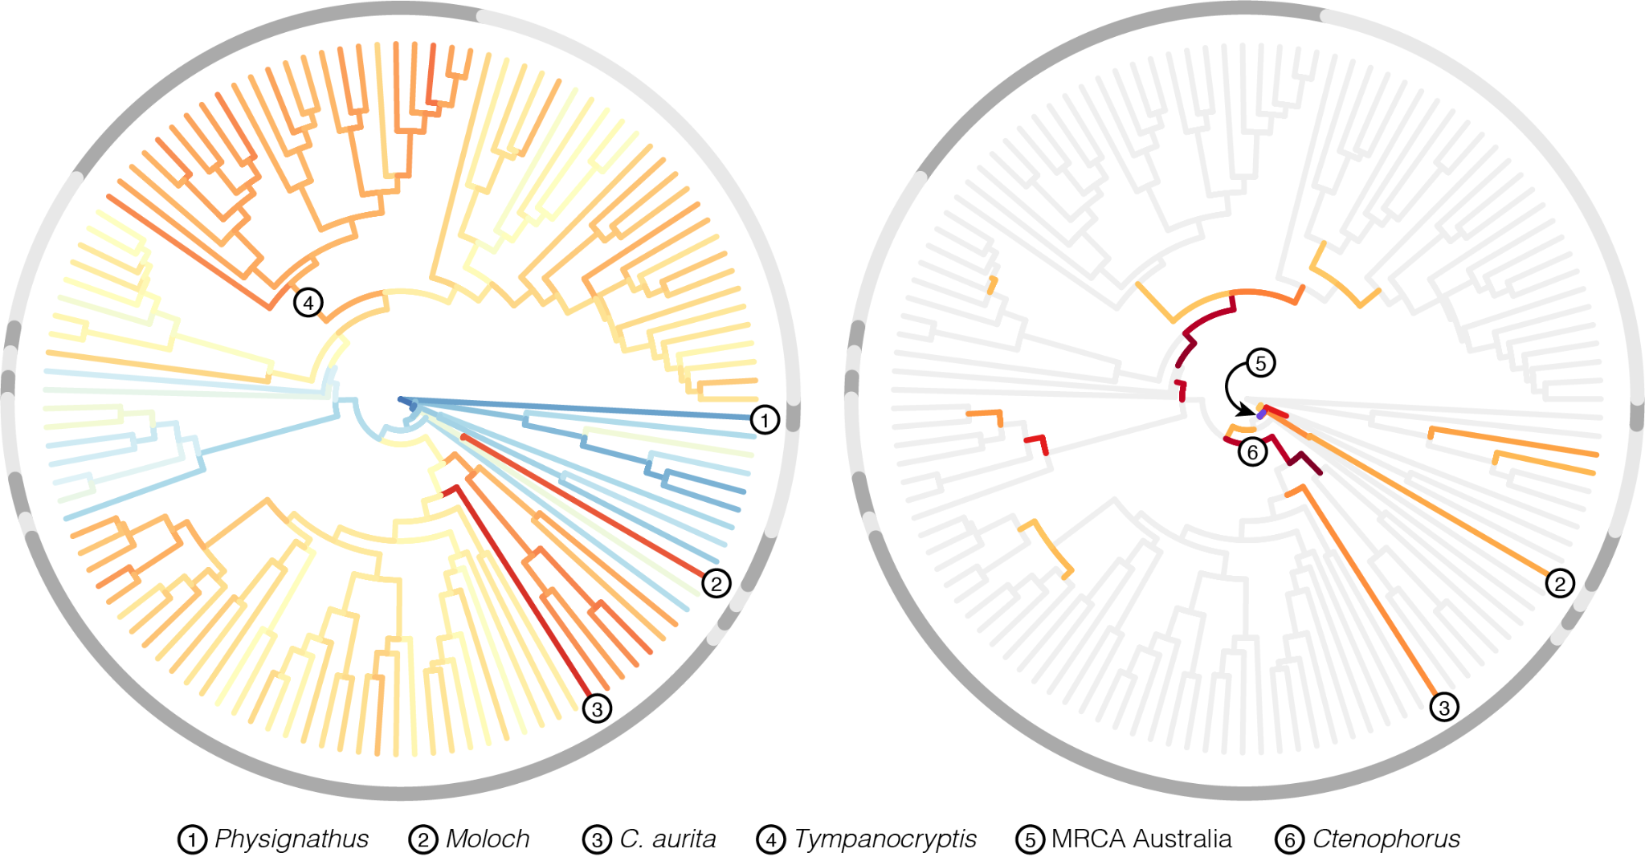

Figure 3. Major shifts in morphologies occur as directional evolutionary changes that are greater than expected. Left, morphological innovation across the dragon tree, with warm colors indicating greater multivariate Euclidean distance from the amphibolurine most recent common ancestor, and cooler colors indicating greater similarity. Grey shading in outer circles delineates genera. Right, the position and strength of directional changes that exceed multivariate shape change under the null evolutionary model. Circle number 5 indicates the branch leading to the Australian radiation of dragon lizards and denotes a 26-fold increase over the expected amount of morphological change. This very short branch accounts for a paradigm shift in the evolution of amphibolurine lizards away from an arboreal ancestor towards a more generalist morphology.

# Conclusion

The adaptive landscape is a popular metaphor for linking form to function and contextualizing organismal diversity. For a long time we have focused on studying the peaks, but it has been difficult to imagine how species have traversed the landscape to establish new adaptive zones. Our investigation into the evolution of the morphological landscape in amphibolurine dragon lizards emphasizes the importance of generalist forms in connecting discrete peaks. While the ancestral amphibolurine was likely an arboreal dragon, the diversity of Australian forms were only realized following strong directional changes to a labile generalist form. As others have noted (Collar et al. 2010; Gray et al. 2019a; Gray et al. 2019b), this was likely driven by ecological opportunity in the form of a range of new habitats after landing in Australia. As a result, Australian dragons represent one of the continent’s most impressive adaptive radiations. Importantly, this system shows how the adaptive landscape itself can change and grow, expanding its borders and altering its topography in response to new opportunities.

# Acknowledgements

This project represents an output of the Australian Amphibian and Reptile Genomics initiative (AusARG), generously funded by BioPlatforms Australia. We appreciate the provision of computing and data resources provided by the Australian BioCommons Leadership Share (ABLeS) program and Seqera Tower service. These programs are co-funded by Bioplatforms Australia (enabled by NCRIS), the National Computational Infrastructure and Pawsey Supercomputing Centre. Special thanks to Sophie Mazard and Ziad al Bkhetan. We thank our many Australian partner institutions (Australian Museum, Museum and Art Gallery of the Northern Territory, Queensland Museum, Museums Victoria, South Australian Museum, Western Australian Museum) and their associated curators and collections managers, who made this work possible through generous tissue loans and collections access. We declare no conflicts of interest.

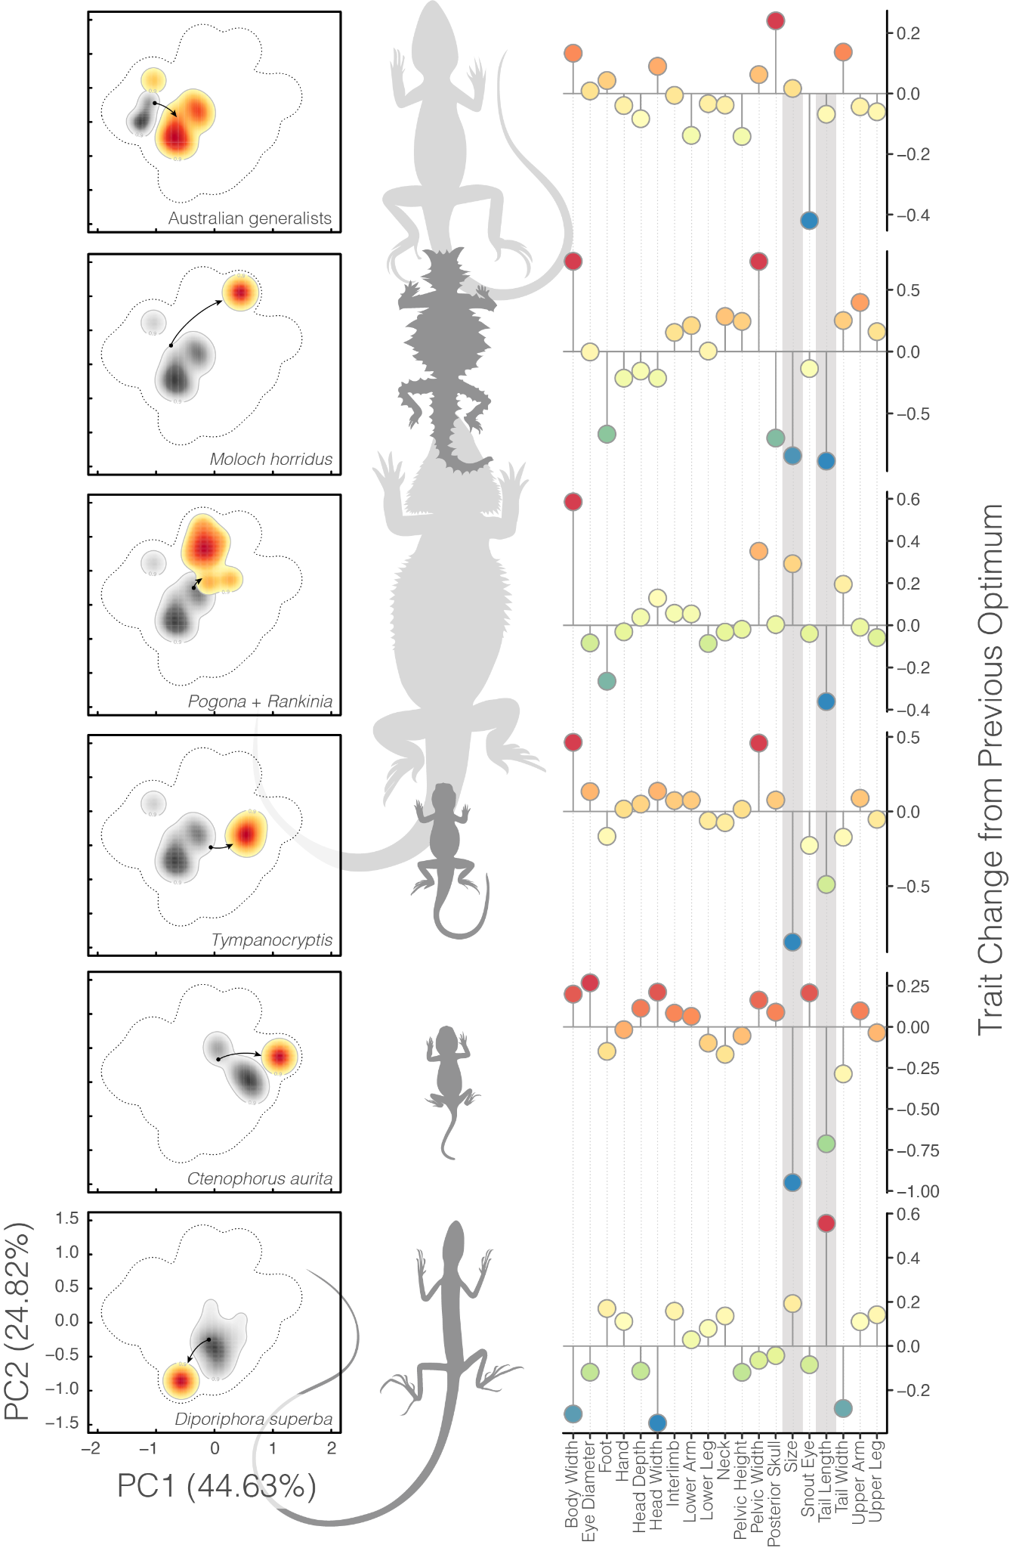

Figure 4. Movement among optima occurs via changes in different suites of traits. Plots in the left column visualize the shift from the immediately ancestral optimum (grey shading) to a new optimum (warm shading) represented in two dimensional space. Lizards at center illustrate the morphological extremes of new optima. Plots at right indicate how individual traits changed in evolving from the previous optima to current. Grey bars highlight the two most variable traits: size (a composite of the geometric mean of all trait measures) and tail length.

# References

Arnold, S. J., Pfrender, M. E., & Jones, A. G. (2001). The adaptive landscape as a conceptual bridge between micro-and macroevolution. *Genetica*, *112*, 9-32.

Bastide, P., Ané, C., Robin, S., & Mariadassou, M. (2018). Inference of adaptive shifts for multivariate correlated traits. *Systematic Biology*, *67*(4), 662-680.

Blomberg, S. P., & Garland Jr, T. (2002). Tempo and mode in evolution: phylogenetic inertia, adaptation and comparative methods. *Journal of Evolutionary Biology*, 15(6), 899-910.

Blonder, B. (2016). Do hypervolumes have holes?. *The American Naturalist*, *187*(4), E93-E105.

Blonder, B., Morrow, C. B., Maitner, B., Harris, D. J., Lamanna, C., Violle, C., Enquist, B. J., & Kerkhoff, A. J. (2018). New approaches for delineating n‐dimensional hypervolumes. *Methods in Ecology and Evolution*, 9(2), 305-319.

Bolger, A. M., Lohse, M., & Usadel, B. (2014). Trimmomatic: a flexible trimmer for Illumina sequence data. *Bioinformatics*, 30(15), 2114-2120.

Borowiec, M. L. (2016). AMAS: a fast tool for alignment manipulation and computing of summary statistics. *PeerJ*, 4, e1660.

Brennan, I. G., Lemmon, A. R., Lemmon, E. M., Portik, D. M., Weijola, V., Welton, L., ... & Keogh, J. S. (2021). Phylogenomics of monitor lizards and the role of competition in dictating body size disparity. *Systematic Biology*, *70*(1), 120-132.

Brennan, I. G., Singhal, S., & Al Bkhetan, Z. (2024). *pipesnake*: generalized software for the assembly and analysis of phylogenomic datasets from conserved genomic loci. *Bioinformatics*, *40*(5), btae195.

Brennan, I. G., Chapple, D. G., Keogh, J. S., & Donnellan, S. (2024). Evolutionary bursts drive morphological novelty in the world’s largest skinks. *Current Biology*, *34*(17), 3905-3916.

Bruton M., Melville J., Sumner J., Porter J., Mahony S. & Doughty P. (2025). The last piece of the puzzle: Detection of an extremely rare lizard in the Kimberley completes the phylogeny of Australian dragons (Agamidae). *Australian Journal of Taxonomy* 93: 1–15. doi: https://doi.org/10.54102/ajt.zoa0

Burbrink, F. T., Grazziotin, F. G., Pyron, R. A., Cundall, D., Donnellan, S., Irish, F., ... & Zaher, H. (2020). Interrogating genomic-scale data for Squamata (lizards, snakes, and amphisbaenians) shows no support for key traditional morphological relationships. *Systematic biology*, *69*(3), 502-520.

Burin, G., Park, T., James, T. D., Slater, G. J., & Cooper, N. (2023). The dynamic adaptive landscape of cetacean body size. *Current Biology*, *33*(9), 1787-1794.

Bushnell, B. (2014). BBMap: A Fast, Accurate, Splice-Aware Aligner. Berkeley, CA: Lawrence Berkeley National Lab.

Chaplin, K., Sumner, J., Hipsley, C. A., & Melville, J. (2020). An integrative approach using phylogenomics and high-resolution X-ray computed tomography for species delimitation in cryptic taxa. *Systematic Biology*, *69*(2), 294-307.

Charlesworth, B., Lande, R., & Slatkin, M. (1982). A neo-Darwinian commentary on macroevolution. *Evolution*, 36(3), 474-498.

Collar, D. C., Schulte, J. A., O’meara, B. C., & Losos, J. B. (2010). Habitat use affects morphological diversification in dragon lizards. *Journal of Evolutionary Biology*, *23*(5), 1033-1049.

Covacevich, J., Couper, P., Molnar, R. E., Witten, G., & Young, W. (1990). Miocene dragons from Riversleigh: new data on the history of the family Agamidae (Reptilia: Squamata) in Australia. *Memoirs of the Queensland Museum*, 29(2), 339-360.

Deline, B., Greenwood, J. M., Clark, J. W., Puttick, M. N., Peterson, K. J., & Donoghue, P. C. (2018). Evolution of metazoan morphological disparity. *Proceedings of the National Academy of Sciences*, *115*(38), E8909-E8918.

dos Reis, M. and Yang, Z. (2011). Approximate likelihood calculation for Bayesian estimation of divergence times. *Molecular Biology and Evolution*, 28:2161-2172.

Esquerré, D., Donnellan, S., Brennan, I. G., Lemmon, A. R., Moriarty Lemmon, E., Zaher, H., ... & Keogh, J. S. (2020). Phylogenomics, biogeography, and morphometrics reveal rapid phenotypic evolution in pythons after crossing Wallace’s line. *Systematic Biology*, *69*(6), 1039-1051.

Fenker, J., Melville, J., & Moritz, C. (2024). Dragons in the tropics–Phylogeography and speciation in Diporiphora lizards and common geographic breaks in co-distributed taxa. *Molecular Phylogenetics and Evolution*, *197*, 108090.

Gray, J. A., Sherratt, E., Hutchinson, M. N., & Jones, M. E. (2019a). Evolution of cranial shape in a continental-scale evolutionary radiation of Australian lizards. *Evolution*, *73*(11), 2216-2229.

Gray, J. A., Hutchinson, M. N., & Jones, M. E. (2019b). Exceptional disparity in Australian agamid lizards is a possible result of arrival into vacant niche. *The Anatomical Record*, *302*(9), 1536-1543.

Harmon, L. J., Kolbe, J. J., Cheverud, J. M., & Losos, J. B. (2005). Convergence and the multidimensional niche. *Evolution*, 59(2), 409-421.

Harmon, L. J., Losos, J. B., Jonathan Davies, T., Gillespie, R. G., Gittleman, J. L., Bryan Jennings, W., Kozak, K.H., McPeek, M.A., Moreno-Roark, F., Near, T.J., Purvis, A., Ricklefs, R.E., Schluter, D., Schulte III, J.A., Seehausen, O., Sidlauskas, B.L., Torres-Carvajal, O., Weir, J.T., & Mooers, A. Ø. (2010). Early bursts of body size and shape evolution are rare in comparative data. *Evolution*, *64*(8), 2385-2396.

Hugall, A. F., Foster, R., Hutchinson, M., & Lee, M. S. (2008). Phylogeny of Australasian agamid lizards based on nuclear and mitochondrial genes: implications for morphological evolution and biogeography. *Biological Journal of the Linnean Society*, *93*(2), 343-358.

Hutchinson, G.E. (1957). Concluding Remarks. Cold Spring Harbor Symposia on Quantitative Biology, 22, 415-427.

Kalyaanamoorthy, S., Minh, B. Q., Wong, T. K., Von Haeseler, A., & Jermiin, L. S. (2017). ModelFinder: fast model selection for accurate phylogenetic estimates. *Nature methods*, *14*(6), 587-589.

Katoh, K., & Standley, D. M. (2013). MAFFT multiple sequence alignment software version 7: improvements in performance and usability. *Molecular Biology and Evolution*, *30*(4), 772-780.

Keogh, J. S. (1998). Molecular phylogeny of elapid snakes and a consideration of their biogeographic history. *Biological Journal of the Linnean Society*, 63(2), 177-203.

Kent, W. J. (2002). BLAT—the BLAST-like alignment tool. *Genome Research*, *12*(4), 656-664.

Liaw, A., & Wiener, M. (2002). Classification and regression by randomForest. *R news*, *2*(3), 18-22.

Marshall, C. R. (2014). The evolution of morphogenetic fitness landscapes: conceptualising the interplay between the developmental and ecological drivers of morphological innovation. *Australian Journal of Zoology*, *62*(1), 3-17.

Macey, J. Robert, James A. Schulte, Allan Larson, Natalia B. Ananjeva, Yuezhao Wang, Rohan Pethiyagoda, Nasrullah Rastegar-Pouyani, and Theodore J. Papenfuss. Evaluating trans-Tethys migration: an example using acrodont lizard phylogenetics. *Systematic Biology* 49, no. 2 (2000): 233-256.

Meiri, S. (2010). Length–weight allometries in lizards. *Journal of Zoology*, 281(3), 218-226.

Melville, J., Schulte, J. A., & Larson, A. (2001). A molecular phylogenetic study of ecological diversification in the Australian lizard genus Ctenophorus. *Journal of Experimental Zoology*, *291*(4), 339-353.

Melville, J., Ritchie, E. G., Chapple, S. N., Glor, R. E., & Schulte II, J. A. (2018). Diversity in Australia's tropical savannas: An integrative taxonomic revision of agamid lizards from the genera *Amphibolurus* and *Lophognathus* (Lacertilia: Agamidae). *Memoirs of Museum Victoria*, *77*, 41-61.

Melville, J., Date, K. S., Horner, P., & Doughty, P. (2019). Taxonomic revision of dragon lizards in the genus *Diporiphora* (Reptilia: Agamidae) from the Australian monsoonal tropics. *Memoirs of Museum Victoria*, *78*, 23-55.

Melville, J., & Wilson, S. K. (2019). Dragon Lizards of Australia: Evolution, ecology and a comprehensive field guide. Museums Victoria Publishing.

Minh, B. Q., Nguyen, M. A. T., & von Haeseler, A. (2013). Ultrafast approximation for phylogenetic bootstrap. *Molecular Biology and Evolution*, *30*(5), 1188-1195.

Minh, B. Q., Schmidt, H. A., Chernomor, O., Schrempf, D., Woodhams, M. D., Von Haeseler, A., & Lanfear, R. (2020). IQ-TREE 2: new models and efficient methods for phylogenetic inference in the genomic era. *Molecular Biology and Evolution*, *37*(5), 1530-1534.

Moen, D. S. (2019). What determines the distinct morphology of species with a particular ecology? The roles of many-to-one mapping and trade-offs in the evolution of frog ecomorphology and performance. *The American Naturalist*, 194(4), E81-E95.

Pagel, M., O’Donovan, C., & Meade, A. (2022). General statistical model shows that macroevolutionary patterns and processes are consistent with Darwinian gradualism. *Nature communications*, *13*(1), 1113.

Pavanetto N, Puglielli G (2024). *funspace*: Creating and Representing Functional Trait Spaces. R package version 0.2.2, https://CRAN.R-project.org/package=funspace.

Pepper, M., & Keogh, J. S. (2021). Life in the “dead heart” of Australia: The geohistory of the Australian deserts and its impact on genetic diversity of arid zone lizards. *Journal of Biogeography*, 48(4), 716-746.

Pennell, M. W., Eastman, J. M., Slater, G. J., Brown, J. W., Uyeda, J. C., FitzJohn, R. G., ... & Harmon, L. J. (2014). geiger v2. 0: an expanded suite of methods for fitting macroevolutionary models to phylogenetic trees. *Bioinformatics*, 30(15), 2216-2218.

Prjibelski, A., Antipov, D., Meleshko, D., Lapidus, A., & Korobeynikov, A. (2020). Using SPAdes de novo assembler. *Current protocols in bioinformatics*, *70*(1), e102.

R Core Team. (2024). R: A language and environment for statistical computing. R Foundation for Statistical Computing, Vienna, Austria. www.R-project.org

Rannala, B., Yang, Z. (2007) Inferring speciation times under an episodic molecular clock. *Systematic Biology*, 56:453-466.

Revell, L. J. (2024). phytools 2.0: an updated R ecosystem for phylogenetic comparative methods (and other things). *PeerJ*, 12, e16505.

Schluter, D. (2000). The ecology of adaptive radiation. OUP Oxford.

Shoo, L. P., Rose, R., Doughty, P., Austin, J. J., & Melville, J. (2008). Diversification patterns of pebble-mimic dragons are consistent with historical disruption of important habitat corridors in arid Australia. *Molecular Phylogenetics and Evolution*, *48*(2), 528-542.

Simpson, G. G. (1944). Tempo and mode in evolution. Columbia University Press.

Singhal, S., Grundler, M., Colli, G., & Rabosky, D. L. (2017). Squamate conserved loci (Sq CL): a unified set of conserved loci for phylogenomics and population genetics of squamate reptiles. *Molecular ecology resources*, *17*(6), e12-e24.

Smith, K. L., Harmon, L. J., Shoo, L. P., & Melville, J. (2011). Evidence of constrained phenotypic evolution in a cryptic species complex of agamid lizards. *Evolution*, *65*(4), 976-992.

Streicher, J. W., Schulte, J. A., & Wiens, J. J. (2016). How should genes and taxa be sampled for phylogenomic analyses with missing data? An empirical study in iguanian lizards. *Systematic biology*, *65*(1), 128-145.

Talavera, G., & Castresana, J. (2007). Improvement of phylogenies after removing divergent and ambiguously aligned blocks from protein sequence alignments. *Systematic biology*, *56*(4), 564-577.

Thompson, G., & Withers, P. (2005). Shape of western Australian dragon lizards (Agamidae). *Amphibia-Reptilia*, *26*(1), 73-85.

Tiatragul, S., Brennan, I. G., Broady, E. S., & Keogh, J. S. (2023). Australia’s hidden radiation: Phylogenomics analysis reveals rapid Miocene radiation of blindsnakes. *Molecular Phylogenetics and Evolution*, *185*, 107812.

Title, P. O., Singhal, S., Grundler, M. C., Costa, G. C., Pyron, R. A., Colston, T. J., ... & Rabosky, D. L. (2024). The macroevolutionary singularity of snakes. *Science*, *383*(6685), 918-92.

Wagner, P., Stanley, E. L., Daza, J. D., & Bauer, A. M. (2021). A new agamid lizard in mid-Cretaceous amber from northern Myanmar. *Cretaceous Research*, 124, 104813.

Welt, R. S., & Raxworthy, C. J. (2022). Dispersal, not vicariance, explains the biogeographic origin of iguanas on Madagascar. *Molecular Phylogenetics and Evolution*, *167*, 107345.

Wainwright, P. C., Alfaro, M. E., Bolnick, D. I., & Hulsey, C. D. (2005). Many-to-one mapping of form to function: a general principle in organismal design?. *Integrative and Comparative Biology*, 45(2), 256-262.

Wright, S. (1932). The roles of mutation, inbreeding, crossbreeding and selection in evolution. In: Proceedings of the sixth international congress of genetics, pp 356–366.

Yoder, J. B., Clancey, E., Des Roches, S., Eastman, J. M., Gentry, L., Godsoe, W., ... & Harmon, L. J. (2010). Ecological opportunity and the origin of adaptive radiations. *Journal of Evolutionary Biology*, 23(8), 1581-1596.

Zhang, J., Kobert, K., Flouri, T., & Stamatakis, A. (2014). PEAR: a fast and accurate Illumina Paired-End reAd mergeR. *Bioinformatics*, *30*(5), 614-620.

Zhang, C., & Mirarab, S. (2022). Weighting by gene tree uncertainty improves accuracy of quartet-based species trees. *Molecular Biology and Evolution*, *39*(12), msac215.

# Supplement

### Molecular Data

We used the *pipesnake* v1.2 workflow (Brennan et al. 2024) <https://github.com/AusARG/pipesnake> to handle, process, assemble, and align our molecular data, estimate gene trees and a species tree. All software employed for individual tasks are indicated in the Supplementary file *software_versions.yml*. Assembled target sequences organized by sample (pseudo-reference genomes; PRGs) are available from XXX. Raw sequence data for newly sampled taxa are available from <https://data.bioplatforms.com/dataset/?ext_search_by=&q=agamidae&organization=ausarg&sequence_data_type=Illumina+Capture&sort=score+desc%2C+metadata_modified+desc&ext_bbox=> .

### Optima Model Fitting

To explore the reliability of our results concerning the number and species assignment of optima we fit a number of alternative schemes. In addition to the base scheme of PCs 1-6 (>90% variance) and K=0-15, we also fit PCs 1-9 (>95% variance) and all 19 raw trait axes. To assess a more conservative view we also reduced the number of possible shifts, therefore limiting the number of optima to 5 (K=0-4). The results are highly consistent regardless of input data type (PCs vs. raw traits) or trait number (6, 9, 19), in identifying a core set of 4 shifts that are recovered in every scenario. Those correspond to (1) a baseline shift at the base of the Australian radiation of Amphibolurinae, and three shifts that correspond to primarily terrestrial taxa in (2) the edge leading to *Moloch*, (3) *Ctenophorus* + *Cryptagama*, and (4) *Tympanocryptis*. Additional shifts identified by favored (PCs 1-6) and less conservative (K>4) analyses identify optima that largely correspond to genera, including (5) *Lophosaurus*, (6) *Pogona* + *Rankinia*, (7) *Diporiphora*, and (8) the large-bodied clade of *Ctenophorus*. The remaining shifts identify outlying individual species that show unique morphologies, (9) *Diporiphora superba*, (10) *Chlamydosaurus kingii*, and (11) *Ctenophorus aurita*. The final regime belongs to the taxa at the base of the tree comprising *Intellagama* and *Hypsilurus*.

Identify breakpoints in increasing hypervolume volume through fitting cubic splines and then comparing the difference in AIC values with increasing number of knots. Biggest jump is going from 2 to 3 knots, which maps to breakpoints at 20 and 10 million years.

### Unsampled Amphibolurinae Taxa

*Diporiphora convergens*\* STORR, 1974

*Hypsilurus binotatus* (MEYER, 1874)

*Hypsilurus bruijnii* (PETERS & DORIA, 1878)

*Hypsilurus capreolatus* KRAUS & MYERS, 2012

*Hypsilurus geelvinkianus* (PETERS & DORIA, 1878)

*Hypsilurus godeffroyi* (PETERS, 1867)

*Hypsilurus hikidanus* MANTHEY & DENZER, 2006

*Hypsilurus longi* (MACLEAY, 1877)

*Hypsilurus macrolepis* PETERS, 1872

*Hypsilurus modestus* (MEYER, 1874)

*Hypsilurus nigrigularis* (MEYER, 1874)

*Hypsilurus ornatus* MANTHEY & DENZER, 2006

*Hypsilurus papuensis* (MACLEAY, 1877)

*Hypsilurus schultzewestrumi* (URBAN, 1999)

*Hypsilurus tenuicephalus* MANTHEY & DENZER, 2006

*Tympanocryptis uniformis*\* MITCHELL, 1948

*These species were described from a single specimen and have not been confirmed via genetic data (Melville & Wilson, 2019)

### Node Priors and Agamids in the Fossil Record

Acrodontan lizards are known from the fossil record of Europe, Australia, and across Asia, with arguably the oldest described lineage originating in Myanmar (Wagner et al. 2021). Unfortunately, the oldest fossil taxa (*Protodraco, Gueragama*) are of uncertain phylogenetic placement and remaining fossils (*Uromastyx europaeus*, *Barbaturex, Tinosaurus*) are considerably younger than recent estimates of subfamily splits in agamids (Title et al. 2024; Burbrink et al. 2020). Agamid fossils are known from Australia (Covacevich 1990; Ramm 2025), however most are comparatively young and unlikely to be of value as calibrations. The exceptions are mid-Miocene agamid fossils from Riversleigh World Heritage Area assigned to *Sulcatidens* and ‘*Physignathus*’. The latter were ascribed to *Physignathus* when this genus applied to both *P. cocincinus* and *I. lesueurii*, and leaves the current placement of these fossils uncertain. They are clearly Australian in origin, and while similar to *Intellagama*, they also share affinities with *Physignathus*, *Hypsilurus*, and *Chelosania* (M. Hutchinson, pers. comm.). These fossils were found across a number of Riversleigh sites, all of which have been dated to 16-18 myo by Woodhead et al. (2016): Camel Sputum (17.8), Wayne’s Wok (17.8), Inabayance (17.8), Upper (17.8), and RSO (16.6). To use this fossil we applied it as a minimum on the crown of Australian Amphibolurinae, with a soft upper bound of 50 mya informed by estimates of the Amphibolurinae—Draconinae/Agaminae split as estimated by Burbrink et al. (2020) and Title et al. (2024). We applied a secondary calibration on the divergence between Amphibolurinae and Agaminae (*Phrynocephalus*) as a uniform prior with soft bounds (50-80 mya) following Burbrink et al. 2020 and Title et al. 2024, and another uniform prior with soft bounds (238-255 mya) on the crown of Lepidosauria representing the fossil *Sophineta*, arguably the oldest stem squamate. To assess the appropriateness of this calibration strategy we downsampled our species tree to a single representative of each genus and ran preliminary analyses in MCMCTree.

### Calculating Morphological Distances

To estimate multivariate morphological distances we calculated euclidean distance between pairs of taxa. For Figure 4 this required identifying transitions among optima and measuring distances between ancestral taxa or between an ancestor and extant taxon (see function *node.to.node* in script *XX_funspace.R*).

### Supplementary Figures

Fig.S1 MCMCTree_PriorPosterior_NodeLabels. Plots of applied priors (blue), effective priors (pink), and posteriors (green) for each node in the tree indicate reasonable behavior. Node numbers correspond to the phylogeny plotted below, plotted with ape, where n129 is the root node. The effective prior (pink) shows how the interaction of multiple priors can shape the expected ages for a given node. This can be seen when comparing input (blue) and effective

(pink) priors on any calibrated node (e.g. n129, n130, n134).

Fig.S2 Animal_Measurements. Schematic of morphological measurements taken and outlined in Table S3.

Fig.S3 Amphibolurinae_CorrPlot. Plot of size-corrected trait correlations with traits grouped by the morphological module they correspond to (either head, body, limb, or tail). Blues indicate positive correlations, red indicate negative correlations, with saturation indicating increasing intensity.

Fig.S4 Amphibolurinae_Sampling. Locus type and number summarized by sample for newly sequenced samples. Dotted line indicates 50% of targeted sequences recovered. Samples in grey text at left were not included in final analyses.

Fig.S5 Amphibolurinae_AllLoci_hASTRAL_ASTRAL4. Species tree including all samples sequenced and agamid outgroups. Local posterior probabilities are 1 for all nodes except those indicated by an orange circle.

Fig.S6 Amphibolurinae_Genera_gCF. Phylogeny of the Amphibolurinae showing intergeneric relationships and support across individual loci. Gene concordance factors (gCF) show the proportion of gene trees which support a given bifurcation. Pie charts on branches indicate the percent of loci which support the presented bifurcation (gCF1, orange), one of each of the two other most common resolutions (gCF2, blue; gCF3, pink) or all other possibilities (gCFp, grey). Areas of low concordance (e.g. placement of *Lophosaurus*) indicate topological uncertainty, likely as a result of high levels of incomplete lineage sorting.

Fig.S7 Trait_Variance. Individual traits show different levels of variance among amphibolurine species, with the greatest variances occurring in size (geometric mean) and tail length. Some traits, such as hand length and upper arm length show vanishingly small variation once corrected for absolute size. (Right) Traits with higher variances are more likely to fit the *fabric* model, which better partitions large changes in trait values.

Fig.S8 VTT_LTT. The Amphibolurinae hypervolume expands early and late in their evolution, with a period of niche packing in the Miocene. Diversification and morphological expansion are coupled in the early radiation of dragon lizards, but are largely decoupled from the Miocene onwards.

Fig.S9 RF_PhyloEM_Optima5. Adaptive peaks corresponding to morphological regimes identified under a multi-optima OU model in *PhyloEM* and applied to ancestral taxa using *randomForests*. (Bottom) Tree shows the preferred 5 regime model estimated from all 19 size corrected morphological traits, with regime shifts denoted by small white circles. (Top) Tree shows the preferred 5 regimes including likelihoods for ancestors as estimated by *randomForest*. The amphibolurine MRCA is estimated as a *Hypsilurus/Lophosaurus-*like arboreal dragon and the Australian MRCA is estimated as a semiarboreal generalist lizard (both indicated with black outline to pie).

Fig.S10 RF_PhyloEM_Optima12. Adaptive peaks corresponding to morphological regimes identified under a multi-optima OU model in *PhyloEM* and applied to ancestral taxa using *randomForests*. (Bottom) Tree shows the preferred 12 regime model estimated from the first 6 PC axes of the morphological data, with regime shifts denoted by small white circles. (Top) Tree shows the preferred 12 regimes including likelihoods for ancestors as estimated by *randomForest*. The amphibolurine MRCA is estimated as a *Hypsilurus-*like arboreal dragon and the Australian MRCA is estimated as a semiarboreal lizard (both indicated with black outline to pie).

Fig.S11 HeatMap_Euclidean_TreeOrder. Heatmap of multivariate morphological euclidean distance among all pairs of amphibolurines. This presentation highlights the conservative evolution of *Tympanocryptis* along with the relative dissimilarity of novel species like *Chlamydosaurus* (more similar to *Lophosaurus/Hypsilurus*), *Ctenophorus aurita* (more similar to *Tympanocryptis*), and *Moloch*. Black boxes along the diagonal delineate genera or clades of morphologically similar taxa.

Fig.S12 Distance2RegimeCentroid. Multivariate Euclidean distance estimated between each extant species and estimated optima, as well as to the amphibolurine MRCA. Tree at bottom is colored according to the k = 5 model of morphological optima. Lollipop plots above show morphological distance between each extant species and the amphibolurine MRCA (black), primarily arboreal regime 1 (red), regime 2 (blue; *Tympanocryptis*), the primarily generalist regime 3 (yellow), regime 4 (green; *Moloch*), and regime 5 (orange; *Ctenophorus*). Based on this metric and our measured traits, the amphibolurine MRCA was most morphologically similar to *Intellagama, Physignathus,* and *Chlamydosaurus*. Terrestrial forms like *Ctenophorus aurita,* the *Ctenophorus adelaidensis* group, and *Tympanocryptis* are likely highly derived and morphologically distinct from the MRCA.

# Cover Letter

[on ANU letterhead]

XX August 2025

Dear Editors of Ecology Letters,

We would like to submit the attached manuscript, *Generalists link peaks in the shifting adaptive landscape of Australia’s dragon lizards* for consideration as a Letter in *Ecology Letters*.

Our paper addresses a fundamental question in biology: how do new ecologies and morphologies develop? We have long used the adaptive landscape as a way to identify and cluster species into adaptive zones following the ideas of G.G. Simpson. However, it has remained difficult to explain how new regions of the adaptive landscape become populated. Using a novel high-dimensional morphological dataset paired with genome-scale genetic data we find evidence for the pivotal role generalist species play in connecting disparate adaptive peaks. Our investigation of the lizard body plan suggests that transitions among specialist morphologies (e.g. arboreality, burrowing) are facilitated by generalist ancestors acting as intermediaries. This generalist-to-specialist transition provides a key pathway for explaining how ecological opportunity can result in adaptive radiation. We believe our framework and findings will be of broad interest to the biological community as it highlights the interplay between ecology and adaptive landscape dynamics.

On behalf of myself and coauthors, we thank you for your time and consideration,

Dr. Ian G. Brennan

Research School of Biology

The Australian National University

ian.brennan@anu.edu.au