3 January 2023

Dear Editors of Systematic Biology,

We would like to submit the attached manuscript *Populating a Continent: Phylogenomics Reveal the Timing of Australian Frog Diversification* for consideration as a Spotlight article in Systematic Biology. We believe this paper addresses a number of longstanding questions at the intersection of evolution, Australian biodiversity, and amphibian phylogenetics, and will be of interest to both biologists and a broader audience. Our work provides insight into the population of a continent and the timing of diversification of replicate frog radiations. Given that this work is entirely empirical and focuses heavily on the study system, we believe it would be a good fit for SysBio’s Spotlight format.

*Scientific Summary*

The Australian continent is home to more than 250 species of frogs, but the relative timing of their diversification is poorly understood. We use an exon capture dataset to present a phylogenomic hypothesis for the three main Australian frog radiations: Myobatrachoidea, Pelodryadidae, and Microhylidae, to identify when these groups colonized Australia and began diversifying. Our time-calibrated phylogeny suggests a staggered population of the continent with the oldest group likely Gondwanan in origin, and the youngest likely late Miocene immigrants from New Guinea. Ultimately this phylogenetic framework provides a basis for further questions about the ecomorphological diversification of replicated continental vertebrate radiations.

*Public Summary*

Australia is generally considered hot, dry, and flat, making it an inhospitable place for frogs. Despite this more than 250 species call the continent home, ranging from enormous green tree frogs, to tiny brown burrowing frogs. But where did Australia’s frogs come from and when did they get here? Our study provides insight into the origins of Australia’s frogs, giving age estimates to the three major frog groups found on the continent and establishing their closest relatives. We find that the oldest groups likely originate from Gondwana before the separation of the Australian continent. In comparison, the youngest group likely immigrated to Australia from New Guinea more than 10 million years ago. This research helps us to better understand and appreciate Australia’s unique biodiversity, of which most species are found nowhere else on Earth.

This manuscript represents original research not submitted elsewhere.

On behalf of myself and coauthors we thank you for your time and consideration.

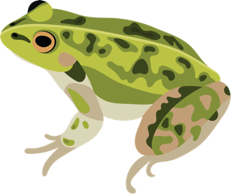

Ian G. Brennan

Division of Ecology & Evolution

Research School of Biology

The Australian National University

Canberra ACT 02600 Australia