Supplementary Materials and Methods for:

Populating a Continent:  
Phylogenomics Reveal the Timing of Australian Frog Diversification

Ian G. Brennan1,2,*, Alan R. Lemmon3, Emily Moriarty Lemmon3, Conrad J. Hoskin4,  
Stephen C. Donnellan5,6 and J. Scott Keogh1

1Division of Ecology & Evolution, The Australian National University, Canberra, ACT 2601, Australia

2Natural History Museum, Cromwell Road, London SW7 5BD, UK

3Department of Biological Science, Florida State University, Tallahassee FL 32306, USA

4College of Science and Engineering, James Cook University, Townsville, QLD 4811, Australia

5School of Biological Sciences, The University of Adelaide, Adelaide, SA 5005, Australia

6South Australian Museum, North Terrace, Adelaide, SA 5000, Australia

*Corresponding author: iangbrennan@gmail.com

Data are available from the Dryad Digital Repository:   
<http://dx.doi.org/10.5061/dryad.zpc866tcj>

and from the GitHub repository:

<https://github.com/IanGBrennan/Crown_Frogs>

*Developing Figure 1*

Figure 1 aims to provide background on the richness and spatial distribution of the focal frog clades, alongside evolutionary context for the accumulation of vertebrate biodiversity on the Australian continent. Neither the top or bottom visualizations are intended to provide an explanation of the *processes* dictating Australian vertebrate diversity. Instead they are visualizations of the *patterns* of contemporary Australian vertebrate diversity.

We downloaded Australian annual rainfall data from NASA using the R package *nasapower*, and combined this with species occurrence records downloaded from the Atlas of Living Australia. Annual rainfall is an easily interpretable measure of water availability in an environment, and as such provides a reflection of habitat suitability for frogs. However, we acknowledge that composite environmental variables such as actual evapotranspiration (AET) may be a better predictor of contemporary frog richness patterns (Powney et al., 2010; Coops et al., 2018).

To plot the relationship between clade age and richness of Australian terrestrial vertebrates we collected data from all available non-nested (each clade is only represented once) clades from the literature. Data are compiled in the supplement *Comparative_Radiations.csv* and can be plotted using the script *Comparative_Radiations.R*. We also incorporated information where available about the biogeographic origin of each group to visualize the contrast between young clades from Asia and old Gondwanan groups. The included regression helps to visualize an interesting *pattern* in the data: species richness increases with clade age. However, we do not present this as an evolutionary explanation for varied richness among Australian terrestrial vertebrate groups.

*Sequence Identity*

To confirm sequence identity we downloaded a fasta file of *Xenopus* genes from Ensembl (UCB_Xtro_10.0) and used *metablastr* to do a reciprocal blast against the Anchored Hybrid Enrichment loci. Of the 450 loci, 390 matched to *Xenopus* exons, and the remainder to intronic and flanking sequences (see *RBH_AHE_Xenopus.csv* in Supplementary Material for list). Downstream divergence time analysis relied on partitioning loci by codon position and so only exonic targets were retained for this exercise. AHE exons are listed under the column *query_id* and *Xenopus* matches under *subject_id* with gene name indicated by *subject_id_name*.

*Phylogenetics*

Phylogeny reconstruction in the era of phylogenomics has simultaneously resolved many longstanding systematic questions and instigated new ones. The search for the most accurate species tree has reignited debates about concatenation versus coalescent methods and their pros and cons. Here we address two common issues resulting in phylogenetic error: incomplete lineage sorting (ILS) and rate variation among lineages and sites (heterotachy). Identifying and modelling heterotachy generally requires long alignments to accurately model rate variation, so most methods rely on concatenated sequence alignments. Because of the ancient age of our focal group and sparse sampling among major groups we risk biases due to heterotachy. To estimate a species tree from our concatenated alignment we used the General Heterogeneous evolution On a Single Topology (GHOST) method. GHOST is implemented in IQTREE and requires a user specified number of mixture (rate) classes and model. We separately fit unlinked GTR models with 2—5 mixture classes (e.g.: *-m GTR*H4*). AIC comparison identified the 4-class model as preferred (*H*2* AICc = 13754122; *H*3* AICc = 13604562; *H*4* AICc = 13500200; *H*5* AICc = 13523685).

Concatenation methods are however expected to perform poorly when the true branching pattern includes nested rapid divergence events. In this case high rates of ILS may bias phylogenetic signal, trapping concatenation in the anomaly zone. To counter this we estimated a species tree using ASTRAL with IQTREE genetrees as input.

*Biogeography*

To assess the biogeographic history of Australian frogs we combined our phylogenetic hypothesis with known fossil information and reconstructed ancestral ranges in *BioGeoBEARS* (Matzke 2014). We started by dividing the geographic distribution of our sampled taxa into eight discrete areas that (1) summarize the general biogeographic history of frogs, (2) are relevant to our sampling and questions, and (3) make sense on a geological timescale with reference to plate tectonics over the last 220 million years. These areas correspond to Africa, Asia (excluding the Indian subcontinent), Australo-Papua, Europe, Madagascar, North America, South America, and Antarctica. For single tips that represent a genus or subfamily we coded their geographic range accordingly, however this never resulted in an overrepresentation of areas that might inflate dispersal estimates. Our primary objective was to identify the ancestral distributions of each Australian frog clade to provide an estimate of their origins.

While Antarctica seems a strange inclusion in our discrete bioregions owing to its current climate and lack of frogs, a recent discovery has identified the continent’s first anuran (Mörs et al. 2020). This information is vital to our understanding of the connectivity of the Gondwanan supercontinent as well as the biogeographic history of Australian frogs. To incorporate this sample we added a tip to our tree with an appropriate estimated age following Mörs et al. (2020). Due to our limited sampling of extant Calyptocephalellidae however, the addition of this taxon dramatically imbalances range reconstruction. To correct for this and account for the ancient known history of calyptocephalellids in South America (Moura et al. 2021; Nicoli et al. 2022) we included two additional South American fossil taxa, one younger—*Calyptocephalella canqueli* (following Muzzopappa & Báez 2009) and one older—*Calyptocephalella satan* (following Nicoli et al. 2022). Note, here we consider *C.satan* as interchangeable with the similarly aged *Baurubatrachus pricei* (following Báez & Gómez 2018), being representative of a broader extinct South American calyptocephalellid diversity (Nicoli et al. 2022). While the taxonomy and phylogenetic relationships of extant (*Calyptocephalella gayi*, *Telmatobufo spp.*) and extinct (*C. canqueli, C. satan, et al.*) calyptocephalellids is unresolved, we believe this sampling strategy is an appropriate solution for the question at hand.

In addition to the origins of Australian frogs we were interested in identifying how pelodryadids arrived in Australia. Specifically we aimed to test if they arrived via dispersal through Antarctica or overwater dispersal from South America. To test these hypotheses we added an ancestor (*Pelodryadidae_Ancestor*) to our tree along the stem leading to the Pelodryadidae. *BioGeoBEARS* accommodates sampled ancestors as “hooks”, which are represented by a non-zero terminal edge length shorter than an arbitrary threshold (here: 0.000001 million years). This allowed us to force the ancestral pelodryadid to either have had a range in Antarctica (Hypothesis 1; H1; South America🡪Antarctica🡪Australia), or have remained in South America prior to an overwater dispersal event (Hypothesis 2; H2; South America🡪Australia).

The biogeographic history of frogs has played out on a very long timescale (>200 million years) and across continents that have moved dramatically relative to one another. To capture the complex interplay of plate tectonics and biogeography we incorporated several elements that might make this scenario more realistic. We first divided the anuran tree into six equal slices of 30 million years (0—30, 30—60, … 150—180) and one slice of 40 million years (180—220). At the upper bound of each time slice (30, 60 … 180, 220) we then reconstructed continental positions in GPlates following Landis (2017) and extracted pairwise distances (in km) among areas from the closest points of two areas, using the measuring tool in GPlates. Additionally, we characterized regions as (a) in contact with one another, (b) separated by ocean, or (c) separated by another landmass. We used the area distances through time to construct distance matrices following Van Dam & Matzke (2016), and the area adjacency information to construct dispersal matrices.

Constructing these time-specific matrices allowed us to compare a set of scenarios that include the traditional DEC model (Dispersal Extinction Cladogenesis), DEC+j which allows jumps in range expansion (range discontinuity), DEC+x which estimates a parameter *x* corresponding to a correction for dispersal probability as a function of distance between areas (dispersal * relative_distance^*x*), DEC+j+x which allows jumps and corrects for distance among areas, DEC+x+w which estimates *x* (correcting for distance) in addition to a parameter *w* which can be interpreted as correcting for different levels of area adjacency (dispersal * dispersal_multiplier^*w*), and finally DEC+j+x+w which can be interpreted as allowing for jumps in range expansion (*j*) while correcting for geographic distance between areas (*x*) and types of adjacency/separation (*w*). Ultimately the most complex model (DEC+j+x+w) is an attempt to account for differences in the geographic distance between areas (*x*) as well as what separates them (*w*), through time, while allowing taxa to make rapid dispersal events (*j*). Estimating *w* unfortunately necessitates the manual input of dispersal multipliers which scale dispersal probability, however these are ultimately corrected by estimating their relationship via *w*. We established conservative manual dispersal multipliers for adjacent areas (1), areas split by another contiguous landmass (0.5), and areas split by ocean (0.25). Finally, we fit all six models to both the H1 and H2 datasets. We compared models by calculating AIC values, delta AIC against the best fit, and AIC weights as the relative contribution to the pool of models.

Table S1. Taxon sampling for this project.

|  |  |  |  |  |  |
| --- | --- | --- | --- | --- | --- |
| Geography | Superfamily/Clade | Family | Subfamily | Genus species | Registration |
| Outgroup | Pipoidea | Pipidae | ⁠— | *Xenopus tropicalis* | NCBI Genome |
| Outgroup | Pipoidea | Pipidae | ⁠— | *Pipidae Pipa pipa* | MVZ 247511 |
| Outgroup | Pipoidea | Rhinophrynidae | ⁠— | *Rhinophrynus dorsalis* | MVZ 164756 |
| Outgroup | Leiopelmatoidea | Ascaphidae | ⁠— | *Ascaphus montanus* | REF AscMon |
| Outgroup | Discoglossoidea | Bombinatoridae | ⁠— | *Bombina microdeladigitora* | CAS 242112 |
| Outgroup | Discoglossoidea | Alytidae | ⁠— | *Alytes obstetricans* | MVZ 231914 |
| Outgroup | Pelobatoidea | Scaphiopodidae | ⁠— | *Spea hammondii* | MVZ 145187 |
| Outgroup | Pelobatoidea | Pelodytidae | ⁠— | *Pelodytes ibericus* | MVZ 186009 |
| Outgroup | Pelobatoidea | Megophryidae | ⁠— | *Leptolalax bourreti* | AMCC 106489 |
| Outgroup | Pelobatoidea | Pelobatidae | ⁠— | *Pelobates syriacus* | MVZ 234650 |
| Outgroup | ⁠— | Heleophrynidae | ⁠— | *Heleophryne purcelli* | SANBI 1954 |
| Outgroup | Ranoidea | Ptychadenidae | ⁠— | *Ptychadena mascareniensis* | ESP/CJR R1068 |
| Outgroup | Ranoidea | Phrynobatrachidae | ⁠— | *Phrynobatrachus keniensis* | MVZ 226261 |
| Outgroup | Ranoidea | Microhylidae | Phrynomatinae | *Phrynomantis annectens* | ESP/CJR R1330 |
| Outgroup | Ranoidea | Microhylidae | Otophryinae | *Otophryne robusta* | PLVP PT459 |
| Outgroup | Ranoidea | Microhylidae | Gastrophryinae | *Stereocyclops incrassatus* | PLVP PT273 |
| Outgroup | Ranoidea | Microhylidae | Scaphiophryinae | *Scaphiophryne brevis* | PLVP PT312 |
| Outgroup | Ranoidea | Microhylidae | Cophylinae | *Plethodontohyla notosticta* | AMCC 128714 |
| Outgroup | Ranoidea | Microhylidae | Kalophryinae | *Kalophrynus interlineatus* | ABTC 105933 |
| Outgroup | Ranoidea | Microhylidae | Dyscophinae | *Dyscophus guineti* | MVZ 238744 |
| Outgroup | Ranoidea | Microhylidae | Microhylinae | *Kaloula picta* | ABTC 76311 |
| Outgroup | Ranoidea | Microhylidae | Microhylinae | *Microhyla berdmorei* | ABTC 106005 |
| Outgroup | Ranoidea | Microhylidae | Asterophryinae | *Liophryne rhododactyla* | ABTC 49542 |
| Outgroup | Ranoidea | Microhylidae | Asterophryinae | *Callulops doriae* | ABTC 98415 |
| Outgroup | Ranoidea | Microhylidae | Asterophryinae | *Hylophorbus rainerguntheri* | ABTC 98304 |
| Outgroup | Ranoidea | Microhylidae | Asterophryinae | *Genyophryne thomsoni* | PLVP PT452 |
| Outgroup | Ranoidea | Microhylidae | Asterophryinae | *Barygenys flavigularis* | PLVP PT439 |
| Outgroup | Ranoidea | Microhylidae | Asterophryinae | *Copiula pipilans* | ABTC 114698 |
| Outgroup | Ranoidea | Microhylidae | Asterophryinae | *Austrochaperina guttata* | ABTC 141506 |
| Australian Clade | Ranoidea | Microhylidae | Asterophryinae | *Austrochaperina gracilipes* | ABTC 79186 |
| Australian Clade | Ranoidea | Microhylidae | Asterophryinae | *Austrochaperina robusta* | conx5153 |
| Outgroup | Ranoidea | Microhylidae | Asterophryinae | *Oreophryne brachypus* | ABTC 104804 |
| Outgroup | Ranoidea | Microhylidae | Asterophryinae | *Aphantophryne pansa* | ABTC 49605 |
| Outgroup | Ranoidea | Microhylidae | Asterophryinae | *Cophixalus parkeri* | ABTC 49557 |
| Outgroup | Ranoidea | Microhylidae | Asterophryinae | *Cophixalus balbus* | ABTC 114884 |
| Outgroup | Ranoidea | Microhylidae | Asterophryinae | *Cophixalus bewaniensis* | ABTC 112107 |
| Australian Clade | Ranoidea | Microhylidae | Asterophryinae | *Cophixalus crepitans* | conx1112 |
| Australian Clade | Ranoidea | Microhylidae | Asterophryinae | *Cophixalus infacetus* | conx5295 |
| Australian Clade | Ranoidea | Microhylidae | Asterophryinae | *Cophixalus hosmeri* | conx5267 |
| Outgroup | Myobatrachoidea | Calyptocephalellidae | ⁠— | *Calyptocephalella gayi* | PMH 1 |
| Australian Clade | Myobatrachoidea | Myobatrachidae | ⁠— | *Rheobatrachus silus* | ABTC 7324 |
| Australian Clade | Myobatrachoidea | Myobatrachidae | ⁠— | *Rheobatrachus vitellinus* | ABTC 105698 |
| Australian Clade | Myobatrachoidea | Myobatrachidae | ⁠— | *Mixophyes balbus* | ABTC 25323 |
| Australian Clade | Myobatrachoidea | Myobatrachidae | ⁠— | *Mixophyes hihihorlo* | ABTC 45861 |
| Australian Clade | Myobatrachoidea | Limnodynastidae | ⁠— | *Platyplectrum fletcheri* | ABTC 24892 |
| Australian Clade | Myobatrachoidea | Limnodynastidae | ⁠— | *Platyplectrum ornatus* | ABTC 15543 |
| Australian Clade | Myobatrachoidea | Limnodynastidae | ⁠— | *Heleioporus australiacus* | ABTC 67742 |
| Australian Clade | Myobatrachoidea | Limnodynastidae | ⁠— | *Neobatrachus albipes* | ABTC 15833 |
| Australian Clade | Myobatrachoidea | Limnodynastidae | ⁠— | *Notaden nichollsi* | ABTC 15833 |
| Australian Clade | Myobatrachoidea | Limnodynastidae | ⁠— | *Limnodynastes dumerilii* | ABTC 104299 |
| Australian Clade | Myobatrachoidea | Limnodynastidae | ⁠— | *Philoria sphagnicola* | ABTC 25832 |
| Australian Clade | Myobatrachoidea | Limnodynastidae | ⁠— | *Adelotus brevis* | ABTC 24210 |
| Australian Clade | Myobatrachoidea | Myobatrachidae | ⁠— | *Taudactylus liemi* | ABTC 50947 |
| Australian Clade | Myobatrachoidea | Myobatrachidae | ⁠— | *Paracrinia haswelli* | ABTC 26441 |
| Australian Clade | Myobatrachoidea | Myobatrachidae | ⁠— | *Anistisia (Geocrinia) alba* | ABTC 106079 |
| Australian Clade | Myobatrachoidea | Myobatrachidae | ⁠— | *Assa darlingtoni* | ABTC 136278 |
| Australian Clade | Myobatrachoidea | Myobatrachidae | ⁠— | *Crinia (Bryobatrachus) nimbus* | ABTC 25297 |
| Australian Clade | Myobatrachoidea | Myobatrachidae | ⁠— | *Crinia signifera* | ABTC 25676 |
| Australian Clade | Myobatrachoidea | Myobatrachidae | ⁠— | *Spicospina flammocaerulea* | ABTC 144371 |
| Australian Clade | Myobatrachoidea | Myobatrachidae | ⁠— | *Uperoleia laevigata* | MM 1227 |
| Australian Clade | Myobatrachoidea | Myobatrachidae | ⁠— | *Pseudophryne major* | ABTC 16479 |
| Australian Clade | Myobatrachoidea | Myobatrachidae | ⁠— | *Metacrinia nichollsi* | ABTC 17124 |
| Australian Clade | Myobatrachoidea | Myobatrachidae | ⁠— | *Arenophryne rotunda* | ABTC 114066 |
| Australian Clade | Myobatrachoidea | Myobatrachidae | ⁠— | *Myobatrachus gouldii* | WAM R156759 |
| Outgroup | Hyloidea | Hemiphractidae | ⁠— | *Stefania evansi* | BPN1286 |
| Outgroup | Hyloidea | Ceratophryidae | ⁠— | *Ceratophrys cornuta* | MVZ 247561 |
| Outgroup | Hyloidea | Hylidae | Cophomantinae | *Hypsiboas crepitans* | YPM 10666 |
| Outgroup | Hyloidea | Hylidae | Lophohylinae | *Osteopilus dominicensis* | MCZA148702 |
| Outgroup | Hyloidea | Hylidae | Scinaxinae | *Scinax staufferi* | MVZ 257781 |
| Outgroup | Hyloidea | Hylidae | Pseudinae | *Pseudis paradoxa* | LSUMNS 12511 |
| Outgroup | Hyloidea | Hylidae | Dendropsophinae | *Dendropsophus microcephalus* | MVZ 264263 |
| Outgroup | Hyloidea | Hylidae | Acrisinae | *Pseudacris nigrita* | REF PseNig |
| Outgroup | Hyloidea | Hylidae | Hylinae | *Smilisca fodiens* | YPM 014191 |
| Outgroup | Hyloidea | Phyllomedusidae | ⁠— | *Cruziohyla calcarifer* | QCAZ 48552 |
| Outgroup | Hyloidea | Phyllomedusidae | ⁠— | *Phyllomedusa vallantii* | QCAZ 48818 |
| Australian Clade | Hyloidea | Pelodryadidae | ⁠— | *Litoria citropa* | ABTC 7146 |
| Australian Clade | Hyloidea | Pelodryadidae | ⁠— | *Litoria (Nyctimystes) dayi* | ABTC 15997 |
| Australian Clade | Hyloidea | Pelodryadidae | ⁠— | *Litoria genimaculata* | ABTC 42824 |
| Australian Clade | Hyloidea | Pelodryadidae | ⁠— | *Litoria wilcoxii* | ABTC 16804 |
| Australian Clade | Hyloidea | Pelodryadidae | ⁠— | *Litoria andiirrmalin* | ABTC 142651 |
| Australian Clade | Hyloidea | Pelodryadidae | ⁠— | *Litoria xanthomera* | ABTC 102385 |
| Australian Clade | Hyloidea | Pelodryadidae | ⁠— | *Litoria gilleni* | ABTC 30786 |
| Australian Clade | Hyloidea | Pelodryadidae | ⁠— | *Litoria raniformis* | ABTC 12854 |
| Australian Clade | Hyloidea | Pelodryadidae | ⁠— | *Litoria thesaurensis* | ABTC 50489 |
| Australian Clade | Hyloidea | Pelodryadidae | ⁠— | *Litoria dahlii* | ABTC 102434 |
| Australian Clade | Hyloidea | Pelodryadidae | ⁠— | *Cyclorana cultripes* | ABTC 16892 |
| Australian Clade | Hyloidea | Pelodryadidae | ⁠— | *Litoria infrafrenata* | ABTC 86210 |
| Australian Clade | Hyloidea | Pelodryadidae | ⁠— | *Litoria brevipalmata* | ABTC 127632 |
| Australian Clade | Hyloidea | Pelodryadidae | ⁠— | *Nyctimystes disrupta* | ABTC 48225 |
| Australian Clade | Hyloidea | Pelodryadidae | ⁠— | *Litoria revelata* | ABTC 80814 |
| Australian Clade | Hyloidea | Pelodryadidae | ⁠— | *Litoria burrowsi* | ABTC 17631 |
| Australian Clade | Hyloidea | Pelodryadidae | ⁠— | *Litoria tyleri* | ABTC 3925 |
| Australian Clade | Hyloidea | Pelodryadidae | ⁠— | *Litoria balatus* | ABTC 100638 |
| Australian Clade | Hyloidea | Pelodryadidae | ⁠— | *Litoria dorsalis* | ABTC 79181 |
| Australian Clade | Hyloidea | Pelodryadidae | ⁠— | *Litoria adelaidensis* | ABTC 28282 |
| Australian Clade | Hyloidea | Pelodryadidae | ⁠— | *Litoria angiana* | ABTC 48210 |
| Australian Clade | Hyloidea | Pelodryadidae | ⁠— | *Litoria fallax* | ABTC 102409 |
| Australian Clade | Hyloidea | Pelodryadidae | ⁠— | *Litoria tornieri* | ABTC 11777 |

Table S2. Fossil calibrations implemented in MCMCtree analysis of frog divergence dates. Node number (#) corresponds to nodes in supplementary figure below.

|  |  |  |  |  |  |
| --- | --- | --- | --- | --- | --- |
| # | Node Calibrated | Fossil | Minimum | Soft Max. | Source (see Feng et al. 2017) |
| 1 | Anura | *† Liaobatrachus zhaoi* | 129.7 | 252 | Chang et al. (2009) |
| 2 | Alytoidea | *† Iberobatrachus angelae* | 125 | 252 | Gomez et al. (2016) |
| 3 | Pipanura | *† Rhadinosteus parvus* | 148.1 | 252 | Cannatella (2015) |
| 4 | Pipoidea | *† Neusibatrachus wilferti* | 127.2 | 52 | Gomez et al. (2016) |
| 5 | Pipidae | *† Pachycentra taqueti* | 83.6 | 48.1 | Cannatella (2015) |
| 6 | Pelobatoidea | *† Elkobatrachus brocki* | 46.1 | 148.1 | Henrici and Haynes (2006) |
| 7 | Pelodytes + (Pelobatidae + Megophryidae) | *† Miopelodytes gilmorei* | 38.9 | 148.1 | Henrici and Haynes (2006) |
| 8 | Pelobatidae + Megophryidae | *† Macropelobates osborni* | 28.1 | 148.1 | Cohen et al. (2013) |
| 9 | Acosmanura | *† Eurycephalella alcinae* | 113 | 252 | Baez (2009) |
| 10 | Neobatrachia | *† Beelzebufo ampinga* | 66 | 148.1 | Rogers et al. (2013) |
| 11 | Myobatrachoidea | *† Calyptocephalella pichileufensis* | 47.5 | 48.1 | Gomez et al. (2011) |
| 12 | Ranoidea | *† Thamastosaurus gezei* | 33.9 | 148.1 | Rage and Rocek (2007) |
| 13 | Ptychadena + Phrynobatrachus | *Ptychadenidae fossil* | 25 | 148.1 | Blackburn et al. (2015) |

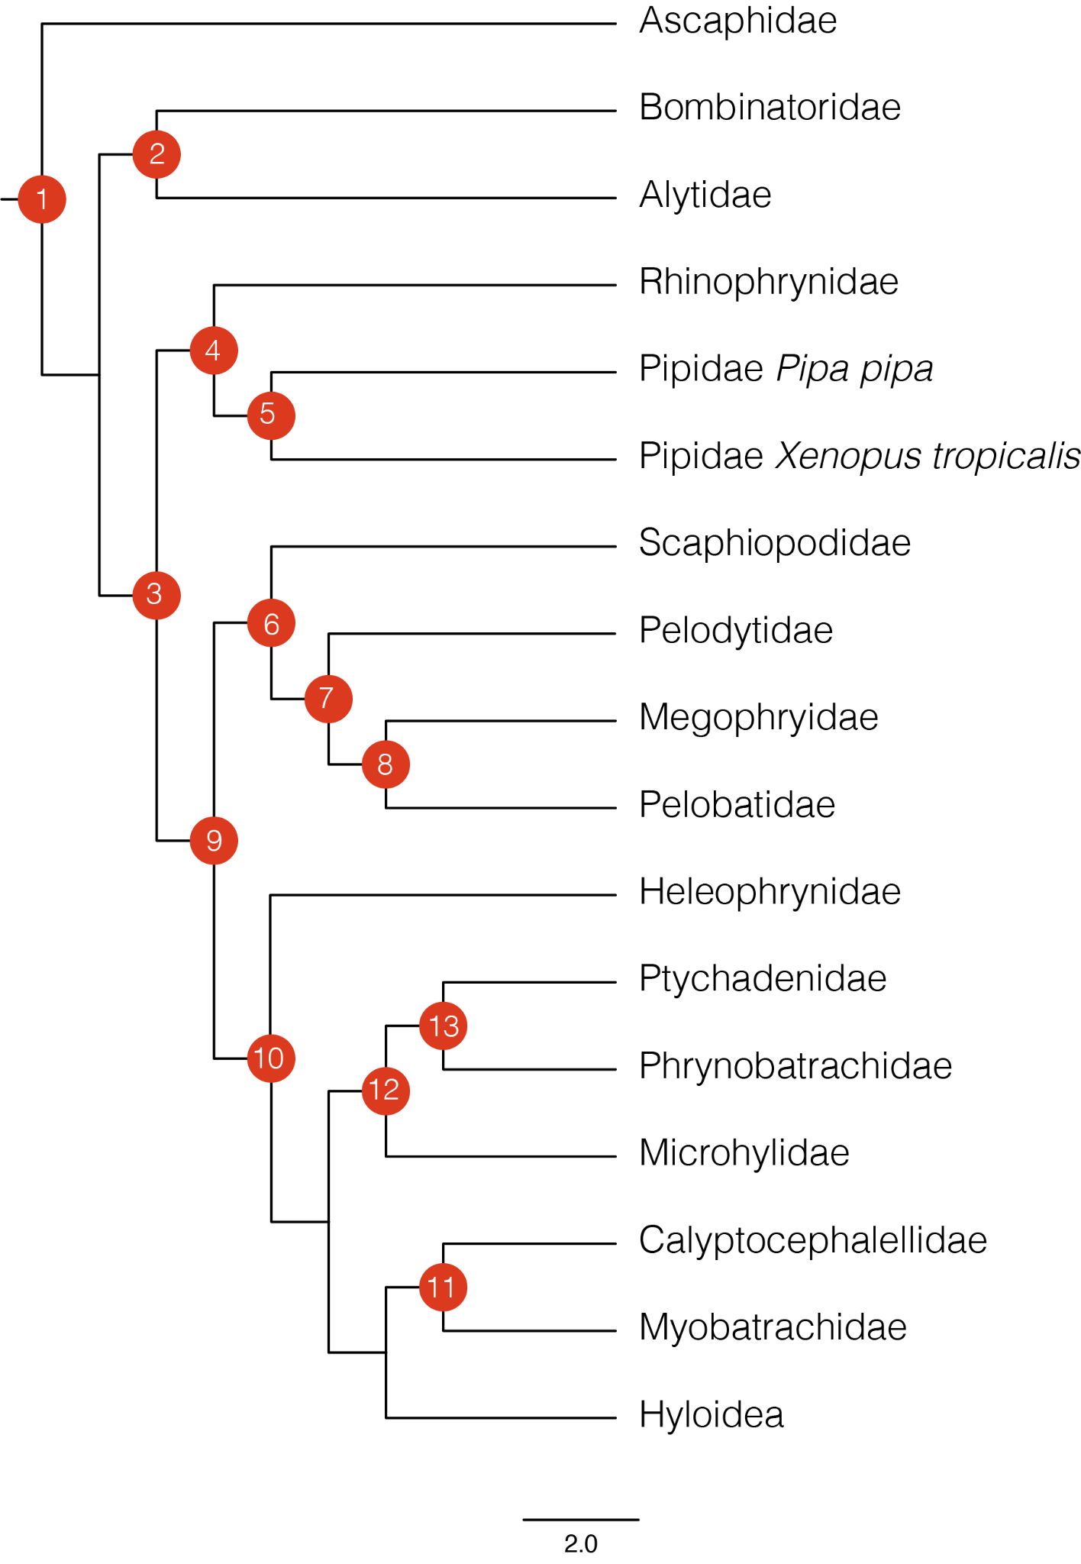

Table S3. Results of biogeographic ancestral range reconstruction in *BioGeoBEARS*. Hypothesis *H1* refers to the dispersal of pelodryadid frogs from South America through Antarctica to Australia, whereas *H2* refers to the over water dispersal of pelodryadid frogs from South America directly to Australia. Models are sorted according to deltaAIC scores, indicating the preferred model at the top.

|  |  |  |  |  |  |  |
| --- | --- | --- | --- | --- | --- | --- |
| Model | Hypothesis | No. Param. | LnL | AIC | deltaAIC | AICw |
| DEC+j+x+w | H1 | 5 | -91.47 | 192.94 | 0 | 59.7 |
| DEC+j+x | H1 | 4 | -93.49 | 194.98 | 2.04 | 21.5 |
| DEC+j+x+w | H2 | 5 | -93.08 | 196.16 | 3.22 | 11.9 |
| DEC+j+x | H2 | 4 | -94.66 | 197.32 | 4.38 | 6.69 |
| DEC+x+w | H2 | 4 | -102.71 | 213.42 | 20.48 | 0 |
| DEC+j | H2 | 3 | -104.91 | 215.82 | 22.88 | 0 |
| DEC+x+w | H1 | 4 | -105 | 218 | 25.06 | 0 |
| DEC+x | H2 | 3 | -106.47 | 218.94 | 26 | 0 |
| DEC+x | H1 | 3 | -107.85 | 221.7 | 28.76 | 0 |
| DEC+j | H1 | 3 | -109.33 | 224.66 | 31.72 | 0 |
| DEC | H2 | 2 | -114.67 | 233.34 | 40.4 | 0 |
| DEC | H1 | 2 | -121.56 | 247.12 | 54.18 | 0 |

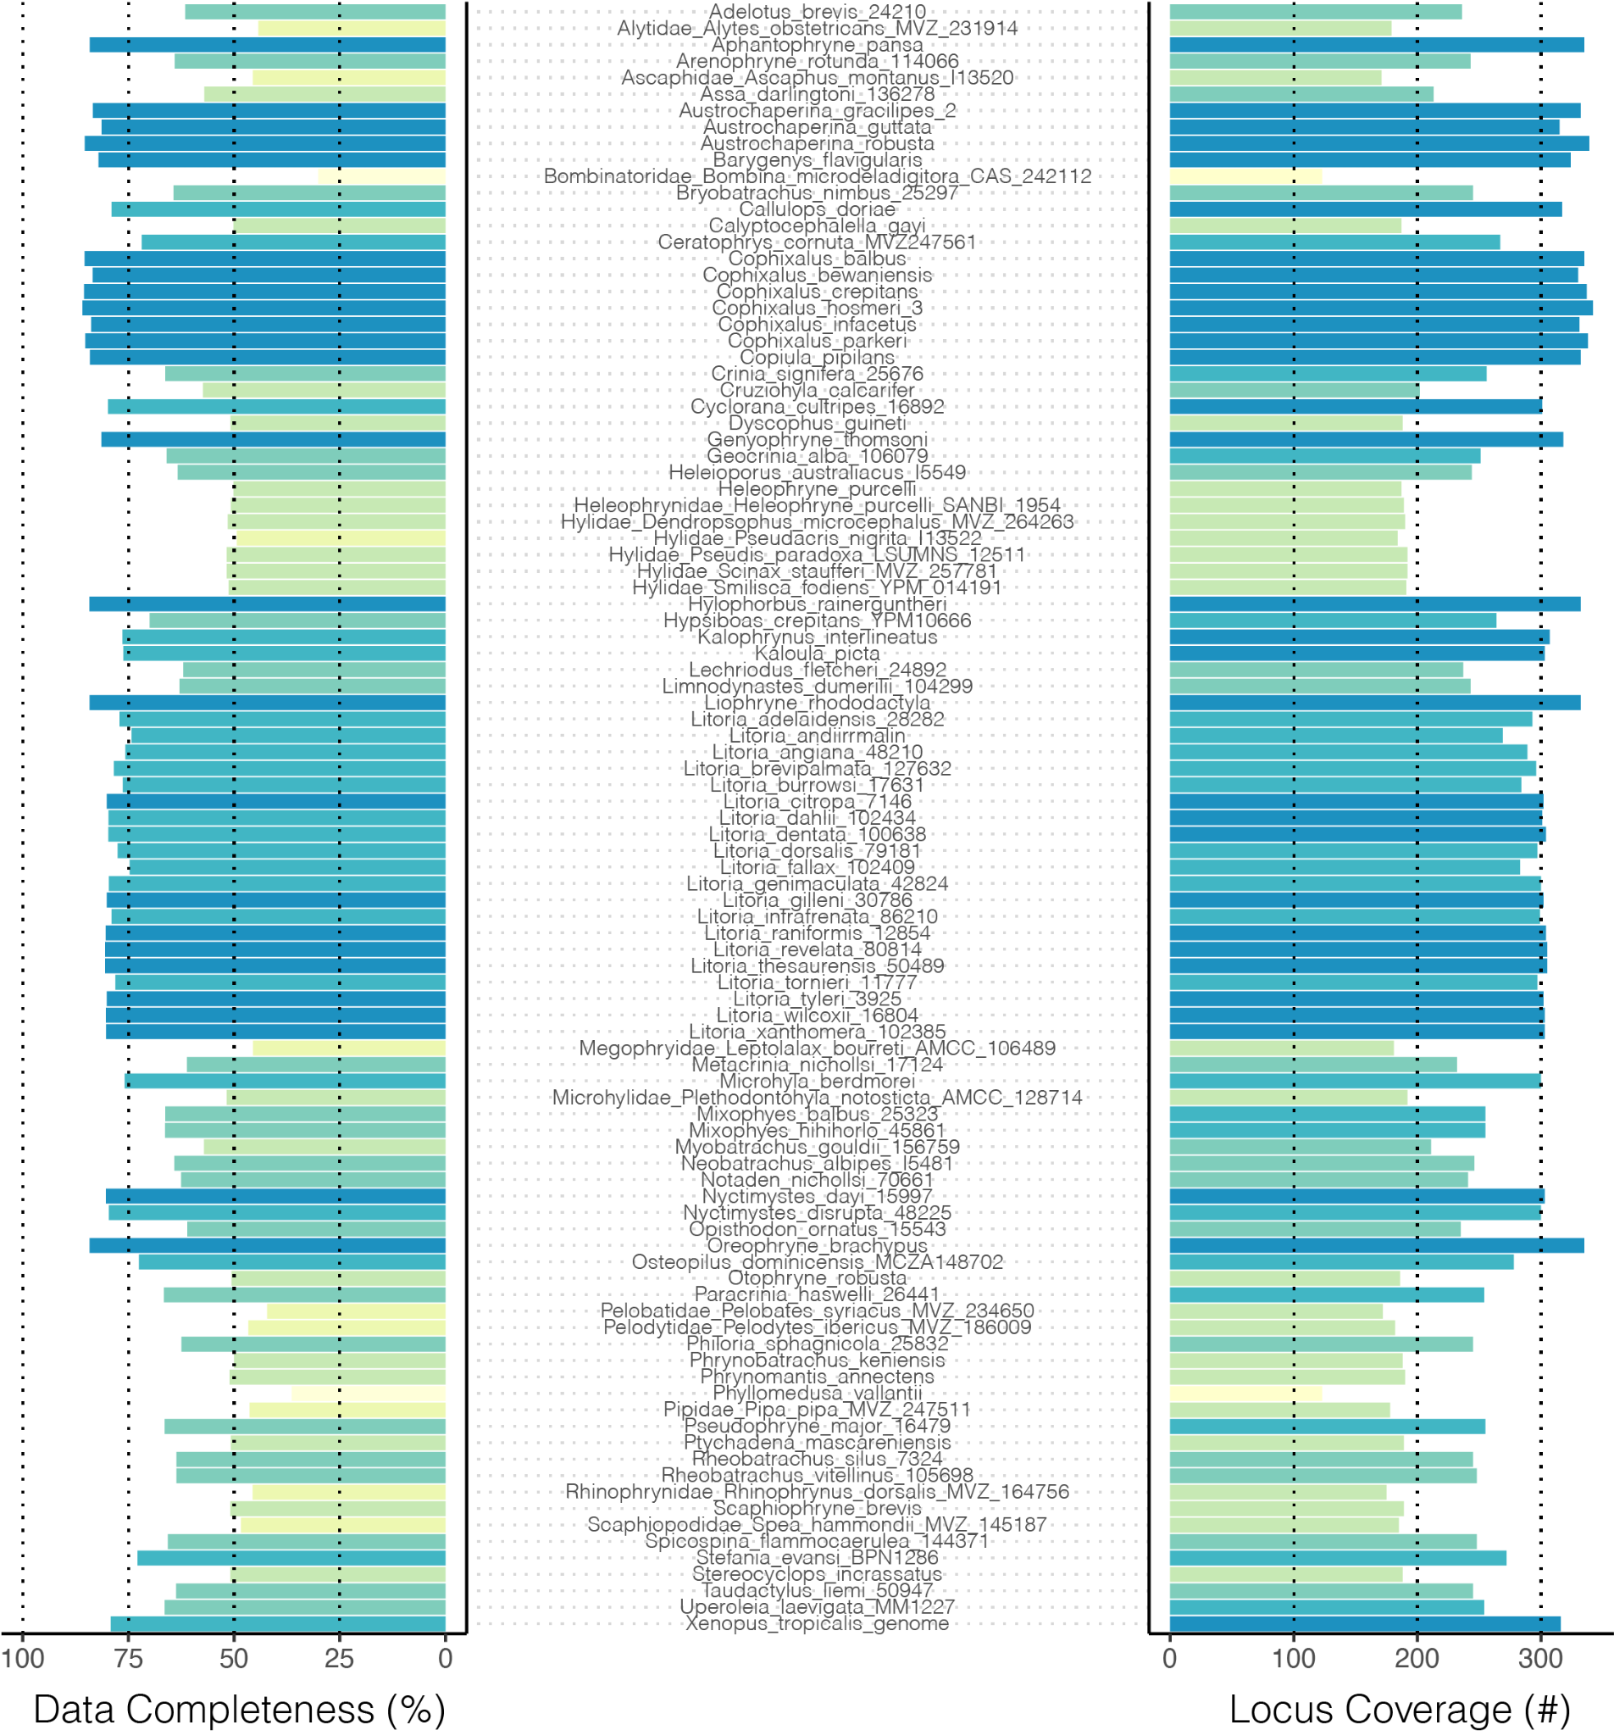

Figure S1. Data completeness across all samples. Left histogram shows data completeness as percent of bases in total alignment (concatenated alignment length 523,036 bp) exclusive of gaps (-) and missing bases (N). Right histogram shows data completeness as the absolute number of loci included per sample, as a representation of the number of gene trees per sample.

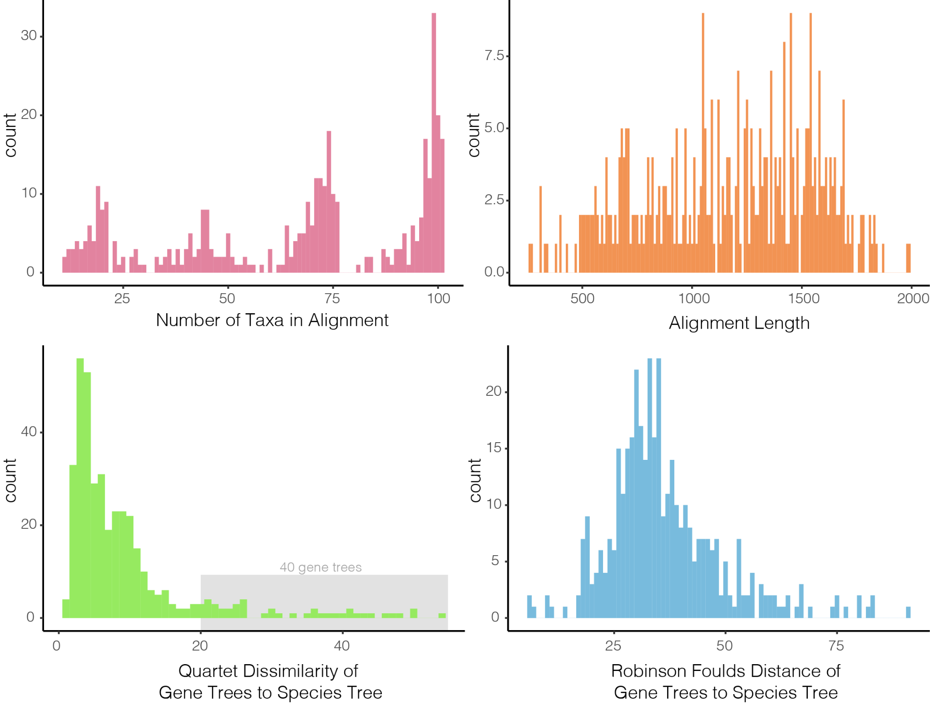

Figure S2. Basic summary statistics of the 450 locus alignments and gene trees. Top row shows histograms of the number of taxa in (max=101, min=11) and length of each alignment. Bottom row shows gene tree--species tree distances as quartet dissimilarity scores and Robinson Foulds distances, two different measures of topological similarity. Both quartet dissimilarity and RF scores are estimated by first subsetting the species tree to match gene tree sampling.

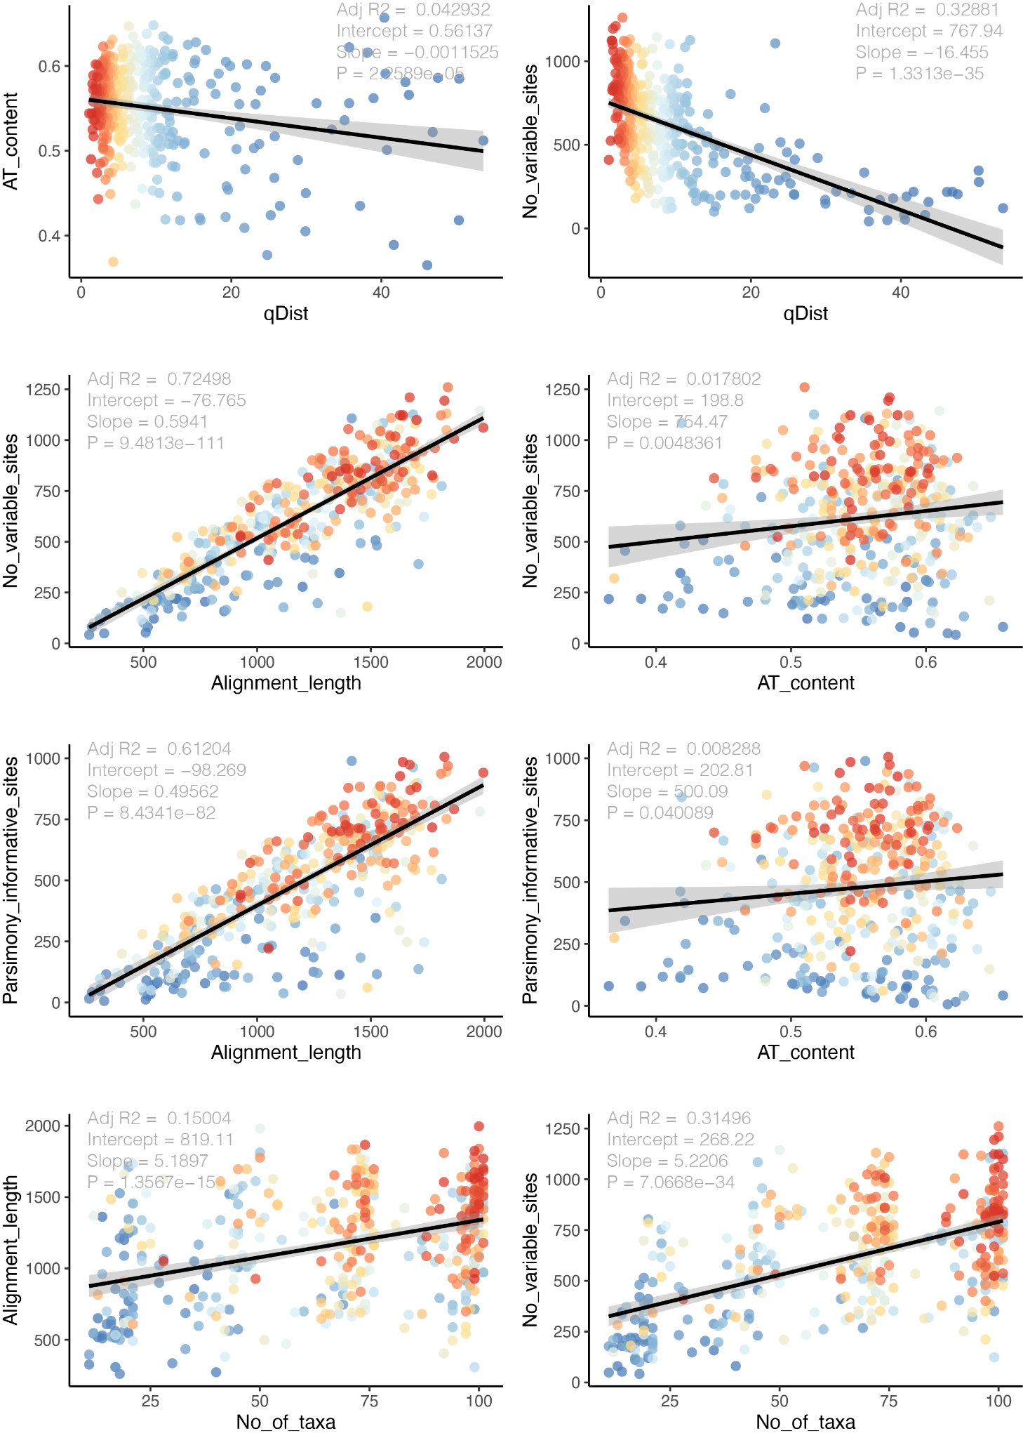

Figure S3. Detailed summary statistics of the 450 locus alignments and gene trees. Top row compares AT content and number of variable sites against quartet distance between each gene tree and the species tree (a measure of topological similarity). The second and third rows compare measures of locus informativeness (number of variable sites, number of parsimony informative sites) against alignment length and AT content. The bottom row shows alignment length and number of variable sites as a function of the number of taxa in the alignment. In all plots points (representing trees or alignments) are colored according to the quartet distance from the species tree.

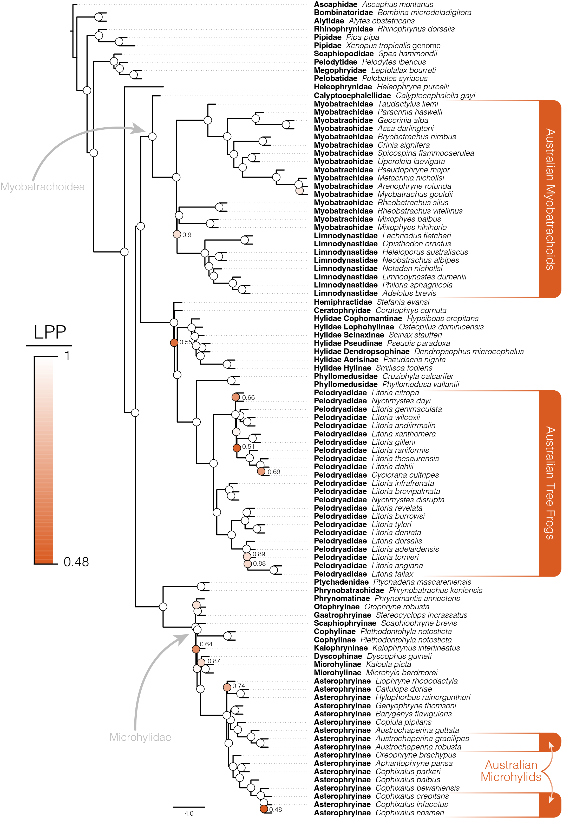

Figure S4. Species tree of Australian frogs and appropriate outgroup taxa estimated using ASTRAL with locus trees estimated by IQTREE as input. Phylogenetic resolution among major frog groups and within Australian frog clades is consistently high. Ultrafast bootstratp support values (Hoang et al. 2018) are shown at nodes and colored according to local posterior probabilities (LPP), values >0.9 are considered strongly supported and not indicated at nodes (white circles).

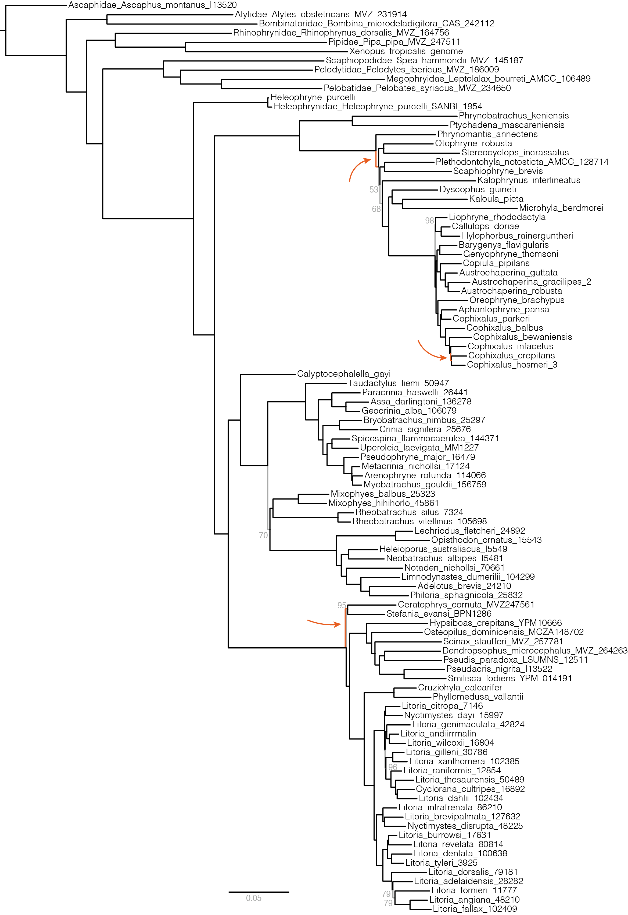

Figure S5. Species tree of Australian frogs and appropriate outgroup taxa estimated from the concatenated sequence alignment under the GHOST model implemented in IQTREE. Phylogenetic resolution among major frog groups and within Australian frog clades is consistently high. Only ultrafast bootstrap support values less than 100 are noted, here by grey branches and text (Hoang et al. 2018). This topology is highly consistent with the phylogeny estimated using ASTRAL (Fig.2, S4), however three differences are highlighted by orange branches and arrows indicating their location. Branch lengths are weighted averages over four heterotachy classes.

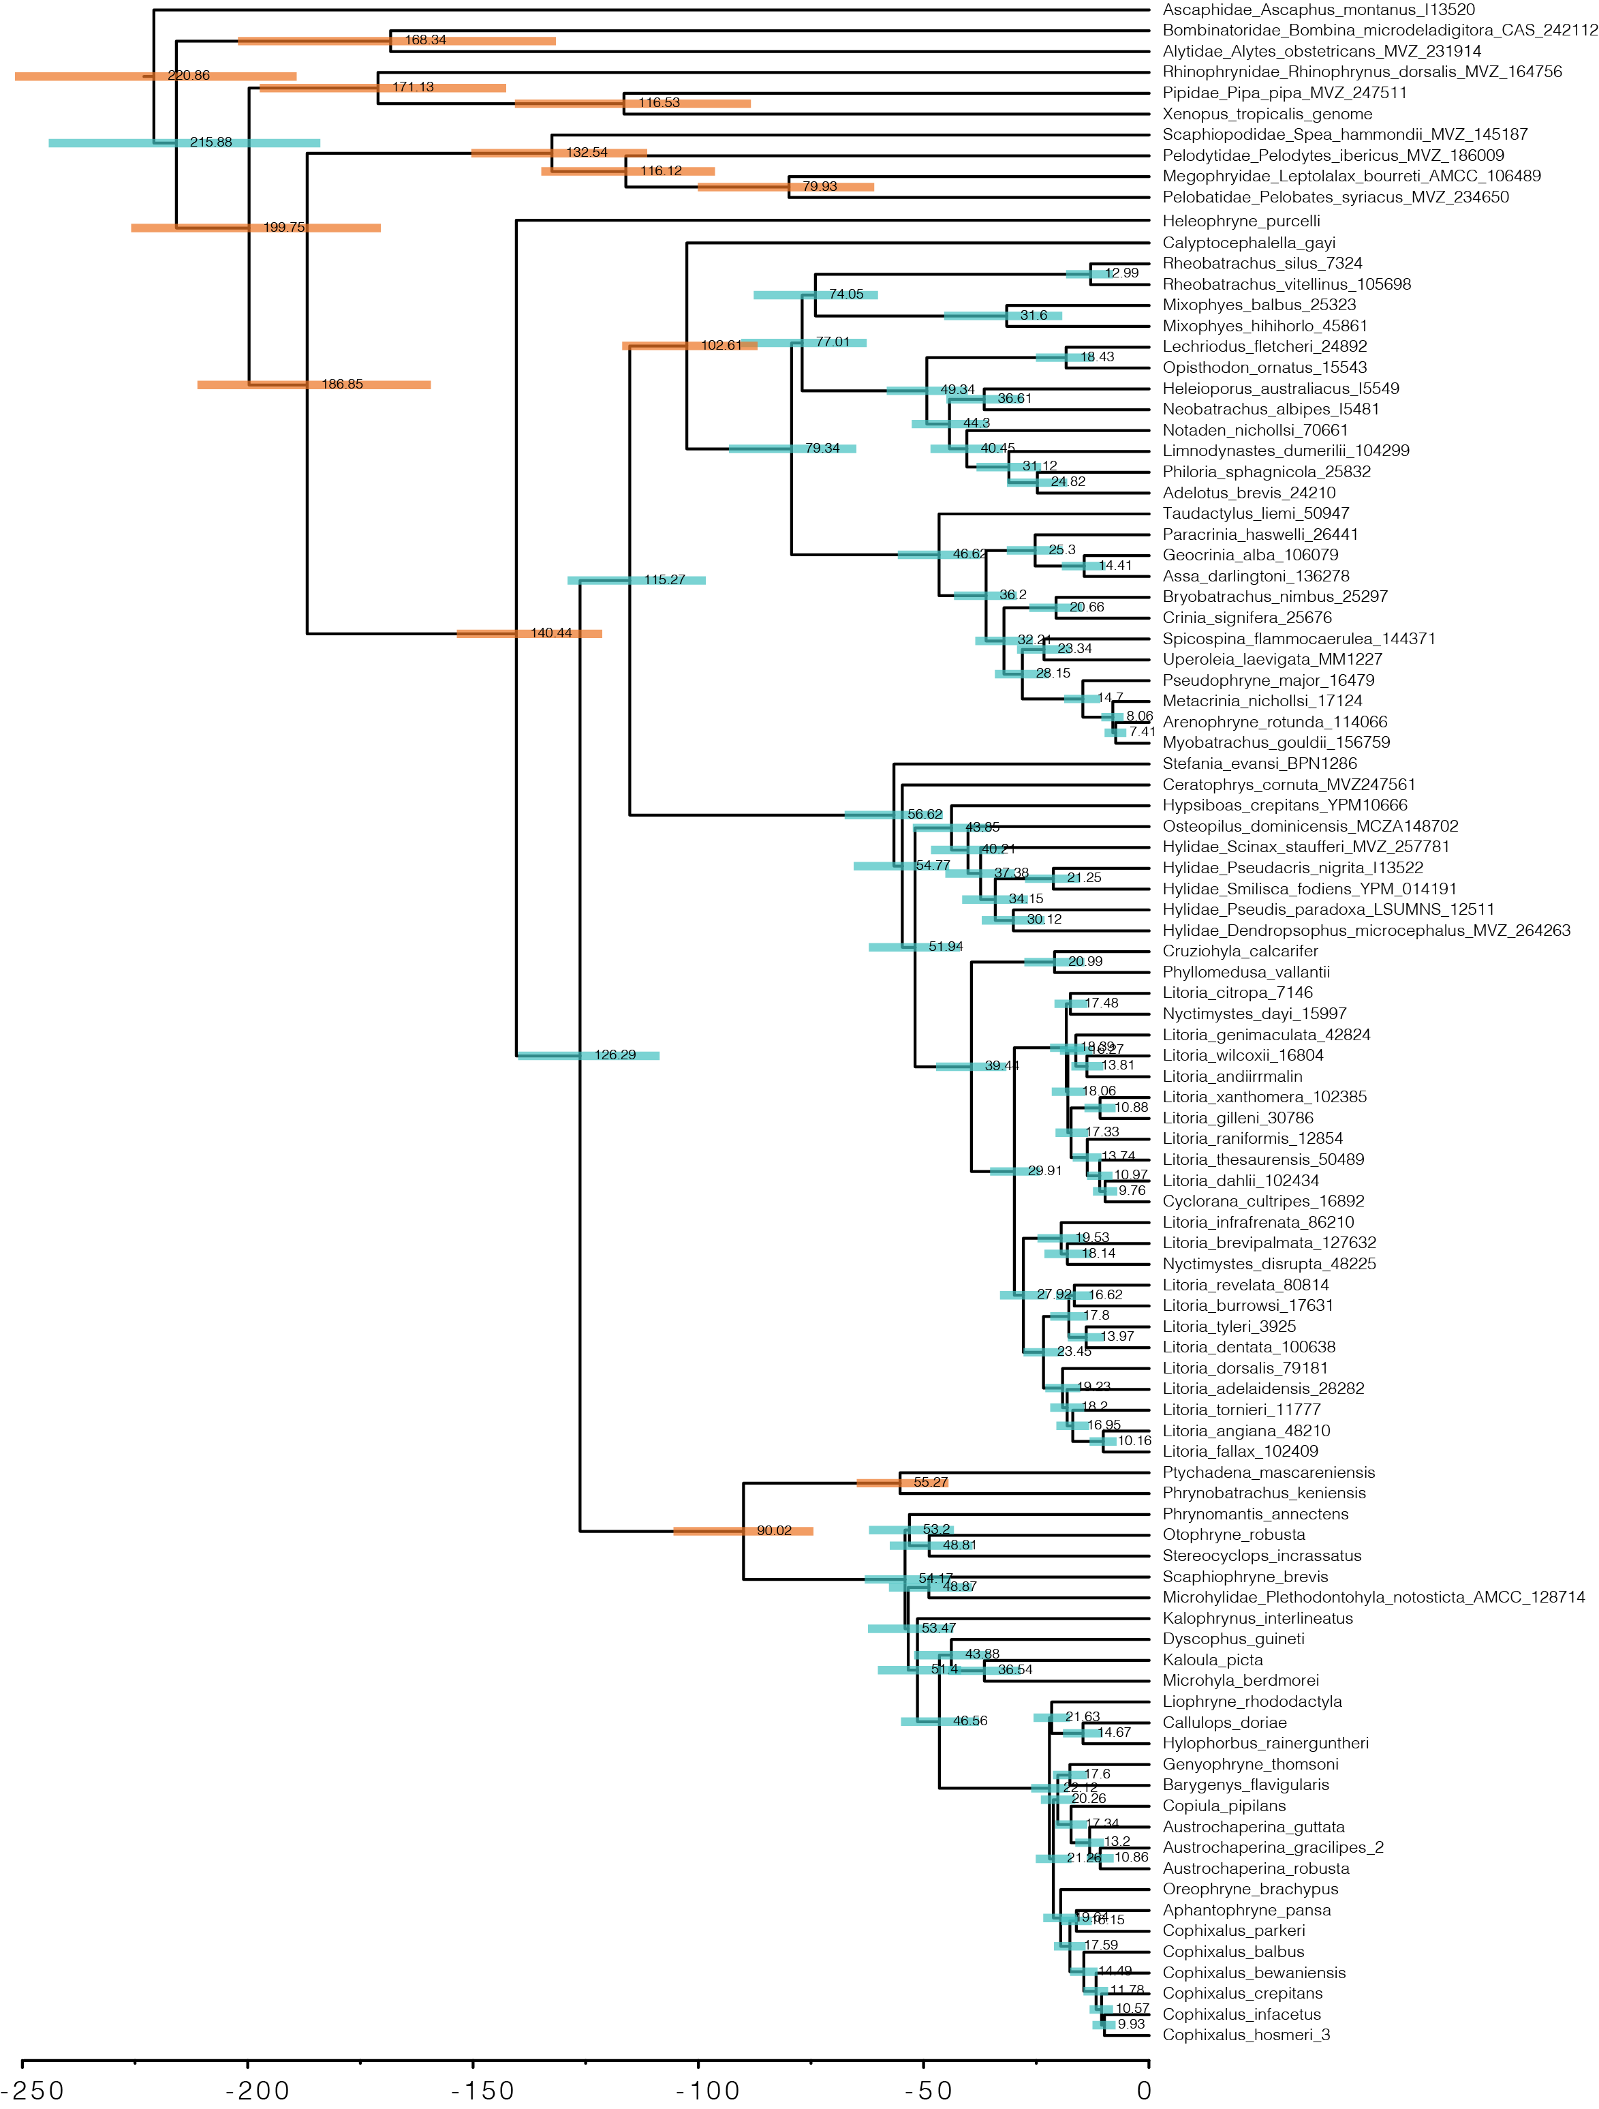

Figure S6. Species tree of Australian and outgroup frogs estimated with ASTRAL from IQTREE genetrees and time-calibrated with MCMCtree. Shaded bars at nodes indicate 95% confidence estimates on ages and numbers indicate mean age estimates. Orange shaded bars indicate nodes which were calibrated with from fossil evidence (see Table S2).

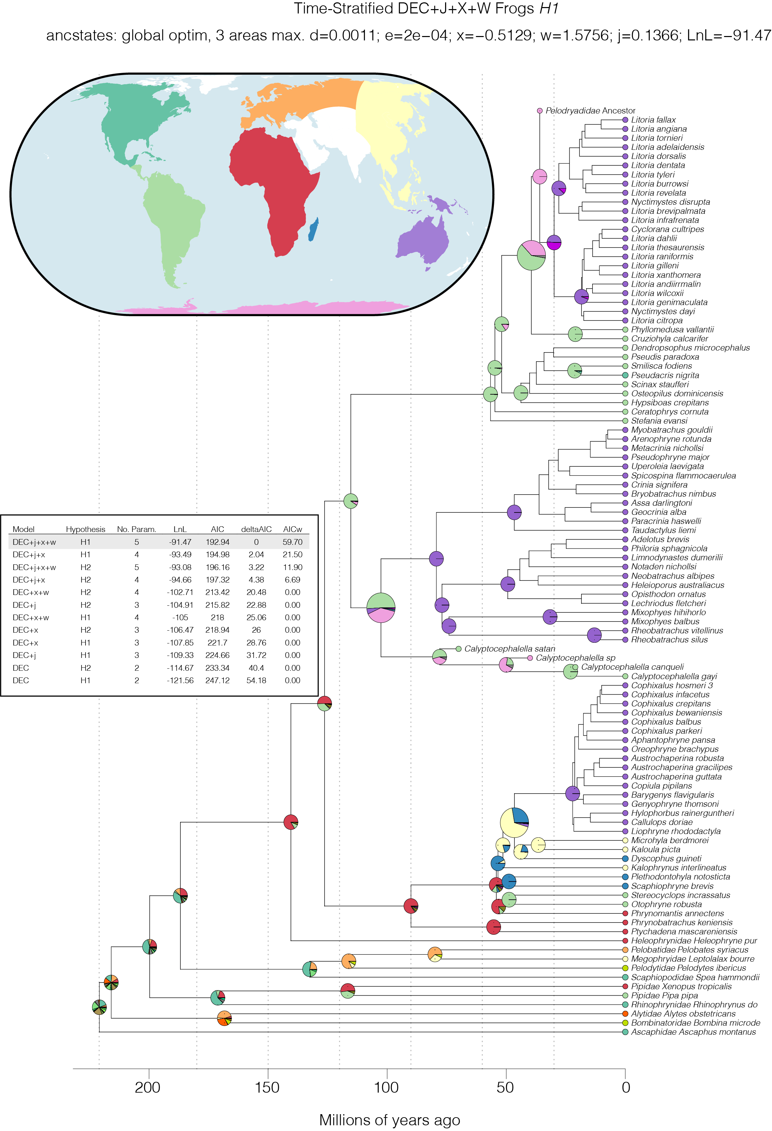

Figure S7. Biogeographic history of frogs with a focus on the range reconstruction of Australian clades. Inset table shows the 12 models fit to the data (6 models across two ‘datasets’), ordered by deltaAIC. Ancestral range estimates under the preferred model DEC+*j*+*x*+*w* *H1* are shown at right as pie charts on the phylogenomic tree with several fossil taxa added. Pie chart for the most recent common ancestor of each Australian clade is enlarged to enhance visualization. The eight bioregions are shown in the inset map and colors correspond to the tip state of taxa on the tree. Additional colors in the pie charts correspond to combinations of areas, but are not discussed further.

Supplementary References

Agnolin, F. (2012). A new Calyptocephalellidae (Anura, Neobatrachia) from the Upper Cretaceous of Patagonia, Argentina, with comments on its systematic position. *Studia geologica salmanticensia*, *48*(2), 129-178.

Báez, A. M., & Gómez, R. O. (2018). Dealing with homoplasy: osteology and phylogenetic relationships of the bizarre neobatrachian frog *Baurubatrachus pricei* from the Upper Cretaceous of Brazil. *Journal of Systematic Palaeontology*, *16*(4), 279-308.

Hoang, D. T., Chernomor, O., Von Haeseler, A., Minh, B. Q., & Vinh, L. S. (2018). UFBoot2: improving the ultrafast bootstrap approximation. *Molecular biology and evolution*, *35*(2), 518-522.

Matzke, N. J. (2014). Model selection in historical biogeography reveals that founder-event speciation is a crucial process in island clades. *Systematic biology*, *63*(6), 951-970.

Moura, P. H. A., Costa, F. R., Anelli, L. E., & Nunes, I. (2021). A new genus of fossil frog (Anura) from lower Cretaceous deposits in South America. *Anais da Academia Brasileira de Ciências*, *93*.

Muzzopappa, P., & Báez, A. M. (2009). Systematic status of the mid-Tertiary neobatrachian frog *Calyptocephalella canqueli* from Patagonia (Argentina), with comments on the evolution of the genus. *Ameghiniana*, *46*(1), 113-125.

Nicoli, L., Muzzopappa, P., Espinoza, N., & Melchor, R. (2022). A new fossil species of *Calyptocephalella* (Anura: Australobatrachia) from the Miocene of northern Patagonia: Novel evidence of the broad past diversity of the genus. *Journal of South American Earth Sciences*, *119*, 104008.

Van Dam, M. H., & Matzke, N. J. (2016). Evaluating the influence of connectivity and distance on biogeographical patterns in the south‐western deserts of North America. *Journal of Biogeography*, *43*(8), 1514-1532.