19 December 2022

Dear Editors of Nature Ecology & Evolution

We would like to gauge your interest in our manuscript *Populating a Continent: Phylogenomics Reveal the Timing of Australian Frog Diversification* with this presubmission enquiry. We believe this manuscript contributes to both our empirical understanding of a diverse vertebrate system as well as conceptually to our knowledge of how continental diversity accumulates over deep time. This work shines a light on the age and relationships among the major clades of Australian frogs which comprise more than 250 species and provides resolution on their biogeographic origins. Below we provide a brief general summary for the public. On the following pages we provide the title, full author list, and abstract, accompanied by the primary figure from our manuscript.

*Public Summary: Where does diversity come from?*

Australia is generally considered hot, dry, and flat, making it an inhospitable place for frogs. Despite this more than 250 species call the continent home, ranging from enormous green tree frogs, to tiny brown burrowing frogs. But where did Australia’s frogs come from and when did they get there? Our study provides insight into the origins of Australia’s frogs, giving age estimates to the three major frog groups found on the continent and establishing their closest relatives. We find that the oldest groups likely originate from the paleocontinent Gondwana long before the separation of Australia around 35 million years ago. In particular, the ground frog group —members of the Myobatrachoidea—may be Australia’s oldest living vertebrate animals. In comparison, the youngest group likely immigrated to Australia from New Guinea around 10 million years ago. This research helps us to better understand and appreciate Australia’s unique biodiversity, of which most species are found nowhere else on Earth.

On behalf of myself and coauthors we thank you for your time and consideration.

Ian G. Brennan

Division of Ecology & Evolution

Research School of Biology

The Australian National University

Canberra ACT 02600 Australia

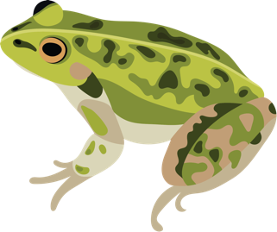

*Article Type*:

Report (2,500 words, 3 figures, 0 tables)

*Title*:

Populating a Continent: Phylogenomics Reveal the Timing of Australian Frog Diversification

*Author List*:

Ian G. Brennan1,2,\*, Alan R. Lemmon3, Emily Moriarty Lemmon3, Conrad J. Hoskin4,  
Stephen C. Donnellan5,6 and J. Scott Keogh1

1Division of Ecology & Evolution, Australian National University, Canberra, ACT 2601, Australia

2Natural History Museum, London, Cromwell Road, London SW7 5BD, United Kingdom

3Department of Biological Science, Florida State University, Tallahassee FL 32306, USA

4College of Science and Engineering, James Cook University, Townsville, QLD 4811, Australia

5School of Biological Sciences, The University of Adelaide, Adelaide, SA 5005, Australia

6South Australian Museum, North Terrace, Adelaide, SA 5000, Australia

\*Corresponding author: iangbrennan@gmail.com

*Abstract*:

The Australian continent’s size and isolation make it an ideal place for studying the accumulation and evolution of biodiversity. Long separated from the ancient supercontinent Gondwana, most of Australia’s plants and animals are unique and endemic, including the continent’s frogs. Australian frogs comprise a remarkable ecological and morphological diversity categorized into a small number of distantly-related radiations. We present a phylogenomic hypothesis based on an exon-capture dataset that spans the main clades of Australian myobatrachoid, pelodryadid, and microhylid frogs. Our time-calibrated phylogeny identifies great disparity in the relative ages of these groups which vary from Gondwanan relics to recent Asian immigrants and include arguably the continent’s oldest living vertebrate radiation. This age stratification provides insight into the population of the Australian continent despite dramatic climatic and community changes through time. Contemporary Australian frog diversity highlights the adaptive capacity of anurans particularly in response to heat and aridity and explains why they are one of the world’s most visible and unique faunas.

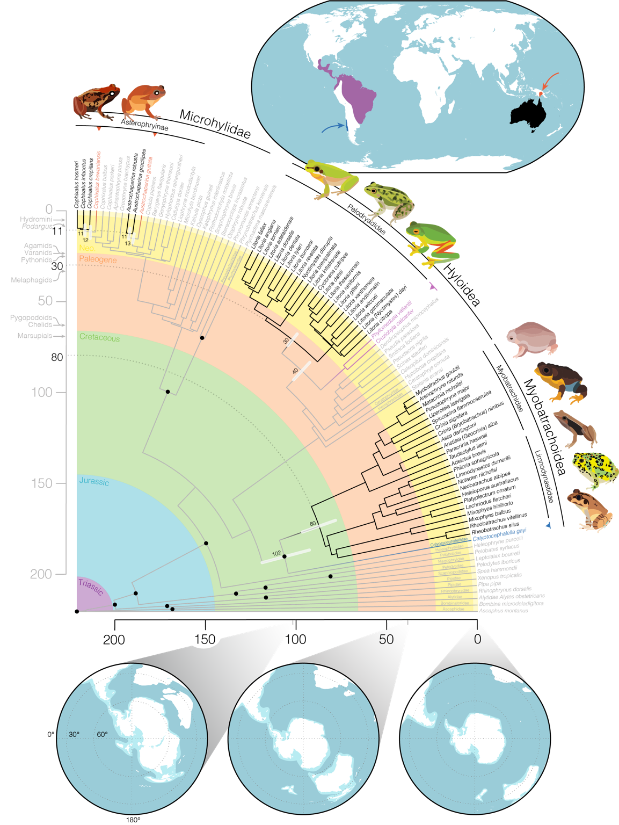

*Figure Caption*: Figure 2. Time-calibrated frog phylogeny highlights the staggered arrival of the four major frog families that comprise the Australian anuran fauna. Primarily Australian clades are identified by black branches and text, their closest living relatives outside of Australia are noted by colored branches and text, and outgroup taxa are grey. Black circles at nodes identify the location of fossil calibrations (see Table S2). Upper inset map shows the general geographic location of: (red) closely related microhylids in New Guinea, (purple) phyllomedusid hylids in South America, and (dark blue) *Calyptocephallela* in Chile. Lower inset maps show the connection and proximity of Australia to other Gondwanan continents as Australia drifted away over the past 100 million years. White indicates contemporary coastlines, light blue the continental plates, and dark blue the oceans. Maps were generated using GPlates and input files modified from Landis (2017). Partial fan phylogeny was plotted using *phytools* in the R programming environment. Annotations on vertical time axis show the age of crown divergences of other notable Australian groups for temporal context (see Fig.S5). Species illustrated clockwise from top left: *Cophixalus infacetus, Austrochaperina robusta, Litoria fallax, Litoria dahlii, Litoria xanthomera, Myobatrachus gouldii, Spicospina flammocaerulea, Taudactylus acutirostris, Notaden bennettii, Mixophyes balbus.*