# [Final Project]

# [Game Overview]

This project is a platformer made with HTML5 and Javascript. It centers around a ninja frog going through a variety of levels with the goal of helping me graduate.

# [Team Personal]

Lead Programmer – Ian Wilson

Lead Designer – Ian Wilson

Lead Artist – Ian Wilson (and random art I found online)

# [Plot and Setting]

Plot – A young man has to make a game to graduate and here we are.

Setting – A hilly area.

# [Core Gameplay]

The gameplay will center around standard platformer mechanics such as running (left and right arrow keys) and jumping (up arrow key) and will feature multiple enemies and powerups. The goal of each level is to reach the door at the end of it. Upon reaching that door if the player meets the correct criteria (killed all enemies or has time left) they successfully complete that level and move on to the next level.

# [Characters, enemies, and powerups]

Characters and Enemies –

Ninja Frog – This is the character the player controls. Using the left, right, and up arrow keys the player can make the frog move left and right as well as jump. By default, the frog can jump high enough to go up one block and run fast enough to cross a gap of one block without falling.

VR headset man – An enemy that simply walks back and forth. Jumping on his head will kill him but touching him from any other direction will kill the player.

Vodoo mask man – An enemy that stands still and shoots “bullets” at set intervals of time. These bullets will kill the player if they touch the player. Jumping on his head will kill him but touching him from any other direction will kill the player.

Pink Finn from adventure time – An enemy that flies around and teleports to set location in pattern. Jumping on his head will kill him but touching him from any other direction will kill the player. Simply standing above him as he flies into your feet will still kill the player, as they are not jumping.

Kiwi – A power up that lets the player jump high enough to get up two blocks.

Apple – A power up that lets the player move fast enough to cover gaps of multiple blocks without falling.

Banana – A power up that gives the player a shield. As long as they have the shield the next enemy the player touches from any direction that would normally kill the player will instead kill the enemy and remove the shield from the player.

# [Interface]

The player will use the left and right arrow keys to move left and right and the up key to jump. Jumping on enemies kills them and hitting them any other way will kill you.

# [Menu and General Game Usage]

The menu will have three buttons from which the player can go to any of the three levels. After either completing a level the player will be sent to the next level. Failing by dying from an enemy or running out of time will have the player restart the current level they are on. After completing the last level the player will be sent back to the main menu.

Below is a UML of how the game works outside of levels.

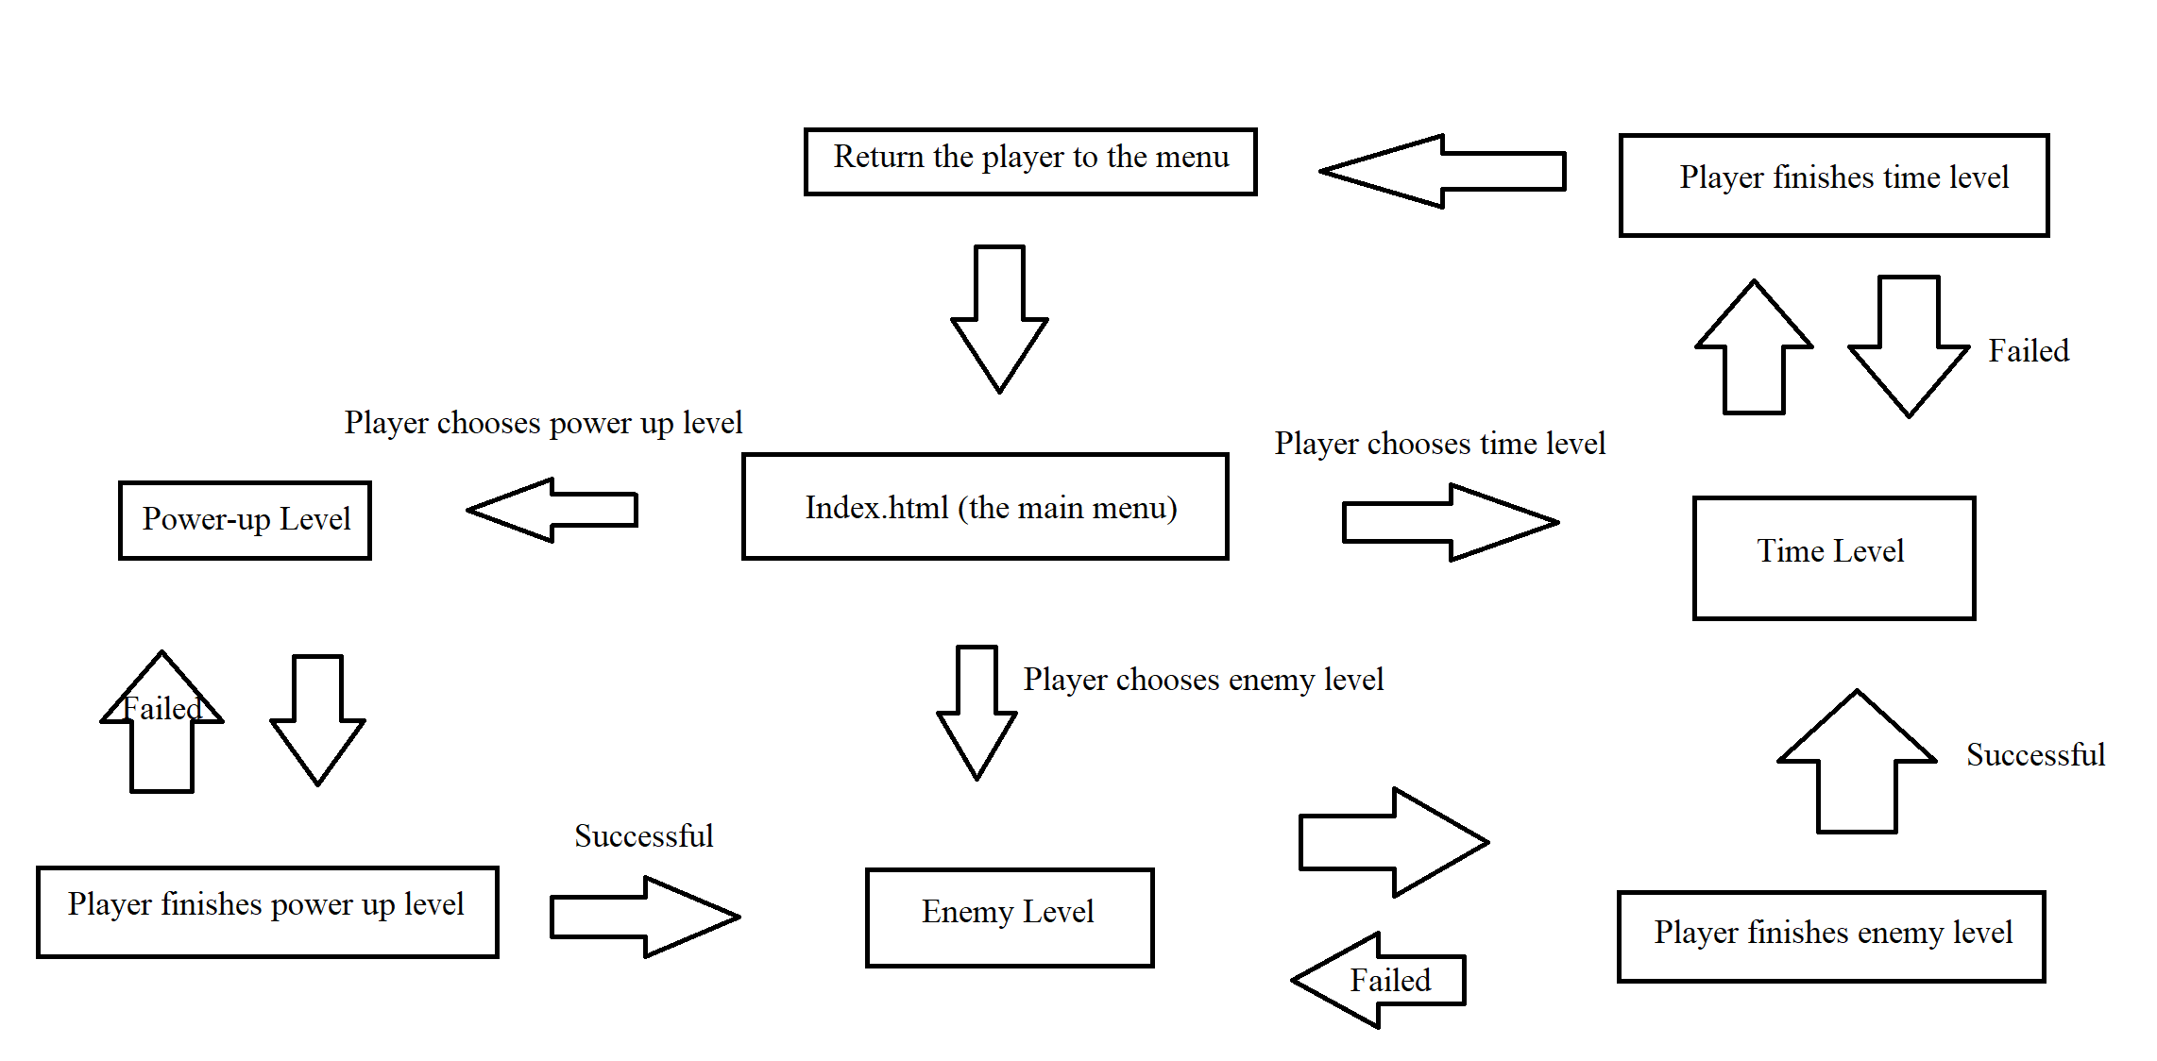

Below is a flow chart of how the game works inside a level.

